ROR1 is upregulated in endometrial cancer and represents a novel therapeutic target.
Dongli Liu¹, Kate Gunther¹, Luis A Enriquez¹, Benjamin Daniels², Tracy A. O’Mara³, Katrina Tang⁴, Amanda B. Spurdle³, Caroline E Ford^{1*}
¹Gynaecological Cancer Research Group, Lowy Cancer Research Centre, School of Women's and Children's Health, Faculty of Medicine, University of New South Wales, Australia
²Medicines Policy Research Unit, Centre for Big Data Research in Health, Faculty of Medicine, University of New South Wales, Australia
³QIMR Berghofer Medical Research Institute, Australia
⁴South Eastern Area Laboratory Services Pathology, Prince of Wales Hospital, Randwick, Australia
*Corresponding author: Dr Caroline Ford, Gynaecological Cancer Research Group, Lowy Cancer Research Centre and School of Women’s and Children’s Health, Faculty of Medicine, University of New South Wales, New South Wales, 2052, Australia. T: +61293851457 F: +61293851510 E: caroline.ford@unsw.edu.au

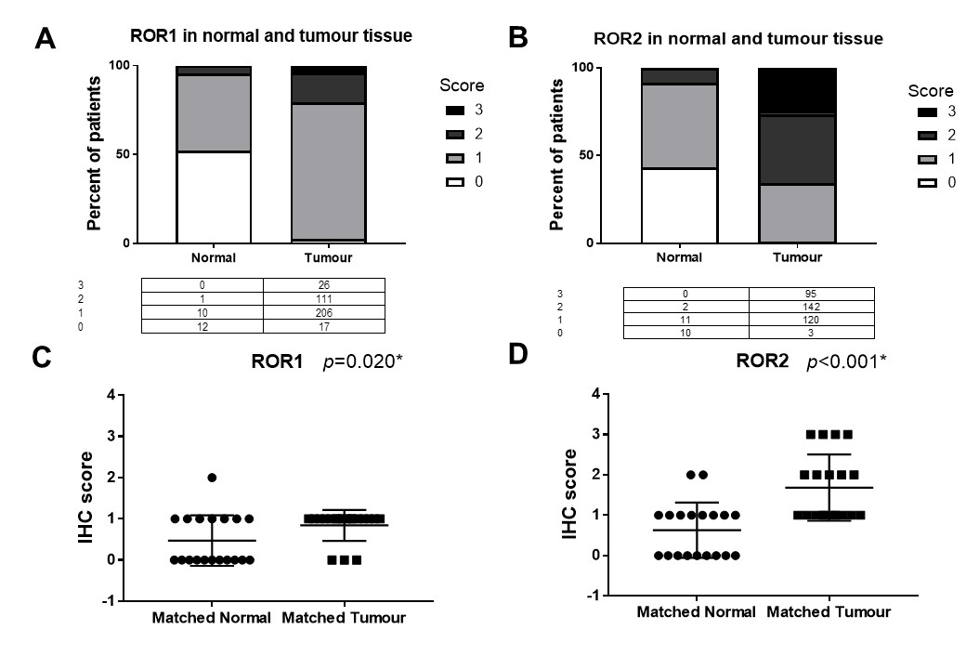
Supplementary Fig. S1. ROR1/2 expression in normal and tumour tissue in endometrial cancer patients. A: Expression of ROR1 in normal (n=23) and tumour tissue (n=360). The values in the table below showed the number of score 0, 1, 2, 3 in each tissue type. B: Expression of ROR2 in normal (n=23) and tumour tissue (n=360). C: Expression of ROR1 in the matched normal and tumour tissue (n=19). P values resulted from paired t-test (two tailed). The expression level of ROR1 in tumour tissue is significantly different from that in the adjacent normal tissue (p=0.020). D. Expression of ROR2 in the matched normal and tumour tissue (n=19). The expression level of ROR2 in tumour tissue is significantly different from that in the adjacent normal tissue (p<0.001). *Significant at p<0.05 level.

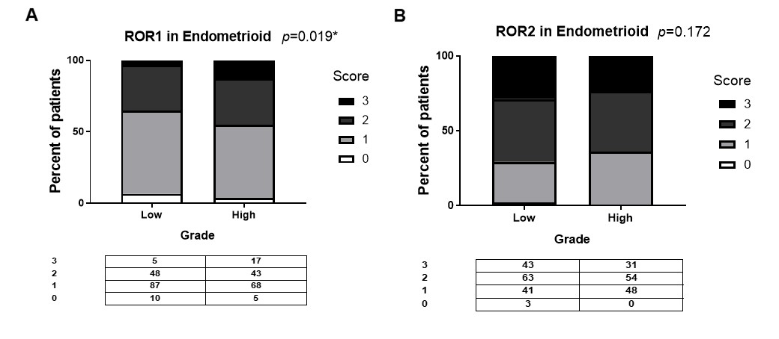
Supplementary Fig. S2. ROR1/2 expression in endometrioid endometrial cancer patient samples stratified by grades. A: The expression level of ROR1 in endometrioid endometrial cancer patients was correlated with grade (p=0.019). The values in the table below showed the number of score 0, 1, 2, 3 in each grade. P values resulted from Chi-square or Fisher’s exact test indicated the significant level of the correlation. B: ROR2 expression did not differ significantly in different grades of the endometrioid endometrial cancer patients.

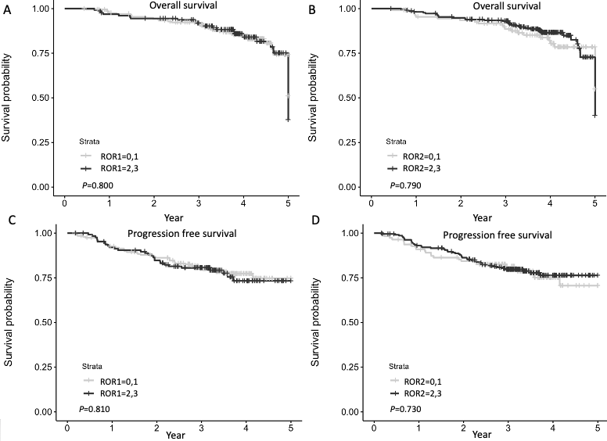
Supplementary Fig. S3. Kaplan-Meier analysis for ROR1 and ROR2 stratified by low (score 0,1) and high (score 2,3) in the complete cohort (n=330). A: Overall survival (OS) according to ROR1 expression. B: Progression free survival (PFS) according to ROR1 expression. C: OS according to ROR2 expression. D: PFS according to ROR2 expression.

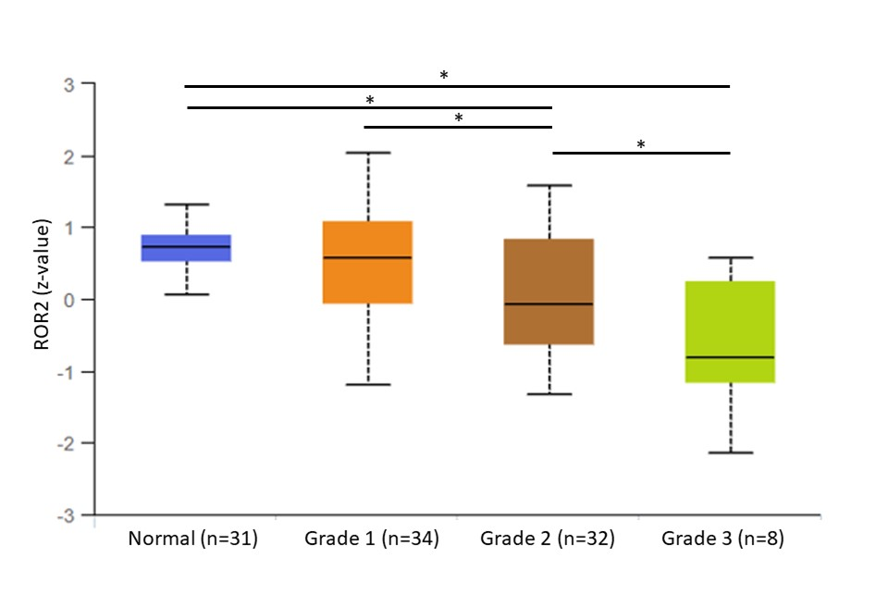
Supplementary Fig. S4. ROR2 expression in Clinical Proteomic Tumor Analysis Consortium (CPTAC) Confirmation/Discovery cohort (n=131) stratified by endometrial cancer tumour grade adjusted from ¹. Z-values represent standard deviations from the median across samples for the given cancer type. P values were obtained from unpaired t-test (2-tailed). *Significant at p<0.05 level.
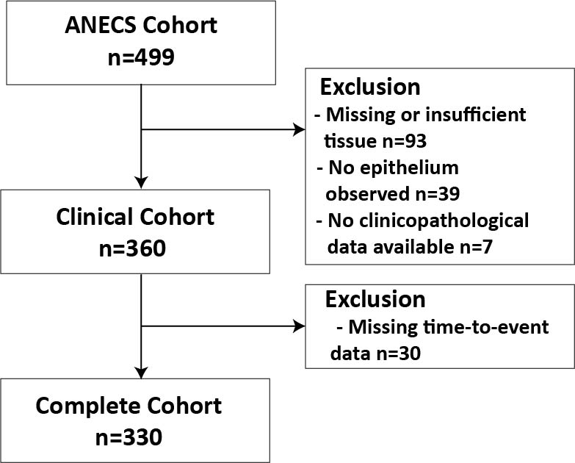
Supplementary Fig. S5. Flowchart of included and excluded sample size. The initial ANECS cohort included samples from 499 patients. We excluded 93 samples because of missing or insufficient tissue for scoring, 39 samples for no epithelium and another 7 due to unavailable clinicopathological parameters to form the clinical cohort of 360 patients. Then we further excluded 30 people as no time to death/progression data was available for survival analysis, resulting in the complete cohort (n=330) for survival analysis.
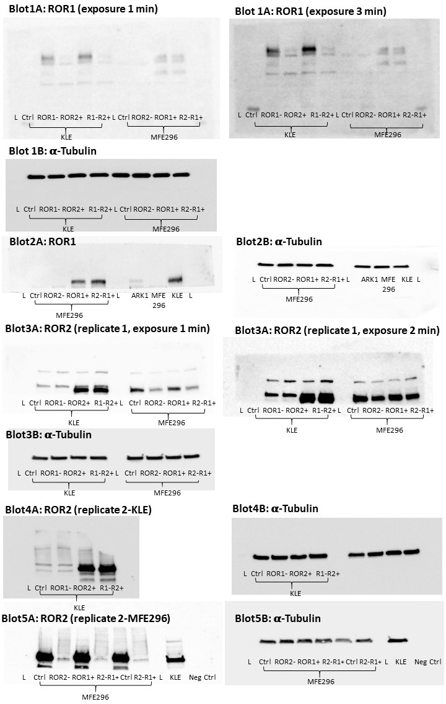
Supplementary Fig. S6. Full-length western blots imaged by the ImageQuant LAS4000 system (GE Healthcare Life Sciences, USA). Blots shown in Figure 4B were extracted from Blot 1A, 3A and 3B. Blots in Figure 5B were extracted from Blot 2A, 3A and 2B. Blot 4 and 5 were replicate blots of Blot 3.

References
1 Chandrashekar, D. S. et al. UALCAN: a portal for facilitating tumor subgroup gene expression and survival analyses. Neoplasia 19, 649-658 (2017).

