Characterization of immune response induced against catalytic domain of botulinum neurotoxin type E

Priyanka Sonkar, Vinita Chauhan, Ritika Chauhan, Nandita Saxena¹ and Ram Kumar Dhaked*

Biotechnology Division, 1- Toxicology and Pharmacology Division, Defence Research & Development Establishment, Gwalior, MP-474002, India

*corresponding author at
Dr. Ram Kumar Dhaked
Biotechnology Division, Defence Research & Development Establishment (DRDE), Jhansi Road, Gwalior 474002, M.P, India
Email address: ramkumardhaked@hotmail.com

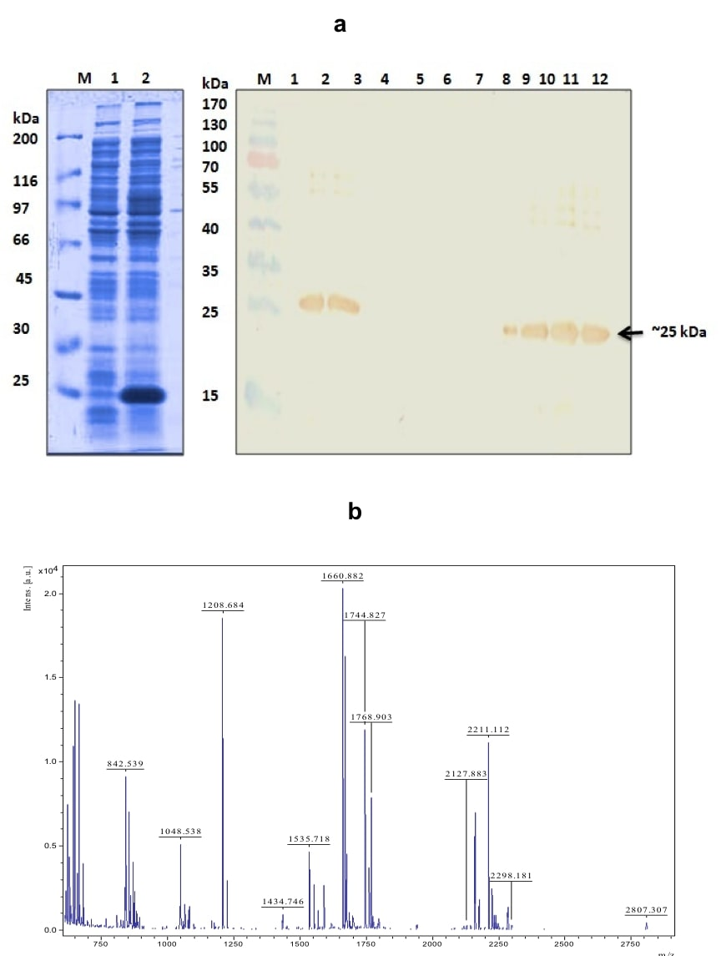

Figure S1: Purification and characterization of rSNAP-25 substrate. (a) The expression of histidine fusion protein induced culture of rSNAP-25 revealed a presence of ~25 kDa protein band. SDS-PAGE gel showing: Lane: M: unstained marker; 1: uninduced; 2: induced pellet. (b) The induced LB culture was purified under native condition using Ni-NTA affinity chromatography. The western blot analysis of purified rSNAP-25 protein using anti-His antibody. Lane: M: prestained marker; 1: uninduced; 2: induced; 3: supernatant after sonication; 4: pellet after sonication; 5: flow through; 6-7: W1-W2: wash fractions; 8-11: E1–E4: eluate fractions; 12: 1 M imidazole. 13 % SDS-PAGE gel showing 25 kDa His tagged protein which was purified under native condition to be used as a substrate to confirm the cleavage activity of rBoNT/E-LC for endopeptidase assay. (c) The purified protein band was cut out, digested with trypsin and characterized further with mass spectrometry analysis. MALDI-TOF/MS spectrum of rSNAP-25 protein tryptic digests in reflectron mode using HCCA as matrix. Labelled peaks correspond to the matched peptide i.e. 16 peptides were matched with 54% coverage to synaptosomal-associated protein-25 (Mus musculus) (NCBI entry: gi|6755588) available in the database.

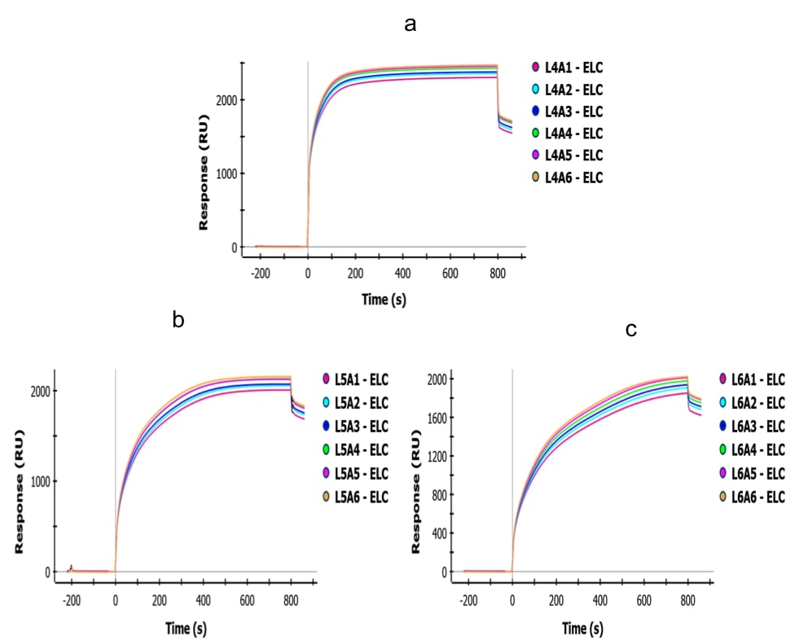

Figure S2: Optimization of concentration of rBoNT/E-LC lysate on HTG chip: The sensorgram values as observed in SPR: the immobilization of the ligand (rBoNT/E-LC) in six different concentrations (1.25, 0.625, 0.312, 0.156, 0.078 and 0.039 μg) on the HTG sensor chip surface. Here, sensorgram graph showing the RU of three concentrations (a:0.156; b:0.078; c: 0.039 μg). The optimum concentration of lysate was found to be 0.039 μg and selected for interaction with antibody.

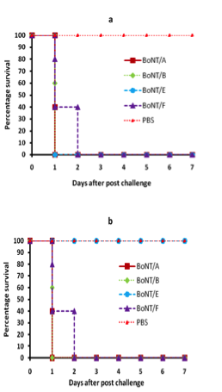

Figure S3: In vivo protection study: (a) The non-immunized BALB/c were administered intraperitoneally with 2X MLD of BoNT/A, B, E & F serotypes and PBS only. The representative graph illustrates the challenged animals were examined for 7 days and their survival and death were recorded. None of the animal group was protected when challenged with BoNT/A, B, E and F. While, in case of those animal group that received PBS alone showed no symptoms of toxicity and no death was observed. (b) The immunized BALB/c were injected with PBS (control), 2X MLD of BoNT/A, B, E & F serotypes. This graph illustrates the challenged animals were examined for 7 days and their survival and death were recorded. Death was observed among those animal group when challenged with BoNT/A, B and F. Whereas, all mice were survived that administered with BoNT/E toxin and PBS alone showed complete survival. No symptoms of toxicity were seen among BoNT/E challenged mice.

