Sex-biased patterns shaped the genetic history of Roma

C.García-Fernández^{1,9}, N.Font-Porterias^{1,9}, V.Kučinskas², E.Sukarova-Stefanovska³, H.Pamjav⁴, H.Makukh⁵, B.Dobon¹ , J.Bertranpetit¹ , MG. Netea^{6,7,8}, F.Calafell¹*, D.Comas¹*

¹ Institute of Evolutionary Biology (UPF-CSIC), Department of Experimental and Health Sciences, Universitat Pompeu Fabra, Barcelona, Spain

² Department of Human and Medical Genetics, Biomedical Science Institute, Faculty of Medicine, Vilnius University, Vilnius, Lithuania

³ Research Center for Genetic Engineering and Biotechnology “Georgi D. Efremov”, Academy of Sciences and Arts of the Republic of North Macedonia – MASA Republic of North Macedonia

⁴ Institute of Forensic Genetics, Hungarian Institute for Forensic Sciences, Budapest, Hungary

⁵ Institute of Hereditary Pathology of the Ukrainian Academy of Medical Sciences, Lviv, Ukraine

⁶ Department of Internal Medicine and Radboud Center for Infectious Diseases, Radboud University Medical Center, 6525 GA Nijmegen, the Netherlands.

⁷ Department of Human Genetics, University of Medicine and Pharmacy Craiova, Romania.

⁸ Department for Genomics & Immunoregulation, Life and Medical Sciences Institute (LIMES), University of Bonn, 53115 Bonn, Germany.

* Corresponding authors
⁹ These authors contributed equally to this work.

E-mail: david.comas@upf.edu francesc.calafell@upf.edu

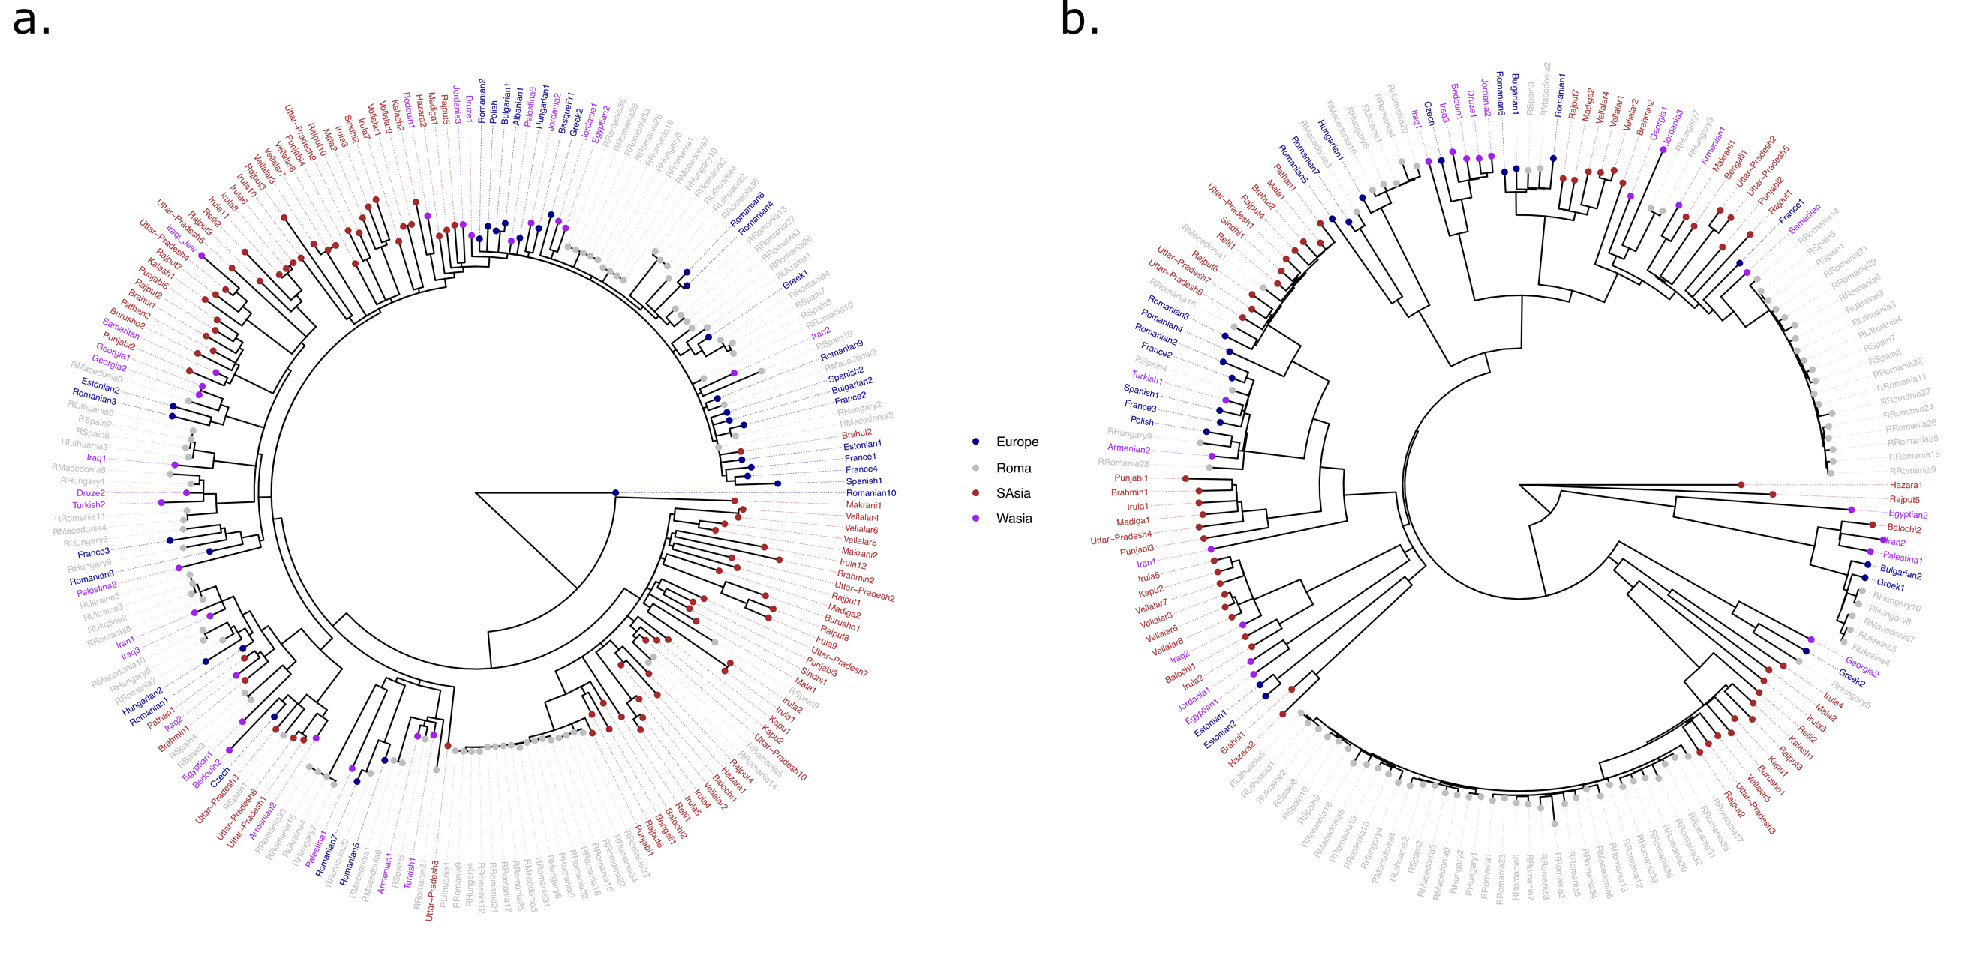
Supplementary Figure S1. Maximum likelihood trees for mtDNA (a) and MSY (b) sequences using Roma and non-Roma samples. Color scale refers to geographical lineage origin: blue for European, purple for West Asian, red for South Asian, and grey for Roma.

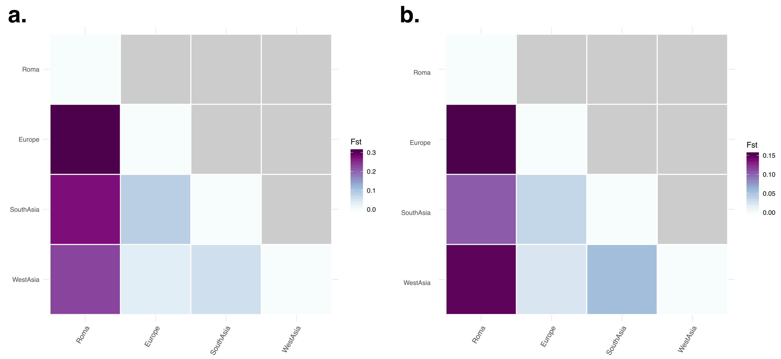

Supplementary Figure S2. φst distance matrices for mtDNA (a) and MSY (b) between Roma and reference panel populations. Color scales represent φst values.
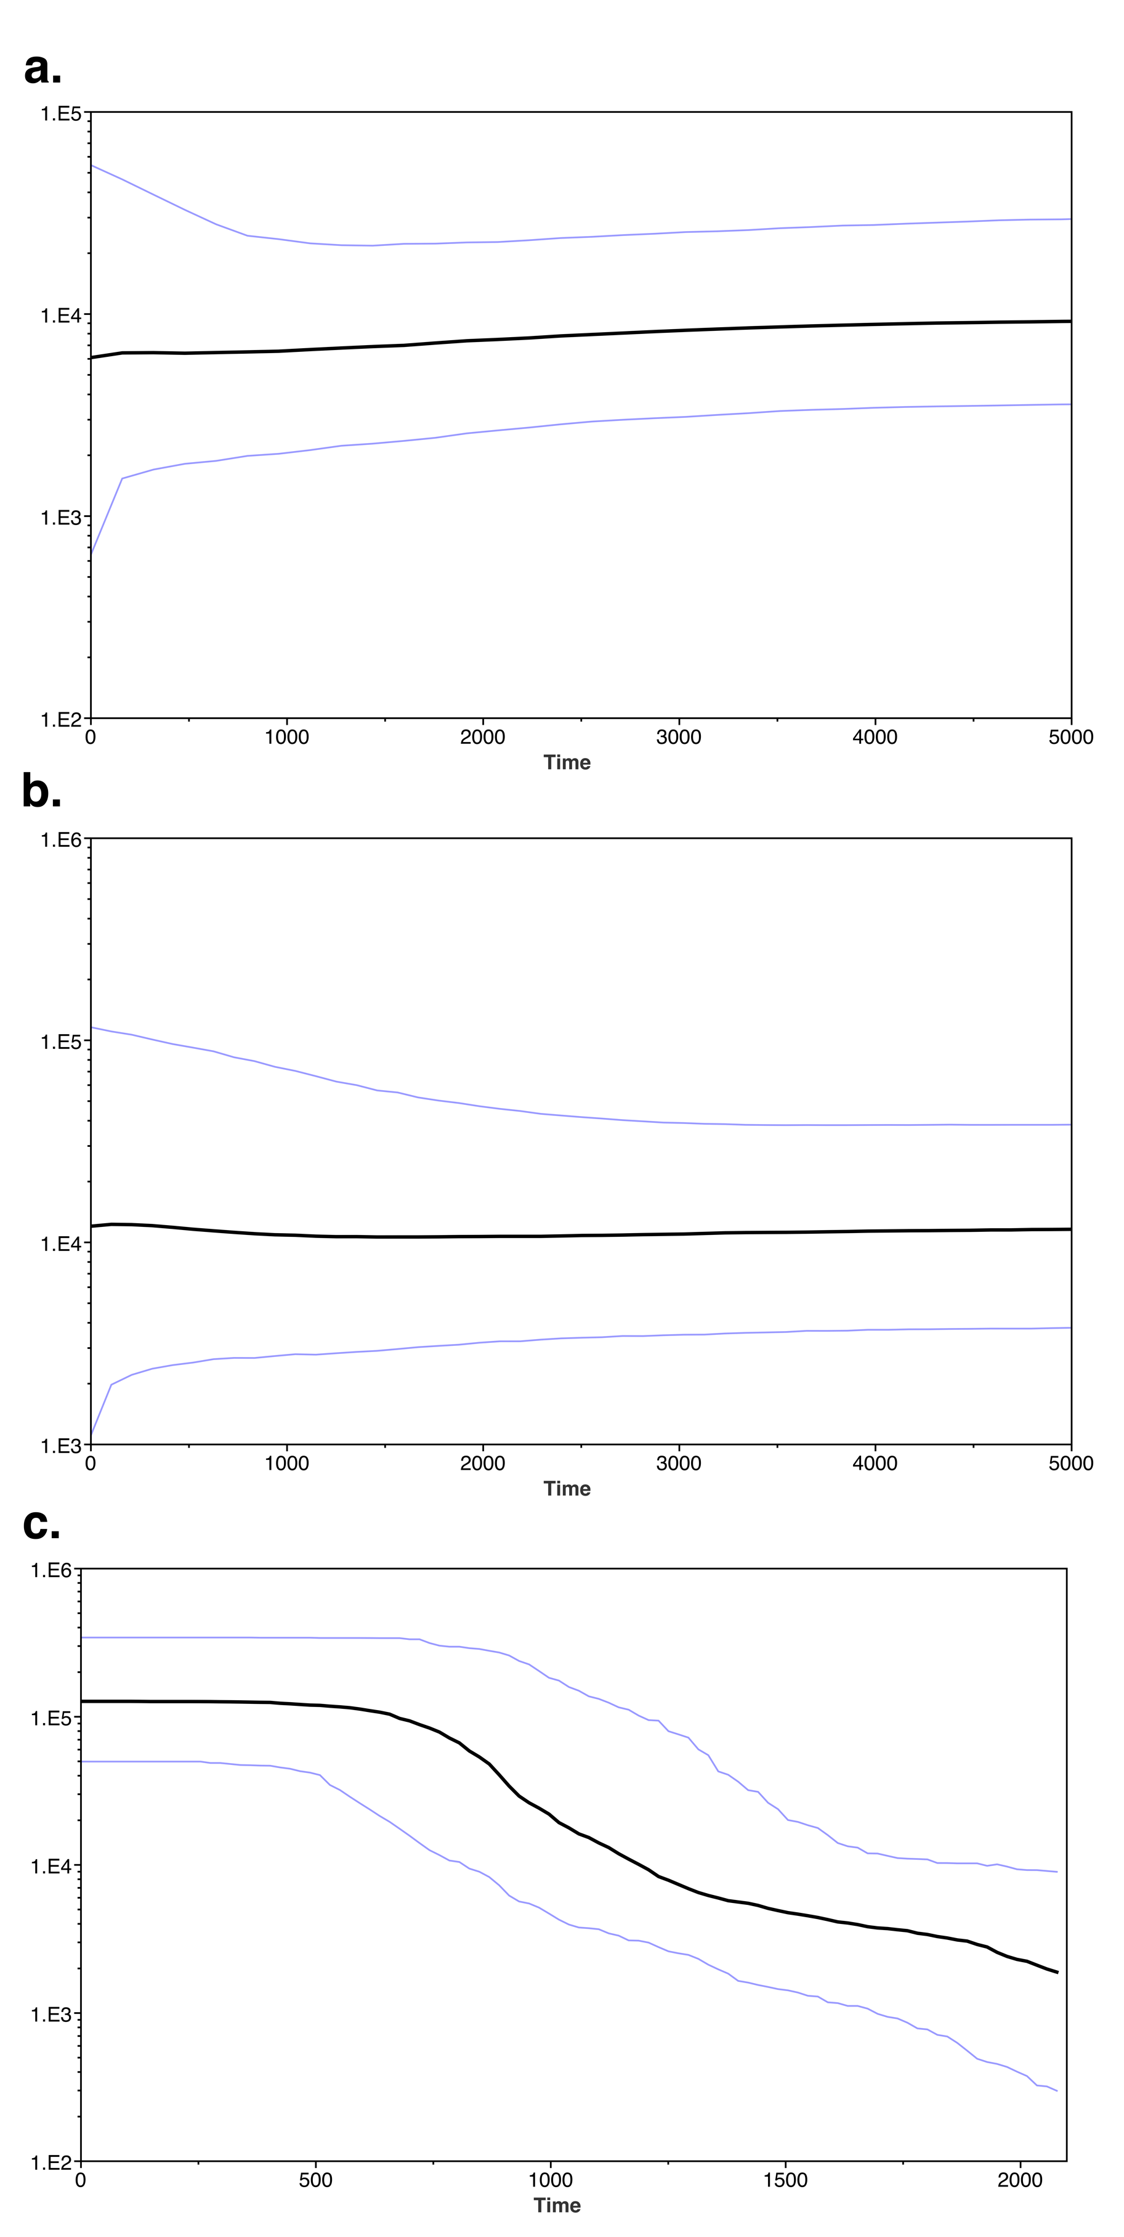
Supplementary Figure S3. BSP with the South Asian lineages from mtDNA coding (a) and control regions (b) and MSY sequences (c). X axis represents time in years ago.

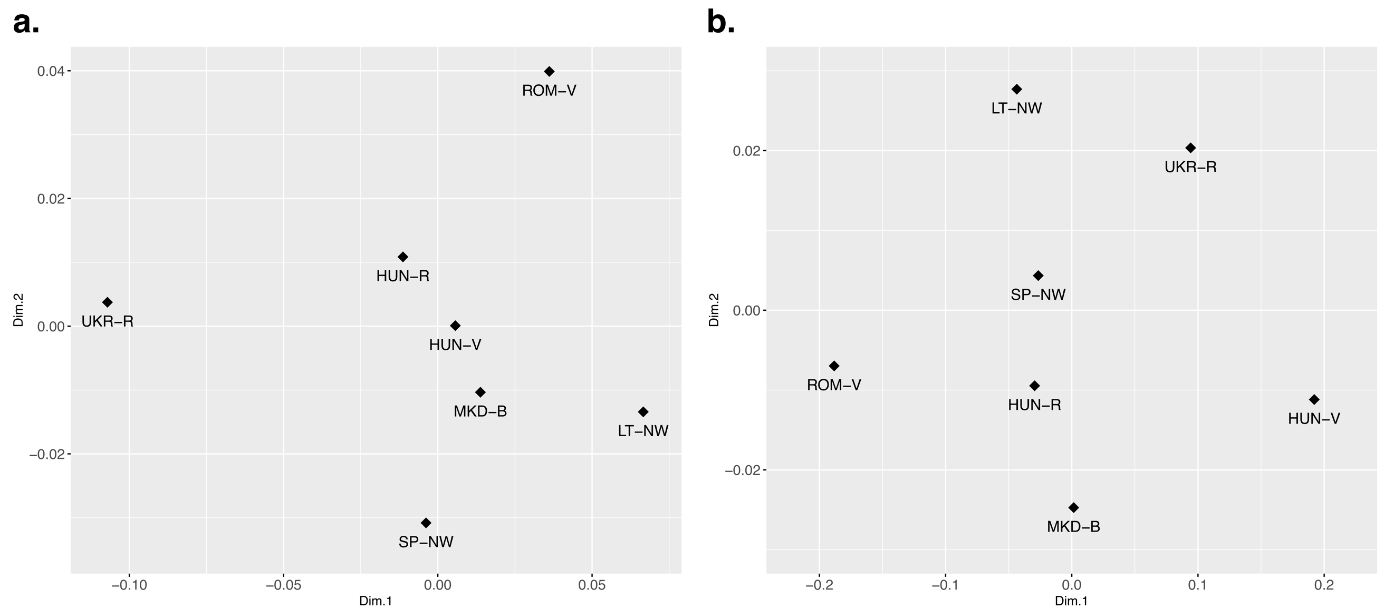

Supplementary Figure S4. MDS analyses from φst distances with mtDNA (a) and MSY (b) within Roma groups.

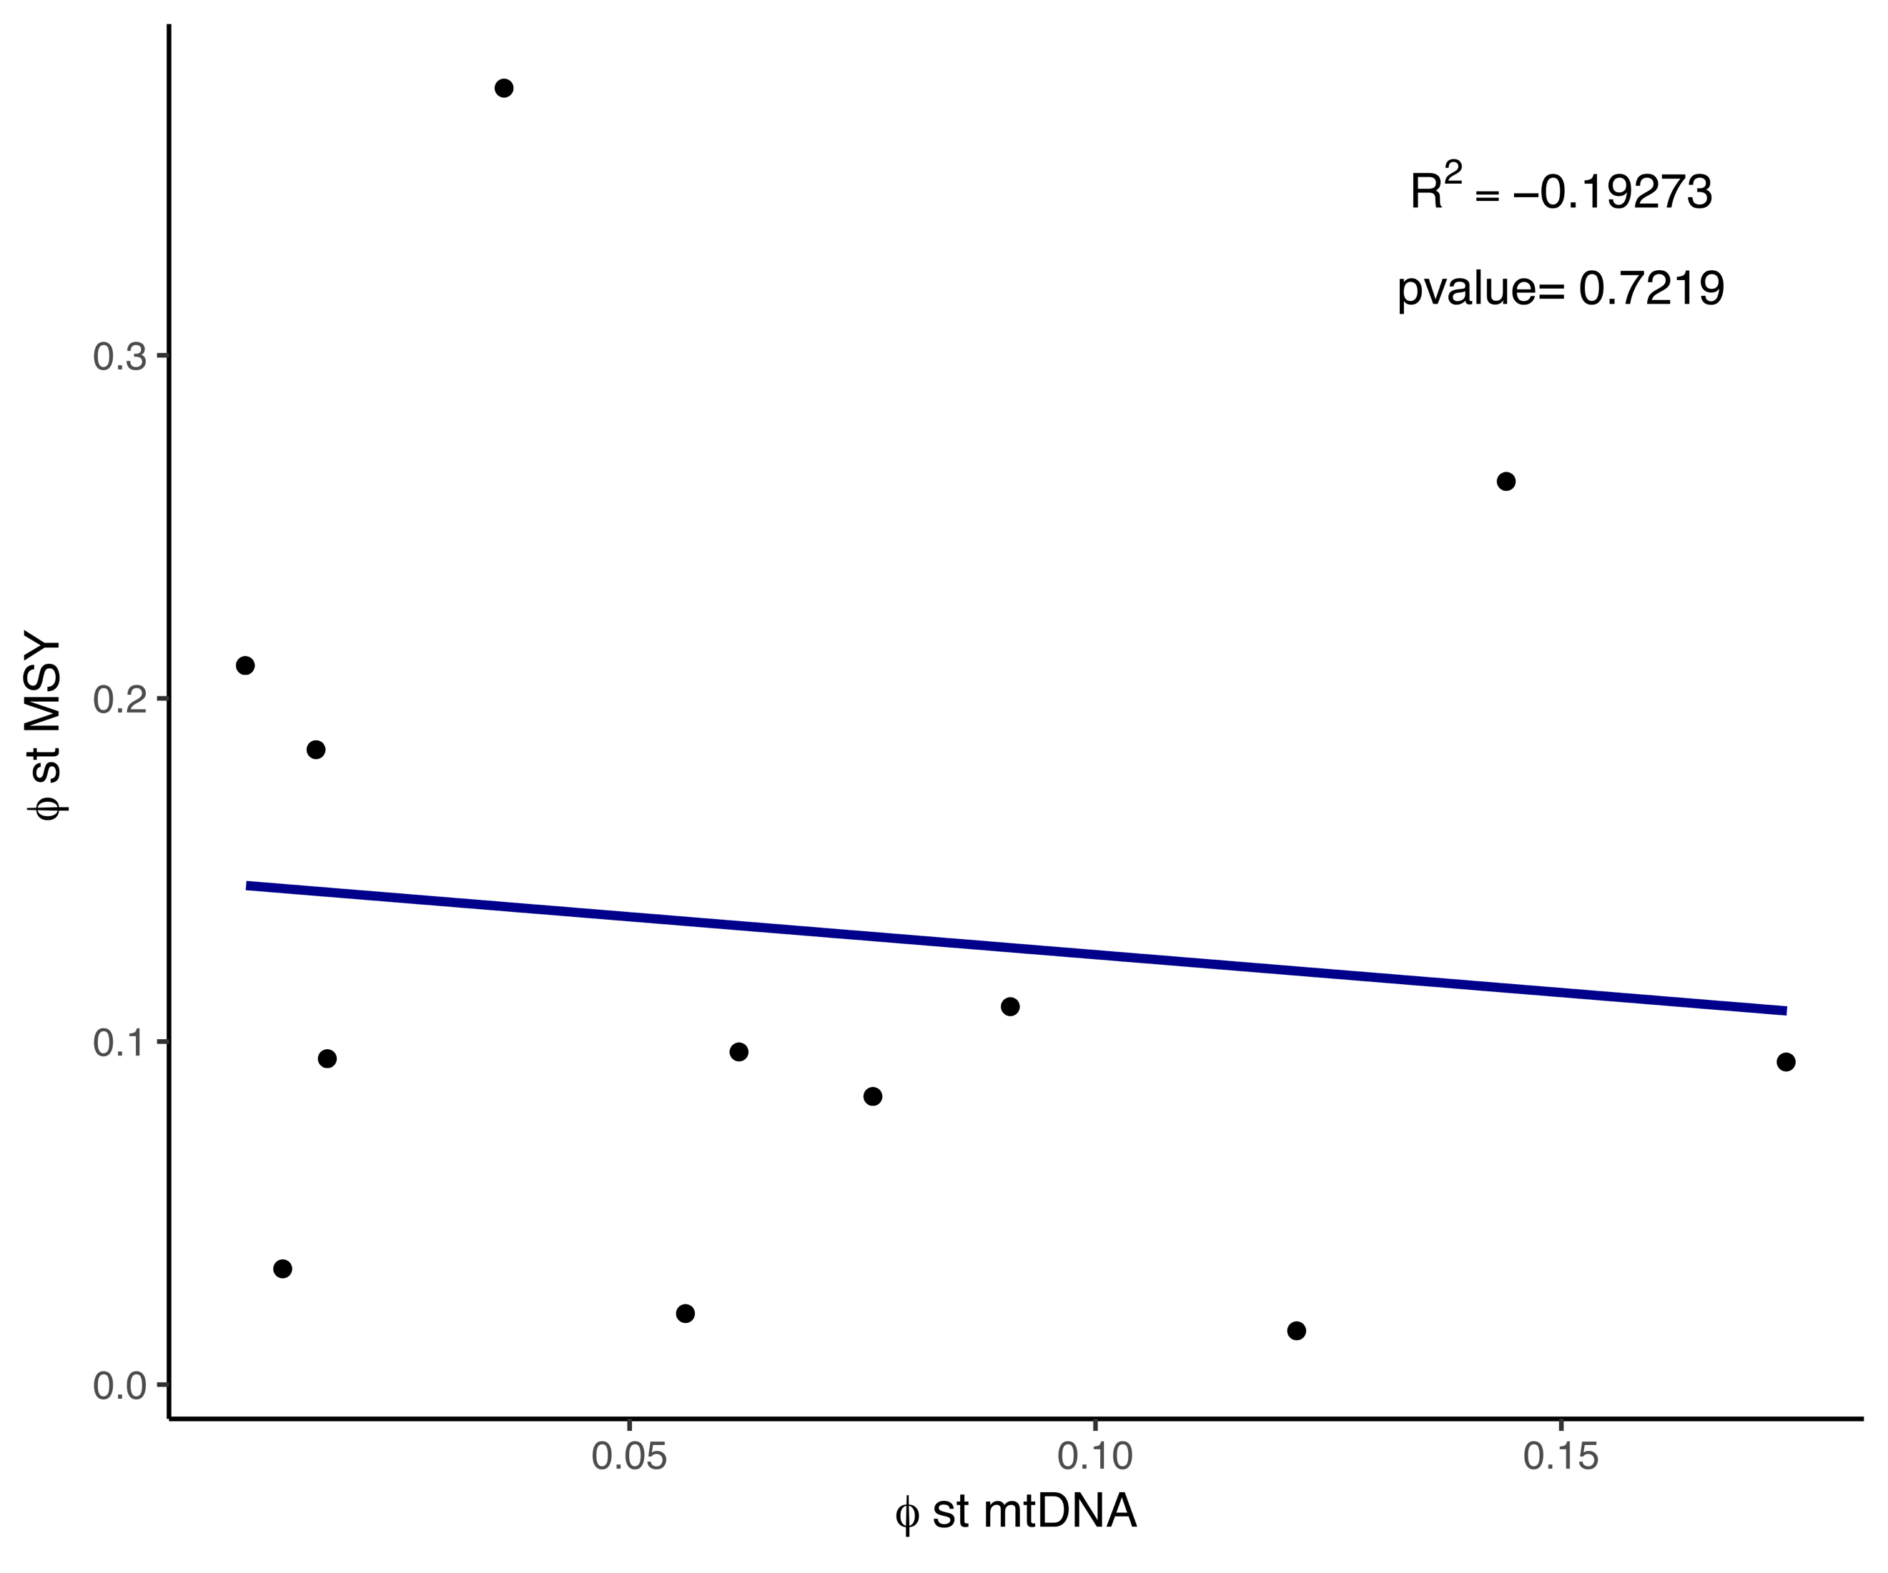

Supplementary Figure S5. Mantel test between mtDNA and MSY φst distances within Roma groups.

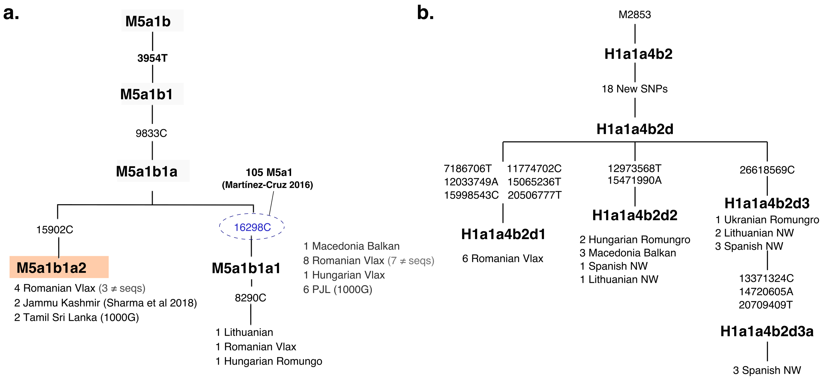

Supplementary Figure S6. Phylogenetic refinement of South Asian haplogroups for the mtDNA (a) and MSY (b).

