Supplementary Information

Mitochondrial genomes illuminate the evolutionary history of the Western honey bee (Apis mellifera)

Erik Tihelka, Davide Pisani, Philip C. J. Donoghue & Chenyang Cai

Contents
Table S1 | Data set used for the phylogenetic, with NCBI accession for all sampled taxa ....................................................................................................................................................................................................2
Table S2 | Data partitioning scheme for the ML analyses …………................................................................................................3
Figure S1 | Analysis of the relationships among Apis mellifera subspecies with the site-homogeneous models based on the P12 dataset with branch lengths displayed. …………………………….…………….……………………………………………………………….…….………4
Figure S2 | Analysis of the relationships among Apis mellifera subspecies with the site-homogeneous models based on the P12 dataset with branch lengths omitted. ………………………………………………………………………………………………………………………….…5
Figure S3 | Analysis of the relationships among Apis mellifera subspecies with the site-homogeneous models based on the P12RNA dataset with branch lengths displayed. …………………………………………………………………………………………………..….……………6
Figure S4 | Analysis of the relationships among Apis mellifera subspecies with the site-homogeneous models based on the P12RNA dataset with branch lengths omitted. …………………..……………………………………………………………………………..…….……………7
Figure S5 | Analysis of the relationships among Apis mellifera subspecies with the site-homogeneous models based on the P123 dataset with branch lengths displayed. ………………..……………………………………………..….……………………………………………………8
Figure S6 | Analysis of the relationships among Apis mellifera subspecies with the site-homogeneous models based on the P123 dataset with branch lengths omitted. ……………………..………………………………..………..…………………………………………..……………9
Figure S7 | Analysis of the relationships among Apis mellifera subspecies with the site-heterogeneous Bayesian CAT-GTR+G model based on the P12 dataset with branch lengths displayed. …………………………….…………….……………………………………………………………………………………….………………………………………………..……10
Figure S8 | Analysis of the relationships among Apis mellifera subspecies with the site-heterogeneous Bayesian CAT-GTR+G model based on the P12 dataset with branch lengths omitted. …………………………….…………….………………………………………………………………………………………………………………………………………...……11
Figure S9 | Analysis of the relationships among Apis mellifera subspecies with the site-heterogeneous Bayesian CAT-GTR+G model based on the P12RNA dataset with branch lengths displayed. …………………………….…………….……………………………………………………………………………………………….…………………………………………..…12
Figure S10 | Analysis of the relationships among Apis mellifera subspecies with the site-heterogeneous Bayesian CAT-GTR+G model based on the P12RNA dataset with branch lengths omitted. …………………………….…………….……………………………………………………………………………………………….…………………………………………..…13
Figure S11 | Analysis of the relationships among Apis mellifera subspecies with the site-heterogeneous Bayesian CAT-GTR+G model based on the P123 dataset with branch lengths displayed. ………………………….…………….………………………………………………………………………………………………….………………………………………………14
Figure S12 | Analysis of the relationships among Apis mellifera subspecies with the site-heterogeneous Bayesian CAT-GTR+G model based on the P123 dataset with branch lengths omitted. ………………………….…………….………………………………………………………………………………………………….…………………………15
Table S1
Data set used for the phylogenetic, with NCBI accession for all sampled taxa.
Taxon | NCBI accession
Western honey bee
A. m. adansonii | MN585109
A. m. capensis | MG552691
A. m. carnica | MN250878
A. m. carpatica | AP018403
A. m. caucasica | AP018404
A. m. iberiensis | MN585110
A. m. intermissa | KY926883
A. m. lamarckii | KY464958
A. m. ligustica | KX908209
A. m. meda | KY464957
A. m. mellifera | KY926884
A. m. monticola | MF678581
A. m. sahariensis | MF351881
A. m. scutellata | MG552698
A. m. simensis | MN585108
A. m. sinisxinyuan | MN733955
A. m. syriaca | KY926882
A. m. unicolor | MN119925
Outgroups
A. cerana | GQ162109
A. dorsata | KX908207
A. florea | JX982136

Table S2
Data partitioning scheme for the ML analyses.
Dataset | Partitioning scheme in nexus format
P12 | #nexus  begin sets;  charset Subset1 = 1-226 453-505 2053-2311 4623-4739;  charset Subset2 = 2312-2570 227-452 4944-5030 6488-7046 5480-5928 3644-3950;  charset Subset3 = 4857-4943 5929-6487 5031-5479 3337-3643 506-558;  charset Subset4 = 1601-1826 2571-2953 559-1079;  charset Subset5 = 1080-1600 2954-3336 1827-2052;  charset Subset6 = 3951-4286 7047-7223;  charset Subset7 = 4740-4856 7224-7400 4287-4622;  charpartition PartitionFinder = K81UF+I+G:Subset1, K81UF+I:Subset2, K81UF+G:Subset3, TIM+G:Subset4, F81+I:Subset5, HKY+I:Subset6, HKY+I:Subset7;  end;
P12RNA | #nexus  begin sets;  charset Subset1 = 1-226 453-505 2053-2311 4623-4739;  charset Subset2 = 1080-1600 2312-2570 227-452 2954-3336 1827-2052;  charset Subset3 = 506-558 4740-4856 7224-7400 4287-4622;  charset Subset4 = 1601-1826 2571-2953 559-1079;  charset Subset5 = 4857-4943 3337-3643 5031-5479 5929-6487 8840-9758;  charset Subset6 = 4944-5030 5480-5928 6488-7046 3644-3950;  charset Subset7 = 3951-4286 7047-7223;  charset Subset8 = 7401-8839;  charpartition PartitionFinder = K81UF+I+G:Subset1, K81UF+I:Subset2, HKY+I:Subset3, TIM+G:Subset4, K81UF+G:Subset5, TIM+I:Subset6, HKY+I:Subset7, GTR+I+G:Subset8;  end;
P123 | #nexus  begin sets;  charset Subset1 = 2401-3078 3856-5004 838-2400 3079-3855 1-678;  charset Subset2 = 10570-11100 679-837 6934-7284 5926-6933;  charset Subset3 = 8893-10569 5005-5925 7285-7545 7546-8892;  charpartition PartitionFinder = GTR+I:Subset1, HKY+I+G:Subset2, TIM+I+G:Subset3;  end;

Figure S1
Analysis of the relationships among Apis mellifera subspecies with the site-homogeneous models based on the P12 dataset with branch lengths displayed
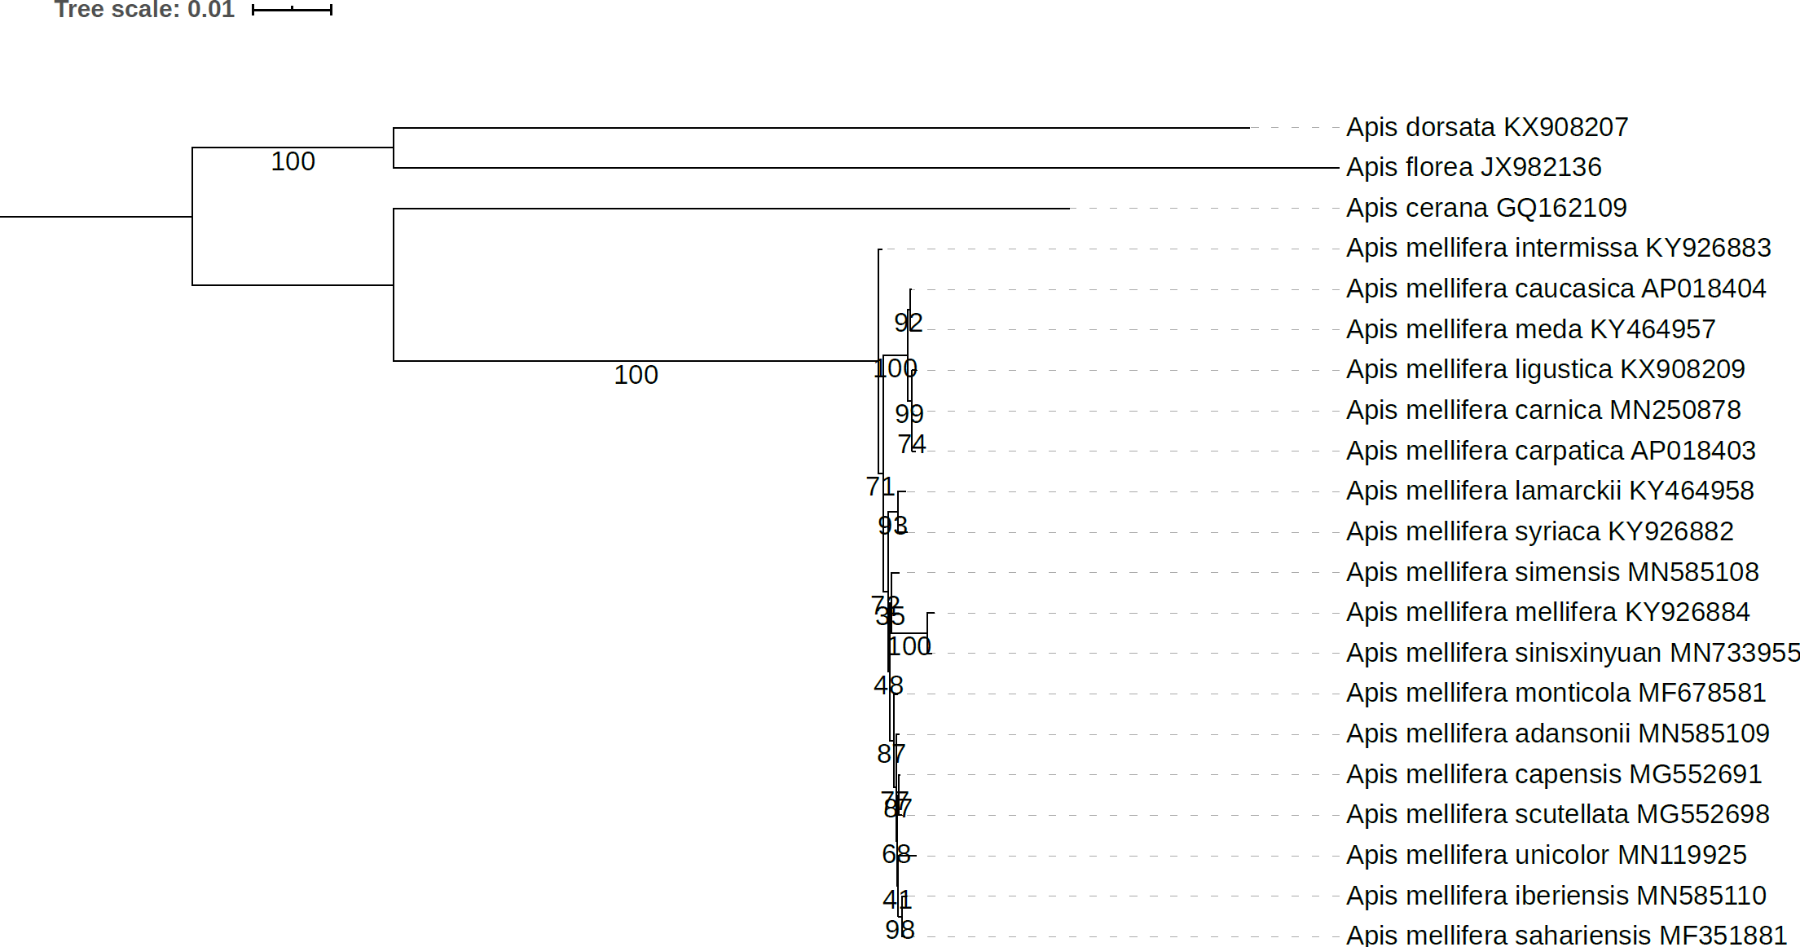

Figure S2
Analysis of the relationships among Apis mellifera subspecies with the site-homogeneous models based on the P12 dataset with branch lengths omitted
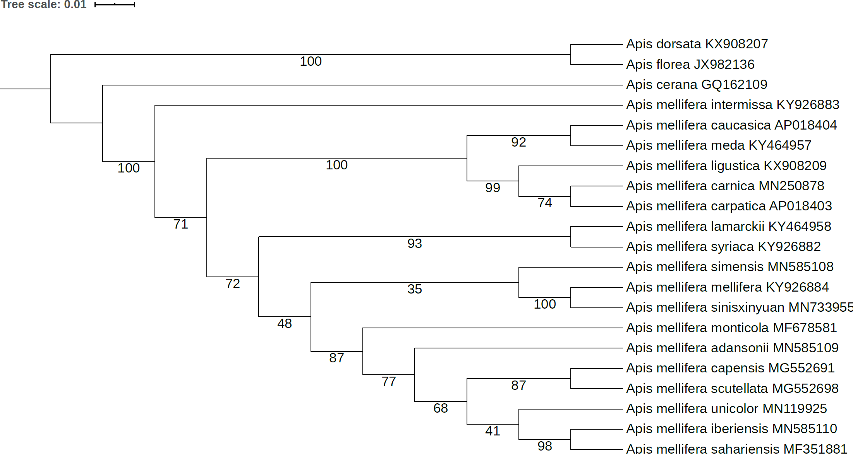

Figure S3
Analysis of the relationships among Apis mellifera subspecies with the site-homogeneous models based on the P12RNA dataset with branch lengths displayed
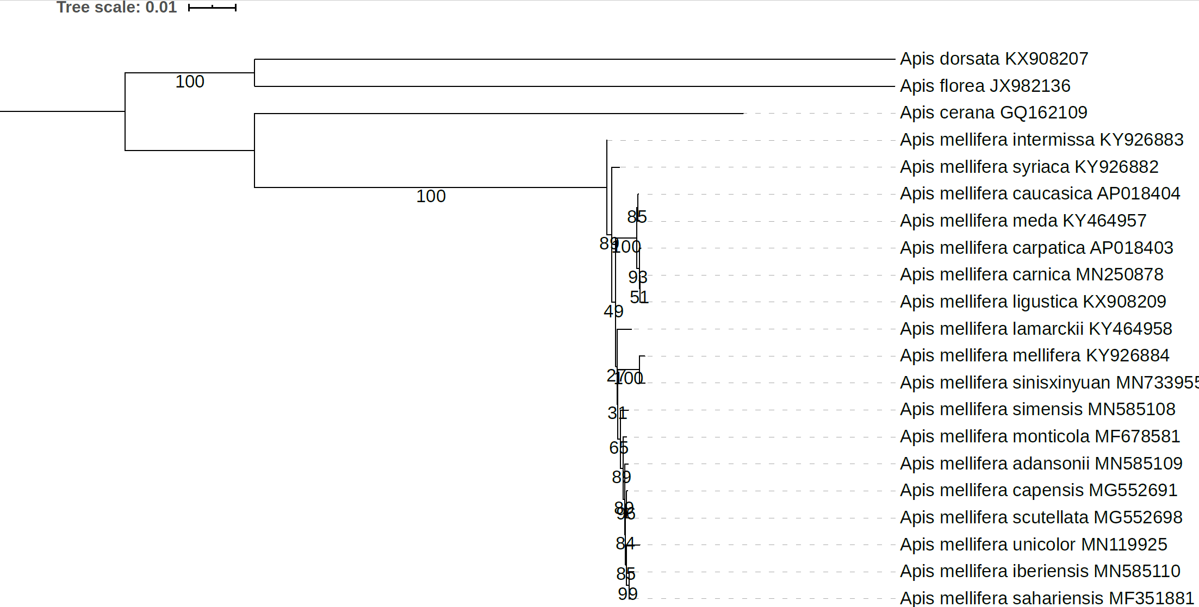

Figure S4
Analysis of the relationships among Apis mellifera subspecies with the site-homogeneous models based on the P12RNA dataset with branch lengths omitted
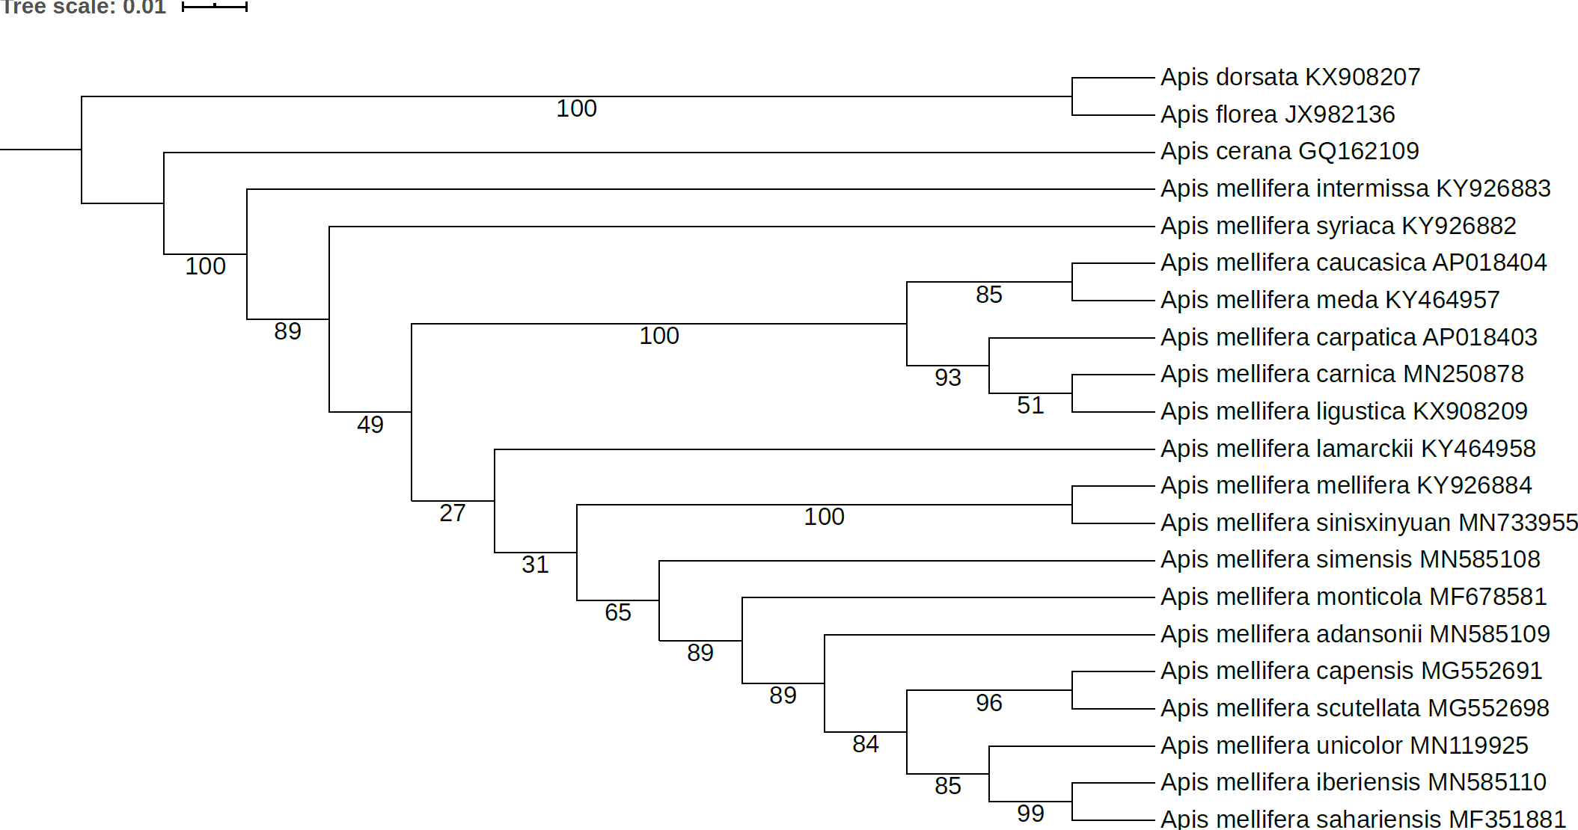

Figure S5
Analysis of the relationships among Apis mellifera subspecies with the site-homogeneous models based on the P123 dataset with branch lengths displayed
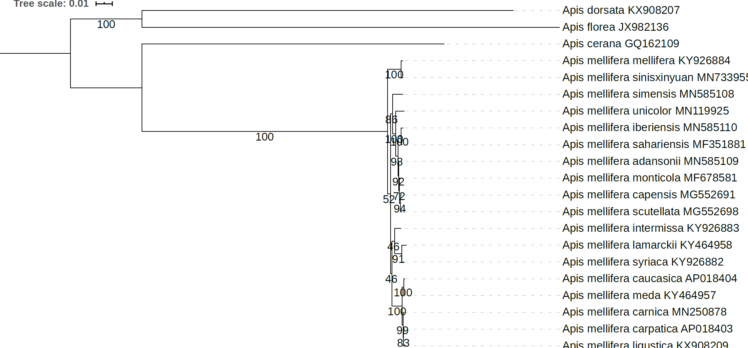

Figure S6
Analysis of the relationships among Apis mellifera subspecies with the site-homogeneous models based on the P123 dataset with branch lengths omitted
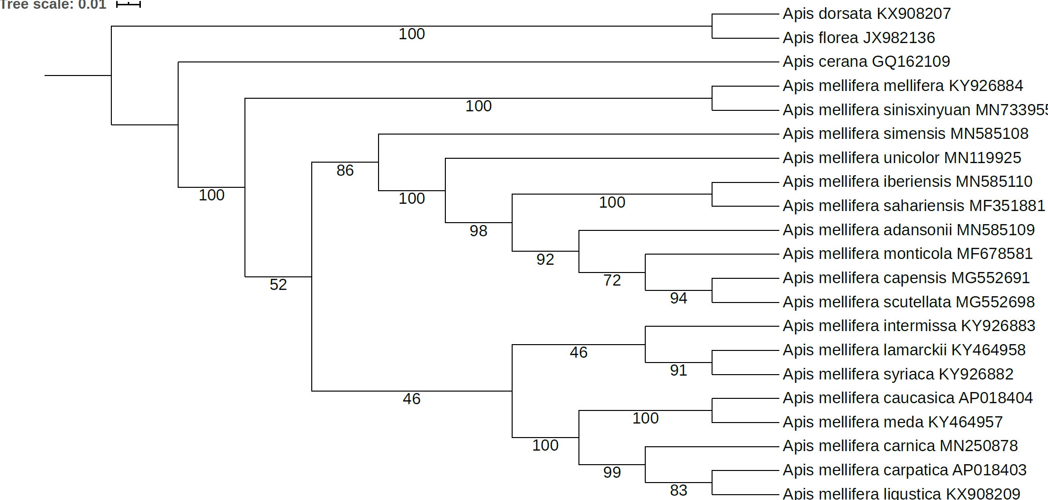

Figure S7
Analysis of the relationships among Apis mellifera subspecies with the site-heterogeneous Bayesian CAT-GTR+G model based on the P12 dataset with branch lengths displayed.
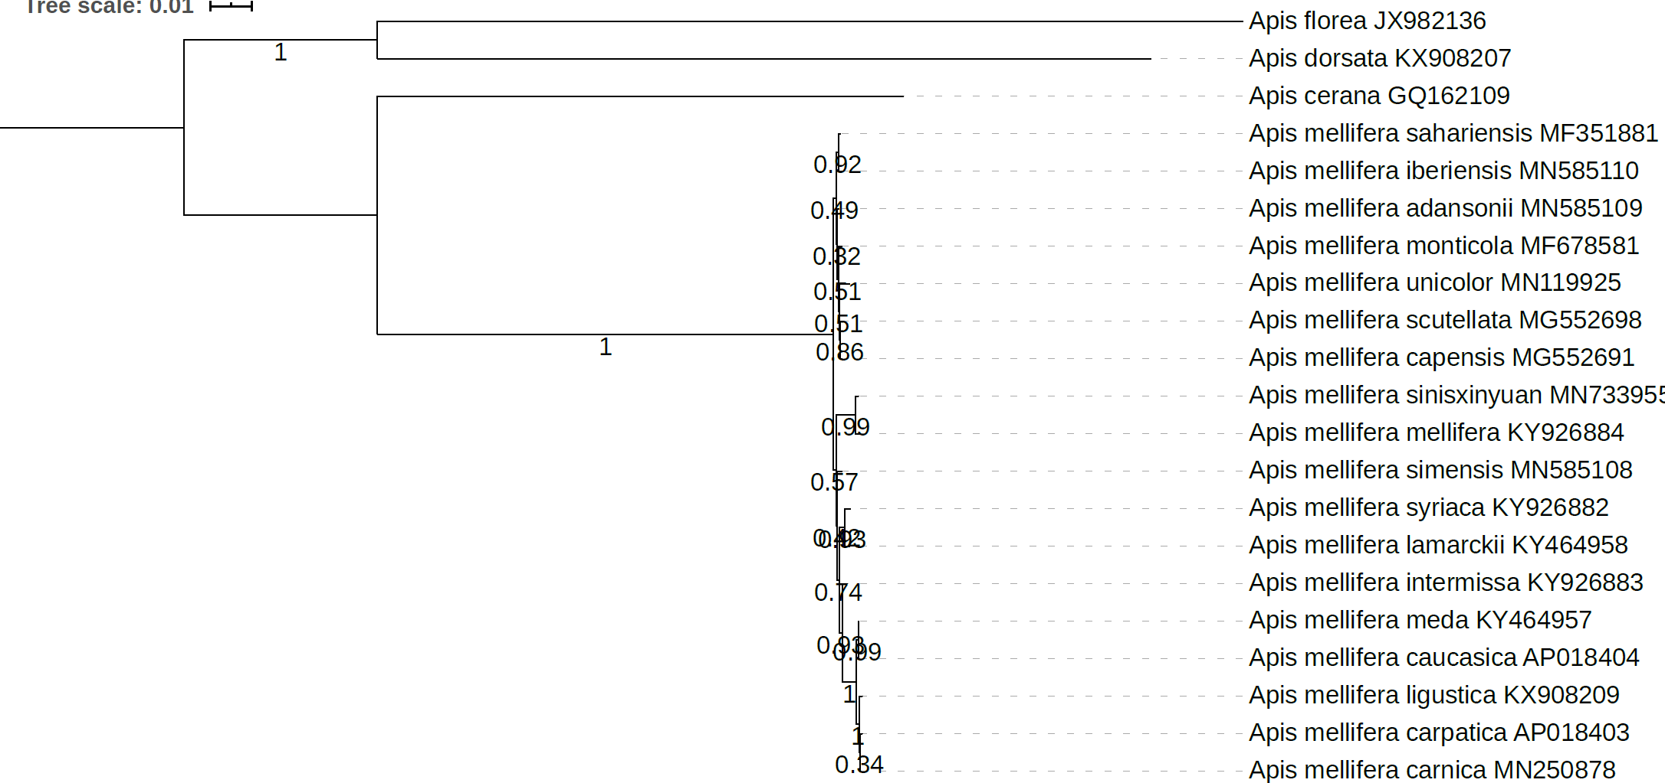

Figure S8
Analysis of the relationships among Apis mellifera subspecies with the site-heterogeneous Bayesian CAT-GTR+G model based on the P12 dataset with branch lengths omitted.
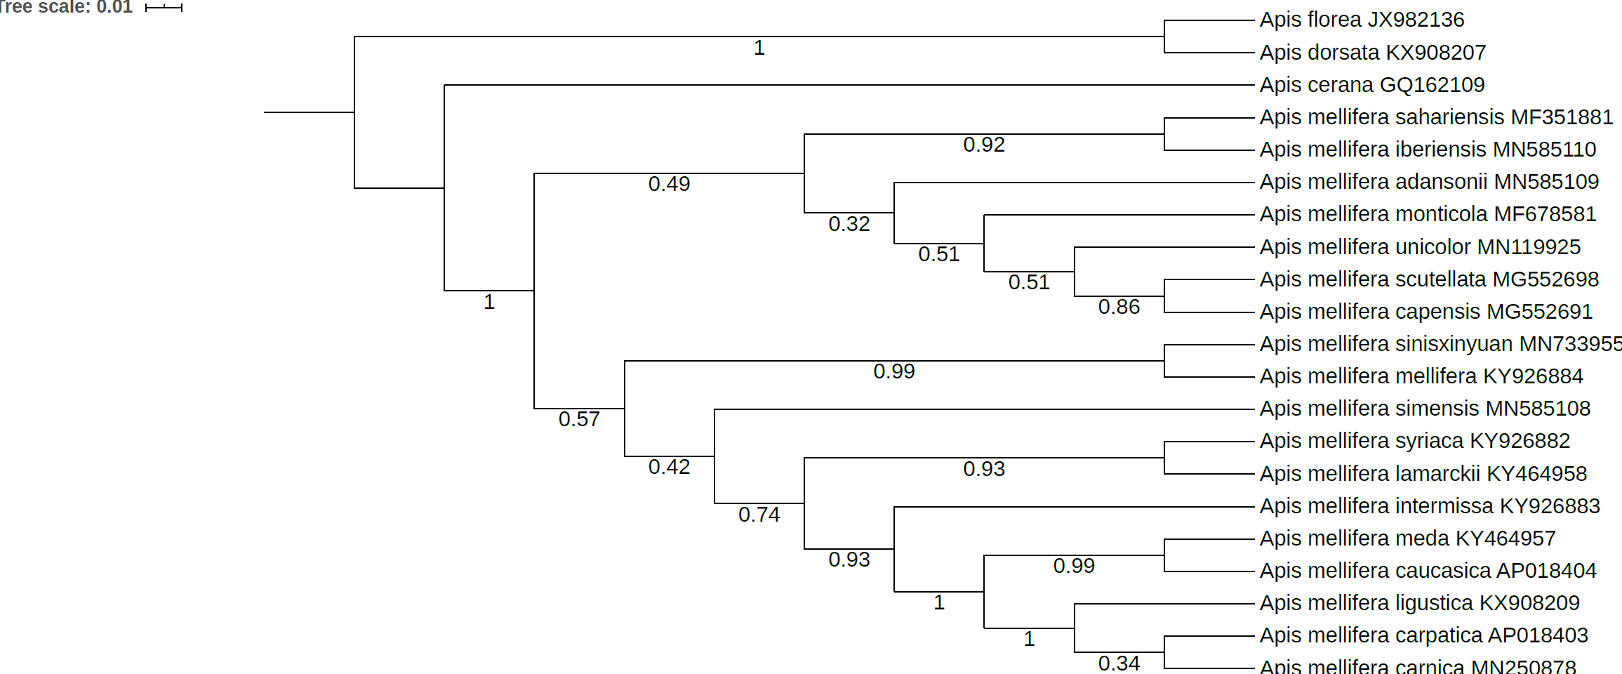

Figure S9
Analysis of the relationships among Apis mellifera subspecies with the site-heterogeneous Bayesian CAT-GTR+G model based on the P12RNA dataset with branch lengths displayed.
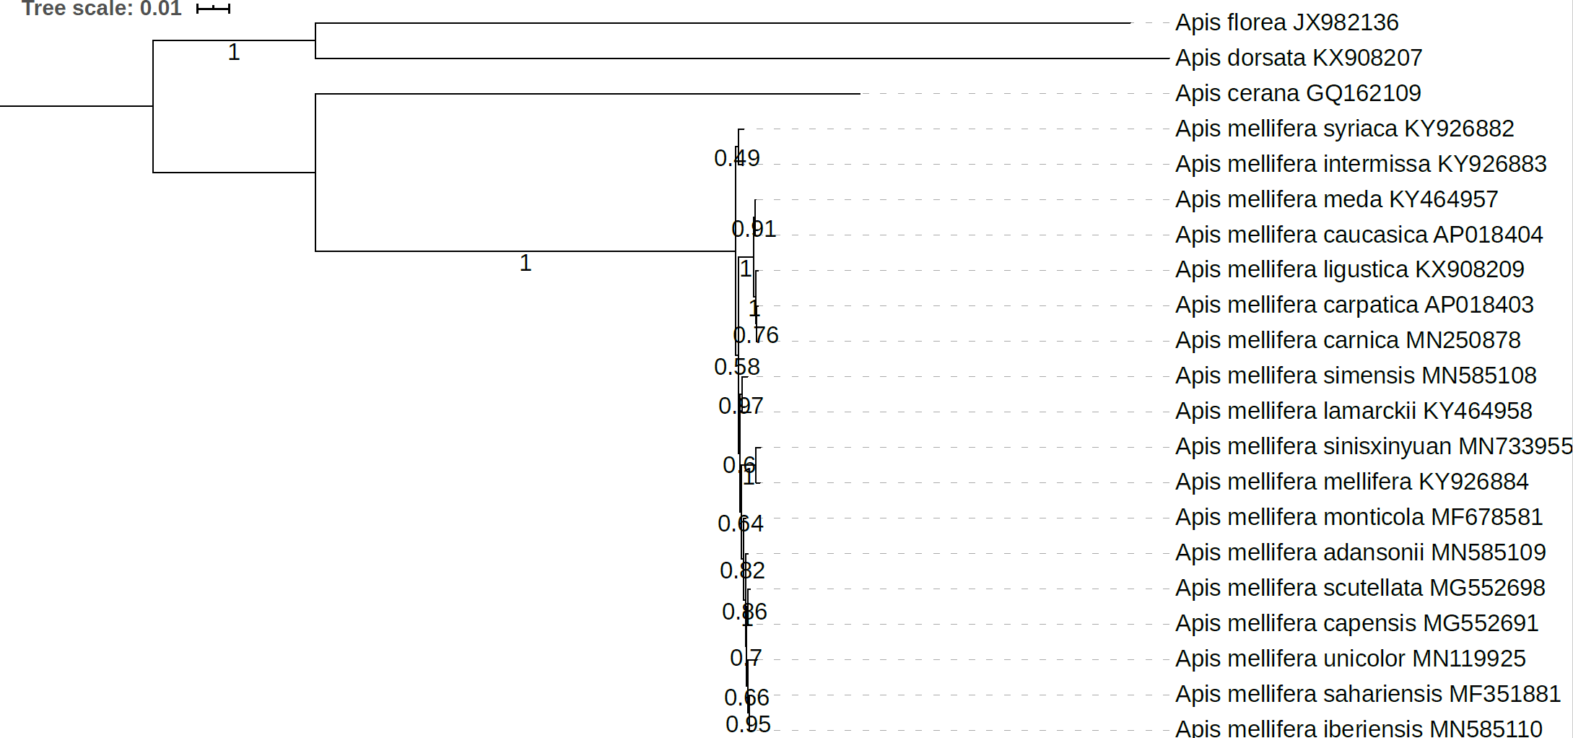

Figure S10
Analysis of the relationships among Apis mellifera subspecies with the site-heterogeneous Bayesian CAT-GTR+G model based on the P12RNA dataset with branch lengths displayed.
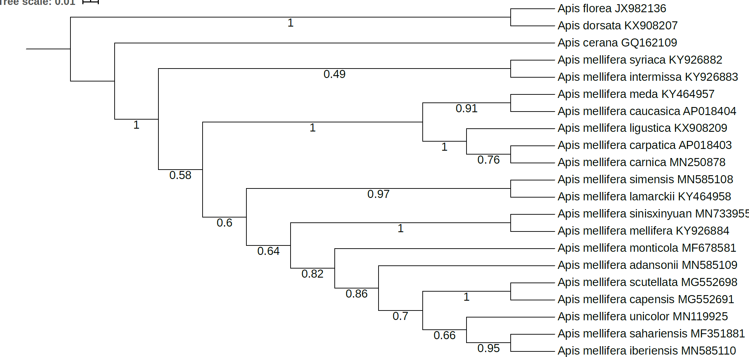

Figure S11
Analysis of the relationships among Apis mellifera subspecies with the site-heterogeneous Bayesian CAT-GTR+G model based on the P123 dataset with branch lengths displayed.
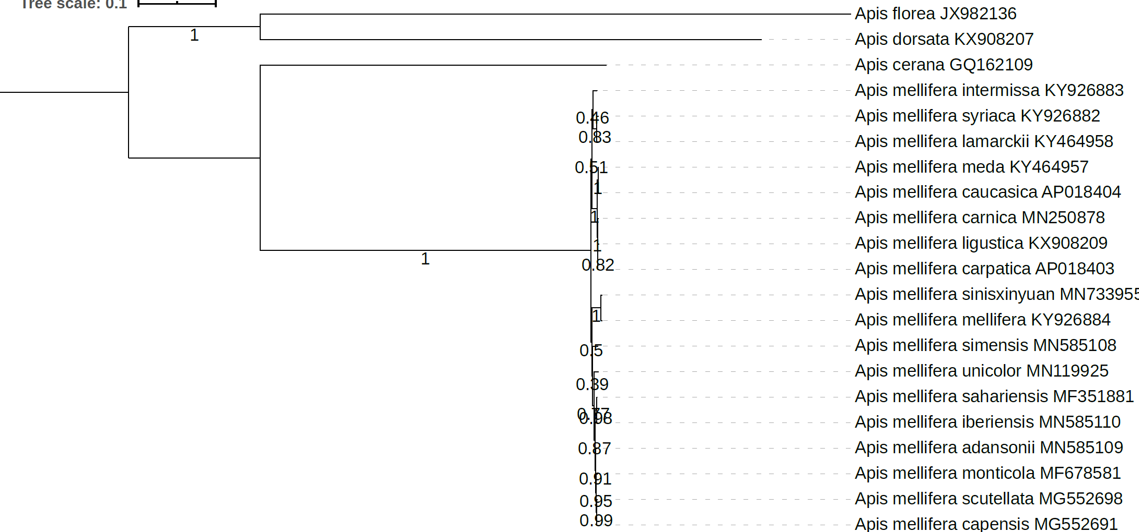

Figure S12
Analysis of the relationships among Apis mellifera subspecies with the site-heterogeneous Bayesian CAT-GTR+G model based on the P123 dataset with branch lengths omitted.
