SUPPLEMENTAL MATERIAL
Biogeographic problem-solving reveals the Late Pleistocene translocation of a short-faced bear to the California Channel Islands

Alexis M. Mychajliw^{1,2,3*}, Torben C. Rick⁴, Nihan D. Dagtas^{1,2}, Jon M. Erlandson^{5,6}, Brendan J. Culleton⁷, Douglas J. Kennett⁸, Michael Buckley⁹, Courtney A. Hofman^{1,2,4}

- Department of Anthropology, University of Oklahoma, Norman OK
- Laboratories of Molecular Anthropology and Microbiome Research, University of Oklahoma, Norman OK
- La Brea Tar Pits and Museum, Los Angeles CA
- Department of Anthropology, National Museum of Natural History, Smithsonian Institution, Washington DC
- Museum of Natural and Cultural History, University of Oregon, Eugene OR
- Department of Anthropology, University of Oregon, Eugene OR
- Institutes of Energy and the Environment, The Pennsylvania State University, University Park, PA 16802, USA
- Department of Anthropology, University of California, Santa Barbara, Santa Barbara CA
- School of Natural Sciences, Manchester Institute of Biotechnology, University of Manchester, M1 7DN, UK

*Correspondence to: mych0000@ou.edu

Supplemental Figures
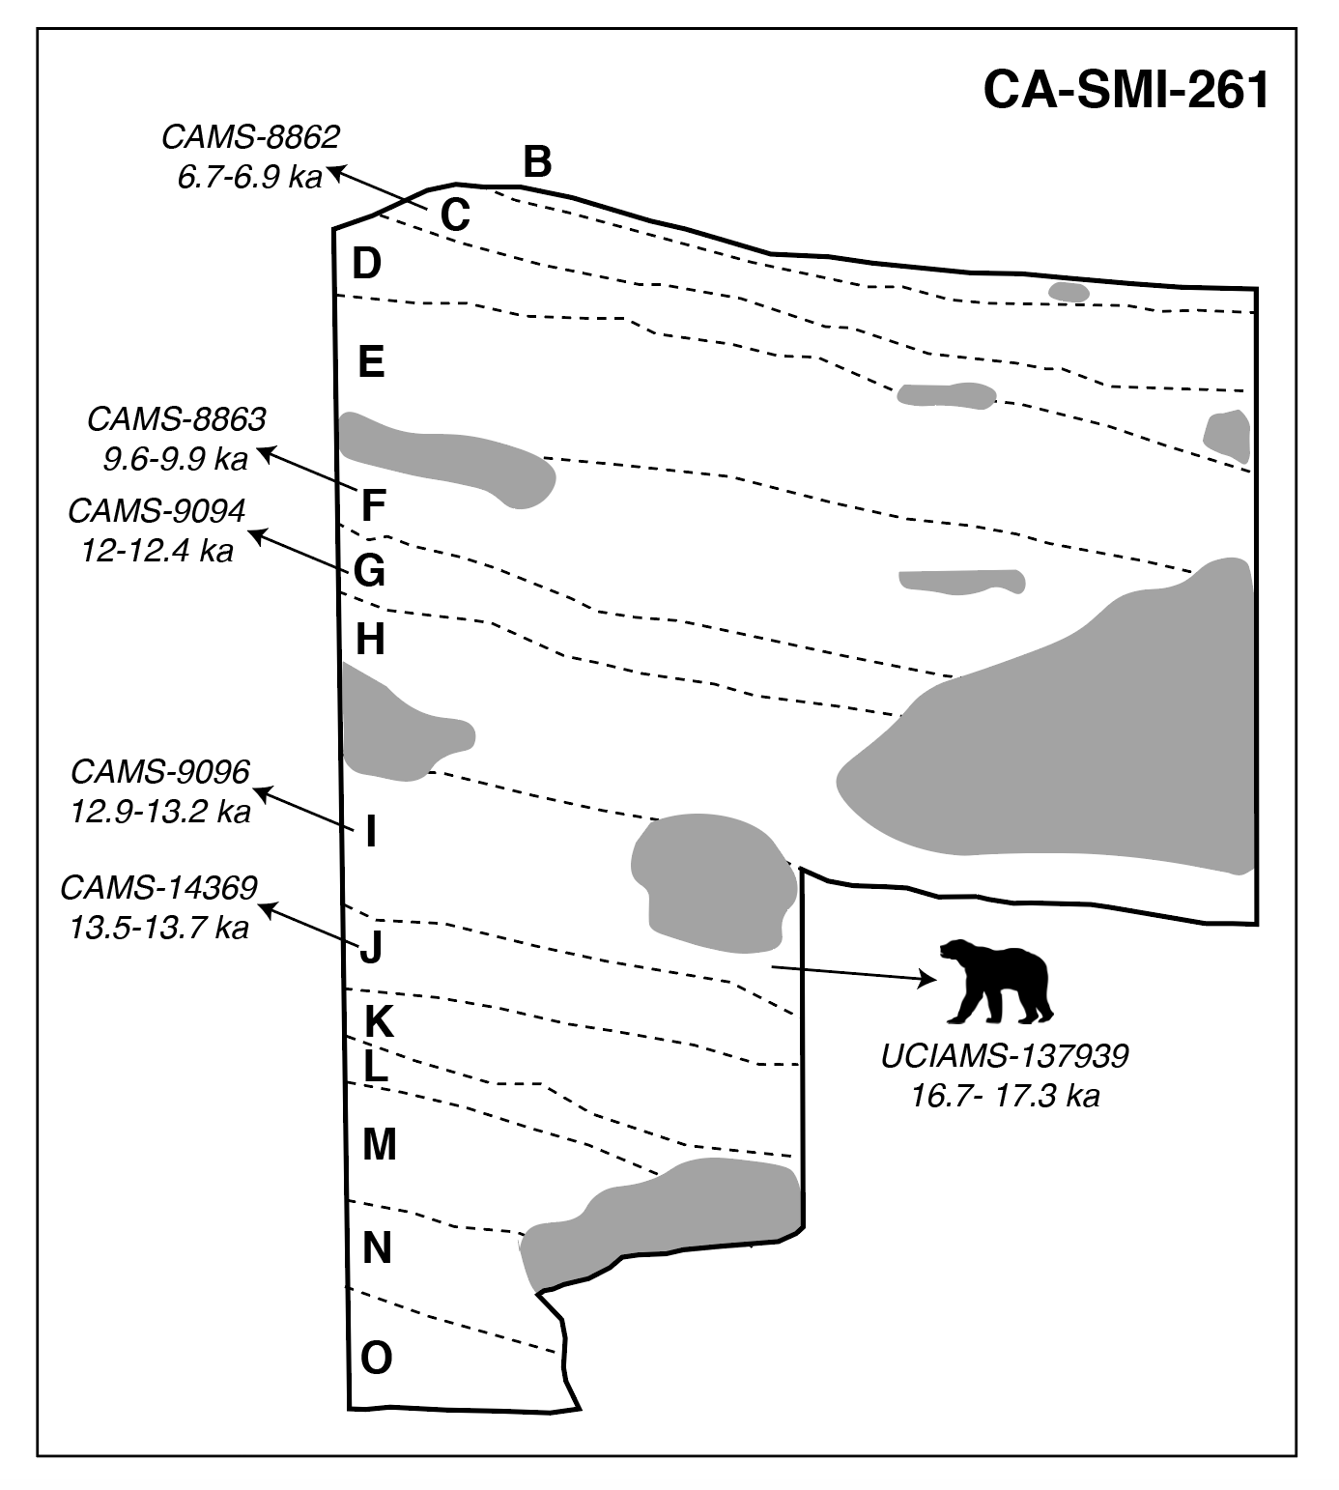
Supplemental Figure 1. Simplified stratigraphic profile from Daisy Cave, San Miguel Island, California Channel Islands (CA-SMI-261) as adapted from Erlandson et al (1996). Dates are calibrated calendar year ranges from Erlandson et al (1996). We refer interested readers to Erlandson et al (1996) for details on stratigraphic profiles and excavation methods. Letters refer to stratigraphic levels, with specific dates called out from Erlandson et al (1996). Gray shapes indicate roof spall. Arctodus simus image courtesy of PhyloPic. Figure was produced in Adobe Illustrator.

Erlandson J. et al. An archaeological and paleontological chronology for Daisy Cave (CA-SMI-261), San Miguel Island, California. Radiocarbon 38, 355-373 (1996).

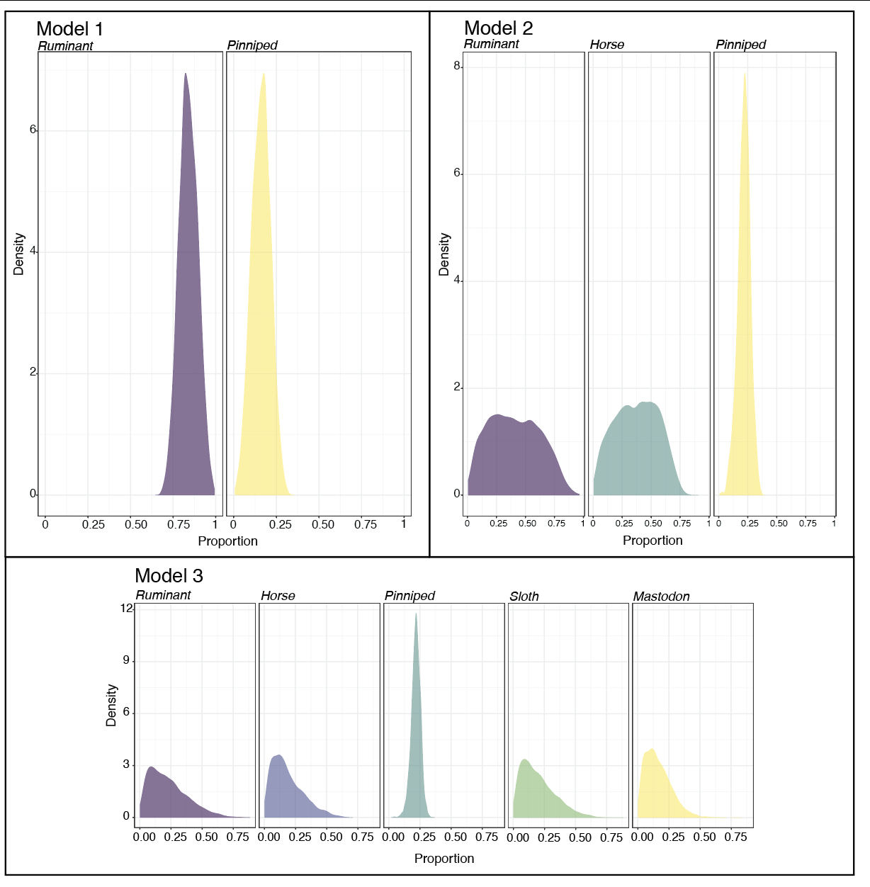
Supplemental Figure 2. Proportional dietary contributions of different food sources based on simmr models. Figures were produced using the statistical software R. Models correspond to those in Supplemental Table 4.

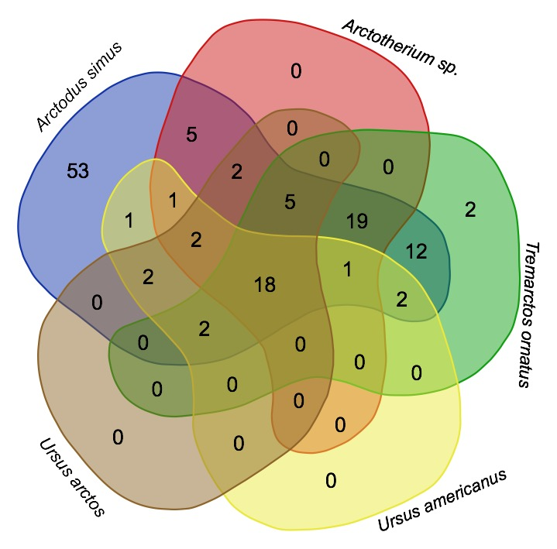

Supplementary Figure 3. Venn Diagram of unique reads mapping to each reference mitochondrial genome. Nearly all unique reads (except two to Tremarctos ornatus) mapped to Arctodus simus in addition to mapping to other reference sequences. Therefore, the consensus sequence of this bone mapped to Arctodus simus likely captures all genetic variation present. Venn Diagram made with tools at http://bioinformatics.psb.ugent.be/webtools/Venn/
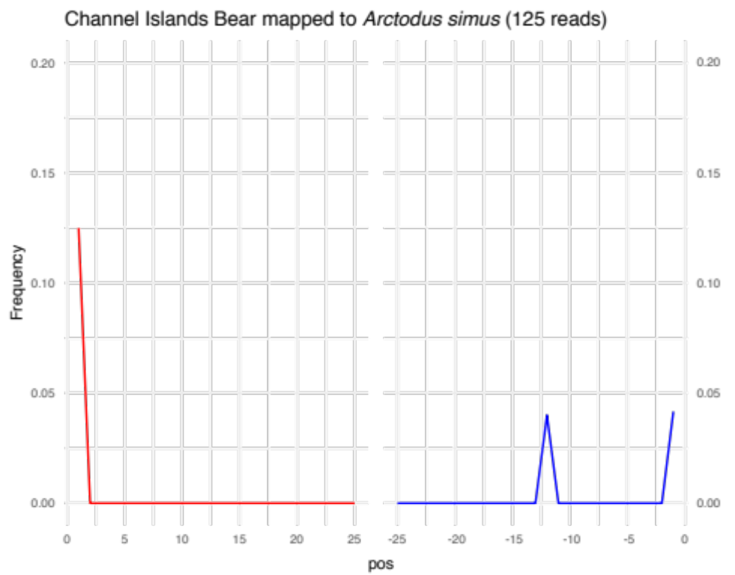

Supplementary Figure 4. Fragment misincorporation plot for Channel Islands Bear mapped to Arctodus simus.

Supplemental Tables

Supplemental Table 1. Hypotheses tested in our study and putative lines of evidence that would be congruent with a given scenario. Hypotheses were developed based on geology (Pleistocene sea level fluctuations), biogeography (patterns of other mainland and island species), dispersal biology (swimming potential, range, and diet), and archaeology (timing of human presence).
 | Hypothesis | Abundance | Skeletal Elements | Specimen Age
Pre-mortem | Standing population | Multiple individuals across a variety of deposits, similar to pygmy mammoths | Multiple skeletal elements would be represented in a cave deposit | Contemporaneous with pygmy mammoths (Late Pleistocene)
Pre-mortem | Single dispersal event | A single individual | Multiple skeletal elements would be represented in a cave deposit | Contemporaneous with pygmy mammoths (Late Pleistocene)
Post-mortem | Human transport | Rare, restricted to deposits with clear human activity (e.g., middens) | An isolated element, potentially modified | After initial human arrival, ~12,000 years or more recent
Post-mortem | Avian transport | Rare, restricted to deposits with evidence of raptor roosts | An isolated element of suitable size | Any time when A. simus was extant

Supplemental Table 2. Comparison of metapodial measurements from the literature. MC = metacarpal; MT = metatarsal; GL = greatest length; DPE = Diameter of proximal end; LWS = least width of shaft; GBD = greatest breadth of distal end. Measurements in mm. ¹This study. ²Merriam & Stock 1925, ³Kurten 1967, ⁴Schubert & Kaufmann 2003, ⁵Emslie & Czaplewski 1985, ⁶Burns & Young 2011, ⁷Pasenko 2018, ⁸Harrington et al 2014, ⁹Kuijper et al 2016.

Element | Locality | Specimen | GL | DPE | LWS | GBD | Species
MC1 | Daisy Cave | UO 14-6778¹ | 71.03 | 24.33 | 11.12 | 17.62 | Arctodus simus
MC1 | Potter Creek Cave | UCMP 3040² | 72.6 | 24.2 | 10.8 | 19.5 | Arctodus simus
MC1 | Potter Creek Cave | UCMP 8291³ | 75 |  | 11.4 | 20.7 | Arctodus simus
MC1 | Big Bear Cave | ISM 496850⁴ | 75.1 |  |  | 19.2 | Arctodus simus
MC1 | Rancho La Brea | UCMP 12768² | 75.7 | 23.5 | 10.6 | 19 | Arctodus simus
MC1 | Frankstown Cave | CM 11019³ | 80 | 25.1 | 10.7 | 19.6 | Arctodus simus
MC1 | Potter Creek Cave | UCMP 3116³ | 80 |  | 12.3 | 21 | Arctodus simus
MC1 | Rancho La Brea | LACM Z93² | 81.5 | 24.8 | 11.6 | 21.2 | Arctodus simus
MC1 | Rancho La Brea | UCMP 17754² | 86.8 | 29.8 | 13.9 | 25.7 | Arctodus simus
MC2 | Potter Creek Cave | UCMP 3040² | 96.8 | 30 | 13.4 | 23.3 | Arctodus simus
MC2 | Big Bear Cave | ISM 496850⁴ | 103 |  |  | 24.4 | Arctodus simus
MC2 | Frankstown Cave | CM 11019³ | 106 | 33.7 | 15.2 | 25 | Arctodus simus
MC2 | Rancho La Brea | UCMP 14816² | 114.3 | 36.5 | 18.6 | 29.4 | Arctodus simus
MC2 | Frankstown Cave | CM11020³ | 126 | 40.8 | 18.8 | 29.8 | Arctodus simus
MC3 | Potter Creek Cave | UCMP 3040² | 104 | 31.6 | 14 | 26.5 | Arctodus simus
MC3 | Potter Creek Cave | UCMP 3042³ | 106 |  | 14.8 | 26 | Arctodus simus
MC3 | Rancho La Brea | UCMP 21004² | 107.6 | 33.3 | 14.6 | 24.8 | Arctodus simus
MC3 | Big Bear Cave | ISM 496850⁴ | 109.5 |  |  | 24.4 | Arctodus simus
MC3 | Frankstown Cave | CM 11019³ | 112 | 33.7 | 15.2 | 25 | Arctodus simus
MC3 | Potter Creek Cave | UCMP 5019³ | 113 |  | 15.5 | 26.6 | Arctodus simus
MC3 | Rancho La Brea | UCMP 17754² | 126.7 | 39.3 | 18.7 | 29.9 | Arctodus simus
MC3 | Hay Springs | FAM 25536³ | 134 | 44 | 22.4 | 35.1 | Arctodus simus
MC3 | Friesenhahn Cave | UTTMM 933³ |  | 30.3 | 14.2 |  | Arctodus simus
MC3 | Labor-of-Love Cave | LACM 122434⁵ |  | 31.1 | 13.5 |  | Arctodus simus
MC4 | Potter Creek Cave | UCMP 3040² | 106.3 | 31 | 15.8 | 25.7 | Arctodus simus
MC4 | Potter Creek Cave | UCMP 3041³ | 107 |  | 15.5 |  | Arctodus simus
MC4 | Big Bear Cave | ISM 496850⁴ | 110.6 |  |  | 26.1 | Arctodus simus
MC4 | Frankstown Cave | CM 11019³ | 113 | 33.2 | 15.2 |  | Arctodus simus
MC4 | Rancho La Brea | LACM Z124² | 123 | 36.9 | 18.6 | 29.7 | Arctodus simus
MC4 | Rancho La Brea | UCMP 17754² | 130.5 | 41.7 | 23 | 34 | Arctodus simus
MC5 | Potter Creek Cave | UCMP 3040² | 104 | 32.3 | 16.1 | 25.5 | Arctodus simus
MC5 | Potter Creek Cave | UCMP 3041³ | 105 | 32.3 |  |  | Arctodus simus
MC5 | Big Bear Cave | ISM 496850⁴ | 111.1 |  |  | 27.3 | Arctodus simus
MC5 | Rancho La Brea | LACM Z117² | 128.3 | 38.1 | 20.8 | 32.6 | Arctodus simus
MC5 | Rancho La Brea | UCMP 17754² | 130.2 | 43.5 | 21 | 34 | Arctodus simus
MT1 | Rock Creek | AMNH 12392³ | 72 | 28.8 | 13.8 | 21.5 | Arctodus simus
MT1 | Rancho La Brea | LACM Z101² | 73.2 | 27.7 | 10.8 | 18.3 | Arctodus simus
MT1 | Big Bear Cave | ISM 496850⁴ | 74.6 |  |  | 18 | Arctodus simus
MT1 | Rancho La Brea | LACM Z102² | 75.2 | 32 | 12 | 21.3 | Arctodus simus
MT1 | Hay Springs | FAM 25536³ | 81 | 30 | 16.4 | 21.6 | Arctodus simus
MT2 | Rock Creek | AMNH 12392³ | 89 | 38.7 | 15.2 | 21.8 | Arctodus simus
MT2 | Big Bear Cave | ISM 496850⁴ | 94.7 |  |  | 23.6 | Arctodus simus
MT2 | Rancho La Brea | LACM Z40² | 101.3 | 36.8 | 16.3 | 24.8 | Arctodus simus
MT3 | Big Bear Cave | ISM 496850⁴ | 103.4 |  |  | 23.3 | Arctodus simus
MT3 | Rancho La Brea | LACM Z99² | 106.3 | 37.8 | 16 | 23.2 | Arctodus simus
MT3 | Yukon | NMC-36237⁶ | 115.4 | 36.4 | 21 |  | Arctodus simus
MT3 | Edmonton | P93.8.41⁶ | 115.5 | 41.1 | 20.1 | 26.3 | Arctodus simus
MT3 | Edmonton | P89.13.91⁶ | 118.5 | 44.8 | 15.9 | 25.3 | Arctodus simus
MT3 | Rancho La Brea | LACM Z90² | 121.2 | 41.8 | 20.8 | 30.5 | Arctodus simus
MT3 | Hay Springs | FAM 25536³ | 124 | 75 | 22.7 |  | Arctodus simus
MT4 | Frankstown Cave | CM 11019³ | 106 | 34.7 | 17.7 |  | Arctodus simus
MT4 | Rock Creek | AMNH 12392³ | 108 | 35.8 | 17.4 |  | Arctodus simus
MT4 | Big Bear Cave | ISM 496850⁴ | 114.1 |  |  | 24.9 | Arctodus simus
MT4 | Rancho La Brea | LACM Z99² | 115.7 | 38 | 17.4 | 25.2 | Arctodus simus
MT4 | Rancho La Brea | LACM Z88² |  | 40.6 | 19.8 |  | Arctodus simus
MT5 | Rancho La Brea | UCMP 24251² | 110 | 39.8 | 13.8 | 24.3 | Arctodus simus
MT5 | Rock Creek | AMNH 12392³ | 113 | 38.7 | 16.9 |  | Arctodus simus
MT5 | Big Bear Cave | ISM 496850⁴ | 113.1 |  |  | 25.7 | Arctodus simus
MT5 | RLB | LACM Z99² | 115.8 | 37 | 15.6 | 24.5 | Arctodus simus
MT5 | RLB | LACM Z85² | 129 |  | 19.8 | 30.8 | Arctodus simus
MT5 | Frankstown Cave | CM 11019³ |  | 36 |  |  | Arctodus simus
MC1 | Arizona | SHM 17844⁷ | 52 |  |  |  | Ursus americanus
MC2 | Arizona | SHM 17844⁷ | 63 |  |  |  | Ursus americanus
MC3 | Arizona | SHM 17844⁷ | 67 |  |  |  | Ursus americanus
MC4 | Arizona | SHM 17844⁷ | 69 |  |  |  | Ursus americanus
MC5 | Arizona | SHM 17844⁷ | 71 |  |  |  | Ursus americanus
MT3 | Canada | CMN 41055⁸ | 68.4 | 15 | 10.5 |  | Ursus americanus
MT3 | Canada | CMN 1583⁸ | 66.5 | 14.8 | 9.6 |  | Ursus americanus
MT3 | Canada | CMN 75389⁸ | 67.1 | 14.1 | 9 |  | Ursus americanus
MT3 | Canada | CMN 34109⁸ | 64.4 | 11.5 | 8.8 |  | Ursus americanus
MT3 | Canada | CMN 5009⁸ | 61.1 | 12.2 | 8.3 |  | Ursus americanus
MT3 | Canada | CMN Z-162⁸ | 57.6 | 10.6 | 8.7 |  | Ursus americanus
MC1 | Netherlands | Unknown⁹ | 66.5 | 20.1 |  |  | Ursus arctos
MC2 | Netherlands | Unknown⁹ | 75.6 | 15.8 |  |  | Ursus arctos
MC3 | Netherlands | Unknown⁹ | 75.3 | 15.1 |  |  | Ursus arctos
MC4 | Netherlands | Unknown⁹ | 78.3 | 15.5 |  |  | Ursus arctos
MC5 | Netherlands | Unknown⁹ | 78.9 | 20 |  |  | Ursus arctos
MT3 | Canada | MPEP 82.1⁸ | 72.6 | 16.1 | 10.8 |  | Ursus arctos
MT3 | Canada | CMN 41056⁸ | 79 | 18.6 | 13.5 |  | Ursus arctos
MT3 | Canada | CMN 2772⁸ | 82.4 | 19 | 12.6 |  | Ursus arctos
MT3 | Canada | CMN 31187⁸ | 84 | 19.9 | 13.0 |  | Ursus arctos

- This study.
- Merriam, J. C. & Stock, C. Relationship and structure of the short-faced bear Arctotherium, from the Pleistocene of California. Carnegie Inst. Washington 437, 1-35 (1925).
- Kurten, B. Pleistocene bears of North America, Part 2. Genus Arctodus, short-faced bears. Acta Zool. Fennica 117, 1-60 (1967).
- Schubert, B. W. & Kaufmann, J. E. A partial short-faced bear skeleton from an Ozark cave with comments on the paleobiology of the species. Journal of Cave and Karst Studies 65, 101-110 (2003).
- Emslie, S. D. & Czaplewski, N. J. A new record of the giant short-faced bear, Arctodus simus, from western North America with a reevaluation of its paleobiology. Natural History Museum of Los Angeles County Contributions in Science 371, 1-12 (1985).
- Burns, J. A. & Young, R. R. Pleistocene mammals of the Edmonton area, Alberta. Part I. The carnivores. Canadian Journal of Earth Sciences 31, 393-400 (2011).
- Pasenko, M. R. A partially articulated black bear (Ursus americanus) from Late Quaternary deposits in the Tonto National Forest, Central Arizona. J of the Arizona-Nevada Academy of Science 47, 28-35 (2018).
- Harington, C. R., Cournoyer, M., Chartier, M., Fulton, T. L. & Shapiro B. Brown bear (Ursus arctos) (9880±35 BP) from late-glacial Champlain Sea deposits at Saint-Nicolas, Quebec, Canada, and the dispersal history of brown bears. Canadian Journal of Earth Sciences 51, 527-535 (2014).
- Kuijper, W. J., Verheijen, I. K. A., Ramcharan, A., van der Plicht, H. & van Kolfschoten, T. One of the last wild brown bears (Ursus arctos) in the Netherlands (Noordwijk). Lutra 59, 49-64 (2016).

Supplemental Table 3. Potential dietary sources as used in SIMMR. All values represent bone collagen. ¹Coltrain et al 2004 from Rancho La Brea; ²Chamberlain et al 2005 from Rancho La Brea; ³Newsome et al 2007 from San Miguel Island.

Species | Category | N | δ¹³C Mean ± sd | δ¹⁵N Mean ± sd
Camelops hesternus¹ | Terrestrial | 12 | -20.48 ± 0.34 | 8.89 ± 0.66
Equus occidentalis^{1,2} | Terrestrial | 19 | -21.33 ± 0.54 | 5.78 ± 1.30
Paramylodon harlani¹ | Terrestrial | 10 | -20.99 ± 0.52 | 7.93 ± 1.26
Bison antiquus^{1,2} | Terrestrial | 31 | -20.33 ± 0.62 | 8.92 ± 0.90
Mammut americanum¹ | Terrestrial | 7 | -20.33 ± 0.37 | 4.41 ± 0.31
Callorhinus ursinus, Phoca vitulina³ | Marine | 16 | -12.8 ± 0.3 | 17.5 ± 0.4

- Coltrain, J. B. et al. Rancho La Brea stable isotope biogeochemistry and its implications for the paleoecology of late Pleistocene, coastal southern California. Palaeogeography, Palaeoclimatology, Palaeoecology 205, 199-219 (2004).
- Chamberlain, C. P. et al. Pleistocene to recent dietary shifts in California condors. Proceedings of the National Academy of Sciences 102, 16707-16711 (2005).
- Newsome, S. D. et al. The shifting baseline of northern fur seal ecology in the northeast Pacific Ocean. Proceedings of the National Academy of Sciences 104, 9709-9714 (2007).

Supplemental Table 4. SIMMR model outputs of proportional diet contribution estimates for different food sources. The ruminant category includes both bison and camel. See Supplemental Table 3 for isotopic values of food sources.
Source | Model 1 | Model 2 | Model 3
Ruminant | 0.84 ± 0.055 | 0.408 ± 0.215 | 0.229 ± 0.152
Pinniped | 0.16 ± 0.055 | 0.218 ± 0.053 | 0.217 ± 0.037
Horse |  | 0.374 ± 0.182 | 0.187 ± 0.125
Sloth |  |  | 0.202 ± 0.136
Mastodon |  |  | 0.165 ± 0.105

Supplemental Table 5. Differing calibration schemes employed, including the use of terrestrial and marine curves and inclusion of marine reservoir correction. Calibrations were carried out using OxCal v. 4.3 (Bronk Ramsey 2009). *Delta_R = 225 ± 35 (Erlandson et al 2011).

Calibration | Mean | σ | Median | 95.4% Range
IntCal13 100% | 17200 | 129 | 17198 | 16955-17460
MarineCal13 20% | 17080 | 130 | 17079 | 16820-17361
MarineCal13 20%, Delta_R* | 17170 | 135 | 17016 | 16713-17296
MarineCal13 100%, Delta_R* | 16260 | 132 | 16254 | 16004-16539

Supplemental Table 6. Compilation of all direct radiocarbon dates for Arctodus simus across pre and post Last Glacial Maximum (~21-18,000 years before present) periods.
*Dates combined pre-calibration in Oxcal v. 4.3 using the “combine” function, as they are multiple dates on the same individual. Chi square test to confirm combination is statistically appropriate.
Locality | Lab # | Element | ¹⁴C age | Median cal ybp | Reference
Friesenhahn Cave, Texas | NZA-28895 | Dentine (m3) | 10814 ± 55 | 12718 | Schubert 2010
Bonner Springs, Kansas | NZA-28889 | Lumbar vertebra | 10921 ± 50 | 12776 | Schubert 2010
Huntington, Utah | AA-6974  NZA-28855 | Maxilla | 10953 ± 36 | 12788 | Madsen 2000;  Schubert 2010
McKittrick, California | CAMS-138657 | Ulna | 11040 ± 310 | 12936 | Fox-Dobbs et al 2014
Sheridan Cave, Ohio* | CAMS-12837,  NZA-28856,  CAMS-33968,  CAMS-12839,  CAMS-12845 | Scapholunars, Astragali | 11556 ± 25 | 13397 | Tankersley et al 1997; Tankersley et al 1999; Schubert 2010
Rochester, Indiana | GX-12483 | Rib | 11500 ± 520 | 13473 | Richards & Turnbull 1995
Bonner Springs, Kansas | NZA-28890 | Femur | 11688 ± 50 | 13513 | Schubert 2010
Pellucidar, Vancouver Island* | UCIAMS-41049,  OxA-24005,  UCIAMS-41048 | Palatine, M2, humerus | 11700 ± 20 | 13517 | Steffen & Fulton 2018
Lake Bonneville, Utah | Unknown | Femur | 12650 ± 70 | 15037 | Nelson & Madsen 1983
San Miguel Island, California | UCIAMS- 137939 | Metapodial | 14130 ± 70 | 17016 | This paper
Saltville Valley, Virginia | NZA-21830 | Dentine (m2) | 14853 ± 55 | 18058 | Schubert & Wallace 2009
Perkins Cave, Missouri | CAMS-77882 | Dentine | 16910 ± 50 | 20399 | Schubert 2004
Last Glacial Maximum
La Sena, Nebraska | NZA-28896 | Dentine (I3) | 19487 ± 95 | 23477 | Schubert 2010
Ophir Creek, Canada | Beta-79852 | Unknown | 20210 ± 110 | 24280 | Matheus 1997
Fairbanks, Alaska | AA-17511 | Unknown | 20524 ± 180 | 24727 | Matheus 1997
Eldorado Creek, Canada | Wk20235 | Right calcaneum | 22417 ± 452 | 26713 | Krause et al 2008
Vancouver Island, Canada | UCIAMS-56480 | Right ulna | 22750 ± 140 | 27106 | Steffen & Harrington 2010
Hunker Creek, Canada | TO-3707 | Unknown | 24850 ± 150 | 28884 | Matheus 1997
Alaska | Wk20236 | Humerus | 25264 ± 650 | 29450 | Bray 2011
Fairbanks, Alaska | AA-17512 | Unknown | 25496 ± 224 | 29632 | Matheus 1997
Gold Run Creek, Canada | TO-2696 | Unknown | 26040 ± 270 | 30284 | Matheus 1997
Hester Creek, Canada | OxA-9259 | Ulna | 26720 ± 270 | 30899 | Bray 2011
Quartz Creek, Canada | ANUA-38615 | Unknown | 26940 ± 570 | 31029 | Bray 2011
Ikpikpuk River, Alaska | TO-2539 | Humerus | 27160 ± 280 | 31142 | Churcher et al 1993
Rancho La Brea,  California | CAMS-119957 | Left humerus | 27330 ± 140 | 31217 | Fuller et al 2015
Upper Cleary Creek, Alaska | AA-17513 | Unknown | 27511 ± 279 | 31355 | Matheus 1997
Rancho La Brea,  California | CAMS-119965 | Right metatarsal | 28130 ± 330 | 32040 | Fuller et al 2015
Rancho La Brea,  California | CAMS-119956 | VI cervical vertebra | 28350 ± 470 | 32335 | Fuller et al 2015
Lower Hunker Creek, Yukon | I-11037 | Humerus | 29600 ± 1200 | 33744 | Harrington 1980
Gittin Down Mt. Cave, Oklahoma | NZA-27734 | Dentine (m2) | 34063 ± 460 | 38550 | Schubert 2010
Island Ford Cave, Virginia | NZA-23693 | Dentine (m1) | 34080 ± 480 | 38569 | Schubert 2010
Birch Creek, Alaska | AA-17515 | Unknown | 34974 ± 652 | 39576 | Matheus 1997
Fairbanks, Alaska | AA-17514 | Unknown | 39565 ± 1126 | 43536 | Matheus 1997
Sixty Mile, Canada | TO-2699 | Unknown | 44240 ± 930 | 47621 | Matheus 1997

Bray, S. C. 2011. Mitochondrial DNA analysis of the evolution and genetic diversity of ancient and extinct bears. PhD Thesis, University of Adelaide (2011).
Churcher, C. S., Morgan, A. V. & Carter, L. D. Arctodus simus from the Alaskan arctic slope Canadian Journal of Earth Sciences 30, 1007-1013 (1993).
Fox-Dobbs, K., Leonard J. A., & Koch, P. L. Pleistocene megafauna from eastern Beringia: paleoecological and paleoenvironmental interpretations of stable carbon and nitrogen isotope and radiocarbon records. Palaeogeography, Palaeoclimatology, Palaeoecology 261, 30-46 (2008).
Fuller, B. T., Harris, J. M., Farrell, A. B., Takeuchi, G. & Southon, J. R. Sample preparation for radiocarbon dating and isotopic analysis of bone from Rancho La Brea. Natural History Museum of Los Angeles County Science Series 42, 151-167 (2015).
Harington, C. R. Radiocarbon dates on some Quaternary mammals and artifacts from northern North America. Arctic 33, 815-832 (1980).
Krause, J. et al. Mitochondrial genomes reveal an explosive radiation of extinct and extant bears near the Miocene-Pliocene boundary. BMC Evolutionary Biology 8, 220 (2008).
Madsen, D. B. A high-elevation Allerød-Younger Dryas megafauna from the west-central Rocky Mountains. In: Madsen. D.B., Metcalf, M.D. (Eds.), Intermountain Archaeology. University of Utah Anthropological Papers No. 122, Salt Lake City, pp. 100–113 (2000).
Matheus, P. Paleoecology and ecomorphology of the giant short-faced bear in Eastern Beringia. PhD Thesis, Univesity of Alaska, Fairbanks (1997).
Nelson, M. E. & Madsen, J. H. A giant short-faced bear (Arctodus simus) from the Pleistocene of Utah. Transactions of the Kansas Academy of Science 86, 1-9 (1983).
Richards, R. L. & Turnbull, W. D. Giant short-faced bear (Arctodus simus yukonensis) remains from Fulton County, northern Indiana. Fieldiana: Geology 30, 1-34 (1995).
Schubert, B. W. A full-glacial short-faced bear (Arctodus simus) from Perkins Cave, Missouri. Current Research in the Pleistocene 21, 115-116 (2004).
Schubert, B. W. Late Quaternary chronology and extinction of North American giant short-faced bears (Arctodus). Quaternary International 217, 188-194 (2010).
Schubert, B. W. & Wallace, S. C. Late Pleistocene giant short-faced bears, mammoths, and large carcass scavenging in the Saltville Valley of Virginia, USA. Boreas 38, 482-492 (2009).
Steffen, M. L. & Fulton, T. L. On the association of giant short-faced bear (Arctodus simus) and brown bear (Ursus arctos) in late Pleistocene North America. Geobios 51, 61-74 (2018).
Steffen, M. L. & Harington, C. R. Giant short-faced bear (Arctodus simus) from late Wisconsinan deposits at Cowichan Head, Vancouver Island, British Columbia. Canadian Journal of Earth Sciences 47, 1029-1036 (2010).
Tankersley, K. B. Sheriden: a stratified Pleistocene-Holocene cave site in the Great Lakes region of North America. British Archaeological Research International Series 800, 67-75 (1999).
Tankersley, K. B., Ford, K. M., McDonald, H. G., Genheimer, R. A. & Hendricks, R. Late-Pleistocene archaeology of Sheriden Cave, Wyandot County, Ohio. Current Research in the Pleistocene 14, 81-83 (1997).

Supplemental Table 7. Gaussian-resampled inverse-weighted McInerny (GRIWM) results across multiple subsets of radiocarbon dates, in calibrated years before present.
Subset | n | 2.5% upper CI | Median | 97.5% lower CI
California | 5 | 1753 | 3413 | 5103
Post-LGM | 12 | 11383 | 12505 | 12735
All Direct Dates | 34 | 11155 | 12432 | 12720

Supplemental Table 8. Sequence statistics. ¹After trimmed and merged,
²Mapped reads /Analysis-ready reads, ³Mapped reads/ Unique Q37 mapped reads
Reference | GenBank Accession # | Sample | Total Reads | Analysis-ready reads¹ | Proportion kept reads¹ | Mapped reads | Proportion of reads mapped² | Q37 mapped reads
Arctodus  simus | FM177762.1 | CI-Bear | 2,011,568 | 1,866,293 | 0.9277 | 1901 | 0.001 | 1901
Arctodus  simus | FM177762.1 | CI-Bear-ExtNeg | 151,501 | 125,282 | 0.8269 | 0 | 0 | 0
Tremarctos  ornatus | EF196665.1 | CI-Bear | 2,011,568 | 1,866,293 | 0.9277 | 1347 | 0.0007 | 1067
Tremarctos  ornatus | EF196665.1 | CI-Bear-ExtNeg | 151,501 | 125,282 | 0.8269 | 0 | 0 | 0
Arctotherium  sp. | NC_030174.1 | CI-Bear | 2,011,568 | 1,866,293 | 0.9277 | 1185 | 0.0006 | 762
Arctotherium  sp. | NC_030174.1 | CI-Bear-ExtNeg | 151,501 | 125,282 | 0.8269 | 0 | 0 | 0
Ursus  arctos | AF303110.1 | CI-Bear | 2,011,568 | 1,866,293 | 0.9277 | 775 | 0.0004 | 634
Ursus  arctos | AF303110.1 | CI-Bear-ExtNeg | 151,501 | 125,282 | 0.8269 | 0 | 0 | 0
Homo  sapien | NC_012920.1 | CI-Bear | 2,011,568 | 1,866,293 | 0.9277 | 178 | 0 | 159

Reference | Unique Q37 mapped reads | Average length of mapped reads | Rescaled or Not | Mean coverage | Std dev of mean coverage | % reference covered >= 1X | Cluster factor³
Arctodus  simus | 125 | 58.728 | Yes | 0.4382X | 0.6998X | 33.29% | 15.208
Arctodus  simus | 0 | No unique mapped reads | BAM file was empty, truncated, or not generated | N/A | N/A | N/A | N/A
Tremarctos  ornatus | 61 | 55.1311 | Yes | 0.2006X | 0.5183X | 15.57% | 22.0819
Tremarctos  ornatus | 0 | No unique mapped reads | BAM file was empty, truncated, or not generated | N/A | N/A | N/A | N/A
Arctotherium  sp. | 53 | 54.1321 | Yes | 0.1735X | 0.4803X | 13.63% | 22.36
Arctotherium  sp. | 0 | No unique mapped reads | BAM file was empty, truncated, or not generated | N/A | N/A | N/A | N/A
Ursus  arctos | 31 | 50.4839 | Yes | 0.092X | 0.3675X | 6.83% | 25
Ursus  arctos | 0 | No unique mapped reads | BAM file was empty, truncated, or not generated | N/A | N/A | N/A | N/A
Homo  sapien | 8 | 47.375 | No | 0.0228X | 0.1829X | 1.71% | 22.25

Supplemental Methods
Mitogenome Reconstruction
Sample preparation and DNA extraction
For decontamination purposes the sample was gently wiped once with a tissue damped with 1.5 % NaClO and once with dH₂O, exposed crosslinking with UV light for 1 min on each side. The outer surface then was scraped, a piece was cut out by using a Dremel diamond blade and pulverized using a sterilized hammer. The total amount of bone powder going into the extraction was 138.8 mg. The extraction batch also included a negative control.
The following is a modified version of the extraction method used in Dabney et al. 2013. Extraction started with an EDTA wash step, where 1 ml of 0.5M EDTA was added to the bone powder and powder was resuspended by vortexing. Then the tubes were put on a nutator for 15 min. This step further helps eliminate contamination originating from the environment. After incubation, tubes were centrifuged at 13k rpm for 3 min, the supernatant was discarded and fresh 1 ml 0.5M EDTA was added to the pellet. Pellet was resuspended by briefly vortexing the tube and the tubes were left on a rotator for overnight incubation at room temperature. Next day, after a brief spin to move any liquid away from the cap, 100 ul of Qiagen Proteinase K (Cat. no. 19133) was added to the tubes and tubes were left on the rotator for another round of incubation for 3 days. After incubation the tubes were centrifuged at 13k rpm for 3 min and the supernatant was transferred to a new tube (labelled EDTA-A) and kept at 4ºC for later use. One ml fresh 0.5 M EDTA and 50 ul Proteinase K was added to the pellet and pellet was resuspended by vortexing. The tubes were incubated at room temperature on a rotator for another 5 days, until most of the pellet is dissolved exhibiting buoyancy.
Before transferring the supernatant, Zymo reservoirs (Cat. no. C103125) were UV treated and reservoir-Qiagen MinElute column (Cat. no. 28006) apparatus was manually assembled using force. Then 13 ml Qiagen PB buffer was added into the assembled apparatus and the sample tubes were centrifuged for 2 min at 13k rpm. Supernatant was then transferred to the apparatus containing PB, by slowly pipetting to mix the contents. Supernatant kept in EDTA-A tubes was also transferred on top of that and mixed well by pipetting. The apparatus was centrifuged for 4 min at 1500 g, then rotated 90º and centrifuged for another 2 min. The flow-through was discarded and the filtered column was washed twice using 650 ul Qiagen PE buffer, centrifuging at 10k rpm for 1 min in between washes. Tubes were dry spun for an additional minute at 13k rpm to eliminate any remaining EtOH. Columns were transferred to new 1.5 ml tubes and 30 ul Qiagen EB buffer was added onto the filter and tubes were incubated at room temperature for 5 min, then centrifuged at 13k rpm for 1 min. Addition of 30 ul EB buffer and the steps after that were performed again until a DNA extract of 60 ul was collected. The extracts were quantified using Qubit 3.0 fluorometer (Thermo Fisher Scientific, Waltham USA) with dsDNA HS assay kit (Cat. no. Q32854) following manufacturer’s protocol. DNA concentration of the bear extract was 0.77 ng/ul, while the extraction negative was too low to be detected.
Single tube DNA library preparation
Preparation of adapters: Following Meyer & Kircher (2010), a 10X oligo hybridization buffer was prepared with final concentrations of 500mM NaCl, 10mM Tris-Cl (pH 8), and 1mM EDTA (pH 8). The P5 and P7 adapters (using the modified IS3_BEDC3 adapter from Caroe et al. (2018) were mixed in separate PCR tubes and incubated in a thermocycler at 95ºC for 10 sec, followed by a ramp from 95 to 12ºC at a rate of 0.1ºC/sec. The two reactions were then combined to obtain an adapter mix.
Preparation of libraries: Illumina sequencing libraries were built following Caroe et al. (2018) with minor modifications. Library building started with a partial UDG treatment step as in Rohland et al. (2015). The final concentration of reagents used in this step was as follows; 1X NEB Buffer2, 0.1 uM dNTP mix, 0.1 mg/ml BSA, 1.2 mM ATP, 0.072 U/ul USER enzyme, mixed with 9.7 ul of DNA extract in a final volume of 14 ul. The reaction was then incubated for 30 min at 37ºC and for 1 min at 12ºC. A microliter of UGI enzyme was then added to each library individually. Tubes were flicked and quickly spun, then incubated at 37ºC for 30 min and at 12ºC for 1 min. For the end repair step, final concentrations of 1X T4 DNA ligase reaction buffer, 0.5 uM dNTP mix, and 0. 12 ul End Repair enzyme mix were mixed and distributed to the tubes containing 15 ul of UDG-treated DNA. Tubes were flicked and quickly spun before they were incubated for 30 min at 20ºC and for another 30 min at 65ºC. For adapter ligation, first an aliquot of 1 ul 10 uM adapter mix was added to each tube separately and mixed by pipetting. Then 3 ul of a master mix containing 0.4 ul of Quick ligation buffer, 2.5 ul of PEG 4000 (50%), and 0.1 ul of Quick T4 ligase was added to the tubes and mixed well. The tubes were incubated at 20ºC for 30 min. For the adapter fill-in step, a master mix was prepared using 3 ul of Isothermal amplification buffer, 0.3 ul of 25 mM dNTP mix, 6.2 ul molecular grade H₂O, 0.5 ul Bst 2.0 Warmstart polymerase and 10 ul aliquots were added to the adapter ligated libraries. Tubes were incubated at 65ºC for 20 min, and then at 80ºC for 20 min. After fill-in step, a 1.5X bead clean-up using Sera-mag Speedbeads (Fisher, Cat. no. 09-981-123) was performed. 46.7 ul beads were added to each reaction and tubes were incubated at room temperature for 5 min. They were then placed on a magnetic particle collector for 5 min and the supernatant was discarded. Beads were washed on the magnet twice with 100 ul 80% ethanol, let dry for 3-4 min to remove remaining EtOH. 25 ul Qiagen EB buffer was added to the dry beads and beads were resuspended. After incubation at room temperature for 5 min, tubes were again put on the magnetic particle collector and clean libraries were eluted and collected in clean tubes.
Quantification of libraries and double indexing
Before libraries were indexed for Illumina sequencing, a quantification must be performed to determine the number of PCR cycles needed. For that purpose, we performed a qPCR quantification on LightCycler 96 (Roche, Switzerland) using a master mix prepared with the final concentrations of 1X KAPA HiFi+Uracil mix, 0.1 mg/ml BSA, 0.3 uM forward primer, 0.3 uM reverse primer, and 8 uM SYTO 9 Green. Aliquots of 24 ul of master mix were distributed to PCR tubes and 1 ul from each library was added to the tubes. The qPCR profile was as follows; initial denaturation at 94ºC for 5 min, followed by 45 cycles of denaturation at 98ºC for 20 sec, annealing at 50ºC for 15 sec, elongation at 72ºC for 30 sec. Depending on the plateau phase for each sample, number of PCR cycles were determined. They were 16, 25 and 23 cycles for the sample, extraction negative and library negative, respectively.
For double indexing a master mix containing 6 ul H₂O, 12.5 ul KAPA HiFi HotStart Uracil+ mix and 1 ul 2.5 mg/ml BSA was prepared. After distributing 19.5 ul of the mix to individual tubes, 4 ul of library template was added. As the last component, 0.75 ul of forward and reverse indexing primers were each added to the tubes so that each sample has a unique pair of indices. All indexing reactions were performed in triplicates. The PCR profile contained an initial denaturation step at 95ºC for 5 min, followed by a denaturation segment at 98ºC for 20 sec, annealing segment at 60ºC for 15 sec and elongation segment at 72ºC for 30 sec (different number of cycles for each sample) and a final elongation at 72ºC for a minute. The PCR products were checked on 2% agarose gels before pooling the replicates. Pooled replicates were cleaned up using Sera-mag Speedbeads as explained in the “Preparation of libraries” section. Indexed and cleaned libraries were then quantified using Qubit 3.0 fluorometer with dsDNA HS assay kit (Cat. no. Q32854) following manufacturer’s protocol. DNA concentrations were 38.2, 40.2 and 28.8 ng/ul for the bear, extraction negative and library negative libraries, respectively. Later, these samples were run on the Fragment Analyzer (Agilent, Santa Clara USA) using the NGS kit (DNF-474) to assess the fragment length distribution and DNA concentration in the desired range.
MyBaits In-Solution Capture for mitogenome enrichment
The bait used to enrich this bone sample for bear DNA was designed to target a diverse group of mammals, fish, amphibians, reptiles, and birds living on the California Channel Islands. This probe set was designed from 225 input sequences (105 from CO1 gene, 108 from Cytochrome b gene and 12 complete mitogenomes). It also included a complete Ursus americanus mitogenome (NC_003426.1) in light of the discovery of this bone. Probes were generated according to MyBaits standards as 80mer probes with 4 x tiling density yielding 18,052 unique probes.
Hybridization capture of mtDNA fragments was performed following MyBaits v3.02 manual with slight modifications. We used half the amount of probes stated in the original manual. We also followed a touchdown strategy for the hybridization step, with a temperature range of 65 – 55ºC for 47 hours. Enriched libraries were qPCR quantified on LightCycler 96 using a master mix composed of 7 ul nuclease free H₂O, 12.5 ul 2X KAPA Hifi HS Ready mix, 1 ul 2.5 mg/ml BSA, 0.75 ul IS5 and IS6 primers each (as in Meyer & Kircher, 2010), and 2 ul SYTO 9 Green. A microliter of enriched library was mixed with 24 ul of the master mix, and amplified using the following PCR profile: preincubation at 95ºC for 2 min, a 45 cycle 3-step amplification at 98ºC for 20 sec, 60ºC for 15 sec, 72ºC for 30 sec, cooling at 72ºC for 1 min. After quantification, all samples were amplified for 25 cycles to increase the number of enriched molecules for efficient sequencing. PCR master mix was prepared using 5 ul nuclease free H₂O, 25 ul 2X KAPA HiFi HS Ready mix, 2.5 ul of 10 uM IS5 and IS6 each, and 15 ul of enriched library on-beads. Amplified enriched libraries were then taken off the beads on a magnetic particle collector, and then subjected to 1.8X bead clean-up following the protocol described above.
Quantification, pooling and preparation for sequencing
Quantification was done using Qubit 3.0 fluorometer with dsDNA HS assay kit and two microliters of each sample were diluted to approximately 1 ng/ul to be run on the Fragment Analyzer (Agilent, Santa Clara USA). Samples were then pooled in equimolar concentrations using the concentration values within the 150-500 bp range after running the Fragment Analyzer NGS kit (DNF-474). The sequencing pool was dried down to 30 ul on Savant DNA 120 Speedvac (Thermo Fisher Scientific, Waltham USA) and mixed with 10 ul of the marker supplied with the 2% agarose gel cassette (CDF2010) for Pippin Prep (Sage Science, USA). Adapter dimers and other impurities were eliminated and only the fragments within the 150-500 bp range were eluted on the Pippin Prep run. The cleaned pool was later quantified using the following protocol on LightCycler 96: initial denaturation at 95ºC for 5 min, and 35 cycles of denaturation at 95ºC for 30 sec and acquisition at 60ºC for 45 sec. This run was set up using 12 ul of the KAPA SYBR FAST qPCR Master Mix + Primer Premix (Roche, Cat. no. KK4824) and 4 ul PCR grade water for 4 ul of each sample or standard (KAPA Library Quantification Standards, Cat. no. KK4824). The pool was diluted, denatured and prepared for sequencing following the Illumina MiSeq System Denature and Dilute Libraries Guide.

Sequencing
The pool was sequenced on a single lane of Illumina MiSeq flowcell using a v2 paired-end 2x150bp kit. Sequencing was carried out at the Consolidated Core Laboratory of the University of Oklahoma. Demultiplexing was performed on Illumina’s BaseSpace and subsequent analyses were performed on the servers of the Laboratories of Molecular Anthropology and Microbiome Research.

References
Caroe, C., Gopalakrishnan, S., Vinner, L., Mak, S. S. T., Sinding, M. H. S., Samaniego, J. A., Wales, N., Sicheritz-Ponten, M. & Gilbert, T. P. Single-tube library preparation for degraded DNA. Methods in Ecology and Evolution 9, 410-419 (2018).
Meyer, M. & Kircher, M. Illumina sequencing library preparation for highly multiplexed target capture and sequencing. Cold Spring Harbor Protocols, 6: pdb.prot5448 (2010).
Rohland, N., Harney, E., Mallick, S., Nordenfelt, S. & Reich, D. Partial uracil-DNA-glycosylase treatment for screening of ancient DNA. Philos Trans R Soc Lond B Biol Sci. 370, 20130624 (2015).

