The Efficacy of First-Line Tyrosine Kinase Inhibitors Combined with Co-medications in Asian Patients with Epidermal Growth Factor Receptor Mutation Non-Small Cell Lung Cancer
Vincent Yi-Fong Su^{1,5}, Kuang-Yao Yang^{3,5,9}, Ting-Yu Huang⁴, Chia-Chen Hsu^{2,8}, Yuh-Min Chen^{3,5,7}, Jiin-Cherng Yen⁴, Yueh-Ching Chou^{2,4,6,8*} , Yuh-Lih Chang^{2,4,8*}, Chien-Hui He³

¹Department of Internal Medicine, Taipei City Hospital, Taipei, Taiwan
²Department of Pharmacy, Taipei Veterans General Hospital, Taipei, Taiwan
³Department of Chest Medicine, Taipei Veterans General Hospital, Taipei, Taiwan
⁴Department and Institute of Pharmacology National Yang-Ming University, Taipei, Taiwan
⁵Faculty of Medicine, School of Medicine, National Yang-Ming University, Taipei, Taiwan
⁶School of Pharmacy, Taipei Medical University, Taipei, Taiwan
⁷School of Medicine, Taipei Medical University, Taipei, Taiwan
⁸Faculty of Pharmacy, National Yang-Ming University, Taipei, Taiwan
⁹Cancer Progression Research Center, National Yang-Ming University, Taipei, Taiwan
These authors contributed equally: Vincent Yi-Fong Su and Kuang-Yao Yang

*Corresponding author, E-mail Address: ycchou@vghtpe.gov.tw, ylchang@vghtpe.gov.tw

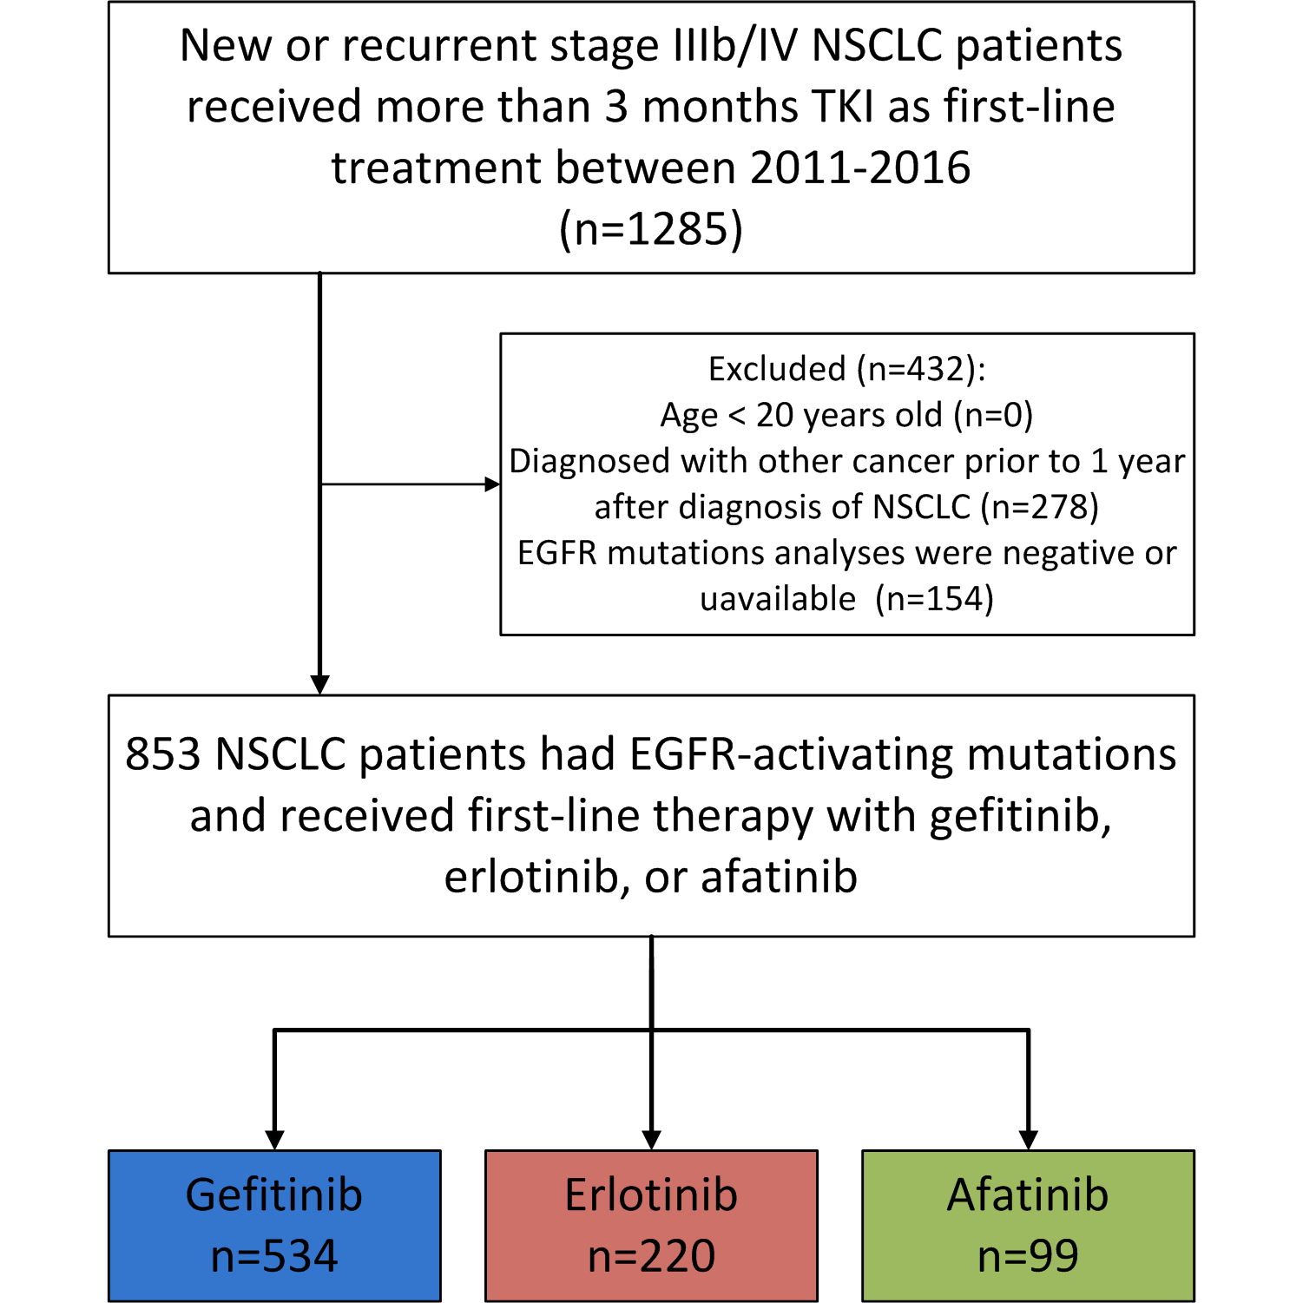
Supplemental Figure 1. Flow diagram summarizing the process of enrollment

Supplemental Table 1. Baseline characteristics of the patient population (n=853)
 | Gefitinib  (n=534) |  | Erlotinib  (n=220) |  | Afatinib  (n=99) |  | Total  (n=853) |  | P-value#
Age, years (mean; SD) | 66.8 (12.8) |  | 63.0 (12.4) |  | 64.1 (10.8) |  | 65.5 (12.6) |  | 0.0004
Sex, (n; %) |  |  |  |  |  |  |  |  | 0.0043
Male | 173 (32.4) |  | 90 (40.9) |  | 47 (47.5) |  | 310 (36.3)
Female | 361 (67.6) |  | 130 (59.1) |  | 52 (52.5) |  | 543 (63.7)
Smoking (n; %) |  |  |  |  |  |  |  |  | <.0001
Never | 443 (83.0) |  | 153 (69.5) |  | 64 (64.7) |  | 660 (77.4)
Current or ever | 91 (17.0) |  | 67 (30.5) |  | 35 (35.3) |  | 193 (22.6)
Clinical stage (n; %) |  |  |  |  |  |  |  |  | 0.9710
IIIB | 20 (3.8) |  | 9 (4.1) |  | 4 (4.0) |  | 33 (3.9)
IV | 514 (96.2) |  | 211 (95.9) |  | 95 (96.0) |  | 820 (96.1)
EGFR mutation (n; %) |  |  |  |  |  |  |  |  | <.0001
Exon 19 deletion | 238 (44.6) |  | 86 (39.1) |  | 53 (53.5) |  | 377 (44.2)
L858R | 272 (50.9) |  | 129 (58.6) |  | 31 (31.9) |  | 432 (50.6)
Other | 24 (4.5) |  | 5 (2.3) |  | 15 (15.2) |  | 44 (5.2)
Baseline brain metastases  (n; %) |  |  |  |  |  |  |  |  | <.0001
Absence | 360 (67.4) |  | 97 (44.1) |  | 63 (63.6) |  | 521 (61.1)
Presence | 174 (32.6) |  | 123 (55.9) |  | 36 (36.4) |  | 332 (38.9)
ECOG PS (n; %) |  |  |  |  |  |  |  |  | 0.0017
0&1 | 427 (80.0) |  | 196 (89.1) |  | 89 (89.9) |  | 712 (83.5)
≥2 | 107 (20.0) |  | 24 (10.9) |  | 10 (10.1) |  | 141 (16.5)
Initial radiotherapy (n; %) |  |  |  |  |  |  |  |  | 0.6196
Yes | 90 (16.9) |  | 38 (17.3) |  | 13 (13.1) |  | 141 (16.5)
No | 444 (83.1) |  | 182 (82.7) |  | 86 (86.9) |  | 712 (83.5)
Deyo’s CCI (n; %) |  |  |  |  |  |  |  |  | 0.8354
2 | 320 (59.9) |  | 137 (62.3) |  | 60 (60.6) |  | 517 (60.6)
>2 | 214 (40.1) |  | 83 (37.7) |  | 39 (39.4) |  | 336 (39.4)
Histology (n; %) |  |  |  |  |  |  |  |  | 0.1523
Adenocarcinoma | 505 (94.6) |  | 202 (91.8) |  | 96 (97.0) |  | 803 (94.1)
Other | 29 (5.4) |  | 18 (8.2) |  | 3 (3.0) |  | 50 (5.9)
Co-medications
Metformin (n; %)* | 27 (5.1) | 9 (4.1) |  | 4 (4.0) |  | 40 (4.7) |  | 0.8064
Statins (n; %)* | 27 (5.1) | 10 (4.6) |  | 1 (1.0) |  | 38 (4.5) |  | 0.2001
Antacids (n; %)* | 69 (12.9) | 15 (6.8) |  | 8 (8.1) |  | 92 (10.8) |  | 0.0320
Glucocorticoids (n; %)* | 28 (5.2) | 21 (9.6) |  | 4 (4.0) |  | 53 (6.2) |  | 0.0535
#p values comparing baseline characteristics of the three TKI groups.
*Patients with co-medications were defined as those who had received co-medications (>28 cumulative defined daily doses) within first 3 months of TKI treatment initiation.

Supplemental Table 2. Risk factor analysis of new brain metastases in patients with stage IIIB or IV NSCLC harboring EGFR-activating mutations
 | Univariate |  | Multivariate
 | HR (95% CI) | P-value | HR (95% CI) | P-value
Age>=65 | 0.60 (0.31-1.13) | 0.113 | 0.56 (0.28-1.12) | 0.101
Female | 0.57 (0.30-1.08) | 0.083 | 0.62 (0.30-1.28) | 0.194
TKIs (Ref: Gefitinib)
Erlotinib | 1.67 (0.80-3.47) | 0.173 | 1.40 (0.64-3.05) | 0.398
Afatinib | 0.59 (0.18-1.94) | 0.380 | 0.43 (0.12-1.49) | 0.181
TKIs (Ref: Erlotinib)
Gefitinib | 0.60 (0.29-1.25) | 0.173 | 0.72 (0.33-1.56) | 0.398
Afatinib | 0.35 (0.10-1.28) | 0.112 | 0.31 (0.08-1.20) | 0.090
EGFR mutation (ref=Ex19d)
L858R | 1.49 (0.73-3.02) | 0.273 | 1.48 (0.71-3.12) | 0.299
Other | 4.26 (1.50-12.1) | 0.007* | 7.48 (2.43-23.0) | <.001
Stage IIIB (ref=IV) | 0.92 (0.22-3.81) | 0.904 | 0.89 (0.21-3.89) | 0.880
ECOG PS≥2 | 0.67 (0.24-1.88) | 0.442 | 0.91 (0.31-2.72) | 0.869
Current or ever smoking | 1.77 (0.89-3.51) | 0.102 | 1.64 (0.74-3.61) | 0.223
Receiving Radiotherapy | 0.61 (0.15-2.55) | 0.503 | 0.51 (0.12-2.20) | 0.368
DCCI Score >2 (Ref: 2) | 0.98 (0.51-1.89) | 0.960 | 0.83 (0.40-1.71) | 0.611
Co-medications
Metformin | 1.67 (0.51-5.44) | 0.394 | 1.66 (0.44-6.34) | 0.458
Statins | 1.59 (0.49-5.17) | 0.442 | 1.95 (0.53-7.22) | 0.318
Antacids | 0.75 (0.23-2.44) | 0.633 | 0.86 (0.24-3.15) | 0.824
Glucocorticoids | 2.92 (0.70-12.2) | 0.141 | 2.89 (0.60-13.8) | 0.184
* All factors were included in the Cox multivariate analysis.

Supplemental Table 3. Risk factor analyses of treatment failure using propensity score adjustments
 | Gefitinib & Erlotinib |  |  | Gefitinib & Afatinib |  |  | Erlotinib & Afatinib
 | aHR (95% CI)* | P-value |  | aHR (95% CI)* | P-value |  | aHR (95% CI)* | P-value
TKIs
Gefitinib | Ref |  |  | Ref |  |  | -
Erlotinib | 0.87 (0.73-1.05) | 0.157 |  | - |  |  | Ref
Afatinib | - |  |  | 0.56 (0.42-0.73) | <0.001 |  | 0.56 (0.41-0.77) | <0.001
* Propensity score and all factors were included in the Cox multivariate analysis.

