– Supplementary material –

Mitochondrial genomics reveals the evolutionary history of the porpoises (Phocoenidae) across the speciation continuum

Yacine Ben Chehida¹, Julie Thumloup¹, Cassie Schumacher², Timothy Harkins², Alex Aguilar³, Asunción Borrell³, Marisa Ferreira^{4,5}, Lorenzo Rojas-Bracho⁶, Kelly M. Robertson⁷, Barbara L. Taylor⁷, Gìsli A. Víkingsson⁸, Arthur Weyna⁹, Jonathan Romiguier⁹, Phillip A. Morin⁷, Michael C. Fontaine^{1,10}*

¹ Groningen Institute for Evolutionary Life Sciences (GELIFES), University of Groningen, PO Box 11103 CC, Groningen, The Netherlands.
² Swift Biosciences, 674 S. Wagner Rd., Suite 100, Ann Arbor, MI 48103, USA.
³ IRBIO and Department of Evolutive Biology, Ecology and Environmental Sciences, Faculty of Biology, University of Barcelona, Diagonal 643, 08071 Barcelona, Spain.
⁴ MATB-Sociedade Portuguesa de Vida Selvagem, Estação de Campo de Quiaios, Apartado EC Quiaios, 3080-530 Figueira da Foz, Portugal.
⁵ CPRAM-Ecomare, Estrada Do Porto de Pesca Costeira, 3830-565 Gafanha da Nazaré, Portugal.
⁶ Comisión Nacional de Áreas Naturales Protegidas (CONANP), C/o Centro de Investigación Científica y de Educación Superior de Ensenada, Carretera Ensenada-Tijuana 3918, Fraccionamiento Zona Playitas, Ensenada, BC 22860, Mexico.
⁷ Southwest Fisheries Science Center, National Marine Fisheries Service, NOAA, 8901 La Jolla Shores Dr., La Jolla, California 92037, USA.
⁸ Marine and Freshwater Research Institute, Fornubúðum 5, 220 Hafnarfjörður, Iceland.
⁹ Institut des Sciences de l’Évolution (Université de Montpellier, CNRS UMR 5554), Montpellier, France.
¹⁰ Laboratoire MIVEGEC (Université de Montpellier, CNRS 5290, IRD 229) et Centre de Recherche en Écologie et Évolution de la Santé (CREES), Centre IRD de Montpellier, Montpellier, France

*Corresponding author: Michael C. Fontaine (michael.fontaine@cnrs.fr). MIVEGEC (IRD 224-CNRS 5290-UM). Institut de Recherche pour le Développement (IRD), 911 Avenue Agropolis, BP 64501, 34394 Montpellier Cedex 5, France.

Index

Supplementary text 3
Text S1. Reads quality check and filtering. 3
Text S2. Mitogenome assembly using MITOBIM. 4
Supplementary tables 5
Table S1. Sampling information by individual. 5
Table S2. Reads filtering and mitochondrial assembly using MITOBIM and Geneious. 8
Table S3. Genetic diversity in the coding regions (13 CDS) of the mitochondrial genome (11,334 bp). 9
Table S4. Genetic diversity in the non-coding regions of the mitochondrial genome (842 bps) 10
Table S5. Time (in million years) to the most recent common ancestor of lineages analyzed in this study. 11
Supplementary Figures 12
Fig. S1. Mitochondrial phylogeny estimated using three different approaches. 12
Fig. S2. Nucleotide diversity (π) along the mitogenome of six species of porpoises. 13
Fig. S3. Evolution of the d_{N}/d_{S} ratio in the porpoise family. 14
Fig. S4. Heat map of the neutrality index estimated in the McDonald-Kreitman (MK) tests between all pairwise interspecific lineages. 15
References 16

Supplementary text

Text S1. Reads quality check and filtering.
An initial quality check (QC) of the reads was conducted using FastQC v.0.11.5. Specifically, we assessed the general phred-scale quality score of the reads (on average and for every site of the reads), the presence of overrepresented sequences or of Illumina specific adaptors in the raw data. General quality statistics of the raw data are provided in Table 1 and S2. Then, low-quality reads, overrepresented sequences and Illumina adaptors were removed using Trimmomatic v0.36¹. We applied two different sets of filters according to the two distinct sequencing technology used (MiSeq or HiSeq). For the 44 Miseq sequences and the finless porpoise short read archive² from NCBI, we used the following command in Trimmomatic: [ILLUMINACLIP:/TruSeq3-PE.fa:2:30:10 LEADING:5 TRAILING:5 SLIDINGWINDOW:4:15 MINLEN:50 HEADCROP:4]. This performed the following operations:
- Remove the Illumina adaptors using the “IlluminaClip” option.
- Remove low phred-scale quality score bases (Q < 5) at the beginning (LEADING option) and ending (TRAILING option) of each read.
- Slide a 4 base-pairs (bps) window along the reads and replace by N's if the average quality is lower or equal to 15.
- Require a minimal read length of 50 bp (before using the HEADCROP option of Trimmomatic v0.36 in 5.) otherwise we dropped it.
- Remove the first 4 bases (to improve the “Sequence content” statistics of FastQC).
For the reads generated using a Hiseq-4000 (at BGI) for the 12 harbor porpoises, we used the following command in Trimmomatic: [ILLUMINACLIP:/TruSeq3-PE.fa:2:30:10 LEADING:20 TRAILING:20 SLIDINGWINDOW:4:15 MINLEN:50 HEADCROP:4]. This performed the following operations:
- Remove the Illumina adaptors using the “IlluminaClip” option.
- Remove low phred-scale quality score bases (inferior to 20) at the beginning (LEADING option) and at the ending (TRAILING option) of each read.
- Slide a four bps window along the reads and replace by N's if the average is quality lower or equal to 15.
- Require a minimal read length of 50 bp (to improve the “Sequence content” statistics of FastQC.), otherwise we dropped it.
- Remove the first 4 bases (to improve the “Sequence content” statistics of FastQC).
A post-cleaning QC assessment showed that the average quality score of the data increased dramatically (Table S2) and no adaptor, nor duplicated reads were detected after the data cleaning step. The number of reads kept and other general statistics about the data after QC filtering are provided in Table S2.

Text S2. Mitogenome assembly using MITOBIM.

As a second approach to assemble mitogenomes from short reads, we used the baiting and iterative elongation procedure of MITOBIM³. This method involves two steps. First, the reads are mapped to a reference genome using MIRA v4.0⁴, generating a new reference genome based only on the most conserved regions. Secondly, the remaining reads that overlap with the new reference genome are iteratively fished and mapped to the reference genome using MITOBIM v1.8³. At each iteration, this process extends the new reference until reaching a stationary number of reads. The first step has significant memory requirements and leads to a significant increase of the computational time. This increased memory consumption can be bypassed using the quick option of MITOBIM by skipping the first steps that use MIRA³. This option reduces the total pool of reads only to the ones that have certain k-mers overlap (≥ 31 bp) to the reference already before the initial assembly. This approach performs well with samples that are not too distantly related from the reference available (see details in Hahn et al.³). We assembled two individuals with the “classical approach” (MIRA and MITOBIM) and with the quick option to compare the results of both methods. As the results were identical, we assembled the 55 remaining samples using only the quick option. The statistics of the assembly with MITOBIM is provided in Table S2.

We compared visually the assemblies generated by Geneious⁵ and MITOBIM in Geneious. When the assembly with Geneious led to ambiguous sites (IUPAC ambiguity codes), we took the nucleotides called by MITOBIM. When disagreements were observed between assemblies, we checked the coverage and visually inspected the reads mapping at those sites in Geneious. If the coverage was less than 5, we used the base attributed by MITOBIM. If the coverage was more than 5 and the majority (at least 75%) of the reads mapped at that site (in Geneious) contained a certain base, we used it.

Supplementary tables

Table S1. Sampling information by individual.

Species | Source¹ | ID | Sex² | Year | Latitude | Longitude | Locality
N. pho. | SWFSC | 983 | NA | NA | NA | NA | China, Yangtze River
N. pho. | SWFSC | 984 | NA | NA | NA | NA | NA
N. pho. | SWFSC | 7859 | NA | NA | NA | NA | NA
N. pho. | SWFSC | 7869 | NA | NA | NA | NA | NA
N. pho | SWFSC | 9559 | F | 1996 | 22.74 | 120.21 | Taiwan, Yung-An
N. pho | SWFSC | 9560 | NA | NA | NA | NA | NA
P. dal. | SWFSC | 145217 | NA | 2014 | 47.87 | -125.15 | NA
P. dal. | SWFSC | 145216 | NA | NA | NA | NA | NA
P. dal. | SWFSC | 145413 | NA | NA | NA | NA | NA
P. dal. | SWFSC | 145242 | NA | NA | NA | NA | NA
P. dal. | SWFSC | 145258 | NA | NA | NA | NA | NA
P. dal. | SWFSC | 145412 | NA | 2014 | 33.35 | -120.33 | NA
P. dio. | SWFSC | 981 | NA | 1989 | -53.1 | -66.5 | Argentina, Estancia Las Violetas
P. dio. | SWFSC | 7014 | F | 1997 | -42.9 | 148.4 | Australia, Tasmania, Bruny Is., Adventure Bay
P. dio. | SWFSC | 7015 | NA | NA | NA | NA | NA
P. pho. | SWFSC | 161 | M | NA | 36.80 | -121.78 | USA, Ca, Moss Landing
P. pho. | SWFSC | 704 | F | 1989 | 36.90 | -121.83 | USA, Ca, Monterey Bay
P. pho. | SWFSC | 706 | F | 1989 | 36.80 | -121.78 | USA, Ca, Monterey
P. pho. | SWFSC | 707 | M | 1989 | 36.90 | -121.83 | USA, Ca, Santa Cruz Co., Sunset State Beach
P. pho. | SWFSC | 1080 | F | 1988 | 49.05 | -125.72 | Canada, British Columbia, Long Beach
P. pho. | SWFSC | 1082 | M | 1990 | 48.42 | -123.40 | Canada, British Columbia, Victoria
P. pho. | SWFSC | 1084 | F | 1987 | 49.00 | -123.50 | Canada, British Columbia, Gabriola Is.
P. pho. | SWFSC | 3766 | M | 1989 | 36.63 | -121.87 | USA, Ca, (Northern)
P. pho. | SWFSC | 3767 | M | 1989 | 36.55 | -121.98 | USA, Ca, (Northern)
P. pho. | SWFSC | 3768 | M | 1989 | 36.63 | -121.87 | USA, Ca, (Northern)
P. pho. | SWFSC | 5411 | F | 1993 | 57.03 | -154.15 | USA, Ak, Kodiak
P. pho. | SWFSC | 8514 | F | 1994 | 42.83 | -124.58 | USA, Or, Port Orford
P. pho. | SWFSC | 4764 | NA | NA | NA | NA | NA
P. pho. | SWFSC | 26609 | NA | NA | NA | NA | NA
P. pho. | Fontaine et al. 2014 | 2000-24 | M | 2000 | 66.5 | 12.08 | Norway
P. pho. | Fontaine et al. 2014 | IFR4 | M | 1990 | -6.90 | 62.20 | Faroe Islands
P. pho. | Fontaine et al. 2014 | PP118-2004 | M | 2004 | 40.15 | -8.8667 | Portugal
P. pho. | Fontaine et al. 2014 | PP30-2002 | M | 2002 | 40.3167 | -8.86 | Portugal
P. pho. | Fontaine et al. 2014 | PP79-2003 | M | 2003 | 40.4333 | -8.86 | Portugal
P. pho. | Fontaine et al. 2014 | RIM100 | NA | NA | 19 | -17 | Mauritania
P. pho. | Fontaine et al. 2014 | RIM156 | M | NA | 19 | -17 | Mauritania
P. pho. | Fontaine et al. 2014 | RIM99 | M | NA | 19 | -17 | Mauritania
P. pho. | Fontaine et al. 2014 | SV276 | M | NA | -21.95 | 64.27 | Iceland
P. pho. | Fontaine et al. 2014 | U64 | M | 1998 | 44.6 | 33.53 | Ukraine, Black Sea
P. pho. | Fontaine et al. 2014 | U75 | F | 1998 | 44.6 | 33.53 | Ukraine, Black Sea
P. pho. | Fontaine et al. 2014 | U93 | M | 1998 | 44.6 | 33.53 | Ukraine, Black Sea
P. sin. | SWFSC | 703 | NA | 1985 | 34.42 | -120.50 | Mexico, El Burro
P. sin. | SWFSC | 1649 | NA | 1993 | 31.75 | -114.50 | Mexico, Gulf Of California
P. sin. | SWFSC | 1651 | NA | 1993 | 31.75 | -114.50 | Mexico, Gulf Of California
P. sin. | SWFSC | 1654 | F | 1992 | 31.75 | -114.50 | Mexico, Baja California North, El Ouelele
P. sin. | SWFSC | 1655 | M | 1993 | 31.75 | -114.58 | Mexico, Sonora, Gulf Of Santa Clara
P. sin. | SWFSC | 1660 | F | 1993 | 31.75 | -114.58 | Mexico, Sonora, Gulf Of Santa Clara
P. sin. | SWFSC | 4018 | NA | 1980 | 31.75 | -114.50 | Mexico, Upper Gulf Of Ca
P. sin. | SWFSC | 4379 | F | 1990 | 31.75 | -114.50 | Mexico, Gulf Of Santa Clara
P. sin. | SWFSC | 4381 | M | 1990 | 31.75 | -114.50 | Mexico, Gulf Of Santa Clara
P. sin. | SWFSC | 4393 | F | 1991 | 31.75 | -114.50 | Mexico, Gulf Of Santa Clara
P. sin. | SWFSC | 4394 | M | 1991 | 31.75 | -114.50 | Mexico, Gulf Of Santa Clara
P. sin. | SWFSC | 4396 | F | 1991 | 31.75 | -114.50 | Mexico, Gulf Of Santa Clara
P. spi. | SWFSC | 1092 | NA | 1990 | -15 | -76 | Peru
P. spi. | SWFSC | 52776 | F | 1997 | -32.92 | -71.52 | Chile, Mantagua
P. spi. | SWFSC | 52777 | M | 1999 | -35.33 | -72.42 | Chile, Constitucion
NA, Missing information;
¹ SWFSC, Southwest Fisheries Science Centre, NOAA; Fontaine et al.⁶ ;
² Female (F) or Male (M).

Table S2. Reads filtering and mitochondrial assembly using MITOBIM and Geneious.

GenBank: GenBank Accession numbers; Reads: Total number of reads, TBA: To be announced.

Table S3. Genetic diversity in the coding regions (13 CDS) of the mitochondrial genome (11,334 bp).

 |  | N | MD | H | H_{d} (%) | S | Shared P. | Singl. | π (%) | θ_{W} (%) | #Syn | #NSyn | π_{S} (%) | π_{NS} (%) | π_{NS}/π_{S}
Species | All | 63 | 1 | 56 | 99.4 | 2463 | 2283 | 180 | 6.45 | 4.61 | 2059 | 373 | 21.83 | 1.38 | 0.06
Species | FP | 12 | 1 | 12 | 100.0 | 193 | 46 | 147 | 0.42 | 0.56 | 151 | 42 | 1.28 | 0.13 | 0.10
Species | BP | 3 | 0 | 3 | 100.0 | 25 | 0 | 25 | 0.14 | 0.14 | 21 | 4 | 0.5 | 0.03 | 0.06
Species | V | 12 | 0 | 7 | 86.4 | 10 | 2 | 8 | 0.02 | 0.03 | 8 | 2 | 0.07 | 0.004 | 0.06
Species | SP | 3 | 0 | 3 | 100.0 | 120 | 0 | 120 | 0.70 | 0.70 | 106 | 14 | 2.52 | 0.11 | 0.04
Species | DP | 6 | 0 | 5 | 93.3 | 173 | 49 | 124 | 0.60 | 0.67 | 155 | 18 | 2.13 | 0.09 | 0.04
Species | HP | 27 | 1 | 26 | 99.7 | 474 | 357 | 117 | 1.34 | 1.11 | 384 | 90 | 4.36 | 0.31 | 0.07
HP | NAT | 4 | 1 | 4 | 100.0 | 82 | 15 | 67 | 0.38 | 0.40 | 66 | 16 | 1.25 | 0.10 | 0.08
HP | IB | 3 | 1 | 3 | 100.0 | 23 | 0 | 23 | 0.14 | 0.14 | 15 | 8 | 0.35 | 0.07 | 0.20
HP | MA | 3 | 1 | 3 | 100.0 | 9 | 0 | 9 | 0.05 | 0.05 | 6 | 3 | 0.14 | 0.03 | 0.21
HP | BS | 3 | 1 | 3 | 100.0 | 14 | 0 | 14 | 0.08 | 0.08 | 8 | 6 | 0.19 | 0.05 | 0.26
HP | NP | 14 | 1 | 13 | 98.9 | 91 | 52 | 39 | 0.23 | 0.25 | 77 | 14 | 0.79 | 0.05 | 0.06
NP | NP1 | 10 | 1 | 10 | 100.0 | 57 | 19 | 38 | 0.14 | 0.18 | 48 | 9 | 0.46 | 0.03 | 0.07
NP | NP2 | 4 | 1 | 3 | 83.3 | 3 | 1 | 2 | 0.02 | 0.01 | 3 | 0 | 0.06 | 0 | 0
FP | YFP | 6 | 1 | 6 | 100.0 | 26 | 3 | 23 | 0.08 | 0.10 | 17 | 9 | 0.22 | 0.04 | 0.17
FP | EAF | 5 | 1 | 5 | 100.0 | 46 | 2 | 44 | 0.17 | 0.20 | 33 | 13 | 0.48 | 0.07 | 0.14
DP | DP2 | 5 | 1 | 4 | 90.0 | 90 | 40 | 50 | 0.38 | 0.38 | 77 | 13 | 1.34 | 0.07 | 0.05
SP | SP2 | 2 | 1 | 2 | 100.0 | 30 | 2 | 30 | 0.27 | 0.27 | 25 | 5 | 0.89 | 0.06 | 0.06
FP, Neophocaena; BP, P. spinipninis, V, P. sinus; SP, P. dioptrica; DP, P. dalli; HP, P. phocoena; NAT, North Atlantic harbor porpoise; IB, Iberian harbor porpoise; MA, Mauritanian harbor porpoise; BS, Black Sea harbor porpoise; NP; Pacific P. phocoena; YF, N. a. asiaeorientalis; EAF, N. a. sunameri. For NP1, NP2, DP2 and SP2 see main text Fig. 1b. N, Sample size; MD, Number of sites with missing data; H, number of haplotypes; H_{d}, haplotypic diversity; S, segregating sites; Shared P., shared polymorphism; Singl., singleton; π, average nucleotide diversity by site; θ_{W}, theta from S; #Syn., number of synonymous mutations; #NSyn., number of non-Synonymous mutations; π_{S}, nucleotide diversity by site for Synonymous mutations; π_{NS}, nucleotide diversity by site for Non-Synonymous mutations; π(NS/S), Ratio of π_{NS} to π_{Syn}.

Table S4. Genetic diversity in the non-coding regions of the mitochondrial genome (842 bps)

 |  |  |  | N | MD | H | H_{d} (%) | S | Shared P. | Singl. | π (%) | θ_{W} (%)
Species |  | All |  | 63 | 13 | 41 | 96.8 | 114 | 107 | 7 | 4.62 | 3.16
 |  | FP |  | 12 | 8 | 7 | 83.3 | 10 | 5 | 5 | 0.36 | 0.40
 |  | BP |  | 3 | 5 | 3 | 100.0 | 5 | 0 | 5 | 0.40 | 0.40
 |  | V |  | 12 | 4 | 4 | 45.5 | 4 | 0 | 4 | 0.08 | 0.13
 |  | SP |  | 3 | 5 | 3 | 100.0 | 8 | 0 | 8 | 0.68 | 0.64
 |  | DP |  | 6 | 8 | 5 | 93.3 | 15 | 5 | 10 | 0.74 | 0.80
 |  | HP |  | 27 | 10 | 19 | 95.7 | 39 | 30 | 9 | 1.21 | 1.15
HP |  | NAT |  | 4 | 10 | 4 | 100.0 | 5 | 1 | 4 | 0.32 | 0.33
 |  | IB |  | 3 | 8 | 2 | 66.7 | 1 | 0 | 1 | 0.08 | 0.08
 |  | MA |  | 3 | 8 | 3 | 100.0 | 5 | 0 | 5 | 0.40 | 0.40
 |  | BS |  | 3 | 8 | 3 | 100.0 | 2 | 0 | 2 | 0.16 | 0.16
 |  | NP |  | 14 | 7 | 7 | 84.6 | 11 | 8 | 3 | 0.45 | 0.42
NP |  | NP1 |  | 10 | 7 | 4 | 71.1 | 6 | 1 | 5 | 0.19 | 0.26
 |  | NP2 |  | 4 | 6 | 2 | 66.7 | 2 | 1 | 1 | 0.14 | 0.13
FP |  | YFP |  | 6 | 8 | 2 | 33.3 | 2 | 0 | 2 | 0.08 | 0.11
 |  | EAF |  | 5 | 8 | 4 | 90.0 | 6 | 1 | 5 | 0.31 | 0.35
DP |  | DP2 |  | 5 | 8 | 4 | 90.0 | 7 | 4 | 3 | 0.43 | 0.41
SP |  | SP2 |  | 2 | 5 | 2 | 100.0 | 4 | 0 | 4 | 0.35 | 0.35
N, Sample size; MD, Number of sites with missing data; H, number of haplotypes; H_{d}, haplotypic diversity; S, segregating sites; Shared P., shared polymorphism; Singl., singleton; π, average nucleotide diversity by site; θ_{W}, theta from S. The meaning of the group acronyms is provided in Table S3.

Table S5. Time (in million years) to the most recent common ancestor of the lineages analyzed in this study.
Clade | Median age | 95% HPD
FP-V-BP-SP-DP-HP | 5.42 | 4.24-6.89
V-BP-SP-DP-HP | 4.06 | 3.15-5.12
V-BP-SP | 2.39 | 1.74-3.19
BP-SP | 2.14 | 1.51-2.86
DP-HP | 3.12 | 2.31-3.98
FP | 0.49 | 0.31-0.78
YFP-EAF | 0.22 | 0.14-0.35
YFP | 0.06 | 0.03-0.11
EAF | 0.13 | 0.08-0.21
V | 0.04 | 0.02-0.07
BP | 0.08 | 0.04-0.14
SP | 0.43 | 0.27-0.67
SP2 | 0.13 | 0.06-0.21
DP | 0.48 | 0.32-0.77
DP2 | 0.24 | 0.16-0.39
HP | 0.86 | 0.76-0.90
NP | 0.21 | 0.14-0.33
NP1 | 0.1 | 0.06-0.15
NP2 | 0.02 | 0.01-0.05
NA | 0.41 | 0.31-0.55
NAT | 0.22 | 0.14-0.31
IB | 0.09 | 0.05-0.15
MA | 0.06 | 0.03-0.11
BS | 0.05 | 0.02-0.09
HPD = highest posterior density of the age of the lineage.
The meaning of the group acronyms is provided in Table S3.

Supplementary Figures

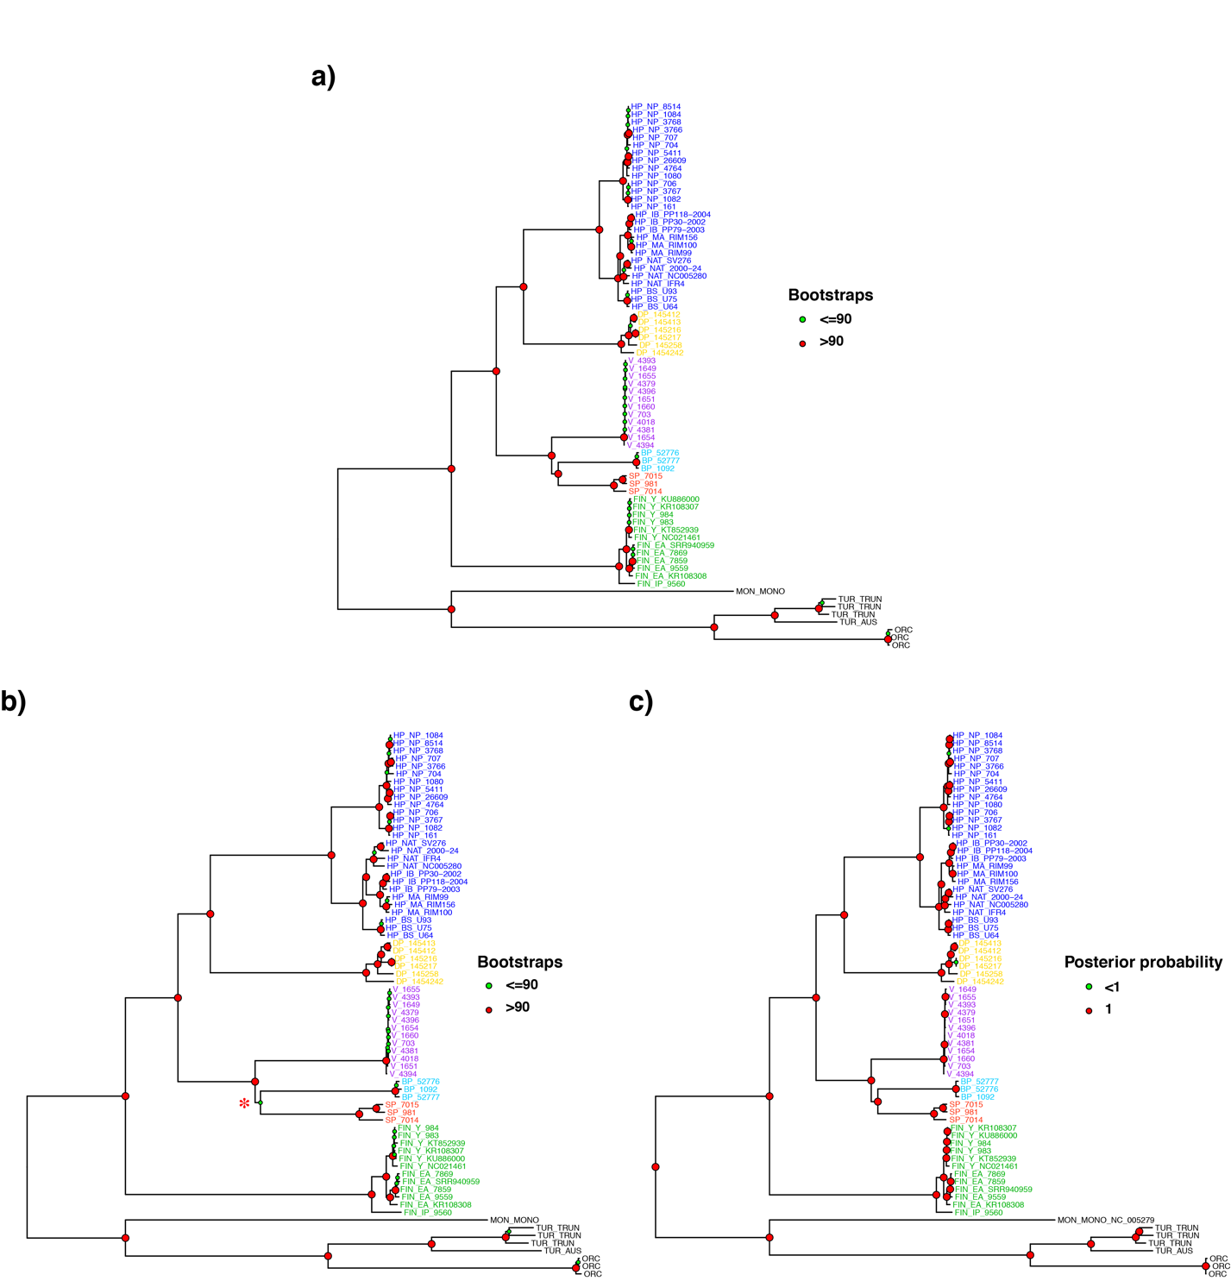
Fig. S1. Mitochondrial phylogeny estimated using three different approaches.
(a) Maximum likelihood phylogeny; (b) distance based (NJ) mitochondrial phylogeny; and (c) Bayesian mitochondrial phylogeny. The statistical support of each node for each method is indicated by the node color coding with the bootstrap support or posterior probability. The terminal branches and tip labels are colored according to the species. The tree is rooted with eight sequences from four closely related Odontoceti species (one M. Monoceros, three T. truncatus, one T. australis and three O. orca in black). The meaning of the group acronyms is provided in Table S3.

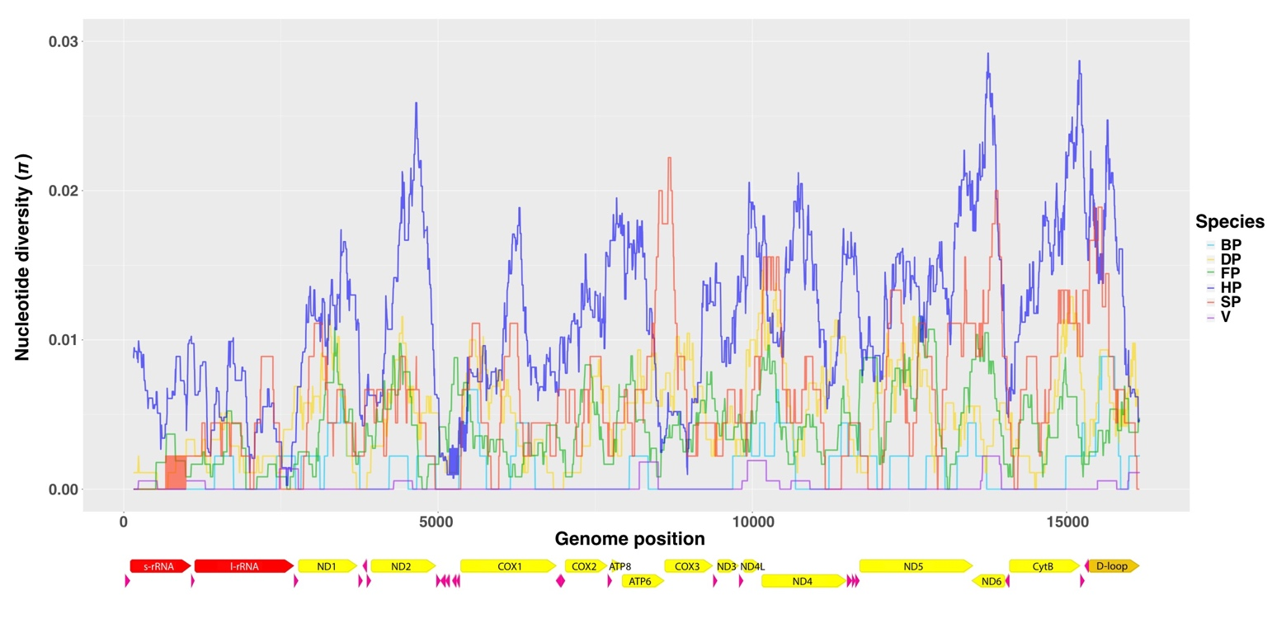
Fig. S2. Nucleotide diversity (π) along the mitogenome of six species of porpoises.
The protein coding genes (yellow), rRNA (red), tRNA (pink) and D-loop (gold) are shown below the x-axis. Arrows indicate the direction of transcription. The meaning of the group acronyms is provided in Table S3.

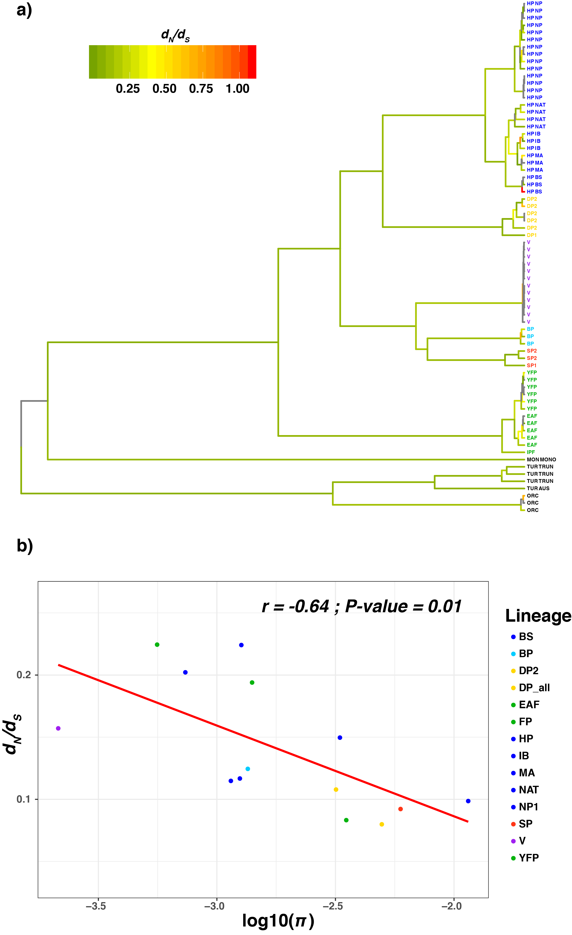

Fig. S3. Evolution of the d_{N}/d_{S} ratio in the porpoise family.
(a) Maximum likelihood mitochondrial phylogeny in which the branches have been colored according to the d_{N}/d_{S} ratio. (b) Relationship between mtDNA d_{N}/d_{S} ratio and log scaled nucleotide diversity (π) across the porpoise family. The regression line is shown in red. The meaning of the group acronyms is provided in Table S3.

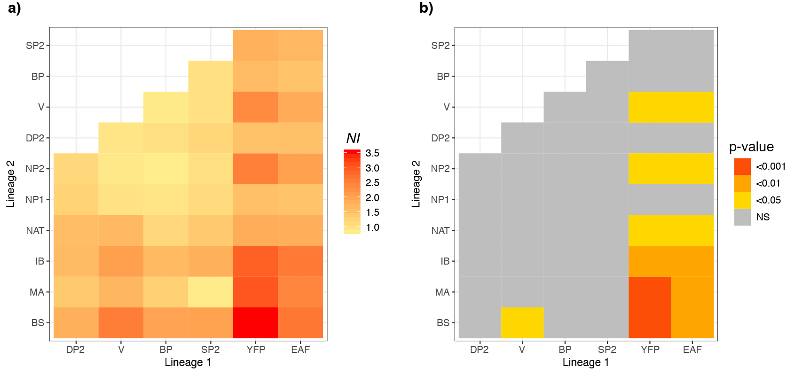

Fig. S4. Heat map of the neutrality index estimated in the McDonald-Kreitman (MK) tests between all pairwise interspecific lineages.
(a) Pairwise Neutral Index (NI) and (b) p-values associated with the MK tests. The meaning of the group acronyms is provided in Table S3.

References

1. Bolger, A. M., Lohse, M. & Usadel, B. Trimmomatic: a flexible trimmer for Illumina sequence data. Bioinformatics 30, 2114–2120 (2014).
2. Yim, H.-S. et al. Minke whale genome and aquatic adaptation in cetaceans. Nat. Genet. 46, 88–92 (2014).
3. Hahn, C., Bachmann, L. & Chevreux, B. Reconstructing mitochondrial genomes directly from genomic next-generation sequencing reads--a baiting and iterative mapping approach. Nucleic Acids Research 41, e129–e129 (2013).
4. Chevreux, B., Wetter, T. & Suhai, S. Genome sequence assembly using trace signals and additional sequence information. German conference on bioinformatics (1999).
5. Kearse, M. et al. Geneious Basic: An integrated and extendable desktop software platform for the organization and analysis of sequence data. Bioinformatics 28, 1647–1649 (2012).
6. Fontaine, M. C. et al. Postglacial climate changes and rise of three ecotypes of harbour porpoises, Phocoena phocoena, in western Palearctic waters. Mol. Ecol. 23, 3306–3321 (2014).
7. Cheng, Y., Liu, D. & Tang, W. The complete mitochondrial genome of the Neophocaena asiaeorientails sunamrei (Phocaenidae: Neophocaena). Mitochondrial DNA Part A 28, 248–249 (2016).
8. Arnason, U., Gullberg, A. & Janke, A. Mitogenomic analyses provide new insights into cetacean origin and evolution. Gene 333, 27–34 (2004).
9. Moura, A. E., Natoli, A., Rogan, E. & Hoelzel, A. R. Atypical panmixia in a European dolphin species (Delphinus delphis): implications for the evolution of diversity across oceanic boundaries. Journal of Evolutionary Biology 26, 63–75 (2013).
10. Morin, P. A. et al. Complete mitochondrial genome phylogeographic analysis of killer whales (Orcinus orca) indicates multiple species. Genome Research 20, 908–916 (2010).

