Supplementary Material

Tile:
Transcriptional analysis of cleft palate in TGFβ3 mutant mice

Authors:
Liu J*√, Chanumolu SK#√, White KM^, Albahrani M#, Otu HH# and Nawshad A°*

Authors Affiliations:
* Department of Oral Biology, College of Dentistry, University of Nebraska Medical Center, Lincoln NE-68583
^ Department of Growth and Development, College of Dentistry, University of Nebraska Medical Center College of Dentistry, Lincoln, NE-68583.
# Department of Electrical and Computer Engineering, University of Nebraska-Lincoln, Lincoln, NE-68588.

√ Co-first authors

°Corresponding author:
Ali Nawshad, PhD
Associate Professor
Department of Oral Biology,
College of Dentistry
University of Nebraska Medical Center,
4000 E Campus loop
Lincoln, NE- 68583

Tel: 402-472-1378
Fax: 402-471-2551
Email: anawshad@unmc.edu

Supplementary Figure 1. (A) Total number of paired-end reads (in logarithmic scale), (B) average read length in base pairs (bp), (C) average read quality, and (D) % of bp in the ensemble of reads that exceed a quality score of 20.

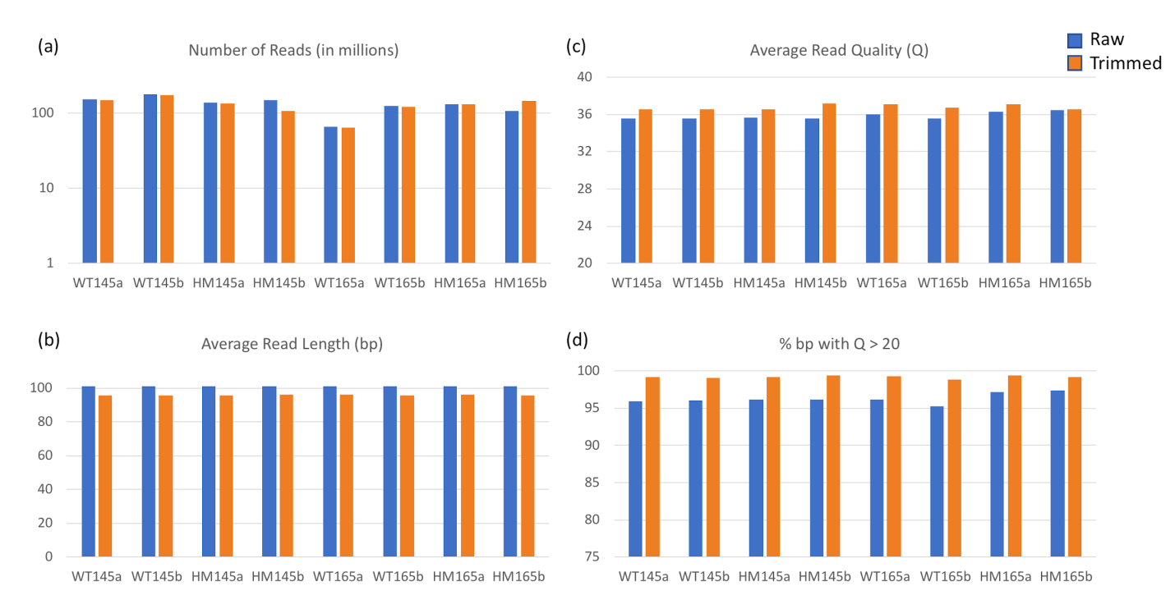
Supplementary Figure 2: Hierarchical clustering of all of the samples using all 52,475 transcripts measured with TPM>1 in at least one sample group.

Supplementary Figure 3. IPA Interaction Network Analysis for the WT specific gene list: genes significantly differentially expressed (adjusted p<0.05) with a |FC| > 2.0 uniquely in WT, E16.5 vs. E14.5. Genes are color coded such that pink implies upregulation and green implies downregulation. Genes that are also involved in major non-Smad pathways (ERK/MAPK, p38MAPK and PI3-AKT) in palatogenesis are indicated with links to the corresponding pathways. The p38MAPK gene appears as a central hub node that has been upregulated in E16.5. A solid line implies a direct interaction while a dashed line implies an indirect interaction

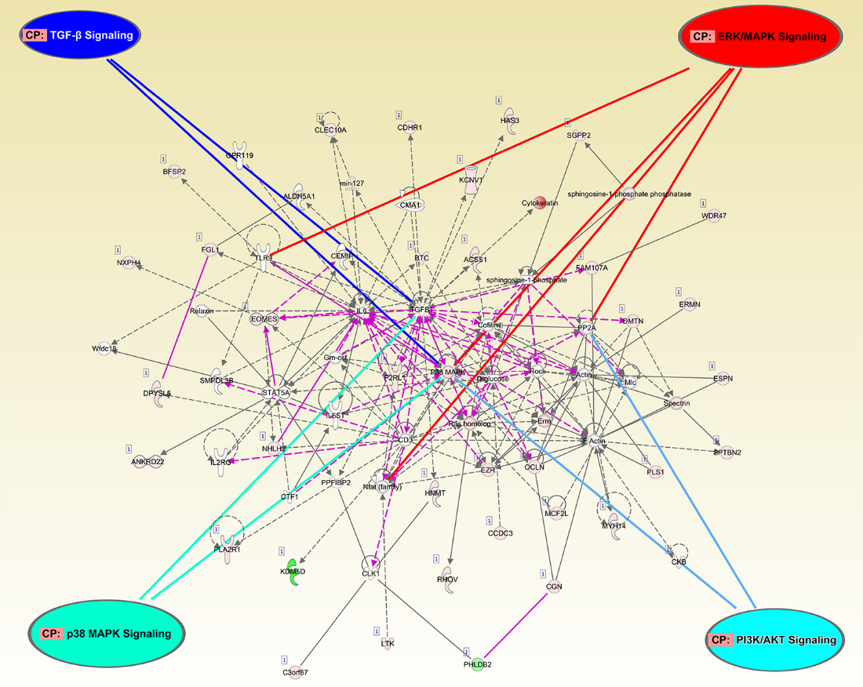

Supplementary Figure 4a
a. IPA upstream regulator analysis of TGF-β 1 and 3 for the WT specific gene list: genes significantly differentially expressed (adjusted p<0.05) with a |FC| > 2.0 uniquely in WT, E16.5 vs. E14.5. Shades of red implies upregulation and shades of green implies downregulation. Arrows highlight the WT specific genes regulated by TGF-β 1 and/or 3. Genes that are involved in Epithelial-Mesenchymal Transition (EMT) are highlighted. A solid line implies a direct interaction while a dashed line implies an indirect interaction

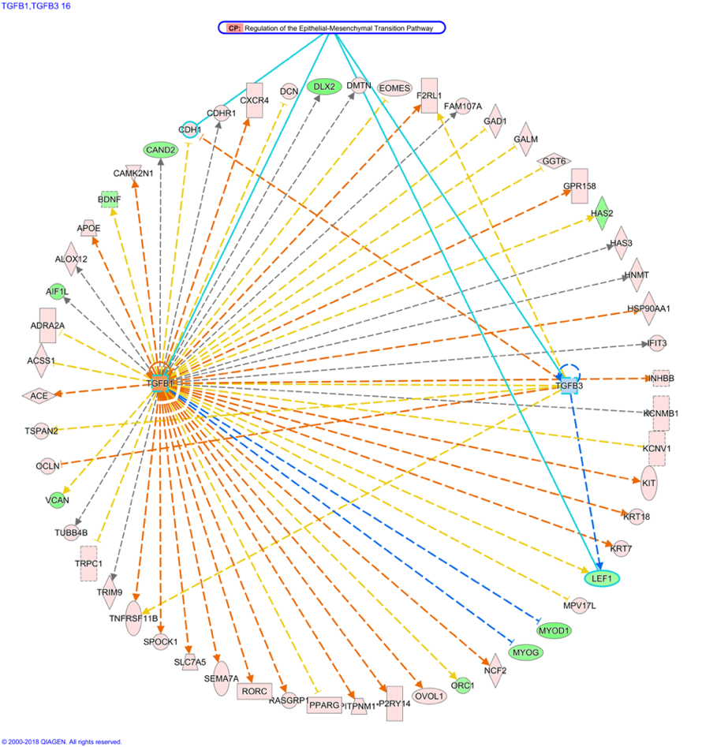

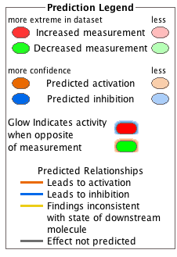

Supplementary Figure 4b
b. IPA mechanistic network depicting the interaction between upstream regulators that explain the observed changes in the WT specific gene list: genes significantly differentially expressed (adjusted p<0.05) with a |FC| > 2.0 uniquely in WT, E16.5 vs. E14.5. Regulators that are involved in Epithelial-Mesenchymal Transition (EMT) are highlighted (none observed, no purple border). A solid line implies a direct interaction while a dashed line implies an indirect interaction

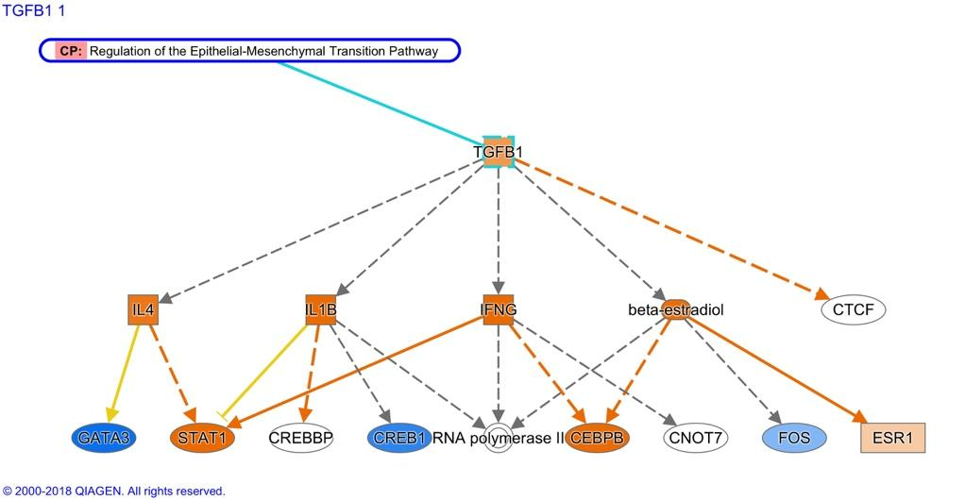

Supplementary Figure 5a
a. IPA upstream regulator analysis of TGF-β 1 and 3 for the WT specific gene list: genes significantly differentially expressed (adjusted p<0.05) with a |FC| > 2.0 uniquely in WT, E16.5 vs. E14.5. Shades of red implies upregulation and shades of green implies downregulation. Arrows highlight the WT specific genes regulated by TGF-β 1 and/or 3. Genes that are involved in the “cell death” functional category are highlighted (in purple border). A solid line implies a direct interaction while a dashed line implies an indirect interaction

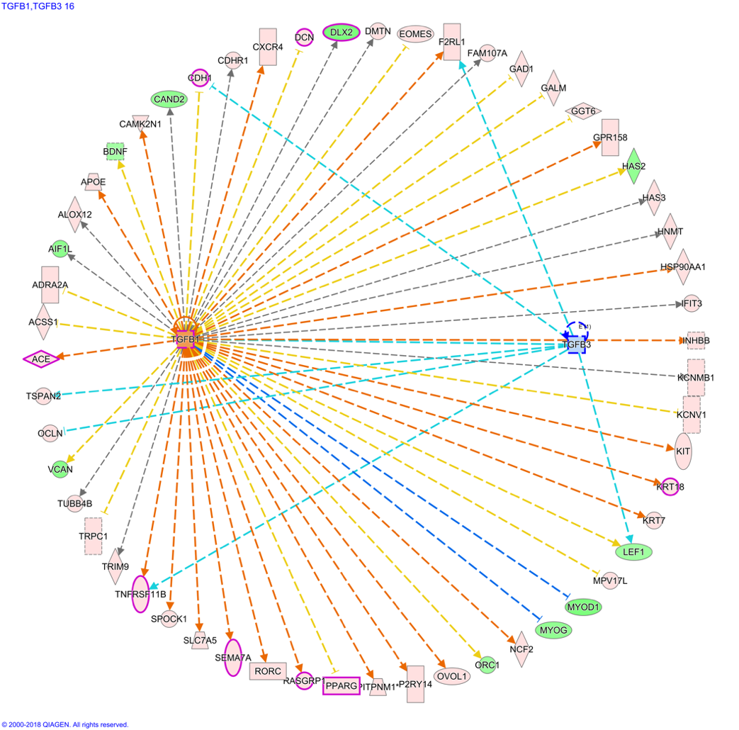
Supplementary Figure 5b
b. IPA mechanistic network depicting the interaction between upstream regulators that explain the observed changes in the WT specific gene list: genes significantly differentially expressed (adjusted p<0.05) with a |FC| > 2.0 uniquely in WT, E16.5 vs. E14.5. Regulators that are involved in the “cell death” functional category are highlighted (in purple border). A solid line implies a direct interaction while a dashed line implies an indirect interaction

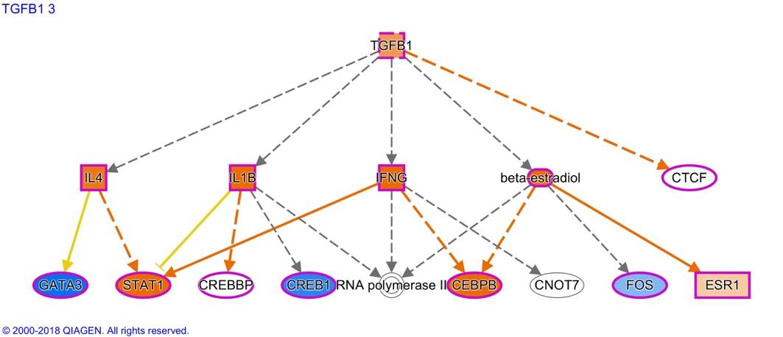

Supplementary Figure 6. Target molecules (upstream analysis) of TGF-β3 signaling pathways in WT palates that are up (pink) /down (green) regulated in response to TGF-β3. A solid line implies a direct interaction while a dashed line implies an indirect interaction

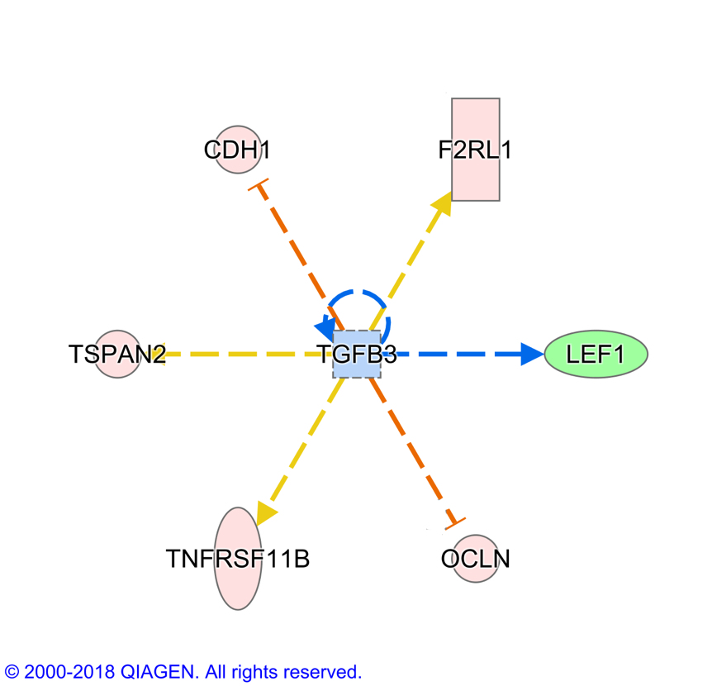

Supplementary Figure 7. IPA Interaction Network Analysis for the HM specific gene list: genes significantly differentially expressed (adjusted p<0.05) with a |FC| > 2.0 uniquely in HM, E16.5 vs. E14.5. Shades of red implies upregulation and shades of green implies downregulation. Genes that are also involved in major non-Smad pathways (ERK/MAPK, p38MAPK and PI3-AKT) in palatogenesis are indicated with links to the corresponding pathways. The p38MAPK gene does not appear in the network. A solid line implies a direct interaction while a dashed line implies an indirect interaction

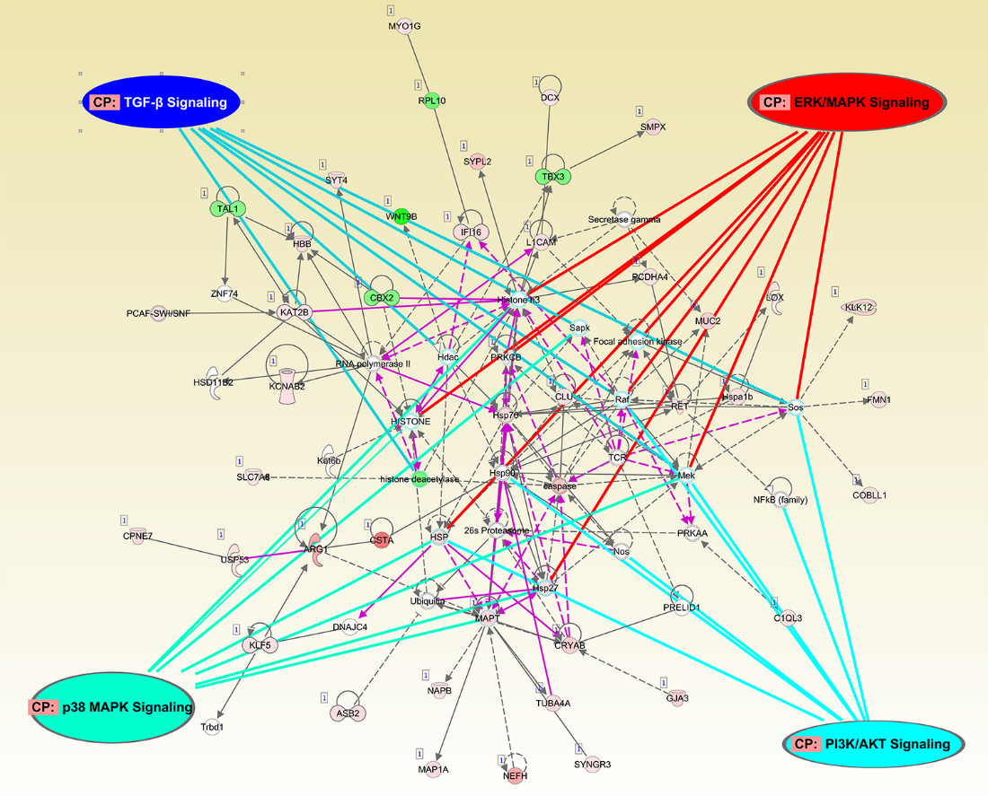

Supplementary data: (attached excel file):
A complete list of differential expression and analysis SDEGs, enriched GO categories and KEGG pathways.

