Supplementary Information

Omega-3 index and blood pressure responses to eating foods naturally enriched with omega-3 polyunsaturated fatty acids; a randomized controlled trial

Alice V. Stanton, M.B., Ph.D.,^{1,2,3} Kirstyn James, M.B., M.D.,^{1,2} Margaret M. Brennan, M.B.¹ Fiona O’Donovan, B.A., M.Sc.^{1,3} Fahad Buskandar, M.B.,¹ Kathleen Shortall, B.S.N.,¹ Thora El-Sayed, B.S.N.,¹ Jean Kennedy, Ph.D.,³ Heather Hayes, Ph.D.,³ Alan G. Fahey, Ph.D.,⁴ Niall Pender, Ph.D.,^{1,2,5} Simon A.M. Thom, M.B., M.D.,⁶ Niamh Moran, Ph.D.,¹ David J. Williams, M.B., Ph.D.,^{1,2} and Eamon Dolan, M.B., M.D..^{1,7}
- Royal College of Surgeons in Ireland, Dublin, Ireland.
- Beaumont Hospital, Dublin, Ireland.
- Devenish Nutrition, Belfast, United Kingdom,
- University College Dublin, Dublin, Ireland.
- Trinity College Dublin, Ireland.
- Imperial College, London, United Kingdom.
- Connolly Hospital, Dublin, Ireland.

Corresponding Author:
Professor Alice V. Stanton,
Royal College of Surgeons in Ireland, RCSI Education & Research Centre, The Smurfit Building, Beaumont Hospital, Beaumont Road, Dublin 9, DO9 YD60, Ireland
Telephone: +353 1 809 3735
Email: astanton@rcsi.ie
Contents

Page
Supplementary figure 1 3
Supplementary figure 2 4
Supplementary table 1 5
Supplementary table 2 6
Supplementary table 3 7 & 8
Supplementary table 4 9
Supplemental Figure 1: Changes in the red cell omega-3 index from baseline after consumption of control or omega-3 PUFA enriched chicken-meat and eggs for 6 months, in females and males (panel A), in younger and older subjects (panel B), in those with lower and higher omega-3 indices at baseline (panel C), and in those with lower and higher baseline blood pressures (panel D). Data shown as mean (SEM) change.
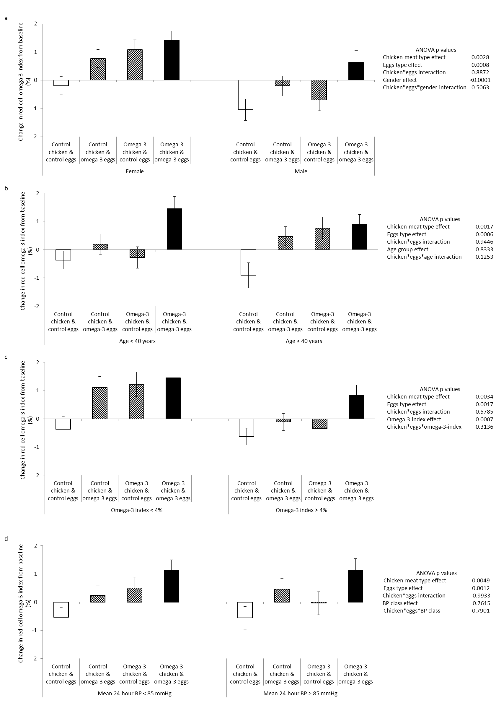
Supplemental Figure 2: Changes in mean 24-hour ambulatory diastolic BP from baseline after consumption of control or omega-3 PUFA enriched chicken-meat and eggs for 6 months, in females and males (panel A), in younger and older subjects (panel B), in those with lower and higher omega-3 indices at baseline (panel C), and in those with lower and higher baseline blood pressures (panel D). Data shown as mean (SEM) change.
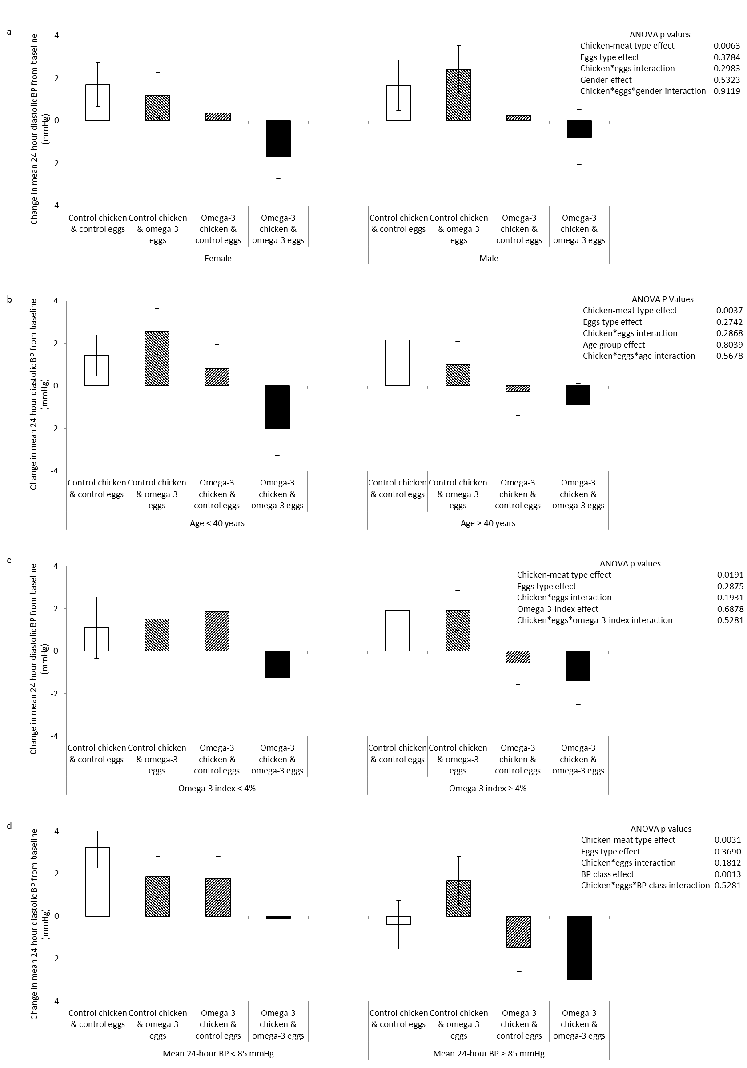

Supplemental Table 1: EPA and DHA content in control and omega-3-PUFA enriched chicken-meat and eggs
Food Product |  | EPA mg/100g | DHA mg/100g | Portion size g | EPA mg/portion | DHA mg/portion
Eggs
Eggs | Control Egg | 0 | 54 | 60 | 0 | 32
Eggs | Omega-3-PUFA Enriched Egg | 5 | 200 | 60 | 3 | 120
Chicken-meat
Chicken-meat | Control Chicken Breast | 3.5 | 5 | 120 | 4 | 6
Chicken-meat | Omega-3-PUFA Enriched Chicken Breast | 12 | 65 | 120 | 14 | 78
Chicken-meat | Control Chicken Thigh | 10 | 11 | 120 | 12 | 13
Chicken-meat | Omega-3-PUFA Enriched Chicken Thigh | 30 | 145 | 120 | 36 | 174

Supplemental Table 2: EPA and DHA Intakes According to Diet.
 |  | Control Chicken & Control Eggs | Control Chicken & Omega-3-PUFA Eggs | Omega-3-PUFA Chicken & Control Eggs | Omega-3-PUFA Chicken & Omega-3-PUFA Eggs
Chicken portions eaten/week |  | 4.0±0.9 | 3.9±1.6 | 3.6±0.7 | 3.6±0.7
White meat % |  | 64±16 | 59±15 | 70±15 | 69±16
Dark meat % |  | 36±16 | 41±15 | 30±15 | 31±16
Eggs eaten/week |  | 5.9±2.5 | 5.0±2.3 | 5.2±1.9 | 5.1±1.8
EPA intake (mg/week) | from white meat | 10.4±2.9 | 9.4±3.4 | 35.9±8.6 | 35.4±10.3
EPA intake (mg/week) | from dark meat | 17.4±9.9 | 19.9±13.0 | 40.7±24.2 | 40.5±22.6
EPA intake (mg/week) | from eggs | 0 | 15.1±7.0 | 0 | 15.2±5.5
EPA intake (mg/week) | total from meat and eggs | 27.8±9.3 | 44.5±18.6 | 76.7±21.9 | 91.2±21.5
DHA intake (mg/week) | from white meat | 14.9±4.1 | 13.5±4.8 | 194.7±46.7 | 191.8±55.6
DHA intake (mg/week) | from dark meat | 19.5±11.1 | 22.4±14.6 | 196.8±117.1 | 196.0±109.3
DHA intake (mg/week) | from eggs | 189.9±80.4 | 602.9±278.3 | 169.7±60.6 | 609.8±221.0
DHA intake (mg/week) | total from meat and eggs | 224.3±86.3 | 638.8±285.9 | 561.3±132.0 | 997.6±255.7
Total EPA+DHA intake from chicken meat and eggs (mg/week) |  | 252.1±92.1 | 683.3±299.8 | 637.9±151.8 | 1088.9±271.5
Data are mean±SD.

Supplemental Table 3: Changes in Red Cell and Plasma Levels of EPA and DHA after Consumption of Control or Omega-3 PUFA Enriched Chicken-meat and Eggs for 3 and 6 Months.
 |  |  | Control Chicken & Control Eggs (n=42) | Control Chicken & Omega-3-PUFA Eggs (n=40) | Omega-3-PUFA Chicken & Control Eggs (n=40) | Omega-3-PUFA Chicken & Omega-3-PUFA Eggs (n=39) | ANOVA P values
 |  |  |  |  |  |  | Chicken-Meat Effect | Eggs Effect | Chicken* Eggs Interaction
Red Cell EPA+DHA (% of total lipids) | Baseline |  | 4.54±1.47 | 4.60±1.78 | 4.61±1.69 | 4.33±1.60
Red Cell EPA+DHA (% of total lipids) | 3 months | Change from baseline | -0.74 (0.25) | 0.18 (0.25) | -0.04 (0.26) | 0.72 (0.25) | 0.0149 | 0.0010 | 0.7595
Red Cell EPA+DHA (% of total lipids) | 3 months | Difference from control foods | na | 0.92 [0.04, 1.81] ^{0.0399} | 0.70 [-0.20, 1.60] ^{ns} | 1.47 [0.57, 2.36] ^{0.0003} | 0.0149 | 0.0010 | 0.7595
Red Cell EPA+DHA (% of total lipids) | 6 months | Change from baseline | -0.55 (0.26) | 0.34 (0.25) | 0.24 (0.28) | 1.12 (0.28) | 0.0036 | 0.0012 | 0.9878
Red Cell EPA+DHA (% of total lipids) | 6 months | Difference from control foods | na | 0.89 [-0.02, 1.79] ^{ns} | 0.79 [-0.15, 1.74] ^{ns} | 1.67 [0.73, 2.62]^{<0.0001} | 0.0036 | 0.0012 | 0.9878
Red Cell EPA (% of total lipids) | Baseline |  | 0.81±0.36 | 0.93±0.40 | 0.90±0.44 | 0.89±0.48
Red Cell EPA (% of total lipids) | 3 months | Change from baseline | -0.18 (0.06) | -0.05 (0.06) | -0.08 (0.06) | -0.04 (0.06) | 0.3664 | 0.1399 | 0.4727
Red Cell EPA (% of total lipids) | 3 months | Difference from control foods | na | 0.13 [-0.08, 0.33] ^{ns} | 0.09 [-0.11, 0.30] ^{ns} | 0.14 [-0.07, 0.35] ^{ns} | 0.3664 | 0.1399 | 0.4727
Red Cell EPA (% of total lipids) | 6 months | Change from baseline | -0.15 (0.06) | -0.09 (0.06) | 0.01 (0.06) | 0.01 (0.06) | 0.0342 | 0.5801 | 0.5796
Red Cell EPA (% of total lipids) | 6 months | Difference from control foods | na | 0.07 [-0.13, 0.27] ^{ns} | 0.16 [-0.05, 0.37] ^{ns} | 0.16 [-0.05, 0.37] ^{ns} | 0.0342 | 0.5801 | 0.5796
Red Cell DHA (% of total lipids) | Baseline |  | 3.73±1.19 | 3.67±1.44 | 3.70±1.35 | 3.44±1.20
Red Cell DHA (% of total lipids) | 3 months | Change from baseline | -0.56 (0.21) | 0.23 (0.20) | 0.04 (0.21) | 0.77 (0.21) | 0.0065 | 0.0003 | 0.8636
Red Cell DHA (% of total lipids) | 3 months | Difference from control foods | na | 0.79 [0.07, 1.51] ^{0.0264} | 0.60 [-0.13, 1.34] ^{ns} | 1.33 [0.60, 2.06]^{<0.0001} | 0.0065 | 0.0003 | 0.8636
Red Cell DHA (% of total lipids) | 6 months | Change from baseline | -0.40 (0.21) | 0.42 (0.21) | 0.24 (0.23) | 1.11 (0.23) | 0.0030 | 0.0002 | 0.8950
Red Cell DHA (% of total lipids) | 6 months | Difference from control foods | na | 0.82 [0.07, 1.57] ^{0.0270} | 0.63 [-0.15, 1.41] ^{ns} | 1.51 [0.73, 2.29]^{<0.0001} | 0.0030 | 0.0002 | 0.8950

Supplemental Table 3: Changes in Red Cell and Plasma Levels of EPA and DHA after Consumption of Control or Omega-3 PUFA Enriched Chicken-meat and Eggs for 3 and 6 Months. (Continued)
 |  |  | Control Chicken & Control Eggs (n=42) | Control Chicken & Omega-3-PUFA Eggs (n=40) | Omega-3-PUFA Chicken & Control Eggs (n=40) | Omega-3-PUFA Chicken & Omega-3-PUFA Eggs (n=39) | ANOVA P values
 |  |  |  |  |  |  | Chicken-Meat Effect | Eggs Effect | Chicken* Eggs Interaction
Plasma EPA+DHA (ug/g) | Baseline |  | 69.0±25.1 | 83.1±32.9 | 81.1±35.6 | 79.3±29.9
Plasma EPA+DHA (ug/g) | 3 months | Change from baseline | -1.3 (4.3) | 3.1 (4.3) | 9.5 (4.4) | 5.9 (4.4) | 0.1175 | 0.9262 | 0.3597
Plasma EPA+DHA (ug/g) | 3 months | Difference from control foods | na | 4.4 [-10.8, 19.6] ^{ns} | 10.9 [-4.5, 26.2] ^{ns} | 7.3 [-8.2, 22.7] ^{ns} | 0.1175 | 0.9262 | 0.3597
Plasma EPA+DHA (ug/g) | 6 months | Change from baseline | -1.3 (4.9) | 0.4 (4.8) | 11.1 (5.1) | 12.3 (5.1) | 0.0156 | 0.7746 | 0.9581
Plasma EPA+DHA (ug/g) | 6 months | Difference from control foods | na | 1.7 [-15.4, 18.6] ^{ns} | 12.4 [-5.1, 30.0] ^{ns} | 13.6 [-4.1, 31.3] ^{ns} | 0.0156 | 0.7746 | 0.9581
Plasma EPA (ug/g) | Baseline |  | 22.2±10.4 | 29.3±16.0 | 27.8±17.0 | 28.3±15.8
Plasma EPA (ug/g) | 3 months | Change from baseline | -1.3 (2.5) | -0.6 (2.5) | 2.4 (2.6) | -3.3 (2.6) | 0.8608 | 0.3249 | 0.2117
Plasma EPA (ug/g) | 3 months | Difference from control foods | na | 0.7 [-8.3, 9.7] ^{ns} | 3.7 [-5.4, 12.7] ^{ns} | -2.1 [-11.2, 7.0] ^{ns} | 0.8608 | 0.3249 | 0.2117
Plasma EPA (ug/g) | 6 months | Change from baseline | -1.6 (2.6) | -3.1 (2.6) | 3.4 (2.7) | -0.5 (2.7) | 0.1530 | 0.3109 | 0.6518
Plasma EPA (ug/g) | 6 months | Difference from control foods | na | -1.5 [-10.6, 7.6] ^{ns} | 5.0 [-4.3, 14.3] ^{ns} | 1.1 [-8.3, 10.5] ^{ns} | 0.1530 | 0.3109 | 0.6518
Plasma DHA (ug/g) | Baseline |  | 46.8±16.3 | 53.7±20.7 | 53.2±21.4 | 50.9±15.8
Plasma DHA (ug/g) | 3 months | Change from baseline | -0.1 (2.2) | 3.7 (2.2) | 7.1 (2.3) | 9.2 (2.3) | 0.0050 | 0.1925 | 0.7285
Plasma DHA (ug/g) | 3 months | Difference from control foods | na | 3.7 [-4.1, 11.6] ^{ns} | 7.2 [-0.7, 15.1] ^{ns} | 9.3 [1.4, 17.3] ^{0.0156} | 0.0050 | 0.1925 | 0.7285
Plasma DHA (ug/g) | 6 months | Change from baseline | 0.3 (2.8) | 3.5 (2.8) | 7.7 (3.0) | 12.8 (3.0) | 0.0045 | 0.1581 | 0.7478
Plasma DHA (ug/g) | 6 months | Difference from control foods | na | 3.2 [-6.9, 13.1] ^{ns} | 7.4 [-2.8, 17.7] ^{ns} | 12.5 [2.2, 22.8] ^{0.0120} | 0.0045 | 0.1581 | 0.7478
Baseline values are mean±SD. Changes from baseline are mean change (SEM). Differences from control foods are mean difference [98.75 % Confidence Intervals]^{Bonferroni adjusted P value}.
Supplementary Table 4: Changes in Mean 24-hour Ambulatory Blood Pressure and Heart Rate after Consumption of Control or Omega-3 PUFA Enriched Chicken-meat and Eggs for 3 and 6 Months.
 |  |  | Control Chicken & Control Eggs (n=42) | Control Chicken & Omega-3-PUFA Eggs (n=40) | Omega-3-PUFA Chicken & Control Eggs (n=40) | Omega-3-PUFA Chicken & Omega-3-PUFA Eggs (n=39) | ANOVA P values
 |  |  |  |  |  |  | Chicken-Meat Effect | Eggs Effect | Chicken* Eggs Interaction
Mean 24-hour Systolic BP (mmHg) | Baseline |  | 116.4±6.9 | 116.1±8.2 | 116.0±9.0 | 115.2±9.9
Mean 24-hour Systolic BP (mmHg) | 3 months | Change from baseline | -0.5 (1.0) | -0.2 (1.0) | -1.5 (1.0) | -0.2 (1.0) | 0.5994 | 0.4211 | 0.5701
Mean 24-hour Systolic BP (mmHg) | 3 months | Difference from control foods | na | 0.2 [-3.1, 3.6] ^{ns} | -1.1 [-4.5, 2.4] ^{ns} | 0.3 [-3.2, 3.7] ^{ns} | 0.5994 | 0.4211 | 0.5701
Mean 24-hour Systolic BP (mmHg) | 6 months | Change from baseline | 0.6 (1.0) | 0.9 (1.0) | 0.0 (1.0) | -1.2 (1.0) | 0.1770 | 0.6489 | 0.4606
Mean 24-hour Systolic BP (mmHg) | 6 months | Difference from control foods | na | 0.3 [-3.1, 3.7] ^{ns} | -0.6 [-4.1, 2.9] ^{ns} | -1.8 [-5.3, 1.7] ^{ns} | 0.1770 | 0.6489 | 0.4606
Mean 24-hour Diastolic BP (mmHg) | Baseline |  | 68.9±7.0 | 67.7±6.2 | 69.3±6.8 | 68.4±5.7
Mean 24-hour Diastolic BP (mmHg) | 3 months | Change from baseline | 0.6 (0.8) | 0.6 (0.8) | -0.2 (0.8) | -0.3 (0.8) | 0.2880 | 0.9005 | 0.9270
Mean 24-hour Diastolic BP (mmHg) | 3 months | Difference from control foods | na | 0.0 [-2.7, 2.7] ^{ns} | -0.7 [-3.4, 2.0] ^{ns} | -0.9 [-3.6, 1.8] ^{ns} | 0.2880 | 0.9005 | 0.9270
Mean 24-hour Diastolic BP (mmHg) | 6 months | Change from baseline | 1.7 (0.8) | 1.7 (0.7) | 0.2 (0.8) | -1.3 (0.8) | 0.0035 | 0.3094 | 0.3048
Mean 24-hour Diastolic BP (mmHg) | 6 months | Difference from control foods | na | 0.0 [-2.6, 2.7] ^{ns} | -1.5 [-4.2, 1.2] ^{ns} | -3.1 [-5.8, -0.3] ^{0.0231} | 0.0035 | 0.3094 | 0.3048
Mean 24-hour Heart Rate (beats /minute) | Baseline |  | 69.5±8.0 | 66.4±9.3 | 68.0±9.0 | 69.2±10.5
Mean 24-hour Heart Rate (beats /minute) | 3 months | Change from baseline | 2.1 (1.0) | 0.4 (1.0) | 0.3 (1.0) | 1.5 (1.0) | 0.7199 | 0.8092 | 0.1597
Mean 24-hour Heart Rate (beats /minute) | 3 months | Difference from control foods | na | -1.7 [-5.3, 1.9] ^{ns} | -1.8 [-5.4, 1.8] ^{ns} | -0.6 [-4.2, 3.0] ^{ns} | 0.7199 | 0.8092 | 0.1597
Mean 24-hour Heart Rate (beats /minute) | 6 months | Change from baseline | 2.2 (1.0) | 0.9 (1.0) | -1.8 (1.0) | 0.1 (1.0) | 0.0226 | 0.8107 | 0.1290
Mean 24-hour Heart Rate (beats /minute) | 6 months | Difference from control foods | na | -1.3 [-4.9, 2.2] ^{ns} | -4.0 [-7.6, -0.3] ^{0.0302} | -2.1 [-5.8, 1.5] ^{ns} | 0.0226 | 0.8107 | 0.1290
Baseline values are mean±SD. Changes from baseline are mean change (SEM). Differences from control foods are mean difference [98.75 % Confidence Intervals]^{Bonferroni adjusted P value}.

