Title: Changes in subclass-specific IgG Fc glycosylation associated with the postnatal maturation of the murine immune system
Gabriela Barrientos^{1,2}, Siniša Habazin³, Mislav Novokmet³, Yahia Almousa⁴, Gordan Lauc^{3,5}, Melanie L. Conrad^{6,7}*

Supplementary Figures
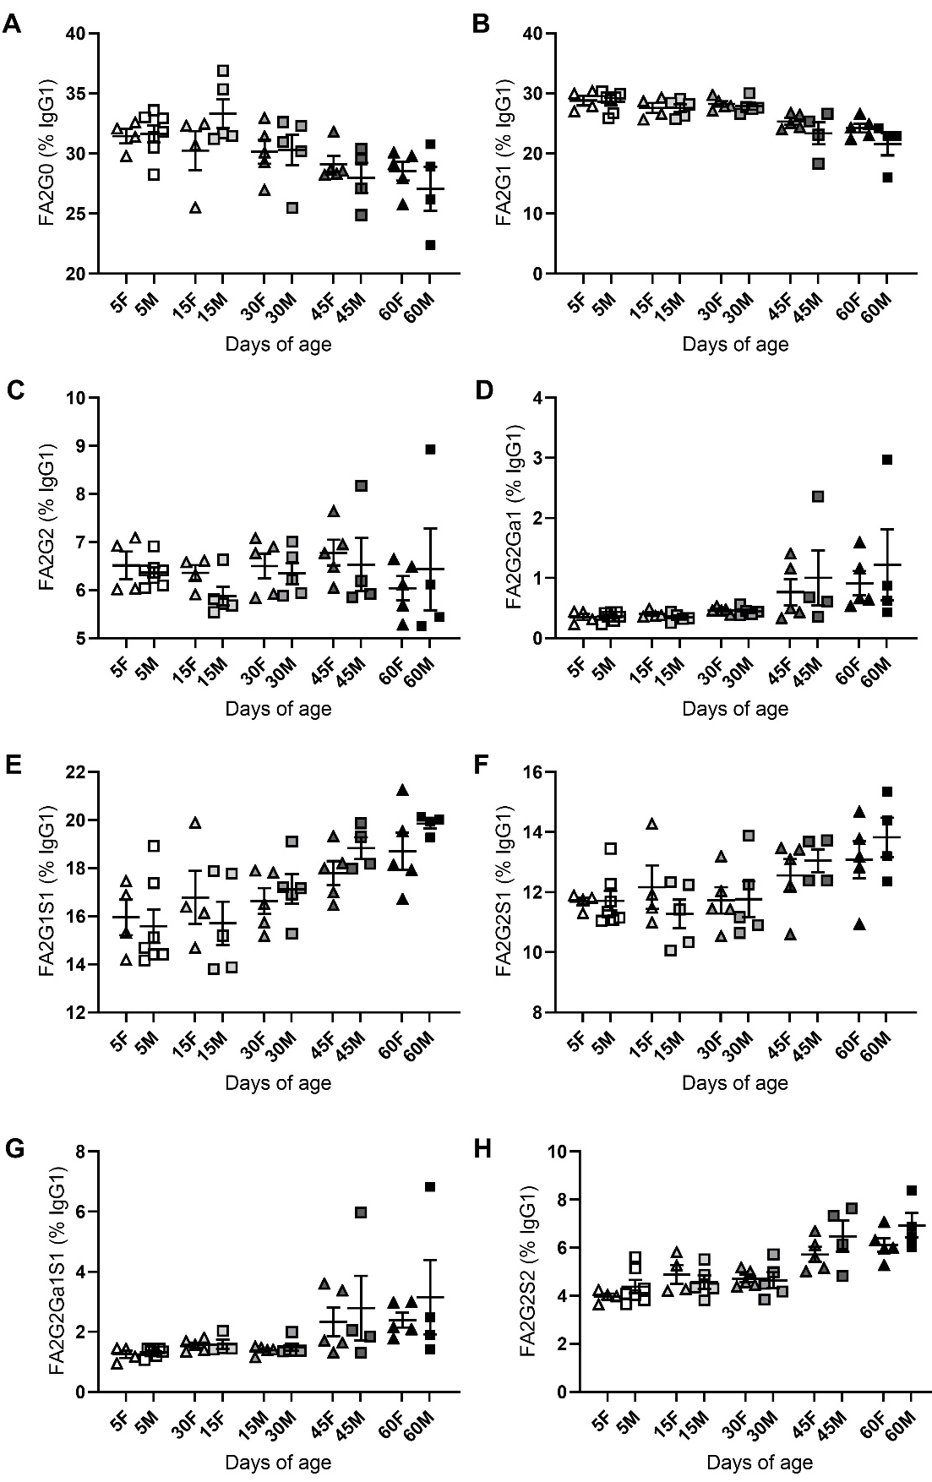

Supplementary Figure 1: Serum IgG1 Fc glycosylation does not significantly differ between male and female mice.
Percent IgG galactosylation and sialylation of in mice from 5-60 days of age. Females (F), Males (M). IgG1- (A) FA2G0, (B) FA2G1, (C) FA2G2, (D) FA2G2Ga1, (E) FA2G1S1 (F) FA2G2S1 (G) FA2G2Ga1S1 (H) FA2G2S2. Means ± SEM are shown. Male and female offspring age: 5 days (n = 11), 15 days (n = 9), 30 days (n = 10), 45 days (n = 9), 60 days (n = 9). Results represent two independently performed experiments. Significance is represented by *P < .05, **P < .01, ***P < .001, ANOVA or Kruskal-Wallis with Dunnett's multiple comparisons test.

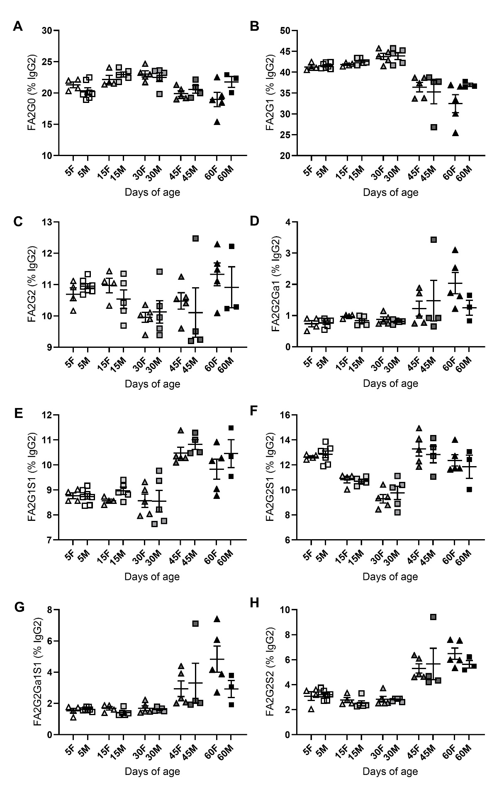
Supplementary Figure 2: Serum IgG2 Fc glycosylation does not significantly differ between male and female mice.
Percent IgG galactosylation and sialylation of in mice from 5-60 days of age. Females (F), Males (M). IgG2- (A) FA2G0, (B) FA2G1, (C) FA2G2, (D) FA2G2Ga1, (E) FA2G1S1 (F) FA2G2S1 (G) FA2G2Ga1S1 (H) FA2G2S2. Means ± SEM are shown. Male and female offspring age: 5 days (n = 11), 15 days (n = 9), 30 days (n = 10), 45 days (n = 9), 60 days (n = 9). Results represent two independently performed experiments. Significance is represented by *P < .05, **P < .01, ***P < .001, ANOVA or Kruskal-Wallis with Dunnett's multiple comparisons test.

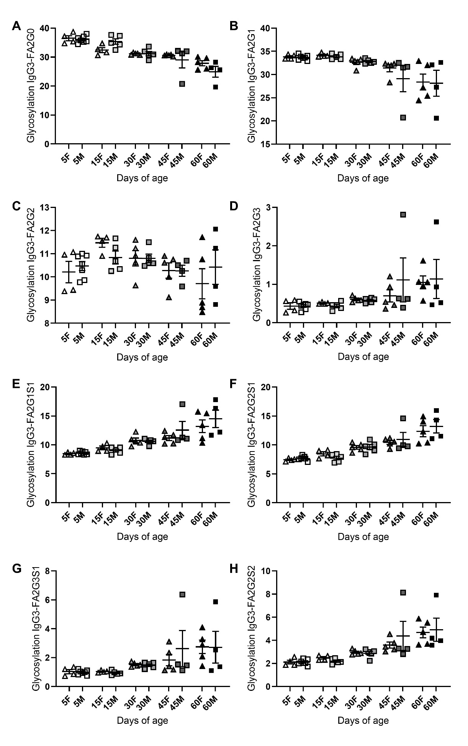
Supplementary Figure 3: Serum IgG1 Fc glycosylation does not significantly differ between male and female mice.
Percent IgG galactosylation and sialylation of in mice from 5-60 days of age. Females (F), Males (M). IgG3- ((A) FA2G0, (B) FA2G1, (C) FA2G2, (D) FA2G2Ga1, (E) FA2G1S1 (F) FA2G2S1 (G) FA2G2Ga1S1 (H) FA2G2S2.. Means ± SEM are shown. Male and female offspring age: 5 days (n = 11), 15 days (n = 9), 30 days (n = 10), 45 days (n = 9), 60 days (n = 9). Results represent two independently performed experiments. Significance is represented by *P < .05, **P < .01, ***P < .001, ANOVA or Kruskal-Wallis with Dunnett's multiple comparisons test.

