Supporting Information S5. Application of Bayes Theorem to the hunting pressure index (HPI).

Background: Thomas Bayes idealized the Bayes theorem (Bayes 1764), which depicts the conditional probability of any event. Given any two events A and B, and the conditional probability of A given B, denoted P (A|B), we can use Bayes Theorem to find P (B|A), the conditional probability of B given A, as follows:
$$P\left(A\right|B)= \frac{P\left(B\right|A). P(A)}{P (B)}$$

Or, in the case our approach:

$$P\left({Eq. 2}_{pot. }\right|{Eq.1}_{am.})= \frac{P\left({Eq. 1}_{am. }\right|{Eq.2}_{pot.}). P({Eq. 2}_{pot.})}{P (B)}$$

Where:
$P\left({Eq. 2}_{pot. }\right|{Eq.1}_{am.})$ (i.e., the posterior degree of belief, having accounted for the degree of hunting inhibition (Eq. 1 _{am.}), is a conditional probability derived from the likelihood of hunting intensification (Eq. 2 _{pot.}) occurring given that hunting inhibition (Eq. 1 _{am.}) is true;
$P\left({Eq. 1}_{am. }\right|{Eq.2}_{pot.})$ is the inverse, i.e. conditional probability derived from the likelihood of hunting inhibition (Eq. 1 _{am.}) occurring given that hunting intensification (Eq. 2 _{pot.}) is true.

As a worked example (see also Supporting Information S4):
Site 1:
Eq. 1 _{am.} = 0.302
Eq. 2 _{pot.} = 0.490
P(B) = ∑ (Eq. 1 _{am.} X Eq. 2 _{pot.}) = 70.51

$P\left({Eq. 2}_{pot. }\right|{Eq.1}_{am.})= \frac{0.302 X 0.490}{70.51}$ = 0.002103

Site 2:
Eq. 1 _{am.} = 0.048
Eq. 2 _{pot.} = 0.473
P(B) = ∑ (Eq. 1 _{am.} X Eq. 2 _{pot.}) = 70.51

$P\left({Eq. 2}_{pot. }\right|{Eq.1}_{am.})= \frac{0.048 X 0.473}{70.51}$ = 0.000329

Therefore, the hunting intensification (P (Eq. 2 _{pot.})) is conditioned on the factors that inhibit hunting (P (Eq. 1_{am.})). The posterior probability value (P$\left({Eq. 2}_{pot. }\right|{Eq.1}_{am.}$) derived from Bayes theorem is more strongly related to the factors that intensify, rather than the factors that reduce hunting pressure. The subtraction of the value “intensification-inhibition” (i.e., the hunting pressure index [HPI]) is correlated with the probability value derived from the Bayes theorem, whereby hunting intensification (Eq. 2_{pot.}) given the factors that inhibit hunting (Eq. 1_{am.}) are true.

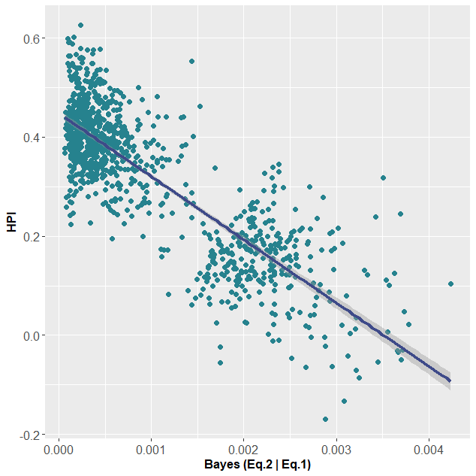

For the statistical analysis we used the R (R Core Team 2020) based on the “BayesTheorem function” (below) of LaplacesDemon package (Statisticat 2020).

R Code of BayesTheorem function:

function (PrA, PrBA)
{if (missing(PrA))
stop("The PrA argument is required.")
if (missing(PrBA))
stop("The PrBA argument is required.")
if (any(PrA < 0) | any(PrA > 1))
stop("PrA is not in the interval [0,1].")
if (any(PrBA < 0) | any(PrBA > 1))
stop("PrBA is not in the interval [0,1].")
PrAB <- (PrBA * PrA)/sum(PrBA * PrA)
class(PrAB) <- "bayestheorem"
return(PrAB)}

References

Bayes, T. 1764. "An Essay Toward Solving a Problem in the Doctrine of Chances", Philosophical Transactions of the Royal Society of London 53, 370-418. [Fascimile available online: the original essay with an introduction by his friend Richard Price].
R Core Team. 2020. R: A language and environment for statistical computing. R Foundation for Statistical Computing.
Statisticat, LLC. (2020). LaplacesDemon: Complete Environment for Bayesian Inference. Bayesian-Inference.com. R package version 16.1.4. [https://web.archive.org/web/20150206004624/http://www.bayesian-inference.com/software].

