Fueling of a marine-terrestrial ecosystem by a major seabird colony
Hentati-Sundberg, J., Raymond C. , Sköld, M., Svensson, O., Gustafsson, B. & Bonaglia, S.

SUPPORTING INFORMATION

Calculation of seabird nutrient emissions

Table S1. N and P concentrations in seabird feaces from a number of previous studies.

Species | Dataset | % N | % P | Reference
Common guillemot |  | 22.2 |  | ¹
Black guillemot |  | 21.6 |  | ¹
King penguin |  | 20.00 | 0.4 | ²
Macaroni penguin 1 |  | 21.54 | 0.362 | ²
Macaroni penguin 2 |  | 21.64 | 0.358 | ²
Commercial guano |  | 11.70 | 2.6 | ³
Tropical seabirds |  | 18.25 | 3.75 | ⁴
Temperate seabirds |  | 9.00 |  | ⁵
Temperate seabirds |  | 18.00 |  | ⁵
Westland petrel | June | 3.00 | 1.62 | ⁶
Westland petrel | November | 12.80 | 1.72 | ⁶
Blue petrel |  | 15.83 | 2.08 | ⁷
Great-winged petrel |  | 16.20 | 1.14 | ⁷
Soft plumaged petrel |  | 17.39 | 1.79 | ⁷
Grey petrel |  | 19.66 | 1.36 | ⁷
White-chinned petrel |  | 14.72 | 2.57 | ⁷
Median |  | 17.70 | 1.67
5 percentile |  | 7.35 | 0.364
95 percentile |  | 21.78 | 3.12

Time series of oxygen concentrations

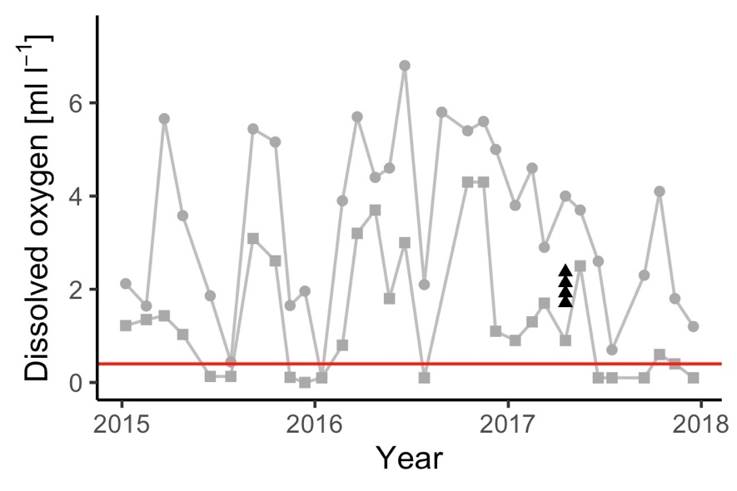
Fig. S1. Timeseries of dissolved oxygen near the seabird colony. Grey points are data for the oceanographic sampling station “BY 38 Karlso” (57.116 N, 17.667 E) at 60 m depth (circles) and 70 m depth (squares), and black triangles are at 65 - 69 m depth at the four stations reported in this study. The red horizontal line indicates 0.4 ml/l oxygen i.e. the level below which no macrofauna will survive⁸.

References

1. Brekke, B. & Gabrielsen, G. W. Assimilation efficiency of adult Kittiwakes and Brünnich’s Guillemots fed Capelin and Arctic Cod. Polar Biol. 14, 279–284 (1994).
2. Lindeboom, H. J. The Nitrogen Pathway in a Penguin Rookery. Ecology 65, 269–277 (1984).
3. Hartz, T. K. & Johnstone, P. R. Nitrogen availability from high-nitrogen-containing organic fertilizers. Horttechnology 16, 39–42 (2006).
4. Smith, J. S. & Johnson, C. R. Nutrient inputs from seabirds and humans on a populated coral cay. Mar. Ecol. Prog. Ser. 124, 189–200 (1995).
5. Gillham, M. E. Ecology of the Pembrokeshire Islands: V. Manuring by the Colonial Seabirds and Mammals, with a Note on Seed Distribution by Gulls. J. Ecol. 44, 429 (1956).
6. Hawke, D. J. Soil P in a forested seabird colony: Inventories, parent material contributions, and N:P stoichiometry. Aust. J. Soil Res. 43, 957–962 (2005).
7. Fugler, S. R. Chemical Composition of Guano of Burrowing Petrel Chicks (Procellariidae) at Marion Island. in Siegfried W.R., Condy P.R., Laws R.M. (eds) Antarctic Nutrient Cycles and Food Webs. Springer, Berlin, Heidelberg 169–179 (1985).
8. Diaz, R. J. & Rosenberg, R. Marine benthic hypoxia: a review of its ecological effects and the behavioural responses of benthic macrofauna. Oceanogr. Mar. Biol. an Annu. Rev. Vol. 33 245–303 (1995).

