Single-cell RNA-seq identifies unique transcriptional landscapes of human Nucleus Pulposus and Annulus fibrosus cells

Lorenzo M. Fernandes^{1,2*}, Nazir M. Khan^{1,2*}, Camila M. Trochez³, Meixue Duan³, Martha E. Diaz-Hernandez^{1,2}, Steven M. Presciutti^{1,2}, Greg Gibson³, Hicham Drissi^{1,2#}

¹Department of Orthopaedics, Emory University, Atlanta, GA, USA
²Atlanta VA Medical Center, Decatur, GA, USA
³Center for Integrative Genomics, Georgia Institute of Technology, Atlanta, GA, USA

*These authors contributed equally

Supplementary Figure. S1
Supplementary Figure. S1. Confirmation of Marker Gene Expression By qPCR analysis: Relative NP marker gene expression as percentage of expression in AF cells. (n=2 with 3 technical replicates).
Supplementary Figure. S2
a
Supplementary Figure. S2. Confirmation of Gene Expression By qPCR analysis: (a) Relative gene expression as percentage of expression in NP cells. (b) Relative gene expression as a percentage of AF cells. (n=2 with 3 technical replicates).
b
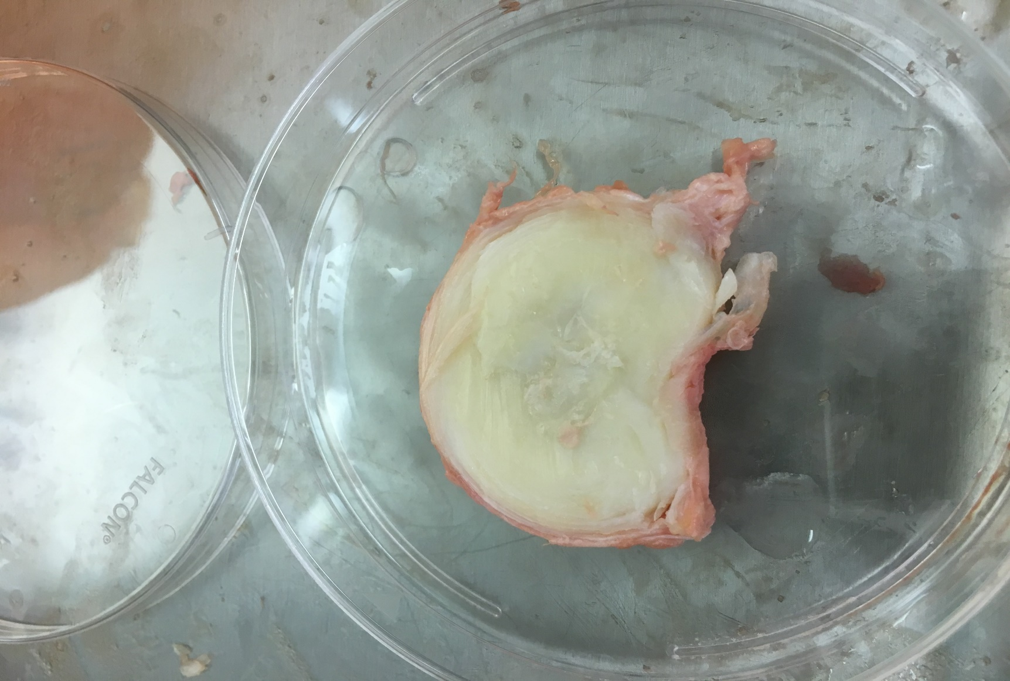
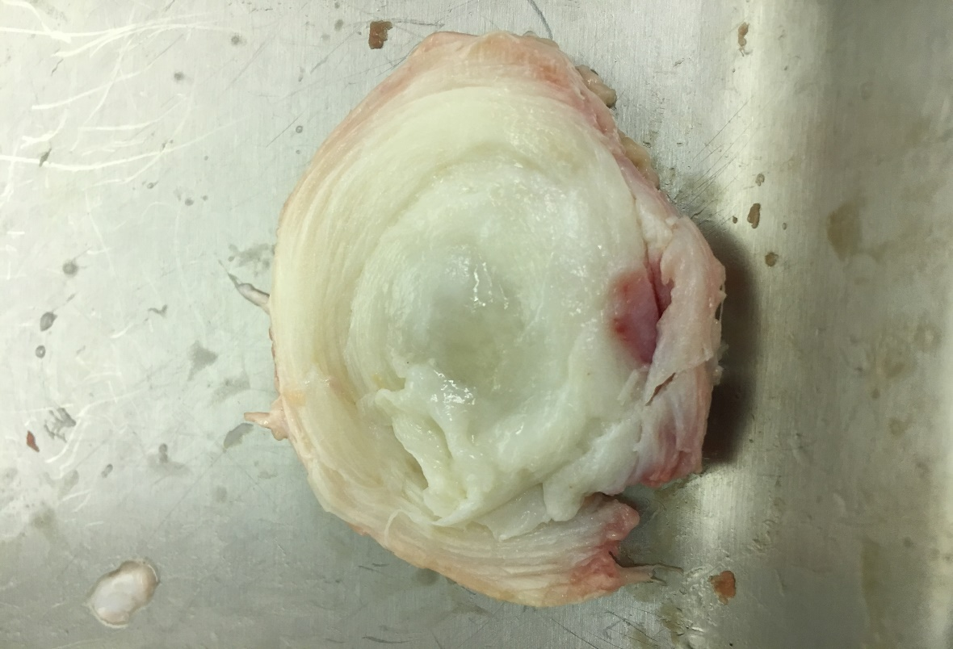
Supplementary Figure. S3
a
35-Year-old Donor Disc
24-Year-old Donor Disc
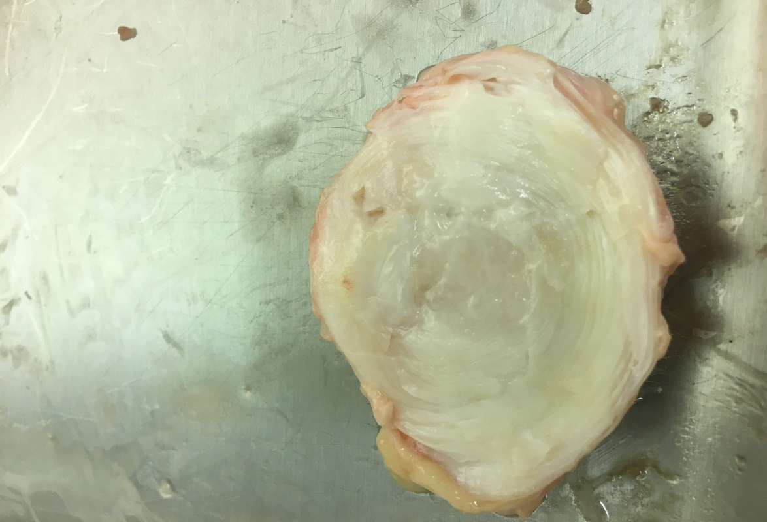
18-Year-old Donor Disc
Supplementary Figure. S3: Images of Discs used for (sc)-RNA-seq analysis and verification by qPCR. (a) Images of 24 year old and 35 year old Donor discs used for (sc)-RNA-seq analysis. (b) Image of 18 year old donor disc used for verification of genes by qPCR.
b
Supplementary Table. S1: List of genes significantly upregulated in AF as compared to NP (shown in excel sheet).

Supplementary Table. S2: List of genes significantly upregulated in NP as compared to AF (shown in excel sheet).

Supplementary Table. S3: NP Network Topology
NP Network Topology
Clustering coefficient | 0.206
Connected components | 3
Network diameter | 9
Network radius | 2
Network centralization | 0.177
Shortest path | 3408 (66%)
Characteristic path length | 3.3
Avg. number of neighbors | 3.806
Number of nodes | 72
Network density | 0.054
Network heterogeneity | 0.906

Supplementary Table. S3: Network Topological Characteristic of interaction network enriched in NP

Supplementary Table. S4: AF Network Topology
AF Network Topology
Clustering coefficient | 0.393
Connected components | 2
Network diameter | 10
Network radius | 1
Network centralization | 0.211
Shortest path | 8936 (94%)
Characteristic path length | 3.849
Avg. number of neighbors | 8.918
Number of nodes | 98
Network density | 0.092
Network heterogeneity | 1.12

Supplementary Table. S4: Network Topological Characteristic of interaction network enriched in AF

Supplementary Table. S5: Number of network clusters in AF
Cluster | Score (Density*#Nodes) | Nodes | Edges | Node IDs
1 | 24.88 | 26 | 311 | DEPDC1, TK1, SHCBP1, CDK1, UBE2C, CCNB2, CCNB1, KIF2C, AURKB, CENPF, CENPE, PLK1, BIRC5, PTTG1, TOP2A, TPX2, FOXM1, NUSAP1, PBK, ASPM, RRM2, CDT1, CENPK, CENPM, UBE2T, KIAA0101
2 | 3.333 | 4 | 5 | SEMA3D, EFNB2, PLXNC1, NTN1
3 | 3 | 5 | 6 | COMP, COL9A3, FMOD, BMP2, ITGA2
4 | 3 | 3 | 3 | LPL, SAA1, APOB

Supplementary Table. S5: Table showing number of clusters, cluster scores, nodes (genes) and edges (interactions) in AF cells. Cluster 1 was the most significant cluster with the highest number of nodes and edges.
Cluster | Score (Density*#Nodes) | Nodes | Edges | Node IDs
1 | 6.667 | 7 | 20 | COL2A1, COL9A3, MATN3, COMP, COL11A1, ACAN, FMOD | 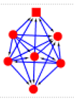
2 | 3 | 7 | 9 | CP, ACKR3, C3, LPL, IGF1, PPARGC1A, SAA1
Supplementary Table. S6: Number of network clusters in NP

Supplementary Table. S6: Table depicting number of clusters, cluster scores, nodes (genes) and edges (interactions) in NP cells. Cluster 1 was the most significant cluster with the largest number of nodes and edges.
Supplementary Table. S7: Transcription factors expressed at higher levels in the AF cells
SN | Gene | Mean FC (Fold change) | Mean FDR  p value
1 | FOXM1 | 6.62 | 8.63E-08
2 | TOX2 | 4.97 | 3.80E-04
3 | MSX1 | 4.86 | 6.94E-10
4 | MAFB | 4.77 | 1.32E-18
5 | HMGA1 | 4.60 | 4.67E-27
6 | ETV4 | 4.45 | 8.91E-05
7 | MSC | 3.85 | 1.50E-04
8 | SOX4 | 3.57 | 4.85E-19
9 | E2F7 | 3.45 | 1.23E-04
10 | FOXQ1 | 3.22 | 8.06E-08
11 | HMGA2 | 3.20 | 1.38E-09
12 | TCF7 | 3.03 | 8.90E-10
13 | ETV1 | 2.42 | 1.58E-10
14 | MXD3 | 2.37 | 2.22E-03
15 | SOX5 | 2.33 | 1.20E-02
16 | NR2F1 | 2.17 | 1.57E-05
17 | SATB1 | 2.17 | 1.85E-04
18 | PRRX1 | 2.08 | 3.31E-17
19 | TBX3 | 2.06 | 1.01E-02
20 | BHLHE41 | 1.96 | 8.92E-03
21 | TEAD2 | 1.93 | 3.59E-03
22 | HOXB2 | 1.88 | 1.72E-06
23 | HES1 | 1.85 | 8.47E-04
24 | SARNP | 1.81 | 1.06E-11
25 | ELK3 | 1.78 | 3.10E-10
26 | ETV5 | 1.77 | 1.54E-05
27 | LCORL | 1.73 | 1.29E-02
28 | JARID2 | 1.72 | 4.31E-03
29 | GPER1 | 1.65 | 9.05E-03
30 | ELK1 | 1.63 | 1.22E-03
31 | NR2F2 | 1.50 | 7.80E-03

Supplementary Table. S7: Table showing a list of transcription factors that were found to be significantly expressed at higher levels in the AF cells compared to NP cells by more than 1.5 fold.

Supplementary Table. S8: Transcription factors expressed at higher levels in the NP Cells
SN | Gene | Mean FC | Mean FDR p-value
1 | ZBTB16 | 3.23 | 1.80E-03
2 | THRB | 2.94 | 1.19E-03
3 | HIVEP3 | 2.87 | 1.13E-02
4 | KLF5 | 2.44 | 4.72E-05
5 | ETV7 | 2.43 | 5.05E-03
6 | TBX18 | 2.34 | 5.23E-09
7 | SNAI1 | 2.28 | 2.31E-04
8 | KLF15 | 2.19 | 1.02E-02
9 | ZBTB10 | 2.05 | 9.98E-05
10 | JDP2 | 2.02 | 9.53E-05
11 | MKX | 1.93 | 5.42E-11
12 | THRA | 1.92 | 2.53E-04
13 | SOX15 | 1.88 | 2.76E-02
14 | VDR | 1.77 | 7.82E-05
15 | PLAGL1 | 1.68 | 3.08E-06
16 | ETS1 | 1.66 | 2.95E-05
17 | TCF7L2 | 1.66 | 7.05E-07
18 | SIX4 | 1.65 | 4.09E-03
19 | CREB3L1 | 1.63 | 3.45E-08
20 | SIX2 | 1.61 | 3.90E-03
21 | FOXP2 | 1.60 | 4.71E-03
22 | PLSCR1 | 1.60 | 2.67E-07
23 | KLF4 | 1.56 | 4.74E-06
24 | STAT5A | 1.56 | 1.23E-02
25 | KLF2 | 1.55 | 3.40E-03
26 | KLF3 | 1.53 | 2.74E-04
27 | EBF1 | 1.53 | 6.02E-05
28 | STAT1 | 1.52 | 6.40E-08
29 | SP110 | 1.50 | 3.93E-03

Supplementary Table. S8: Table showing a list of transcription factors that were found to be significantly expressed at higher levels in the NP cells compared to AF cells by more than 1.5 fold.

Supplementary Table. S9: Thompson grade of donor discs

N | AGE | Race | SEX | Height (inches) | Weight (KG's) | BMI | Thompson grade of Disc
1 | 24 | AA | Female | 70 | 84 | 26.5 | 1
2 | 35 | C | Male | 76 | 78 | 20.9 | 2
3 | 18 | C | Female | 63 | 64 | 25.0 | 1
Supplementary Table. S9: Table showing donor information and Thompson grade of discs.

Supplementary Table S10. Primers information
GENE NAME | NM_ID | Forward Primer | Reverse Primer
LRRC17 | NM_001031692.3 | GCATCCATTCCCCAAGTTCAG | GCCCCAATTACTTCGTGTTAC
AK5 | NM_012093.4 | ACATTATGGAACGTGGAGACC | AACTCTTCCCCTTGCTTCAC
SFRP1 | NM_003012.5 | AAGTGTGACAAGTTCCCCG | TGGCCTCAGATTTCAACTCG
CYTL1 | NM_018659 | TGAAGGACAAAGCACGGAAG | GTAGTCACTGGGATTGGGTATTC
PCLAF  (KIAA0101) | NM_001029989 | AAGCAGACAGTGTTCCAGG | GTGTGATCAGGTTGCAAAGG
COL11A1 | NM_001854 | TTGGTGTTGAGGTTGGGAG | TTCTCCACGCTGATTGCTAC
DSC3 | NM_001941 | TCTATTTTGCACTCGGCCTG | TGTCATTTTCATCCTCTACCCTG
COL2A1 | NM_001844 | AAGACGTGAAAGACTGCCTC | TTCTCCTTTCTGTCCCTTTGG
COL9A3 | NM_001853 | TTCAGTGCCCAAGTATCTGC | TCGCCTTTGTAGCCAGTG
FAM46B | NM_052943 | AGCCGATTCCCATTCACG | GCACATGTAGTCCCTGCTC
FOXM1 | NM_202003 | AGAATTGTCACCTGGAGCAG | TTCCTCTCAGTGCTGTTGATG
KDM4E | NM_001161630 | TCATCTCGCCTACAGTTCTCA | GTTGAAGCCGTGATTGAAGC
ACAN | NM_001135 | TGTGGGACTGAAGTTCTTGG | AGCGAGTTGTCATGGTCTG
FMOD | NM_002023 | CTCTCACACGTTCTCCAACC | GTCATCTTCATACTGGGCCTG
COMP | NM_000095 | GTACCCAACTCAGACCAGAAG | TCACAAGCATCTCCCACAAAG
MSX1 | NM_002448.3 | TCAAGCTGCCAGAAGATGC | TGTGTTTGCGGAGGGTG
EDNRA | NM_001957 | TGCCCTCAGTGAACATCTTAAG | CATCGGTTCTTGTCCATCTCG
PLK1 | NM_005030 | ACAGTTTCGAGGTGGATGTG | GGTTGATGTGCTTGGGAATAC
CDK1 | NM_001786 | ACAAAGGAACAATTAAACTGGCTG | CTGGAGTTGAGTAACGAGCTG
BIRC5 | NM_001012270 | CTTCATCCACTGCCCCAC | ACTTTCTCCGCAGTTTCCTC
C2ORF82  (SNORC) | NM_206895 | TTAACCAGCGCAGTCCTC | GGCTCCTGTGGAACATCG
SAA1 | NM_000331.5 | TTTTCTGCTCCTTGGTCCTG | TGGAAGTATTTGTCTGAGCCG
EFHD1 | NM_025202 | ACTTCGATGGCAAGCTCAG | CACCTTTGACACCCTCCAG
IL15 | NM_000585.5 | ACCGTGGCTTTGAGTAATGAG | AAGCCCTGCACTGAAACA
PCSK2 | NM_002594 | CTGTGGAGTTGGAGTAGCATAC | TGGCGCTGTAGATGTCAATC
ISM1 | NM_080826 | TGAAACCAAAGATCAGCCAGA | TCCTCGATTCTGTTGCAGTG

Supplementary Table S10: Primers sequences (Forward and Reverse) used in PCR

