Physiologic Blood Flow is Turbulent
Supplementary Materials
Khalid M. Saqr^{1*}, Simon Tupin¹, Sherif Rashad^{2,3}, Toshiki Endo³, Kuniyasu Niizuma^{2,3,4}, Teiji Tominaga³, Makoto Ohta¹
¹ Biomedical Flow Dynamics Laboratory, Institute of Fluid Science, Tohoku University, Sendai, 980-8577, Sendai 980-8577, Miyagi, JAPAN.
² Department of Neurosurgical Engineering and Translational Neuroscience, Tohoku University Graduate School of Medicine, Sendai 980-8574, Miyagi, JAPAN.
³ Department of Neurosurgery, Tohoku University Graduate School of Medicine, Sendai 980-8574, Miyagi, JAPAN.
⁴ Department of Neurosurgical Engineering and Translational Neuroscience, Graduate School of Biomedical Engineering, Tohoku University, Sendai 980-8574, Miyagi, JAPAN.

Corresponding author details:
Khalid M. Saqr, Ph.D.
Biomedical Flow Dynamics Laboratory (Ohta-Lab)
Institute of Fluid Science, Tohoku University
Sendai, 980-8577, Sendai 980-8577, Miyagi, JAPAN
*Email: k.saqr@tohoku.ac.jp, kh.saqr@gmail.com

Supplementary figure 1. The ratio of fluctuation to mean velocity $\tilde{u}/U$ shown in colormaps for different arteries based on WFM with dimensionless time and radius in the X and Y axes, respectively.

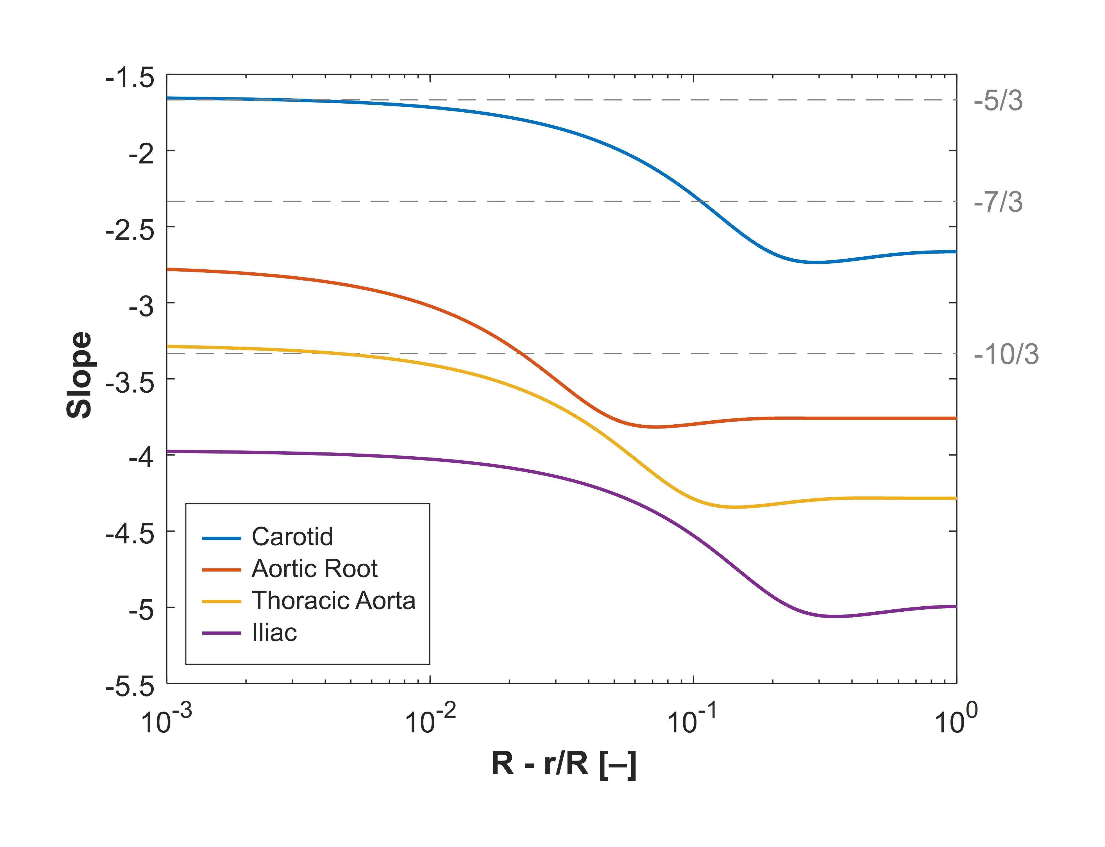
Supplementary Figure 2. Radial profiles of kinetic energy cascade slope of four arteries based on the exact solution of WFM.

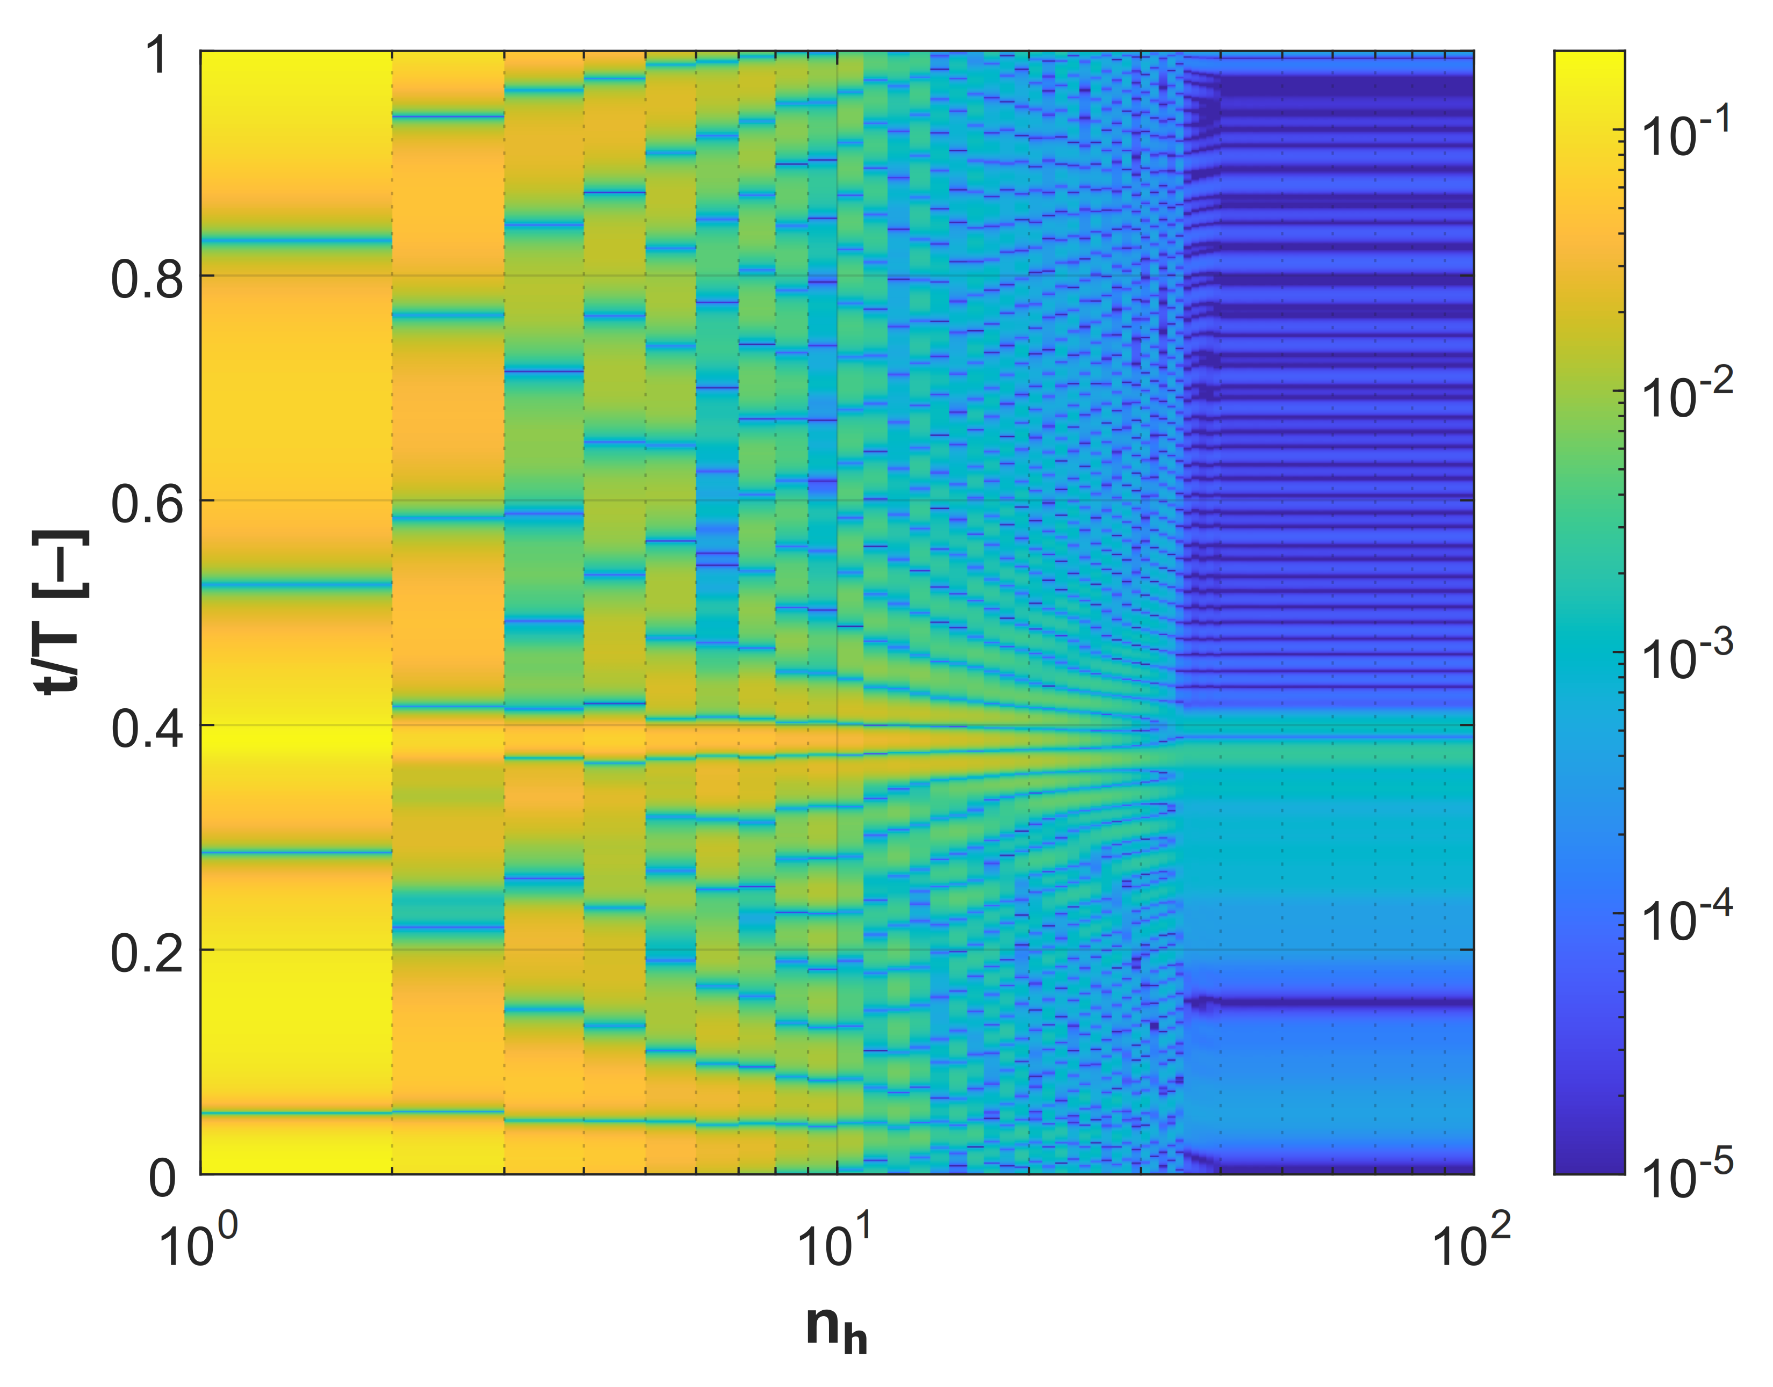
Supplementary figure 3. Color map of $\lim_{n→100}\left|\frac{{\dot{m}}_{t}-{\dot{m}}_{[0:n]}}{{\dot{m}}_{t}}\right|$on x-axis and non-dimensional time on y-axis. (aortic root). Similar results were obtained from other arteries confirming that harmonics higher than $n=40$ could be neglected.

