Pentagalloylglucose from Schinus terebinthifolia inhibits growth of carbapenem-resistant Acinetobacter baumannii

Micah Dettweiler, Lewis Marquez, Michelle Lin, Anne M. Sweeney-Jones, Bhuwan Khatri Chhetri, Daniel V. Zurawski, Julia Kubanek, Cassandra L. Quave

Supplementary Information

Contents
Supplementary Figure S1. Growth inhibition of CR A. baumannii AR-Bank #0035 by 1496 extracts from the QNPL chemical library (plotted by extract identification number ranging from 1-1881) at 256 µg/mL. 3
Supplementary Figure S2. HPLC-FTMS ESI-negative chromatograms for (A) pentagalloyl glucose standard, (B) 429C-F8-PF11-SF4. 4
Supplementary Table S1. Comparison of ¹H NMR data 5
Supplementary Figure S3. ¹H NMR spectrum acquired in CD₃OD (600 MHz). 7
Supplementary Figure S4. ¹H NMR spectrum acquired in DMSO-d₆ (800 MHz). 8
Supplementary Figure S5. ¹³C NMR spectrum acquired in DMSO-d₆ (800 MHz). 9
Supplementary Figure S6. COSY NMR spectrum acquired in DMSO-d₆ (800 MHz). 10
Supplementary Figure S7. HSQC NMR spectrum acquired in DMSO-d₆ (800 MHz). 11
Supplementary Figure S8. HMBC NMR spectrum acquired in DMSO-d₆ (800 MHz). 12
Supplementary Figure S9. Stained A. baumannii biofilm in pentagalloyl glucose treatment wells in A) biofilm formation inhibition experiment (64 µg/mL PGG) and B) biofilm eradication experiment (256 µg/mL PGG). C) shows staining of the media blank and D) shows staining of the vehicle control (DMSO). 13
Supplementary Figure S10. PGG was evaluated for potential activity in the inhibition of A) biofilm formation and B) eradication of established biofilm. No significant difference was noted between PGG and the vehicle control (DMSO) at any of the test concentrations (0.5-64 µg/mL for biofilm inhibition; 2-256 µg/mL for eradication experiments). 14
Supplementary Figure S11. Growth inhibition of A. baumannii AB5075 by PGG in TSA and CAMHA before and after iron (II) and iron (III) supplementation. 15
Supplementary Figure S12. Optical density readings of PGG in 1 mM iron (II) and iron (III) sulfate supplemented media at 600 nm. 16
References 17

Supplementary Figure S1. Growth inhibition of CR A. baumannii AR-Bank #0035 by 1496 extracts from the QNPL chemical library (plotted by extract identification number ranging from 1-1881) at 256 µg/mL.

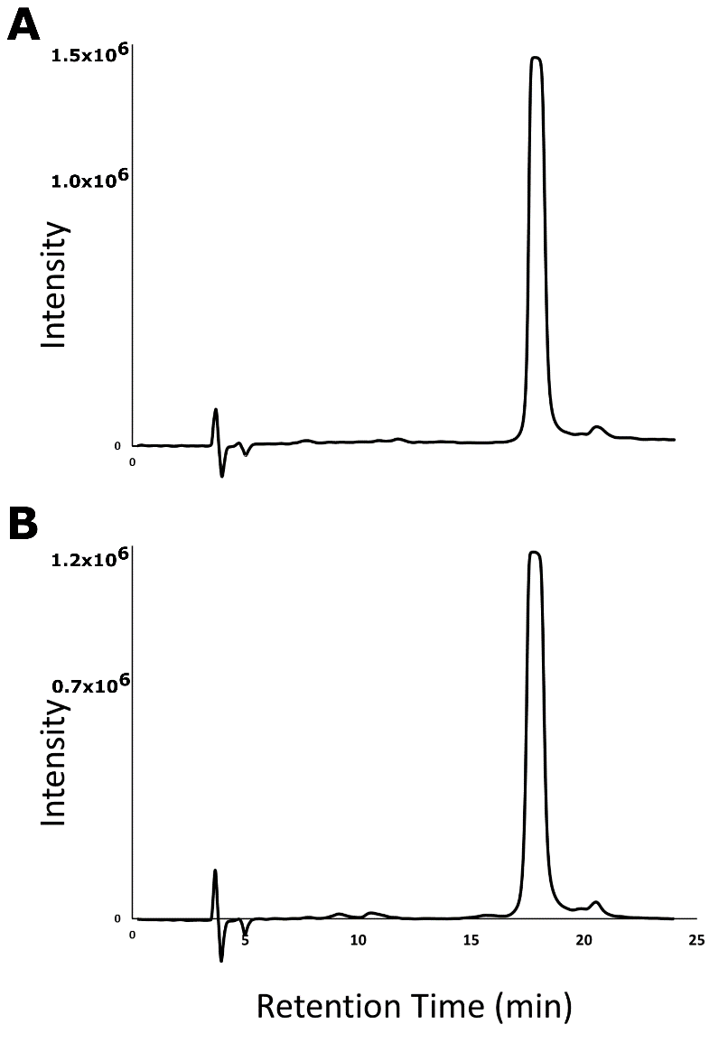

Supplementary Figure S2. HPLC-FTMS ESI-negative chromatograms for (A) pentagalloyl glucose standard, (B) 429C-F8-PF11-SF4.

Supplementary Table S1. Comparison of ¹H NMR data
Position | δ_{H} in CD₃OD, 600 MHz (experimental) | δ_{H} in CD₃OD, 600 MHz (literature) (1) | δ_{H} in DMSO-d₆, 800 MHz (experimental) | δ_{H} in DMSO-d₆, 600 MHz (literature) (2)
Glucose moiety
1 | 6.23, d (8.2) | 6.23, d (8.3) | 6.37, d (8.2) | 6.36, d (9.5)
2 | 5.59, m (overlapped) | 5.58, dd (9.6, 8.3) | 5.42, m (overlapped) | 5.45, t (9.5)
3 | 5.90, t (9.7) | 5.89, t (9.6) | 5.95, t (9.6) | 5.96, t (9.5)
4 | 5.62, m (overlapped) | 5.61, t (9.6) | 5.44, m (overlapped) | 5.94, t (9.5)
5 | 4.39 m (overlapped) | 4.40, m | 4.58, d (9.9) | 4.57, m
6a | 4.51, d (12.5) | 4.51, d (12.2) | 4.30, m | 4.59, m
6b | 4.39 m (overlapped) | 4.37, dd (12.2, 4.2) | 4.30, m | 4.30, m
Galloyl moieties
 | 6.90, 6.95, 6.98, 7.05, 7.11, s (each 2H) | 6.89, 6.94, 6.97, 7.04, 7.10, s (each 2H) | 6.77, 6.82, 6.85, 6.91, 6.97, s (each 2H) | 6.90, s, 10H

Supplementary Table S2. Comparison of ¹³C NMR data
Position | δ_{C} in DMSO-d₆, 800 MHz (experimental) | δ_{C} in DMSO-d₆, 600 MHz (literature) (2)
-C=O | 164.0-165.5 | 164.4-165.9
galloyl: C-3′, C-5′ | 145.4-145.7 | 145.8-146.1
galloyl: C-4′ | 138.8-139.8 | 139.2-140.1
galloyl: C-1′ | 117.3-119.0 | 117.9-119.4
galloyl: C-2′, C-6′ | 108.7-109.0 | 109.2-109.5
glucose: C-1 | 91.7 | 92.2
glucose: C-2 to C-5 | 67.8-72.1 | 68.2-72.6
glucose: C-6 | 61.5 | 61.9

Supplementary Figure S3. ¹H NMR spectrum acquired in CD₃OD (600 MHz).

Supplementary Figure S4. ¹H NMR spectrum acquired in DMSO-d₆ (800 MHz).

Supplementary Figure S5. ¹³C NMR spectrum acquired in DMSO-d₆ (800 MHz).

Supplementary Figure S6. COSY NMR spectrum acquired in DMSO-d₆ (800 MHz).

Supplementary Figure S7. HSQC NMR spectrum acquired in DMSO-d₆ (800 MHz).

Supplementary Figure S8. HMBC NMR spectrum acquired in DMSO-d₆ (800 MHz).

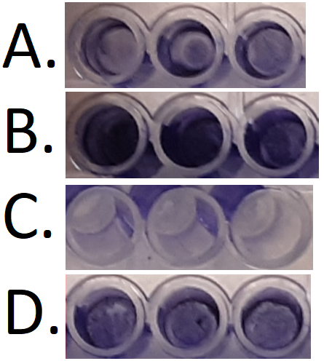

Supplementary Figure S9. Stained A. baumannii biofilm in pentagalloyl glucose treatment wells in A) biofilm formation inhibition experiment (64 µg/mL PGG) and B) biofilm eradication experiment (256 µg/mL PGG). C) shows staining of the media blank and D) shows staining of the vehicle control (DMSO).

Supplementary Figure S10. PGG was evaluated for potential activity in the inhibition of A) biofilm formation and B) eradication of established biofilm. No significant difference was noted between PGG and the vehicle control (DMSO) at any of the test concentrations (0.5-64 µg/mL for biofilm inhibition; 2-256 µg/mL for eradication experiments).

Supplementary Figure S11. Growth inhibition of A. baumannii AB5075 by PGG in TSA and CAMHA before and after iron (II) and iron (III) supplementation.

Supplementary Figure S12. Optical density readings of PGG in 1 mM iron (II) and iron (III) sulfate supplemented media at 600 nm.

References
1. Kant R, Yen CH, Lu CK, Lin YC, Li JH, Chen YMA. 2016. Identification of 1,2,3,4,6-Penta-O-galloyl-beta-D-glucopyranoside as a Glycine N-Methyltransferase Enhancer by High-Throughput Screening of Natural Products Inhibits Hepatocellular Carcinoma. International Journal of Molecular Sciences 17.
2. Zhao WH, Gao CC, Ma XF, Bai XY, Zhang YX. 2007. The isolation of 1,2,3,4,6-penta-O-galloyl-beta-D-glucose from Acer truncatum Bunge by high-speed counter-current chromatography. Journal of Chromatography B-Analytical Technologies in the Biomedical and Life Sciences 850:523-527.

