Urine Metabolomics Based Prediction Model Approach for Radiation Exposure
Ritu Tyagi†, Kiran Maan†, Subash Khushu¹, Poonam Rana*
Metabolomics Research Facility, Institute of Nuclear Medicine and Allied Sciences (INMAS), DRDO, Delhi, India, ¹NMR Research Centre, Institute of Nuclear Medicine and Allied Sciences (INMAS), DRDO, Delhi, India
† Both the authors have an equal contribution.

*Corresponding Author:
Dr. Poonam Rana, Ph. D
Metabolomics Research Facility
Institute of Nuclear Medicine and Allied Sciences (INMAS), DRDO
S. K Mazumdar Road, Timarpur, Delhi-54, India
Tel: 91-11-23905319
Email address: poonam@inmas.drdo.in

Legend for Supplementary Figure 1:
Representative ¹H NMR spectra of urine from control and radiation group

Legend for Supplementary Figure 2:
Representative PCA loading plot (a) 0.5-4.5 ppm and (b) 6.0-9.5 ppm based on ¹H NMR spectra of urine sample at 24 h from control and irradiated mice

Legend for Supplementary figure 3
Representative ROC curve analysis based on logistic regression analysis for individual metabolite (a-f), all four individual (g-j) and combined (k) predictive model.
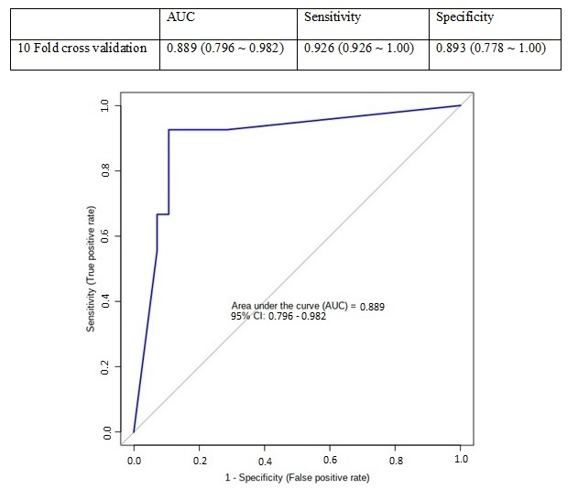

Legend for Supplementary Figure 4
ROC curve with 10 fold cross validation

Supplementary Figure 5:
Sample size estimation analysis depicting the number of animals required for the study. The x-axis represents the predicted power and the y-axis represents the sample size (per group).

