Title: Diagnostic performance of PI-RADS version 2.1 compared to version 2.0 for detection of peripheral and transition zone prostate cancer

Authors: Madhuri Monique Rudolph, Alexander Daniel Jacques Baur, Hannes Cash, Matthias Haas, Samy Mahjoub, Alexander Hartenstein, Charlie Alexander Hamm, Nick Lasse Beetz, Frank Konietschke, Bernd Hamm, Patrick Asbach, Tobias Penzkofer

Supplementary tables

Supplementary Table 1: Per-reader ROC-AUC for Gleason Score ≥7 tumor detection in PI-RADS v2.0 and v2.1 regarding overall PI-RADS scores per lesion and subscores for T2WI and DWI. Differences in area under the ROC curves (AUC) were not significant. v: version. T2WI: T2 weighted imaging. DWI: diffusion weighted imaging.
 |  | Version 2.0 |  |  | Version 2.1
 |  | Overall score | T2W score | DWI score | Overall score | T2W score | DWI score
PZ | Reader 1 | 0.76 | 0.79 | 0.78 | 0.77 | 0.79 | 0.76
PZ | Reader 2 | 0.73 | 0.70 | 0.73 | 0.69 | 0.70 | 0.68
PZ | Reader 3 | 0.80 | 0.82 | 0.82 | 0.74 | 0.72 | 0.76
TZ | Reader 1 | 0.82 | 0.82 | 0.81 | 0.82 | 0.83 | 0.76
TZ | Reader 2 | 0.87 | 0.87 | 0.85 | 0.87 | 0.88 | 0.81
TZ | Reader 3 | 0.69 | 0.69 | 0.71 | 0.69 | 0.69 | 0.69

Supplementary Table 2: ROC-AUC for PI-RADS v2.0 and v2.1 with and without DCE. Differences between mpMRI and bpMRI were not significant. v: version. DCE: dynamic contrast enhanced imaging. mpMRI: multiparametric MRI. bpMRI: biparametric MRI.
 |  | AUC | p-value
PI-RADS v2.0 | bpMRI | 0.70 | 0.09
PI-RADS v2.0 | mpMRI | 0.81 | 0.09
PI-RADS v2.1 | bpMRI | 0.71 | 0.41
PI-RADS v2.1 | mpMRI | 0.76 | 0.41

Supplementary figures

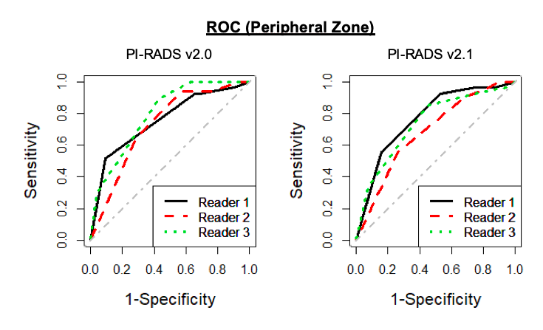
Supplementary Figure 1: Per-reader ROC for Gleason Score ≥7 tumor detection in PI-RADS v2.0 and v2.1 regarding overall PI-RADS scores per lesion. Differences in area under the ROC curves (AUC) were not significant. v: version.

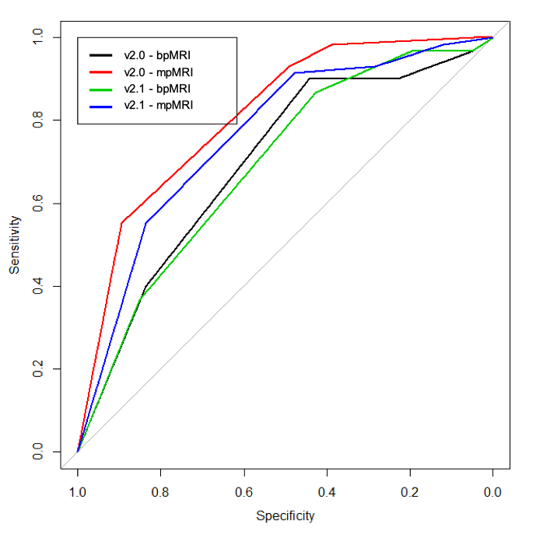
Supplementary Figure 2: ROC for PI-RADS version 2.0 and 2.1 with and without DCE. Differences in area under the ROC curves (AUC) were not significant. v: version.

