Supplementary Data

Antifibrotic treatment improves clinical outcomes in patients with idiopathic pulmonary fibrosis: a propensity-score matching analysis

Jieun Kang^{1,2}, Minkyu Han³, Jin Woo Song¹
¹Department of Pulmonary and Critical Care Medicine, Asan Medical Center, University of Ulsan College of Medicine, Seoul, Republic of Korea
²Division of Pulmonary and Critical Care Medicine, Department of Internal Medicine, Ilsan Paik Hospital, Inje University College of medicine, Ilsan, Republic of Korea
³Department of Clinical Epidemiology and Biostatistics, Asan Medical Center, Seoul, Republic of Korea

Supplementary Table S1. Comparison of baseline characteristics between patients included in the matched cohort and those not included
 | Total | Patients included in the matched cohort | Patients not included in the matched cohort | p-value
No. of patients | 1213 | 948 | 265
Age, years | 66.4 ± 8.0 | 65.8 ± 8.0 | 68.7 ± 7.5 | <0.001
Male | 995 (82.0) | 785 (82.8) | 210 (79.2) | 0.205
BMI | 24.3 ± 3.1 | 24.6 ± 2.9 | 23.3 ± 3.5 | <0.001
Smoking status |  |  |  | 0.408
Current | 148 (12.2) | 118 (12.4) | 30 (11.3)
Former | 777 (64.1) | 613 (64.7) | 164 (61.9)
Never | 288 (23.7) | 217 (22.9) | 71 (26.8)
FVC | 68.6 ± 16.2 | 67.1 ± 15.2 | 74.1 ± 18.5 | <0.001
DL_{CO} | 55.2 ± 17.7 | 53.3 ± 16.6 | 62.7 ± 19.6 | <0.001
Charlson Comorbidity Index | 1.9 ± 1.1 | 1.8 ± 1.1 | 1.9 ± 1.0 | 0.474
Data are presented as mean ± standard deviation or number (%) unless otherwise indicated.
BMI. body mass index; DL_{CO}, diffusing capacity of the lung for carbon monoxide; FVC, forced vital capacity; No., number.

Supplementary Table S2. Causes of the first respiratory-related hospitalisation in patients with idiopathic pulmonary fibrosis
 | Total | Antifibrotic | No antifibrotic
Number of patients | 280 | 105 | 175
Acute exacerbation | 123 (43.9) | 46 (43.8) | 77 (44.0)
Pneumonia | 95 (33.9) | 39 (37.1) | 56 (32.0)
Disease progression | 27 (9.6) | 7 (6.7) | 20 (11.4)
Pneumothorax | 23 (8.2) | 11 (10.5) | 12 (6.9)
Mycobacterial | 5 (1.8) | 0 (0.0) | 5 (2.9)
Pulmonary embolism | 4 (1.4) | 1 (1.0) | 3 (1.7)
Others* | 3 (1.1) | 1 (1.0) | 2 (1.1)
Data are presented as number (%).
*Others included acute exacerbation of asthma (antifibrotic group), diffuse alveolar haemorrhage, and radiation pneumonitis.

Supplementary Table S3. Comparison of baseline characteristics between the antifibrotic and no antifibrotic groups of patients including those who received sildenafil
 | Unmatched groups |  |  | Matched groups
 | Antifibrotic | No antifibrotic | p-value | Antifibrotic | No antifibrotic | p-value
No. of patients | 608 | 751 |  | 530 | 530
Age, years | 65.7 ± 7.8 | 67.0 ± 8.1 | 0.002 | 65.7 ± 7.6 | 65.9 ± 8.1 | 0.699
Male | 503 (82.7) | 602 (80.2) | 0.235 | 438 (82.6) | 433 (81.7) | 0.748
BMI | 24.9 ± 3.0 | 23.8 ± 3.1 | <0.001 | 24.8 ± 2.8 | 24.5 ± 3.0 | 0.176
Smoking status |  |  | 0.895 |  |  | 0.366
Current | 73 (12.0) | 84 (11.2) |  | 63 (11.9) | 60 (11.3)
Former | 389 (64.0) | 485 (64.6) |  | 333 (62.8) | 354 (66.8)
Never | 146 (24.0) | 182 (24.2) |  | 134 (25.3) | 116 (21.9)
FVC | 65.2 ± 14.0 | 69.5 ± 18.1 | <0.001 | 67.1 ± 13.4 | 67.0 ± 16.7 | 0.927
DL_{CO} | 51.0 ± 16.1 | 56.0 ± 20.0 | <0.001 | 53.3 ± 15.2 | 53.3 ± 18.0 | 0.963
Charlson Comorbidity Index | 1.8 ± 1.0 | 1.9 ± 1.1 | 0.399 | 1.8 ± 1.0 | 1.8 ± 1.1 | 0.977
Sildenafil treatment | 67 (11.0) | 79 (10.5) | 0.792 | 59 (11.1) | 61 (11.5) | 0.923
Data are presented as mean ± standard deviation or number (%) unless otherwise indicated.
BMI, body mass index; DL_{CO}, diffusing capacity of the lung for carbon monoxide; FVC, forced vital capacity; No., number.

Supplementary Figure S1. Forest plot demonstrating the risk of clinical outcomes in the study subjects including those who received sildenafil.
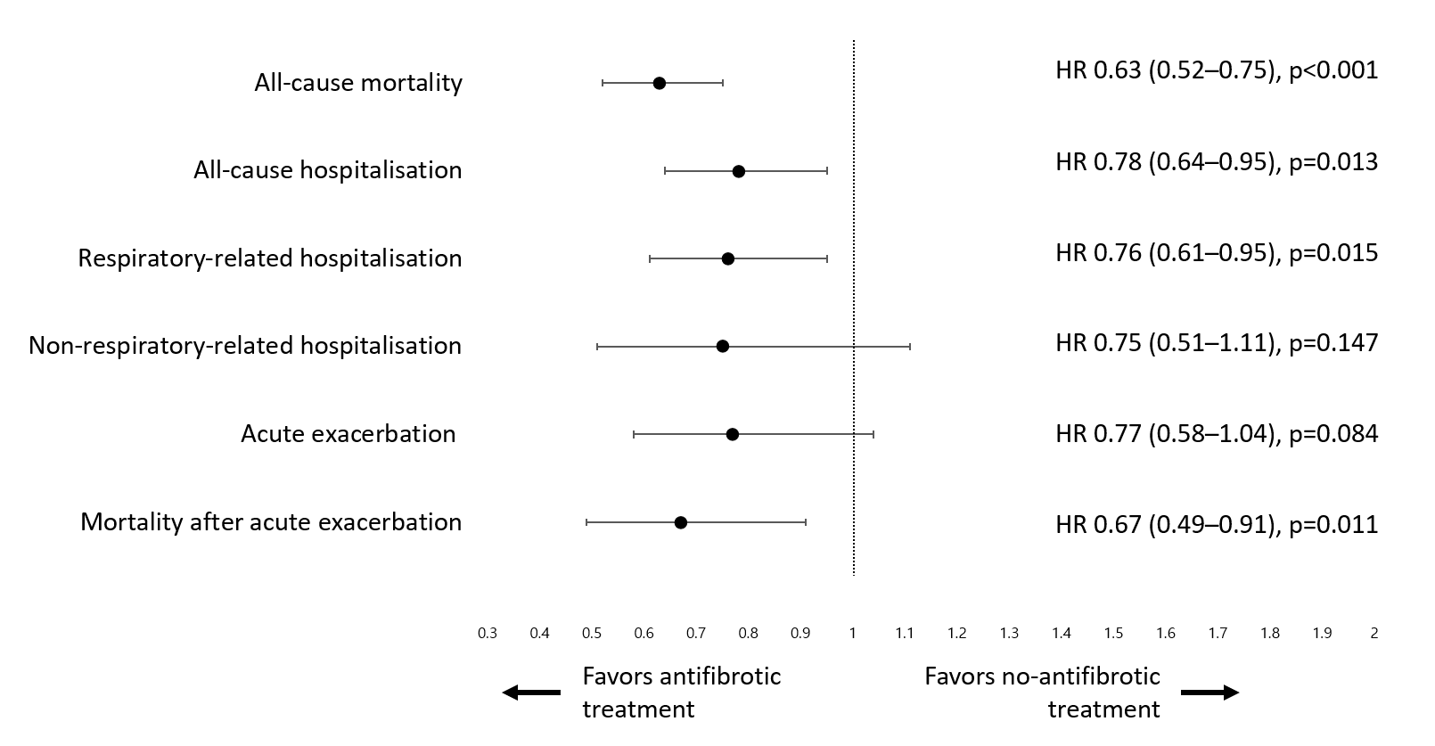
Hazard ratios were calculated from univariable Cox proportional hazard analyses. HR, hazard ratio.

