Supplementary information for manuscript:

Genipin inhibits rotavirus-induced diarrhea by suppressing viral replication and regulating inflammatory responses

Jong-Hwa Kim, Kiyoung Kim, and Wonyong Kim*

Fig. S1. Cytotoxicity effect of genipin on treatment. (A) RAW264.7, (B) MA104, (C) Caco-2 monolayer cells in 96-well plates were treated with genipin at serial concentrations (0, 10, 50, 100, 150, 160, 180, and 200 µM/mL). Cell viability was determined by MTT assay. Control cells were inoculated with media only. Data are presented as mean ± SEM; *p < 0.01, **p < 0.005, ***p < 0.001.

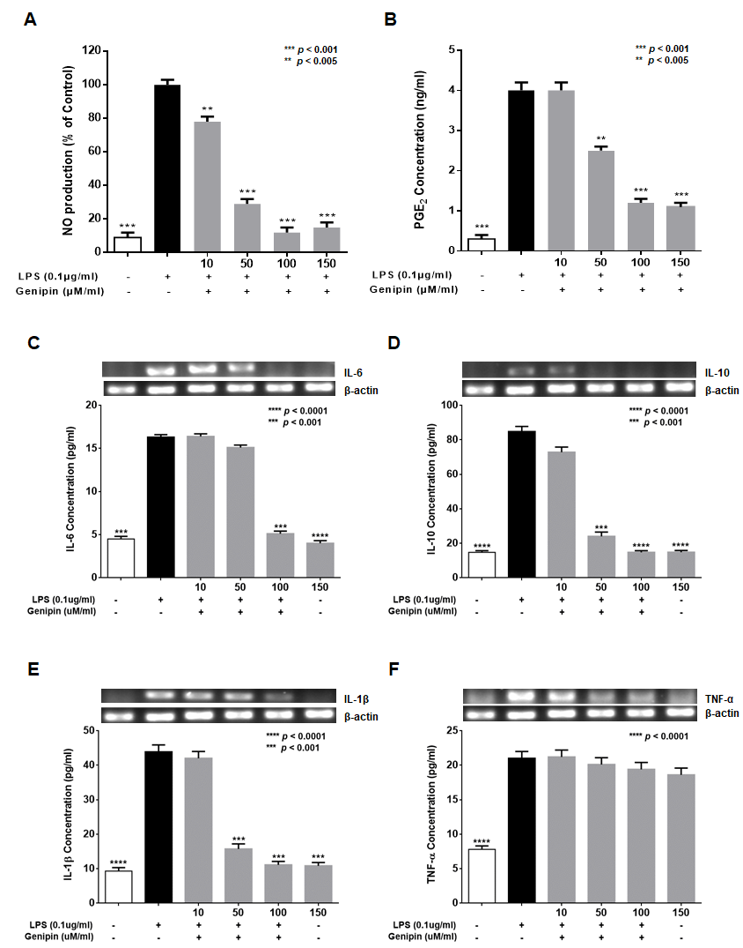
Fig. S2. Suppression effects of genipin on NO, PGE2, and pro-inflammatory cytokines in RAW 264.7 cells. Genipin suppressed LPS-induced (A) NO and (B) PGE₂ in RAW 264.7 cells. Cells were treated with 0.1 μg/μL of LPS in the presence or absence of genipin, and the supernatant was collected to evaluate accumulated NO and PGE₂. Effect of genipin on suppression of LPS-induced production of proinflammatory cytokines, (C) IL-6, (D) IL-10, (E) IL-1β, and (F) TNF-α in RAW264.7 macrophage cells. RAW264.7 cells were pre-treated with 0.1 μg/μL of LPS in the presence of genipin at different concentrations (10, 50, 100, and 150 µM/mL) and incubated for 24 h. Untreated control cells were inoculated with fresh media only. Data are presented as mean ± SEM; **p<0.001, ***p<0.005, ****p<0.0001.

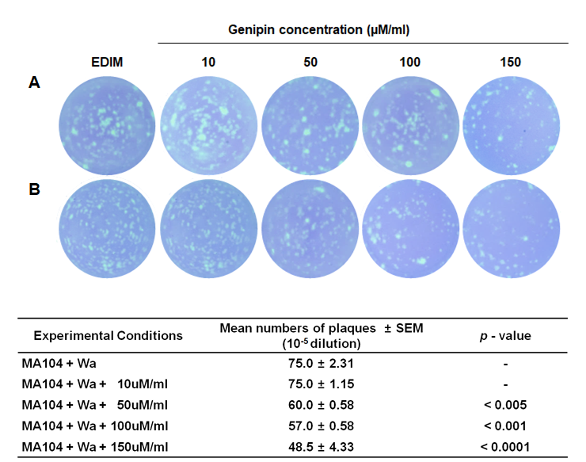
Fig. S3. Inhibitory activity of genipin against rotavirus by plaque assay. MA104 cells were treated with genipin (A) before viral infection and (B) after viral infection at 10, 50, 100, and 150 µM/mL. The human rotavirus Wa-infected group and untreated cells were used as positive controls.

