SUPPLEMENTARY INFORMATION
bFGF blockade reduces intraplaque angiogenesis and macrophage infiltration in atherosclerotic vein graft lesions in ApoE3*Leiden mice
Laura Parma^{1,2}, Hendrika A. B. Peters^{1,2}, Thijs J. Sluiter^{1,2}, Karin H. Simons^{1,2}, Paolo Lazzari³, Margreet R. de Vries^{1,2} and Paul H.A. Quax^{1,2}
Correspondence should be addressed to P.H.A. Quax (P.H.A.Quax@lumc.nl)
P.H.A Quax
Department of Vascular Surgery, D6-33
Leiden University Medical Center
PO Box 9600, 2300 RC Leiden, The Netherlands
Tel: +31 71 526 1584; Fax: +31 71 526 6750; Email: P.H.A.Quax@lumc.nl

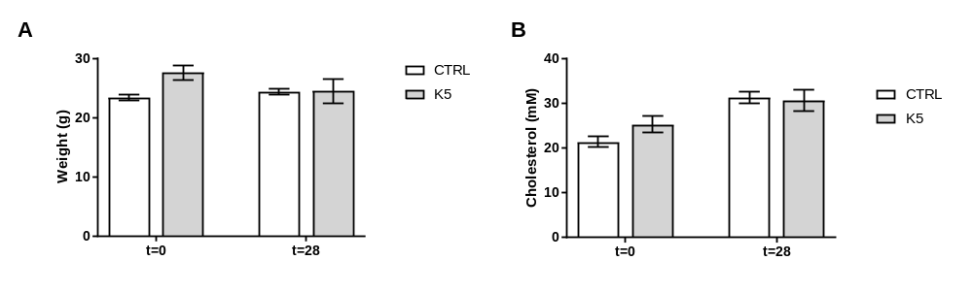
Supplementary figure 1. Bodyweight and cholesterol levels. (A). Bodyweight before (t=0) and 28 days after surgery (t=28) of control and K5 treated mice. (B). Plasma cholesterol levels before (t=0) and 28 days after surgery (t=28) of control and K5 treated mice.

Supplementary information 2. Representative pictures of femoral artery cuffs of ctrl and K5 treated groups stained for DAPI (blue), αSMA (green) and Cleaved caspase 3 (magenta).

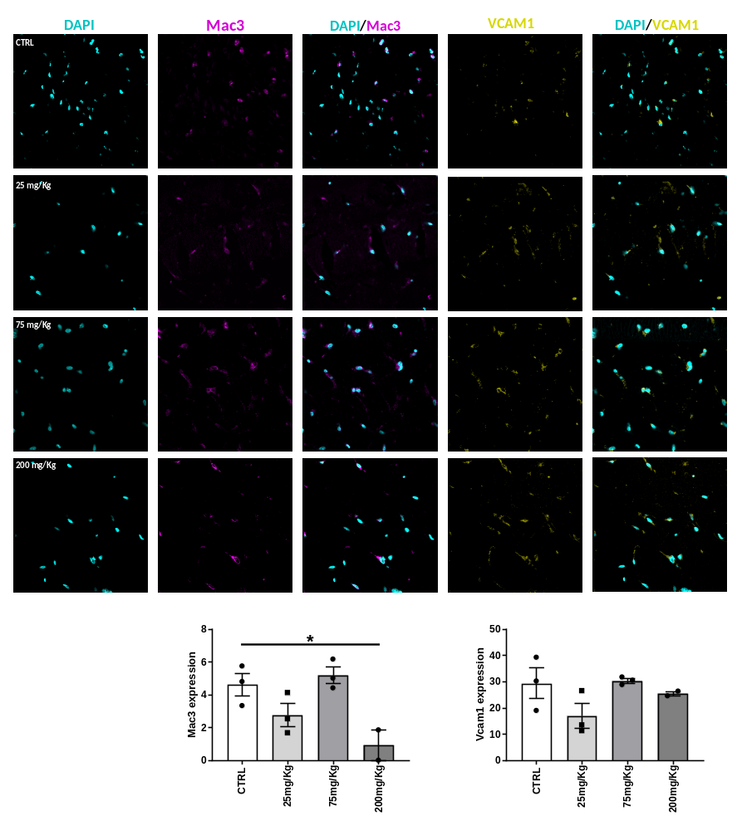
Supplementary information 3. Representative pictures of Matrigel plugs of ctrl and K5 treated groups stained for DAPI (cyan), Mac3 (magenta) and VCAM-1 (yellow) and respective quantifications. Data are presented as mean±SEM *p<0.05; by one way Anova.

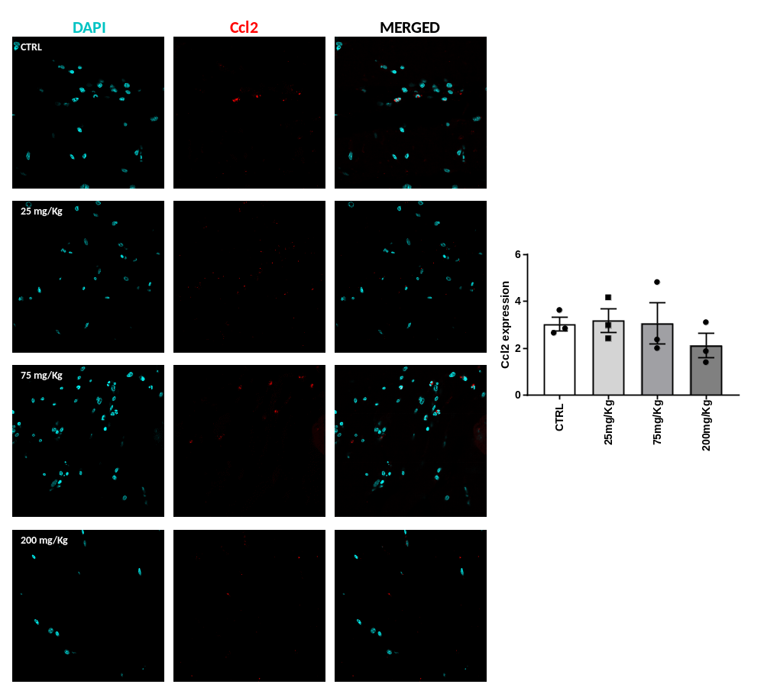
Supplementary information 4. Representative pictures of Matrigel plugs of ctrl and K5 treated groups stained for DAPI (cyan) and CCL-2 (red) and respective quantification. No significant differences could be observed by one way Anova.

