Supplementary information
Application of smart solid lipid nanoparticles to enhance efficacy of 5-Fluorouracil in the treatment of colorectal cancer.
Authors:
Taylor Smith¹, Kevin Affram¹, Ebony L. Nottingham¹, Bo Han², Felix Amissah³, Sunil Krishnan⁴, Jose Trevino⁵, Edward Agyare¹*

Affiliations:
¹ College of Pharmacy and Pharmaceutical Sciences, Florida A & M University, Tallahassee, Florida, USA
² Department of Surgery, Keck School of Medicine University of Southern California, Los Angeles, California, USA
³ College of Pharmacy, Ferris State University, Big Rapids, Michigan, USA
⁴ Mayo Clinic, Jacksonville, Florida, USA
⁵ Department of Surgery, College of Medicine, University of Florida, Gainesville, Florida, USA

Supplementary Figure S1

Supplementary Figure S2

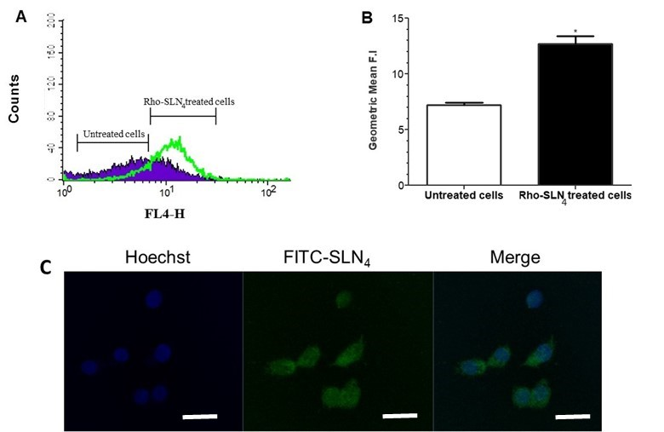

Supplementary Figure S3

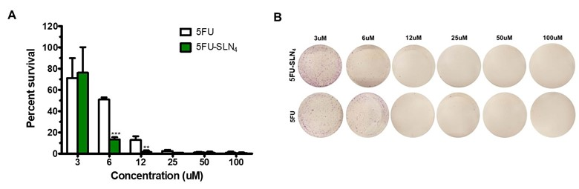

Supplementary Figure S4

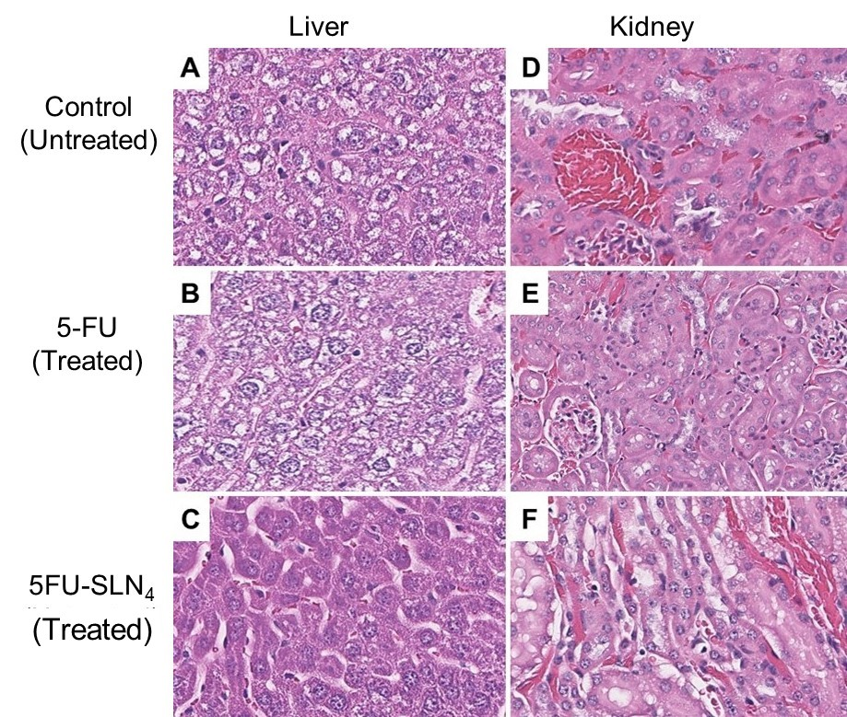

Supplementary Figure S5

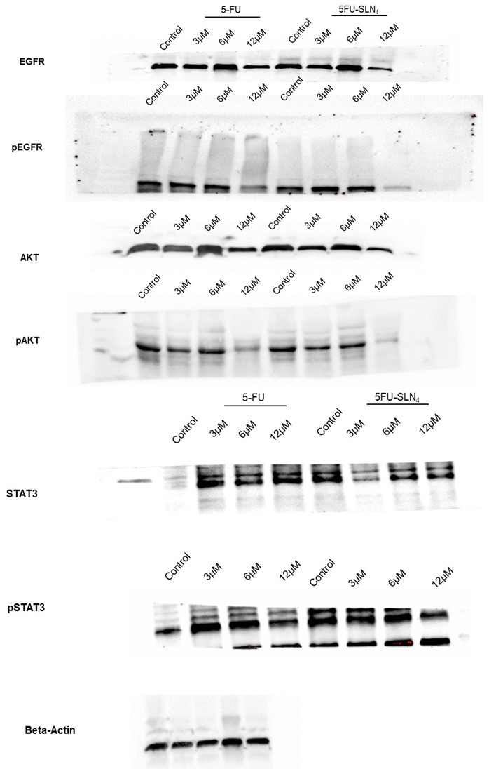

Supplementary Figure S6

Supplementary Figure S7

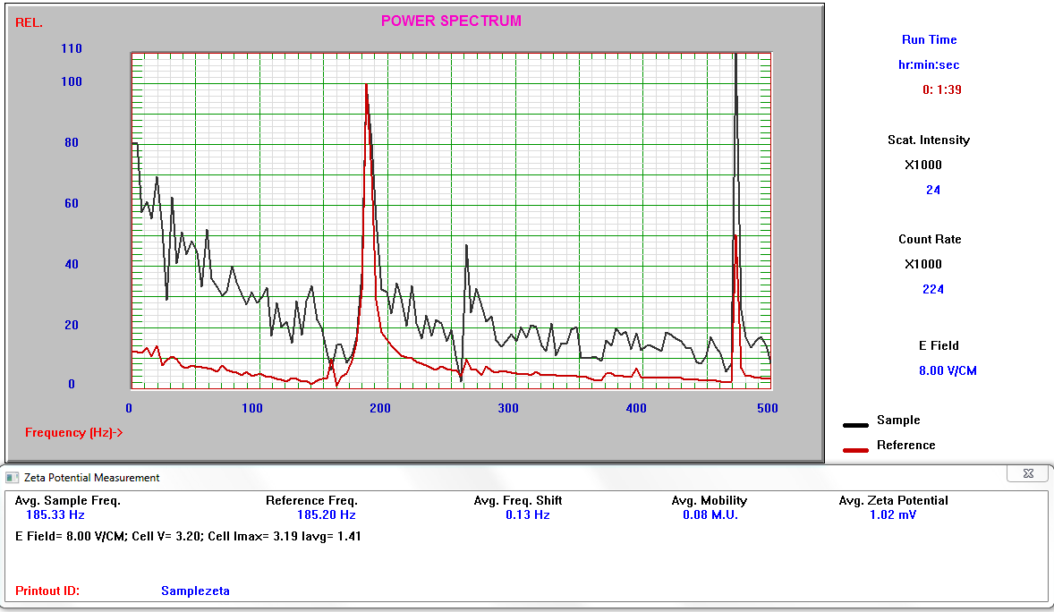

Supplementary Figure S8
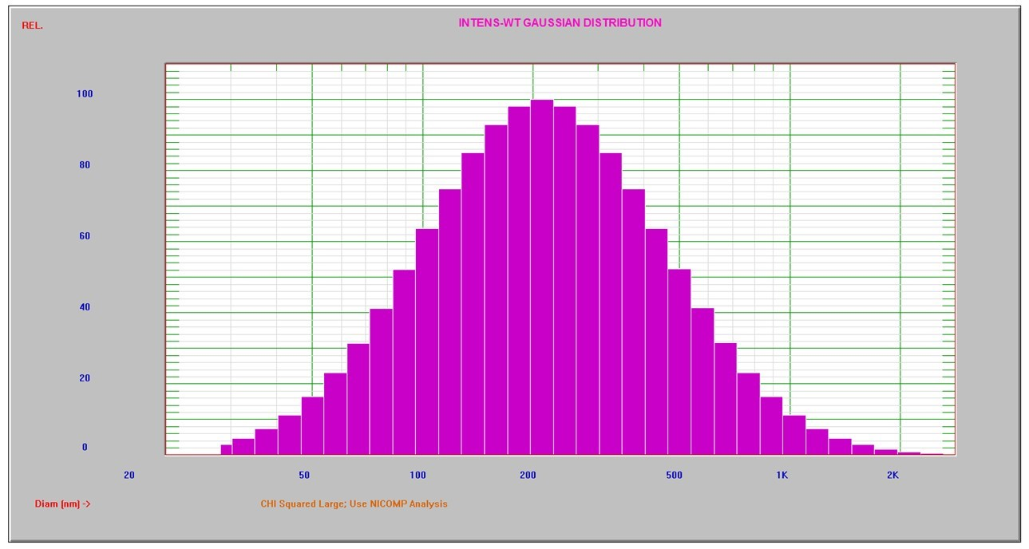

Supplementary Figure Legends

Supplementary Figure S1
Transmission electron micrograph of 5FU-SLN₄ (Scale bar = 400 nm)

Supplementary Figure S2
Cellular uptake studies: (A) Flow cytometry analysis of Rho-SLN₄ on HCT-116 cells, (B) Geometric mean of fluorescence intensity comparing cellular uptake of Rho (untreated HCT-116 cells) and Rho-SLN₄ against HCT-116 cells (*p<0.05), and (C) Confocal microscopy images showing cellular uptake of FITC-SLN₄ by HCT-116 cells after incubation for 3 h. The nucleus was stained by using the DNA-binding dye Hoechst 33342 (shown in blue) after cell fixation and the presence of FITC-SLN₄ in cells labeled in green. Merged image exhibits the co-localization of FITC-SLN₄ and nucleus in HCT-116 cell. (Scale bar =10 µm)

Supplementary Figure S3
Clonogenic assay for 5-FU and 5FU-SLN₄ treated HCT-116 cells: (A) Survival percent, and (B) Colony images after cells were treated with 5-FU and 5FU-SLN₄ at 3-100 µM. For statistical comparison between 5-FU and 5FU-SLN₄ treated groups, p-value was calculated by student’s t-test, (5-FU vs 5FU-SLN₄, **p<0.01 and ***p<0.001).

Supplementary Figure S4
H&E images: Liver from untreated mouse (control) (A), Liver from mouse treated with 5-FU dose of 20 mg/kg (B), Liver from mouse treated with 5FU-SLN₄ (dose equivalent 5-FU, 20 mg/kg) (C), Kidney from untreated mouse (D), Kidney from mouse treated with 5-FU (20 mg/kg) E), Kidney from mouse treated with 5FU-SLN₄ (dose equivalent 5-FU, 20 mg/kg). (Magnification X 40)

Supplementary Figure S5. Uncropped full-length western blot images. Shown are the original blots obtained prior to cropping for better visualization. Membranes were often cut to enable blotting for multiple antibodies. Beta-actin level was used as a loading control for the Western blot to normalize the levels of protein detected by confirming that protein loading is the same across the gel.

Supplementary Figure S6. Cell Viability of HCT-116: Cell viability after exposure of the HCT-116 cells to SLN₄ (Blank) and varying concentration of 5-FU and 5FU-SLN₄ for 72 h (** p<0.01, *** p<0.001 (Student's t-test))

Supplementary Figure S7. Graph of zeta potential distribution for 5FU-SLN₄

Supplementary Figure S8. Dynamic light scattering (DLS) graph showing hydrodynamic particle size distribution of freshly prepared 5FU-SLN₄ with mean diameter of 263 nm.

Formulation | Lipid | Lipid Ratio  (%w/v) | Surfactants Composition | Surfactant Ratio  (%w/v) | Mean Particle Size (nm) | Zeta Potential (mV) | EE (%)
SLN₄ | Precirol | 3 | Tween80/Lecithin | 4:2 | 173 ± 9 | 0.8 ± 0.01 | BLK
5FU-SLN₄ | Precirol | 3 | Tween80/Lecithin | 4:2 | 263 ± 3 | 1.1 ± 0.02 | 81±10
Supplementary Table S1. Comparison of blank SLN and the desired 5FU-SLN₄ formulation
BLK = Blank or empty SLN₄

