Protein-N-myristoylation-dependent phosphorylation of serine 13 of tyrosine kinase Lyn by casein kinase 1γ at the Golgi during intracellular protein traffic

Emiko Kinoshita-Kikuta^{1,2}, Toshihiko Utsumi^{3,4}, Aya Miyazaki², Chiharu Tokumoto², Kyosuke Doi², Haruna Harada³, Eiji Kinoshita^{1,2}*, & Tohru Koike^{1,2}

¹Department of Functional Molecular Science, Graduate School of Biomedical and Health Sciences, Hiroshima University, Hiroshima, Japan
²Department of Functional Molecular Science, School of Pharmaceutical Sciences, Hiroshima University, Hiroshima, Japan
³Graduate School of Sciences and Technology for Innovation, Yamaguchi University, Yamaguchi, Japan
⁴Department of Biological Chemistry, Faculty of Agriculture, Yamaguchi University, Yamaguchi, Japan

*Corresponding author
e-mail: kinoeiji@hiroshima-u.ac.jp

Supplementary Figure S1
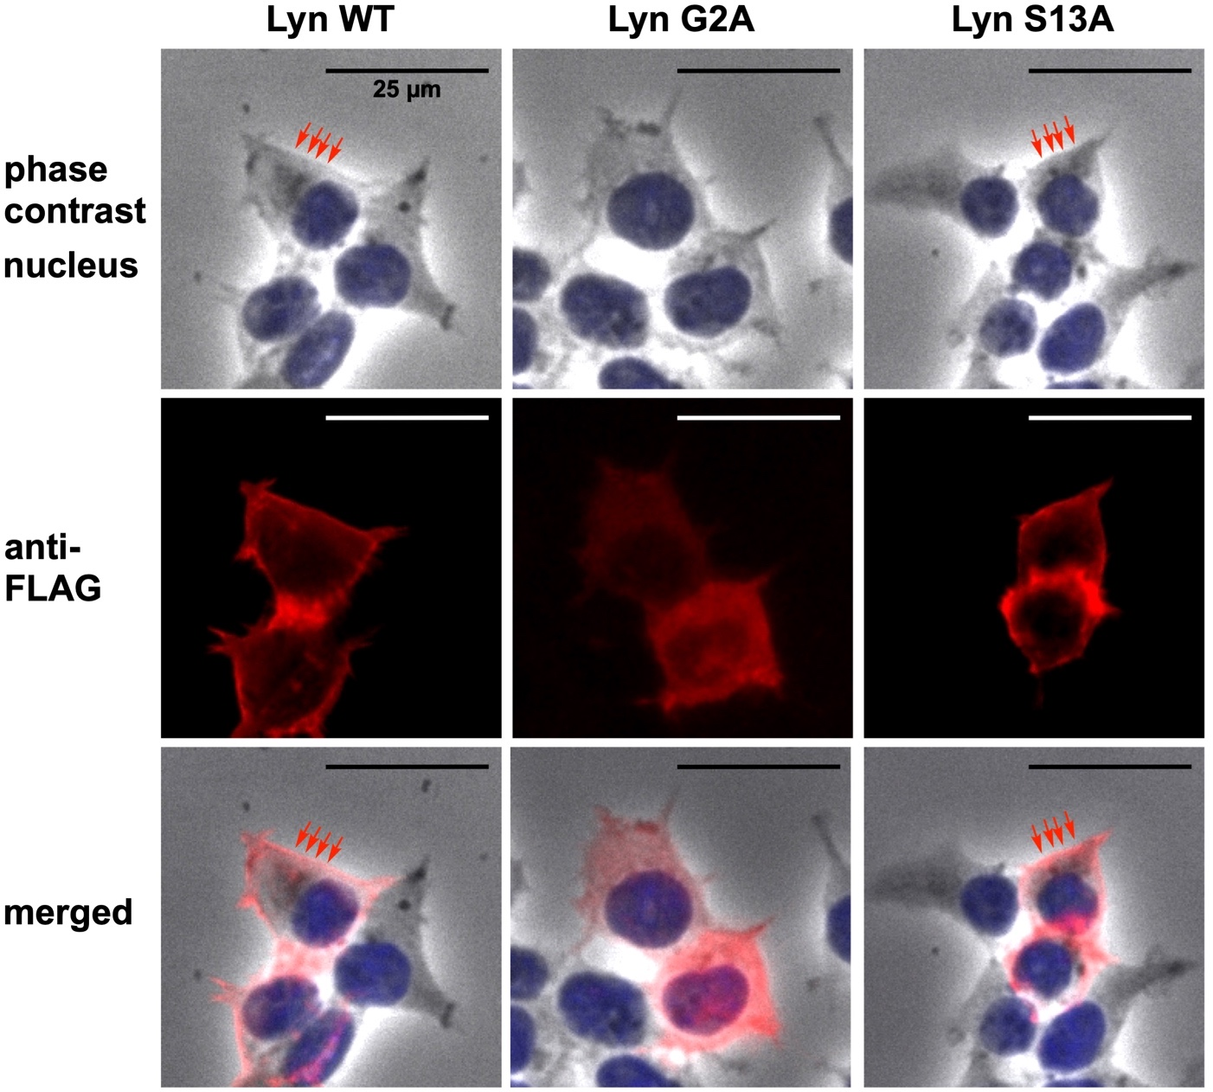

Figure S1. Cellular localizations of FLAG-tagged Lyn WT and its G2A-, and S13A-mutant proteins expressed in HEK293 cells. The expressed proteins and the nucleus were detected by immunofluorescence staining with anti-FLAG antibody (red) and Hoechst 33342 (blue), respectively. The microscopic analysis revealed almost no differences between the image of WT and that of the S13A mutant; moreover, it showed that the main signals were localized at the plasma membrane (red arrows) in HEK293 cells. In the G2A mutant, on the other hand, signals were clearly delocalized from the plasma membrane to the cytosol.

Supplementary Figure S2
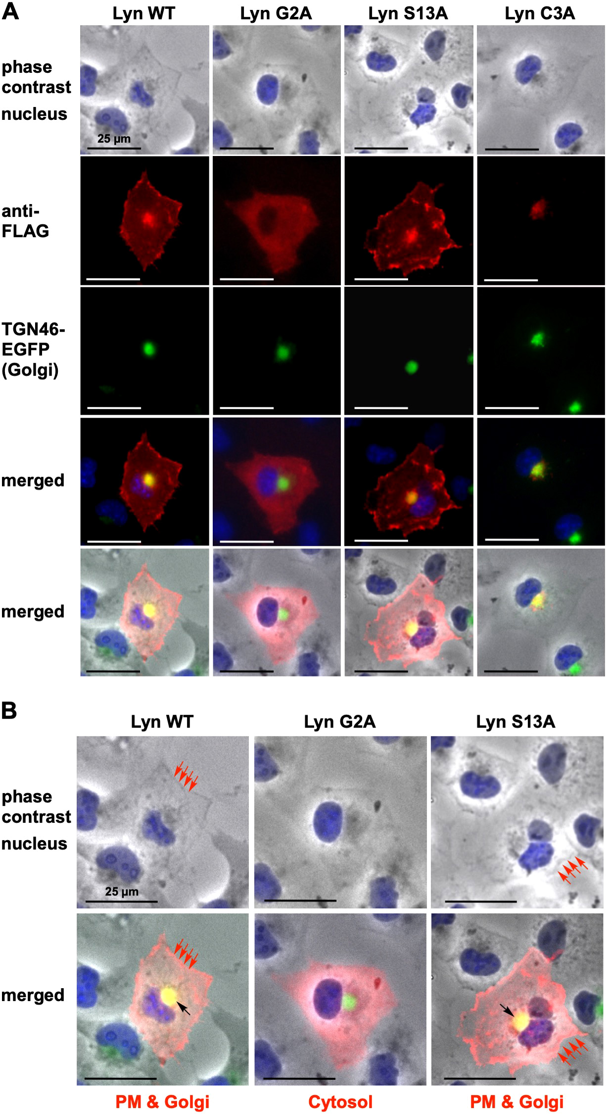

Figure S2. Cellular localizations of FLAG-tagged Lyn WT and its G2A-, S13A-, and C3A-mutant proteins expressed in COS-1 cells. (A) The expressed proteins and the nucleus were detected by immunofluorescence staining with anti-FLAG antibody (red) and Hoechst 33342 (blue), respectively. There was almost no difference between the image for Lyn WT and that for its S13A mutant, in that the main signals were localized at the plasma membrane and perinuclear region in COS-1 cells. In the G2A mutant, on the other hand, signals were clearly delocalized from the plasma membrane and perinuclear region to the cytosol. The perinuclear region was assigned as the Golgi by co-expression with TGN46-EGFP (green). The non-S-palmitoylated Lyn mutant (the C3A mutant) was localized to the Golgi in COS-1 cells. (B) Enlarged views of merged micrographs from phase-contrast and immunofluorescence staining with anti-FLAG antibody (red), clearly showing that the main signals derived from Lyn WT and from the S13A mutant were localized at both the plasma membrane (PM, red arrows) and the Golgi (black arrow) in COS-1 cells. The signal for the G2A mutant was delocalized from the plasma membrane and the Golgi to the cytosol.
Supplementary Figure S3
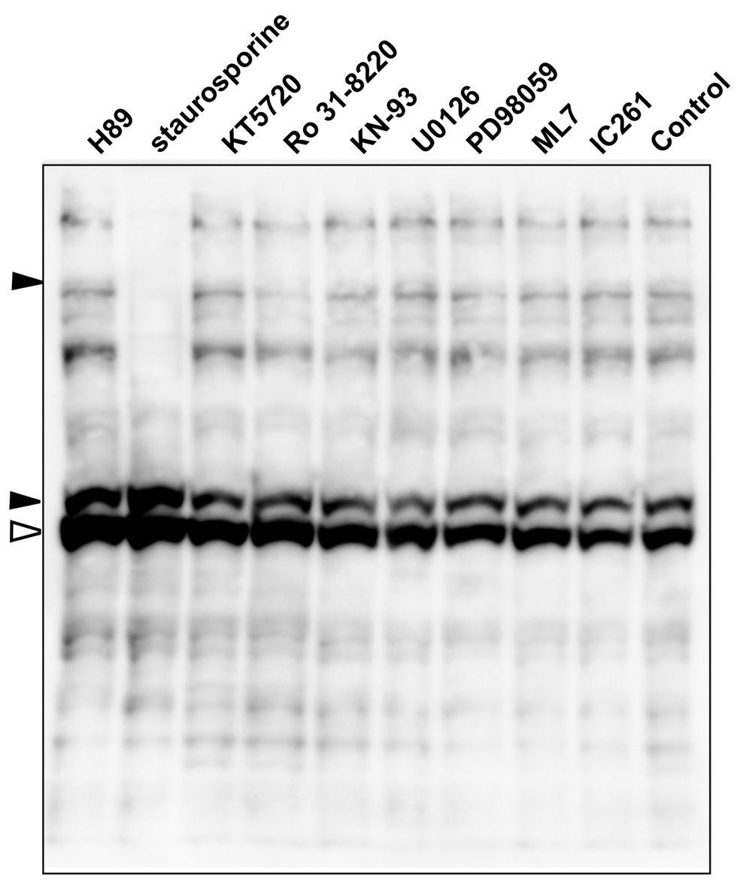

Figure S3. Inhibitor screening of phosphorylation of Lyn-S13. Lyn WT proteins synthesized by using the TnT T7 Insect Cell Extract Protein Expression System in the presence of H-89, staurosporine, KT5720, Ro 31-8220, KN-93, U0126, PD98059, ML7, or IC261 at a concentration of 500 µM were analyzed by Phos-tag SDS-PAGE (20 µM Zn²⁺–Phos-tag and 7% w/v polyacrylamide) followed by immunoblotting with anti-Lyn antibody. Open arrowhead: nonphosphorylated species; closed arrowheads: phosphospecies containing a phosphorylated Ser-13 residue.

Supplementary Figure S4
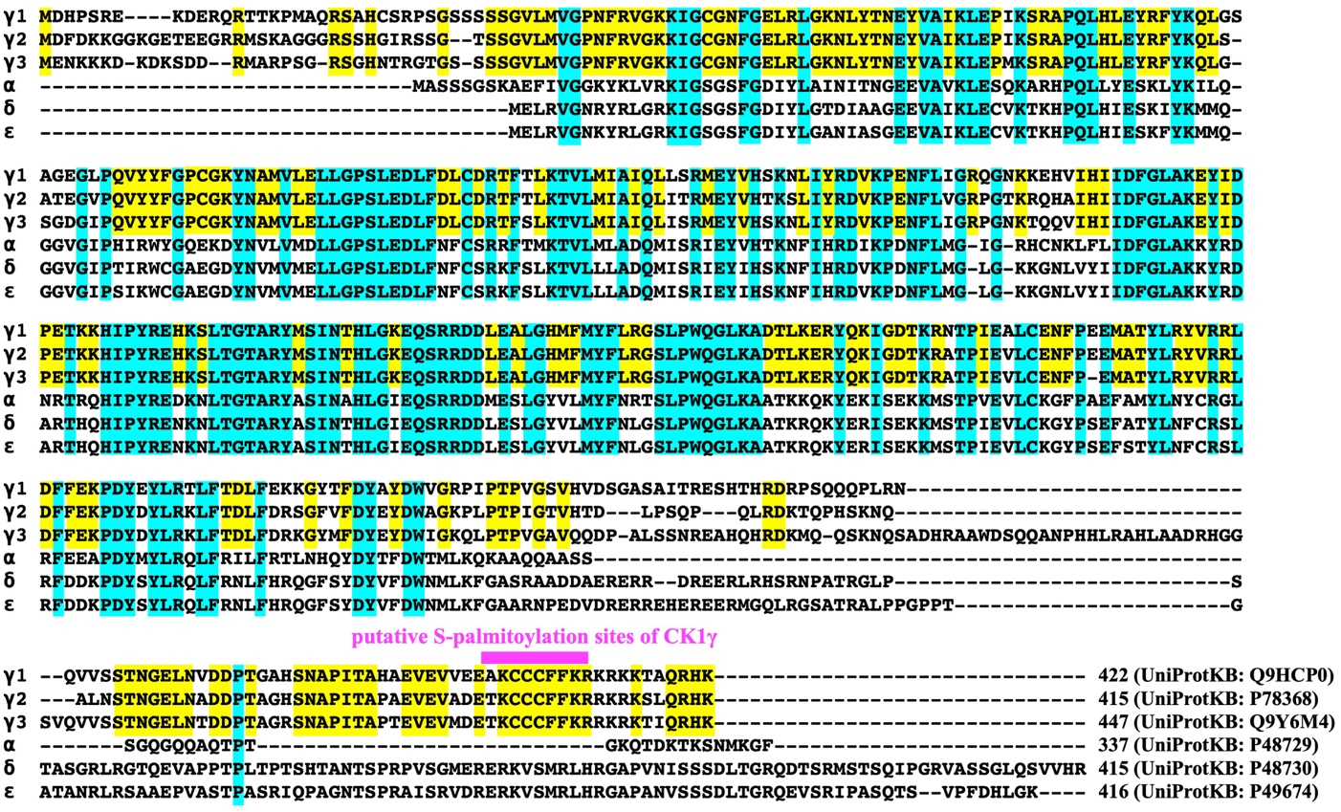

Figure S4. Amino acid sequence alignments of the human CK1 family. All sequences were obtained from UniProt. Cyan and yellow shadings indicate consensus sites in all isoforms and in three CK1γ isoforms, respectively. The magenta-shaded area shows putative S-palmitoylation sites of the CK1γ isoforms.

Supplementary Figure S5

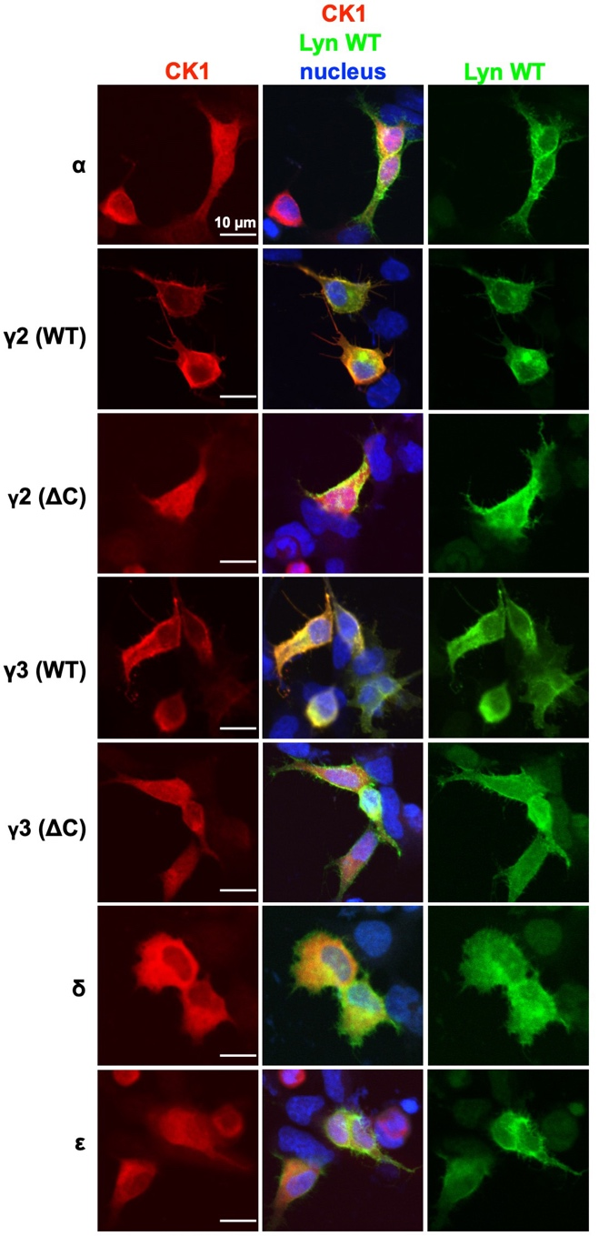

Figure S5. Cellular localizations of Lyn (WT) and CK1 isoforms (α, γ2 WT/ΔC, γ3 WT/ΔC, δ, and ε). FLAG-tagged Lyn WT and each Halo-tagged CK1 isoform co-expressed in HEK293 cells were analyzed by immunofluorescence microscopy. The co-expressed CK1 and Lyn were detected by immunofluorescence staining with anti-HaloTag antibody (red) and anti-FLAG antibody (green), respectively, and the nucleus was stained with Hoechst 33342 (blue). ΔC: deletion of Cys-399, Cys-400, and Cys-401 in CK1γ2; deletion of Cys-431, Cys-432, and Cys-433 in CK1γ3.

Supplementary Figure S6
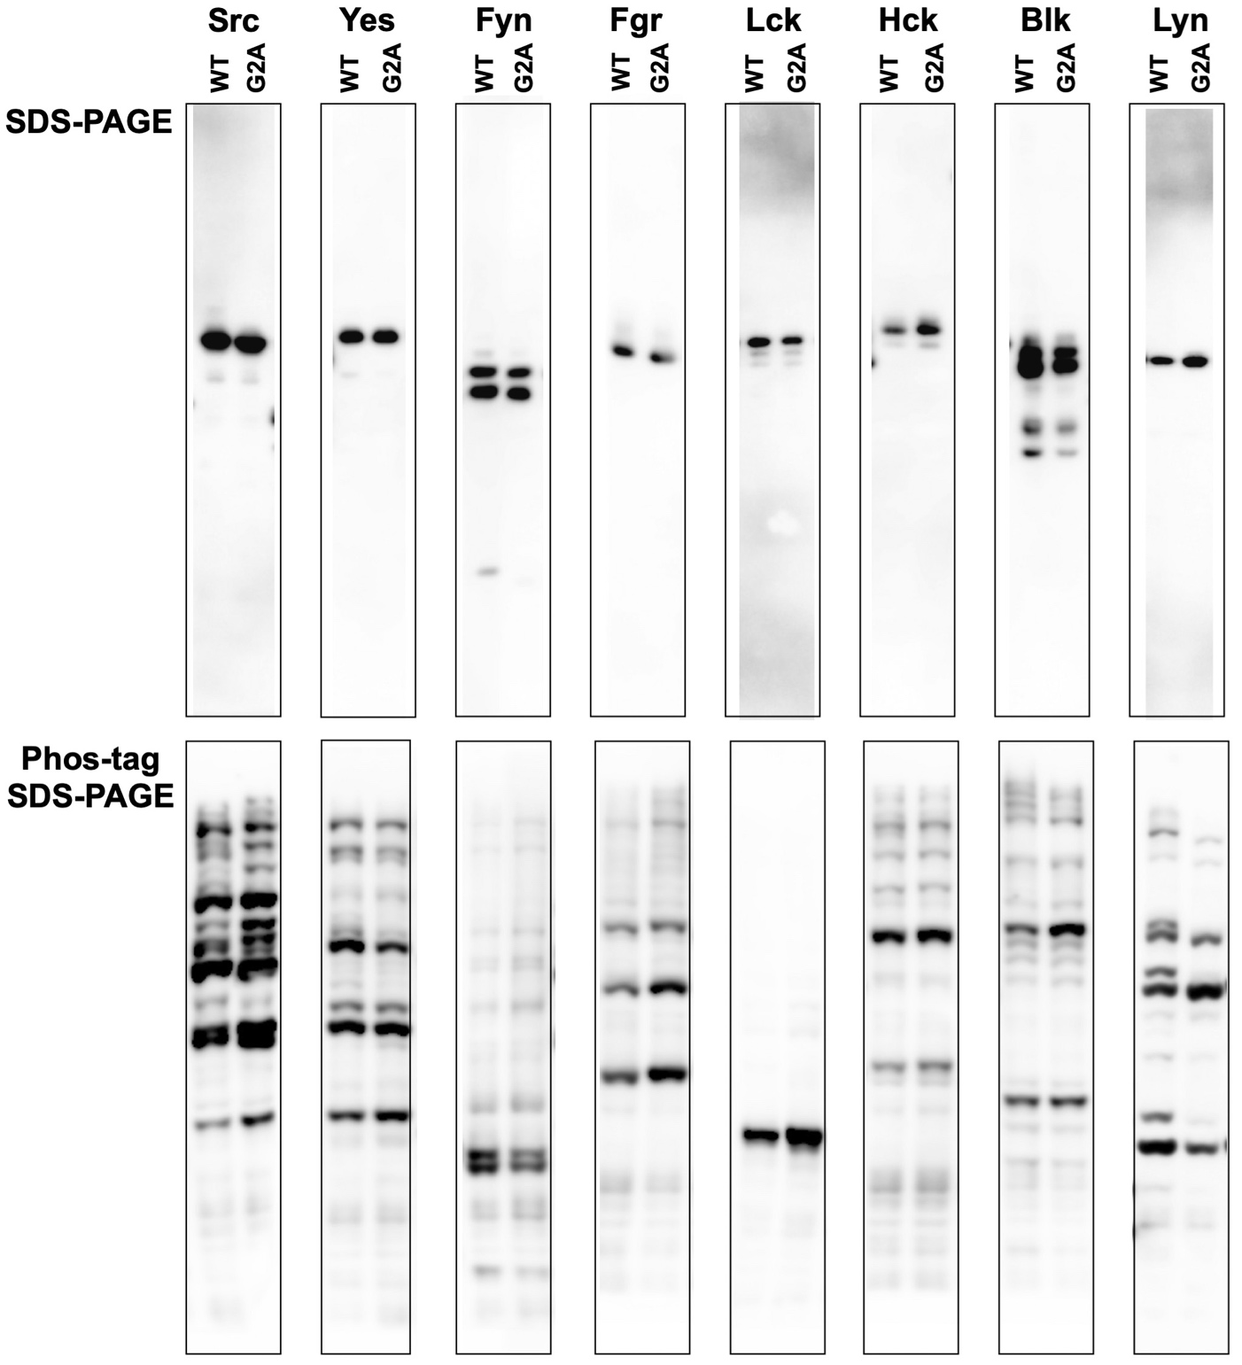

Figure S6. Raw images for Fig. 1.

Supplementary Figure S7

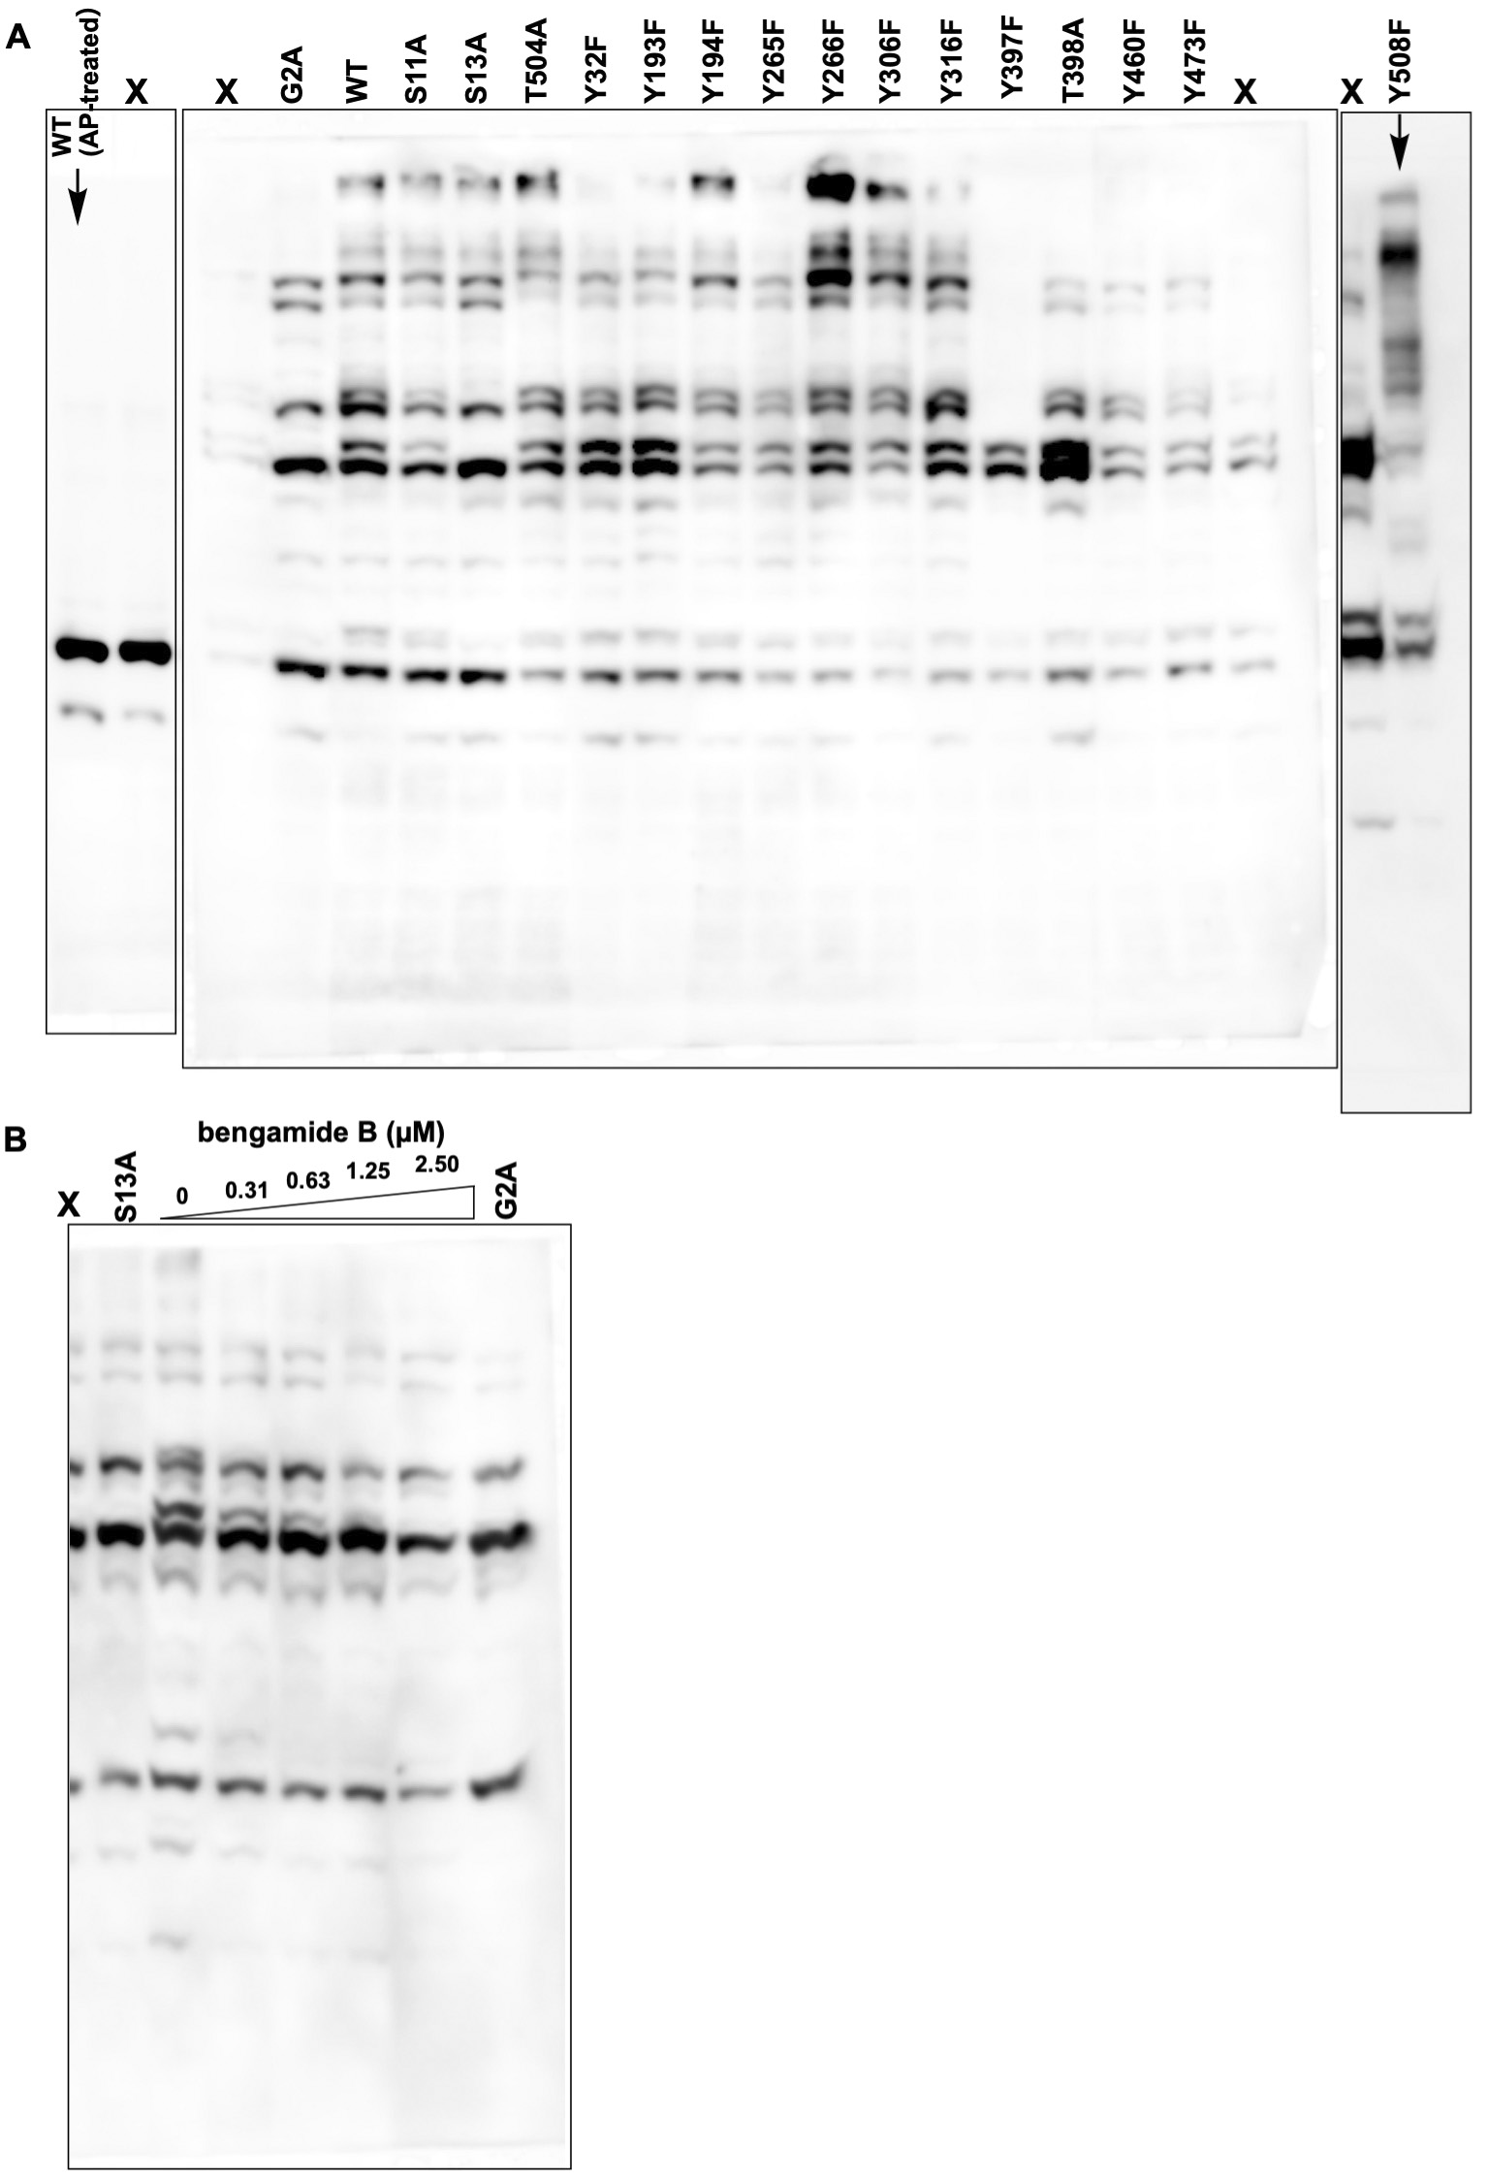

Figure S7. Raw images for Fig. 2. Lanes marked X have been cropped from the blot shown in Fig. 2.

Supplementary Figure S8
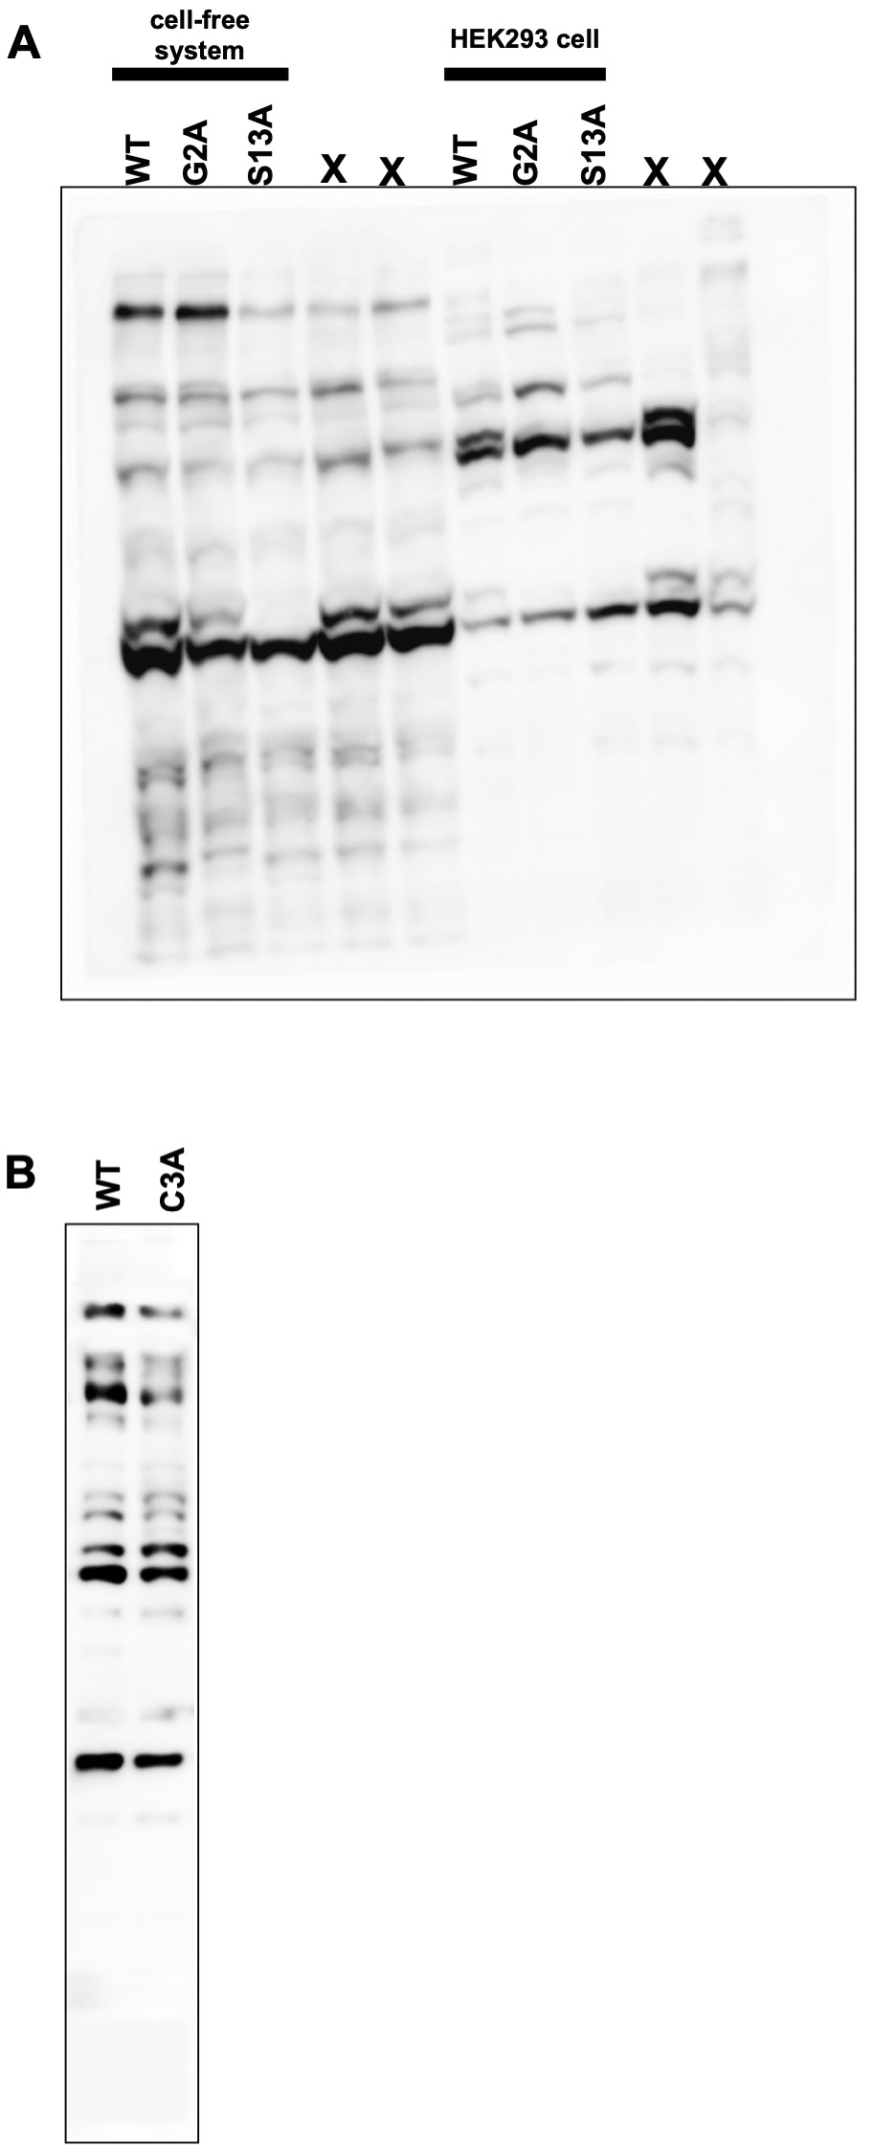

Figure S8. Raw images for Fig. 3. Lanes marked X have been cropped from the blot shown in Fig. 3A.
Supplementary Figure S9
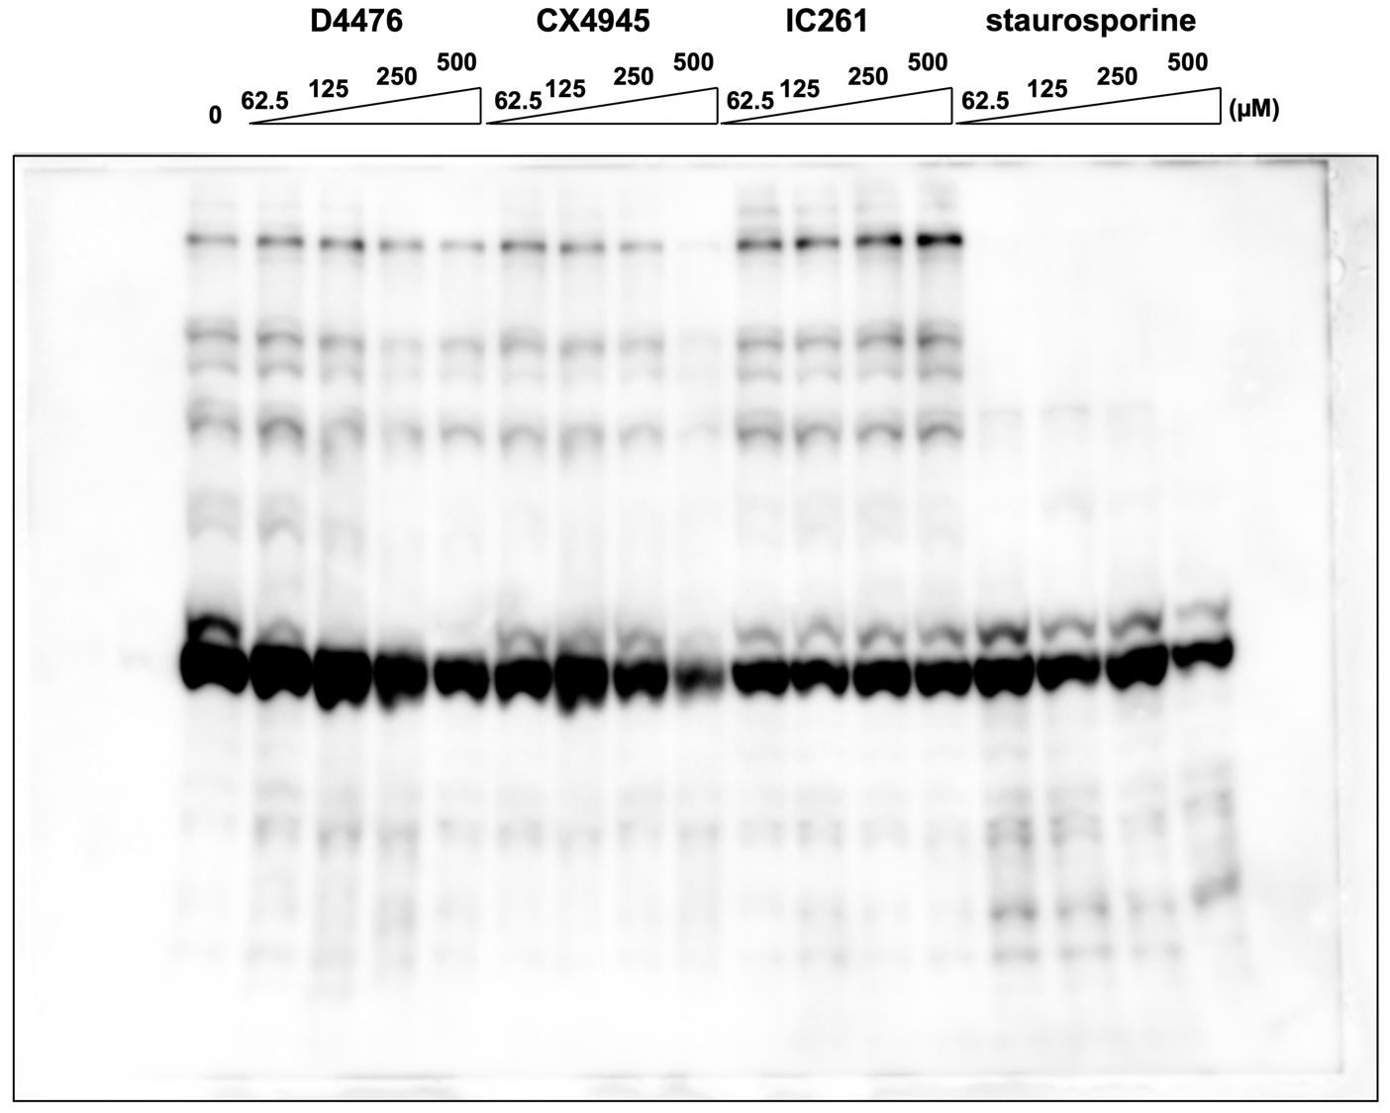

Figure S9. The raw image data of Fig. 4.

Supplementary Figure S10

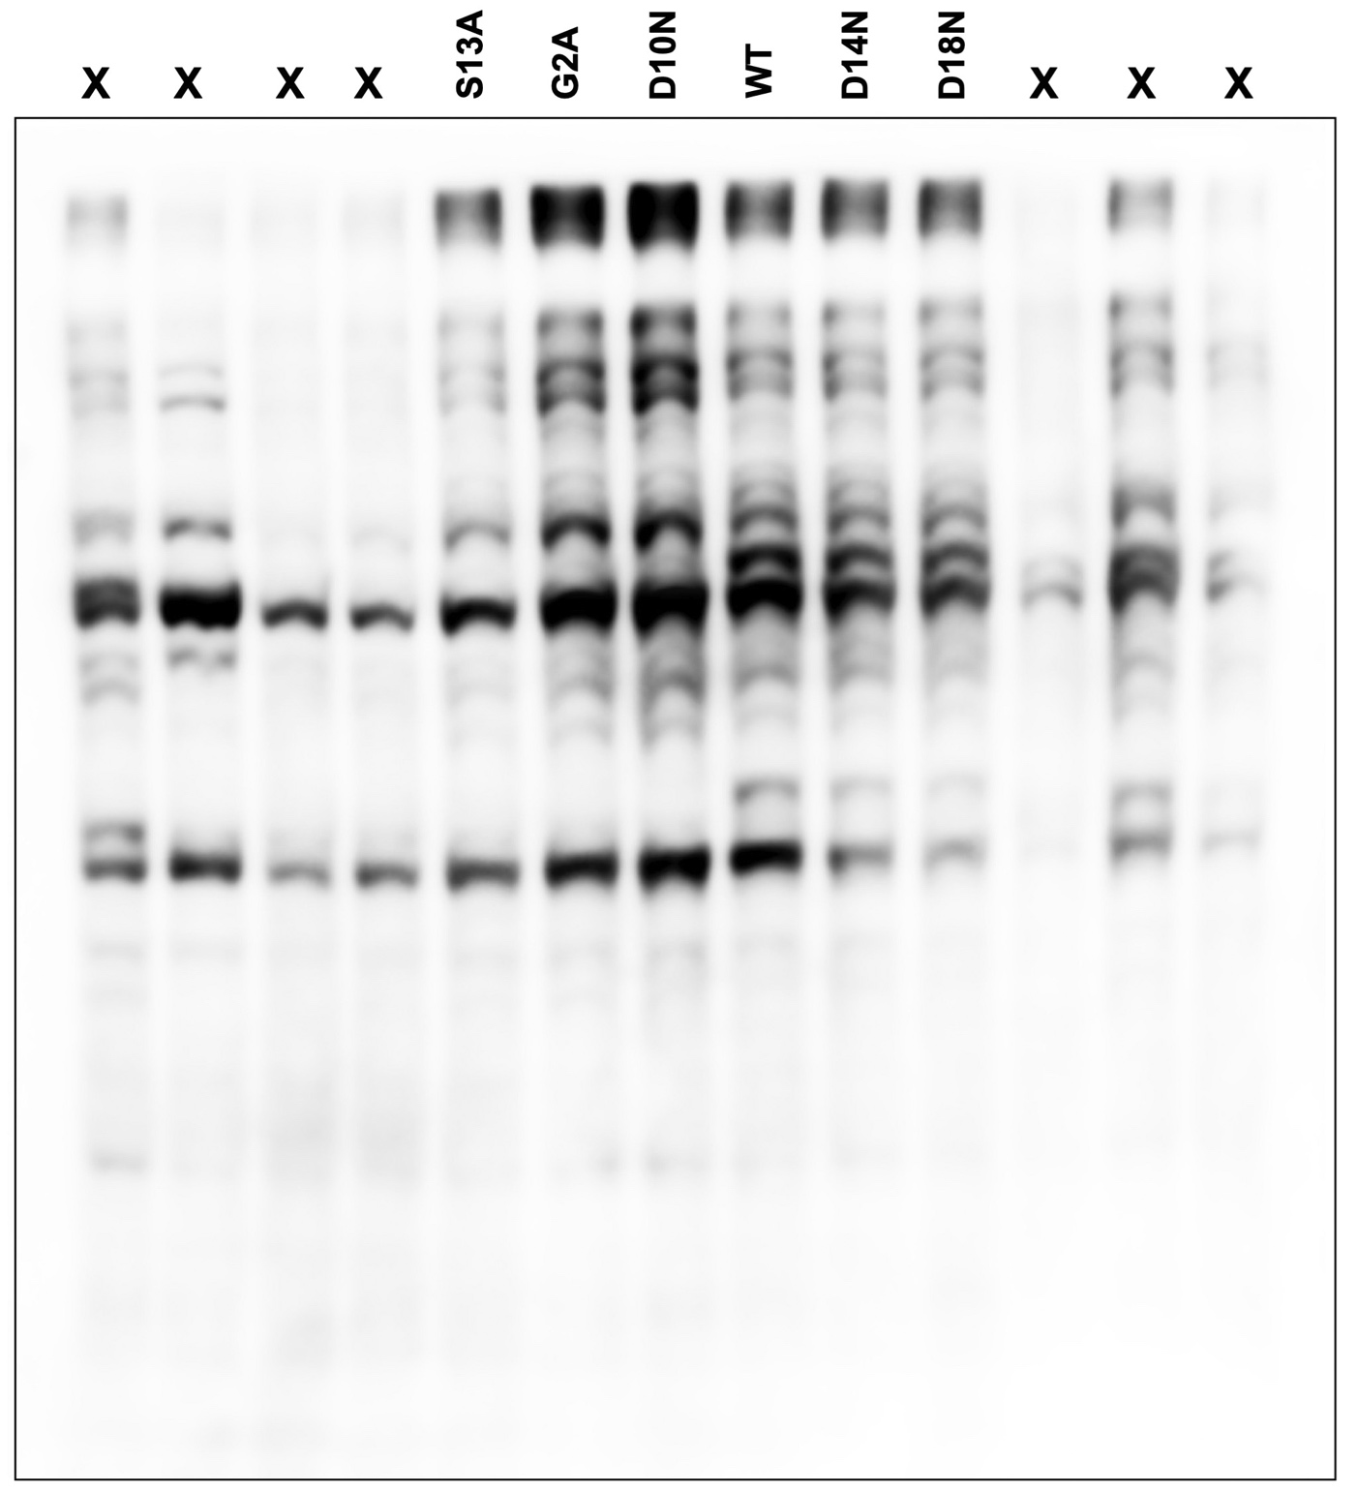

Figure S10. Raw image for Fig. 5B. Lanes marked X have been cropped from the blot shown in Fig. 5B.

Supplementary Figure S11A

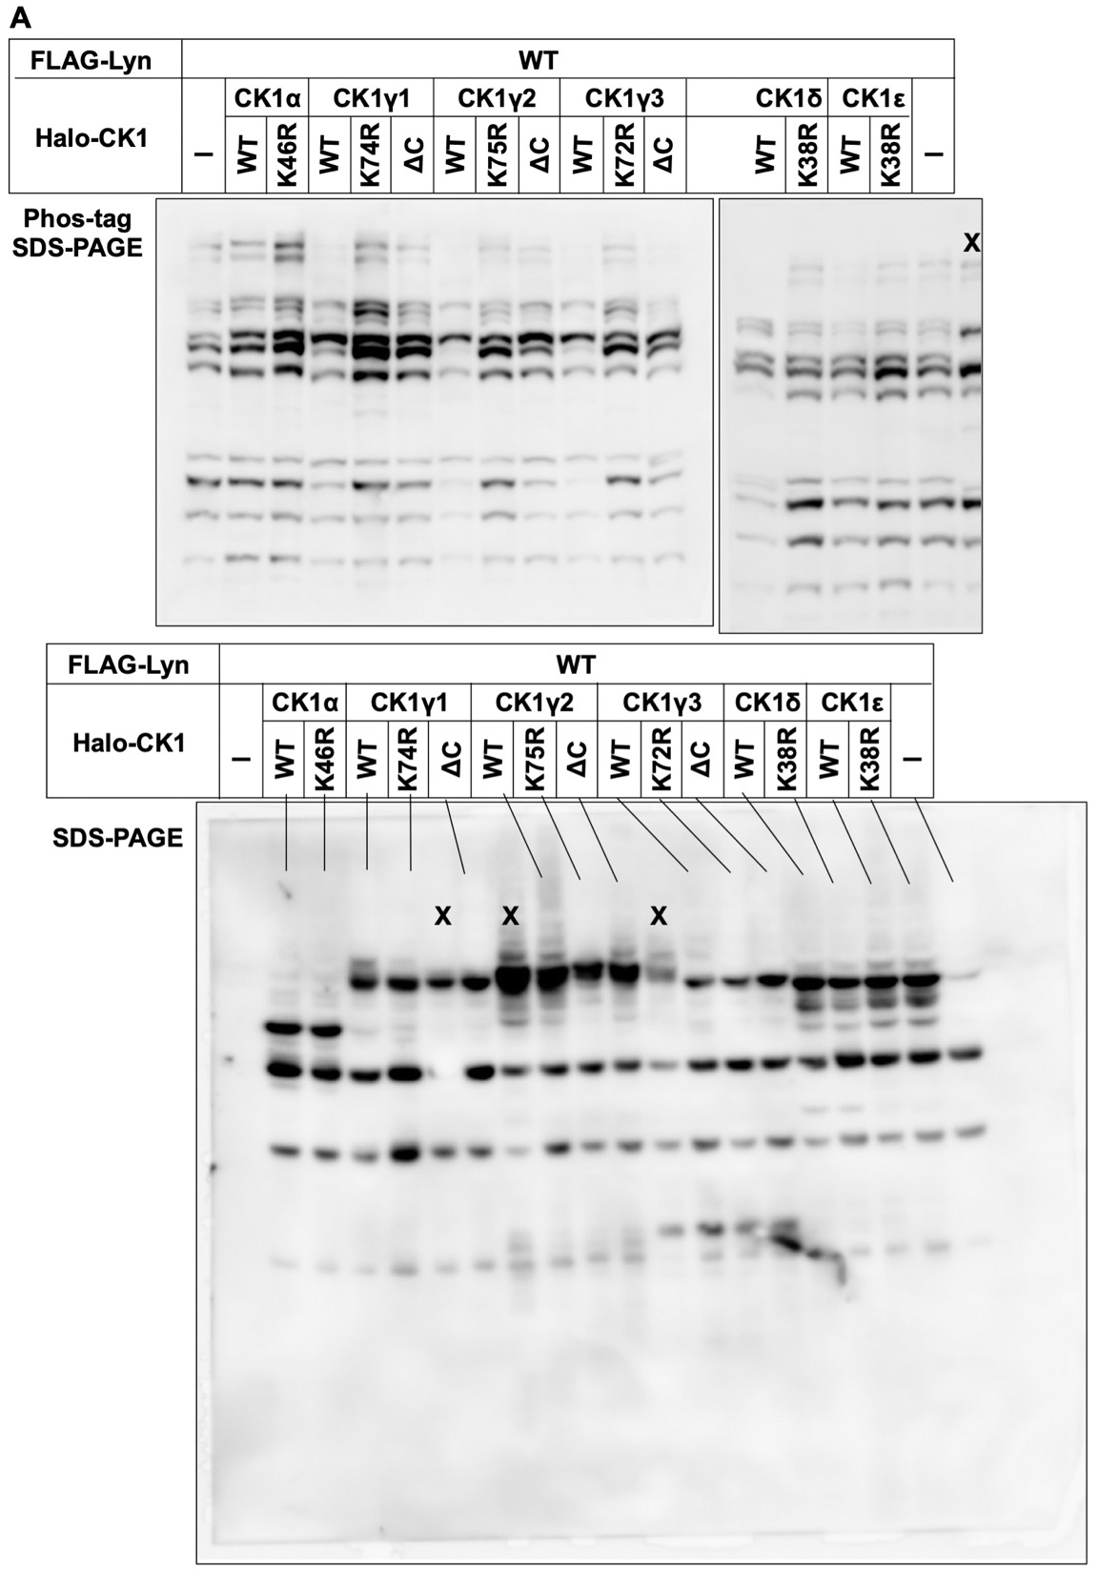

Supplementary Figure S11B

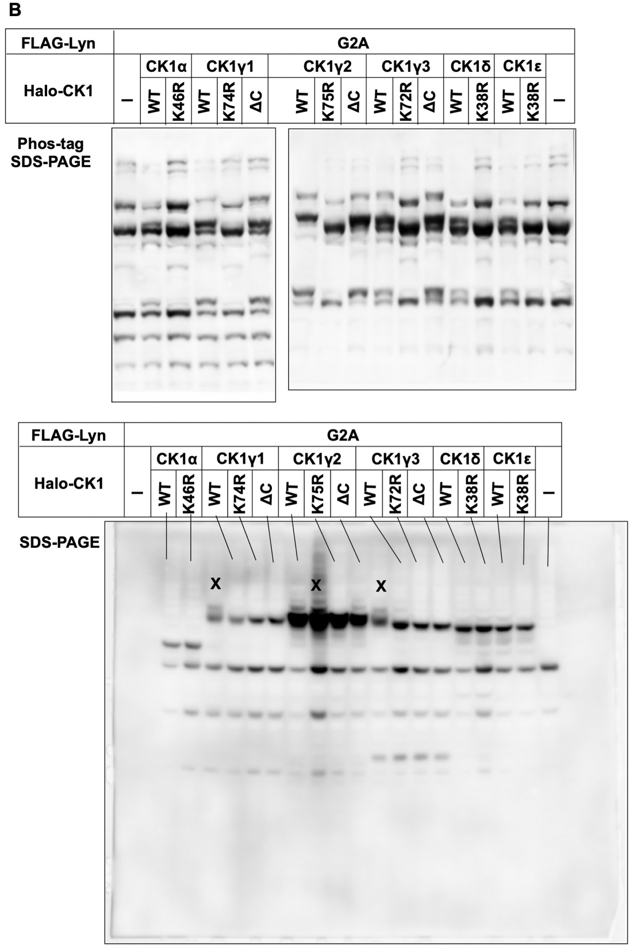

Figure S11. Raw images for Fig. 6. Lanes marked X have been cropped from the blots shown in Fig. 6.
Supplementary Table S1.

Table S1. Sequences of the N-terminal regions of the SFKs.
SFK | UniProtKB ª | Sequence of N-terminal region
Src | P12931 | NH2-MGSNKSKPKDASQRRR········
Yes | P07947 | NH2-MGCIKSKENKSPAIKY········
Fyn | P06241 | NH2-MGCVQCKDKEATKLTE········
Fgr | P09769 | NH2-MGCVFCKKLEPVATAK········
Lck | P06239 | NH2-MGCGCSSHPEDDWMEN········
Hck | P08631 | NH2-MGGRSSCEDPGCPRDE········
Blk | P51451 | NH2-MGLVSSKKPDKEKPIK········
Lyn | P07948 | NH2-MGCIKSKGKDSLSDDG········
Frk | P42685 | NH2-MSNICQRLWEYLEPYL········
ª UniProtKB (https://www.uniprot.org) is an online database, known as Protein Knowledgebase, provided by the UniProt consortium.
Underlined Gly-2 residues are sites for N-myristoylation.
Supplementary Table S2.

Table S2. Phosphorylation sites in human Lyn registered in the PhosphoSitePlusª database.
Site^{b} | Number of reports^{c}
Site^{b} | Identified by MS-based phosphoproteomic methods^{d} | Identified by biochemical  site-specific methods^{e}
Ser-11 | 19 | 0
Ser-13 | 43 | 0
Tyr-32 | 115 | 1
Tyr-193 | 787 | 0
Tyr-194 | 554 | 2
Tyr-265 | 147 | 0
Tyr-266 | 18 | 0
Tyr-306 | 135 | 0
Tyr-316 | 179 | 0
Tyr-397 | 2108 | 21
Thr-398 | 17 | 0
Tyr-460 | 11 | 0
Tyr-473 | 733 | 0
Thr-504 | 10 | 0
Tyr-508 | 1604 | 17
ª PhosphoSite Plus (http://www.phosphosite.org/homeAction.do) is an online database provided by Cell Signaling Technology, Inc. It contains comprehensive information and tools for the study of post-translational modifications, including phosphorylation, ubiquitination, acetylation, and methylation [24].
^{b} Phosphorylation sites assigned in more than 10 reports are listed.
^{c} As of August 20, 2020.
^{d} Phosphorylation sites identified by proteomic discovery-mode MS strategies alone.
^{e} Phosphorylation sites identified by amino acid sequencing, by site-directed mutagenesis, or by using site-specific antibodies.
Supplementary Table S3.

Table S3. Phosphorylation motifs for CK1 and CK2 isoforms in the sequence around Lyn-S13.
Kinase | Phosphorylation motifª
CK1α | ···D··S······
CK1α | ······S····D·
CK1δ | ···D··S······
CK1ε | ···D··S······
CK1γ1 | ···D··S······
CK1γ2 | ···D··S······
CK1γ3 | ···D··S······
CK2α2 | ······SD·····
CK2α2 | ······S····D·
ª Phosphorylation motif from Supplementary Table S3 of Ref. 31.
Underlined Ser residues correspond to Lyn-S13.
Supplementary Table S4.

Table S4. Sources of each clone of SFKs and expression vectors for subcloning.
SFK | Clone name  (catalog number) | Source | Expression vector
Src | IRAL047C19  (HGY098867) | RIKEN BRC | pCDNA3.1(–)
Yes | W01A026C12  (HGE010460) | RIKEN BRC | pHEK Ultra Expression Vector
Fyn | W01A056G21  (HGE022565) | RIKEN BRC | pHEK Ultra Expression Vector
Lck | W01A107I15  (HGE043007) | RIKEN BRC | pCDNA3.1(–)
Hck | IRAL034D12  (HGY093684) | RIKEN BRC | pCDNA3.1(–)
Blk | IRAK064L13  (HGX025877) | RIKEN BRC | pCDNA3.1(–)
Lyn | Lyn/pLY30  (RDB01306) | RIKEN BRC | pHEK Ultra Expression Vector,  pF25A ICE T7 Flexi Vector
Fgr | pF1KB9941  (FXC20165) | Promega | pHEK Ultra Expression Vector

Supplementary Table S5.

Table S5. PCR primers for subcloning of cDNAs encoding SKFs.
Primer | Sequence (5'–3')
Src_F | GCTGGATATCTGCAGAATTCATGGGTAGCAACAAGAGCAAG
Src_R | TTGGTACCGAGCTCGGATCCTCACTTATCGTCGTCATCCTTGTAATCGAGGTTCTCCCCGGGCTG
Yes_F | CTCCCCGGGCTCGAGGGATGGGCTGCATTAAAAGTAAA
Yes_R | TGCCTGCAGGTCGACTCTAGATTACTTATCGTCGTCATCCTTGTAATCTAAATTTTCTCCTGGCTG
Fyn_F | CTCCCCGGGCTCGAGGGATGGGCTGTGTGCAATGTAAG
Fyn_R | TGCCTGCAGGTCGACTCTAGATTACTTATCGTCGTCATCCTTGTAATCCAGGTTTTCACCAGGTTG
Lck_F | GCTGGATATCTGCAGAATTCATGGGCTGTGGCTGCAGCTCA
Lck_R | TTGGTACCGAGCTCGGATCCTCACTTATCGTCGTCATCCTTGTAATCAGGCTGAGGCTGGTACTG
Hck_F | GCTGGATATCTGCAGAATTCATGGGGGGGCGCTCAAGCTGC
Hck_R | TTGGTACCGAGCTCGGATCCTCACTTATCGTCGTCATCCTTGTAATCTGGCTGCTGTTGGTACTG
Blk_F | GCTGGATATCTGCAGAATTCATGGGGCTGGTAAGTAGCAAA
Blk _R | TTGGTACCGAGCTCGGATCCTCACTTATCGTCGTCATCCTTGTAATCGGGCTGCAGCTCGTACTG
Lyn_F | CTCCCCGGGCTCGAGGGATCCATGGGATGTATAAAATCAAAA  (for subcloning to pHEK Ultra Expression Vector)
Lyn_R | TGCCTGCAGGTCGACTCTAGATTACTTATCGTCGTCATCCTTGTAATCAGGCTGCTGCTGGTATTG (for subcloning to pHEK Ultra Expression Vector)
Lyn_F | TATAAAGCGATCGCCATGGGATGTATAAAATCA  (for subcloning to pF25A ICE T7 Flexi Vector)
Lyn_R | CGAATTCGTTTAAACCTGCTGCTGGTATTGCCC  (for subcloning to pF25A ICE T7 Flexi Vector)
Fgr_F | CTCCCCGGGCTCGAGGGATCCATGGGCTGTGTGTTCTGCAAG
Fgr_R | TGCCTGCAGGTCGACTCTAGATTACTTATCGTCGTCATCCTTGTAATCTGTCTGATCCCCGGGCTG
Underlined sequences show FLAG-tag sequences.

Supplementary Table S6.

Table S6. PCR primers for mutagenesis of cDNAs encoding SKFs.
Primer | Sequence (5'–3')
Src_G2A_F | TCTGCAGAATTCATGGCTAGCAACAAGAGCAAG
Src_G2A_R | CTTGCTCTTGTTGCTAGCCATGAATTCTGCAGA
Yes_G2A_F | TCTGCAGAATTCATGGCCTGCATTAAAAGTAAA
Yes_G2A_R | TTTACTTTTAATGCAGGCCATGAATTCTGCAGA
Fyn_G2A_F | TCTGCAGAATTCATGGCCTGTGTGCAATGTAAG
Fyn_G2A_R | CTTACATTGCACACAGGCCATGAATTCTGCAGA
Fgr_G2A_F | ATGGCCTGTGTGTTCTGCAAGAAATT
Fgr_G2A_R | AATTTCTTGCAGAACACACAG
Lck_G2A_F | TCTGCAGAATTCATGGCCTGTGGCTGCAGCTCA
Lck_G2A_R | TGAGCTGCAGCCACAGGCCATGAATTCTGCAGA
Hck_G2A_F | TCTGCAGAATTCATGGCGGGGCGCTCAAGCTGC
Hck_G2A_R | GCAGCTTGAGCGCCCCGCCATGAATTCTGCAGA
Blk_G2A_F | TCTGCAGAATTCATGGCGCTGGTAAGTAGCAAA
Blk_G2A_R | TTTGCTACTTACCAGCGCCATGAATTCTGCAGA
Lyn_G2A_F | ATGGCATGTATAAAATCAAAAGGGAA
Lyn_G2A_R | TTCCCTTTTGATTTTATACAT
Lyn_C3A_F | GGAGCTATAAAATCAAAAGGGAAAGA
Lyn_C3A_ R | TCTTTCCCTTTTGATTTTATA
Lyn_D10N_F | AAAAACAGCTTGAGTGACGATGGAGT
Lyn_D10N_R | ACTCCATCGTCACTCAAGCT
Lyn_S11A_F | GACGCCTTGAGTGACGATGGAGTAGA
Lyn_S11A_R | TCTACTCCATCGTCACTCAA
Lyn_S13A_F | TTGGCTGACGATGGAGTAGATTTGAA
Lyn_S13A_R | TTCAAATCTACTCCATCGTC
Lyn_D14N_F | AGTAACGATGGAGTAGATTTGAAGAC
Lyn_D14N_R | GTCTTCAAATCTACTCCATC
Lyn_D18N_F | GTAAATTTGAAGACTCAACCAGTACG
Lyn_D18N_R | CGTACTGGTTGAGTCTTCAA
Lyn_Y32F_F | AACTTTTTATGTGAGAGATCCAACGT
Lyn_Y32F_R | ACGTTGGATCTCTCACATAA
Lyn_Y193F_F | GGCTTTTACATCTCTCCACGAATCAC
Lyn_Y193F_R | GTGATTCGTGGAGAGATGTA
Lyn_Y194F_F | TATTTCATCTCTCCACGAATCACTTT
Lyn_Y194F_R | AAAGTGATTCGTGGAGAGAT
Lyn_Y265F_F | GGTTTCTATAACAACAGTACCAAGGT
Lyn_Y265F_R | ACCTTGGTACTGTTGTTATA
Lyn_Y266F_F | TACTTTAACAACAGTACCAAGGTGGC
Lyn_Y266F_R | GCCACCTTGGTACTGTTGTT
Lyn_Y306F_F | CTCTTCGCTGTGGTCACCAGGGAGGA
Lyn_Y306F_R | TCCTCCCTGGTGACCACAGC
Lyn_Y316F_F | ATTTTCATCATCACCGAGTACATGGC
Lyn_Y316F_R | GCCATGTACTCGGTGATGAT
Lyn_Y397F_F | GAGTTCACAGCAAGGGAAGGTGCTAA
Lyn_Y397F_R | TTAGCACCTTCCCTTGCTGT
Lyn_T398A_F | TACGCAGCAAGGGAAGGTGCTAAGTT
Lyn_T398A_R | AACTTAGCACCTTCCCTTGC
Lyn_Y460F_F | GGCTTCAGGATGCCCCGTGTGGAGAA
Lyn_Y460F_R | TTCTCCACACGGGGCATCCT
Lyn_Y473F_F | CTCTTTGACATTATGAAAATGTGCTG
Lyn_Y473F_R | CAGCACATTTTCATAATGTC
Lyn_T504A_F | GCCGCGGAAGGGCAATACCAGCAGCA
Lyn_T504A_R | TGCTGCTGGTATTGCCCTTC
Lyn_Y508F_F | CAATTCCAGCAGCAGCCTTAG
Lyn_Y508F_R | CTAAGGCTGCTGCTG
Underlined sequences show substituted codons.

Supplementary Table S7.

Table S7. PCR primers for cloning of cDNAs encoding CK1 isoforms.
Primer | Sequence (5'–3')
CK1α_F | TTTCAGAGCGATAACGCGATCGCCATGGCGAGTAGCAGCGGC
CK1α_R | ACCGAGCCCGAATTCGTTTAAACGAAACCTTTCATGTTACT
CK1γ1_F | TTTCAGAGCGATAACGCGATCGCCATGGACCATCCTAGTAGG
CK1γ1 _R | ACCGAGCCCGAATTCGTTTAAACCTTGTGGCGCTGAGCAGT
CK1γ2_F | TTTCAGAGCGATAACGCGATCGCCATGGATTTTGACAAGAAA
CK1γ2_R | ACCGAGCCCGAATTCGTTTAAACCTTGTGTCGCTGCAGCGA
CK1γ3_F | TTTCAGAGCGATAACGCGATCGCCATGGAAAATAAAAAGAAA
CK1γ3_R | ACCGAGCCCGAATTCGTTTAAACTTTGTGGCGCTGTATGGT
CK1δ_F | TTTCAGAGCGATAACGCGATCGCCATGGAGCTGAGAGTCGGG
CK1δ_R | ACCGAGCCCGAATTCGTTTAAACTCGGTGCACGACAGACTG
CK1ε_F | TTTCAGAGCGATAACGCGATCGCCATGGAGCTACGTGTGGGG
CK1ε_R | ACCGAGCCCGAATTCGTTTAAACCTTCCCGAGATGGTCAAA

Supplementary Table S8.

Table S8. PCR primers for mutagenesis of cDNAs encoding CK1 isoforms.
Primer | Sequence (5'–3')
CK1α_K46R_F | GTGAGGCTAGAATCTCAGAAG
CK1α_K46R_R | GGCCTTCTGAGATTCTAG
CK1γ1_ K74R_F | ATCAGACTGGAACCAATAAAA
CK1γ1_ K74R_R | TGATTTTATTGGTTCCAG
CK1γ2_ K75R_F | ATCAGATTGGAGCCGATCAAG
CK1γ2_ K75R_R | GGACTTGATCGGCTCCAA
CK1γ3_ K72R_F | ATTAGGTTGGAGCCCATGAAA
CK1γ3_ K72R_R | TGATTTCATGGGCTCCAA
CK1δ_ K38R_F | ATCAGGCTTGAATGTGTCAAA
CK1δ_ K38R_R | GGTTTTGACACATTCAAG
CK1ε_ K38R_F | ATCAGGCTGGAGTGTGTGAAG
CK1ε_ K38R_R | TGTCTTCACACACTCCAG
CK1γ1_ΔC_F | TTCTTTAAGAGGAAAAGGAAGAAGACT
CK1γ1_ΔC_R | CTTAGCTTCCTCCACTACCTCCACCTC
CK1γ2_ΔC_F | TTCTTCAAGAGGAGAAAGAGAAAATCG
CK1γ2_ΔC_R | TTTGGTTTCATCGGCCACCTCCACCTC
CK1γ3_ΔC_F | TTTTTCAAACGAAGGAAAAGGAAAACC
CK1γ3_ΔC_R | CTTGGTTTCATCCATCACTTCTACTTC
Underlined sequences show substituted codons.
CK1γ1_ΔC: deletion of Cys-406, Cys-407 and Cys-408
CK1γ2_ΔC: deletion of Cys-399, Cys-400 and Cys-401
CK1γ3_ΔC: deletion of Cys-431, Cys-432 and Cys-433

