Supporting Information

Diurnal stability of cell-free DNA and cell-free RNA in human plasma samples

Josiah T. Wagner^{1*}, Hyun Ji Kim^{1,2}, Katie C. Johnson-Camacho¹, Taylor Kelley³, Laura F. Newell⁴, Paul Spellman^{1,5,6}, Thuy T. M. Ngo^{1,2,5*}

¹Knight Cancer Institute Cancer Early Detection Advanced Research Center (CEDAR), Oregon Health & Science University, Portland, OR 97201, USA.
²Department of Biomedical Engineering, Oregon Health & Science University, Portland, OR 97201, USA.
³Knight Cancer Institute Precision Oncology, Oregon Health & Science University, Portland, OR 97201, USA.
⁴Knight Cancer Institute Hematology and Medical Oncology, Oregon Health & Science University, Portland, OR 97201, USA.
⁵Department of Molecular and Medical Genetics, Oregon Health & Science University, Portland, OR 97201, USA.
⁶Computational Biology Program, Oregon Health & Science University, Portland, OR 97201, USA.
*Correspondence to:
Josiah T. Wagner
wagnejos@ohsu.edu

Thuy T.M. Ngo
ngth@ohsu.edu

Supplemental Figure S1. Total number of droplets accepted by the QX200 ddPCR droplet reader for nucleic acid quantitation. Number of droplets for each draw are shown for cfDNA cfRNA ddPCR analysis. Technical replicates for each sample were averaged.

Supplemental Figure S2. Negative controls for ddPCR measurement of cfDNA. Data points are from the two independent cfDNA extractions performed in this work. Negative controls were measured using ddPCR at the same time as the plasma samples.

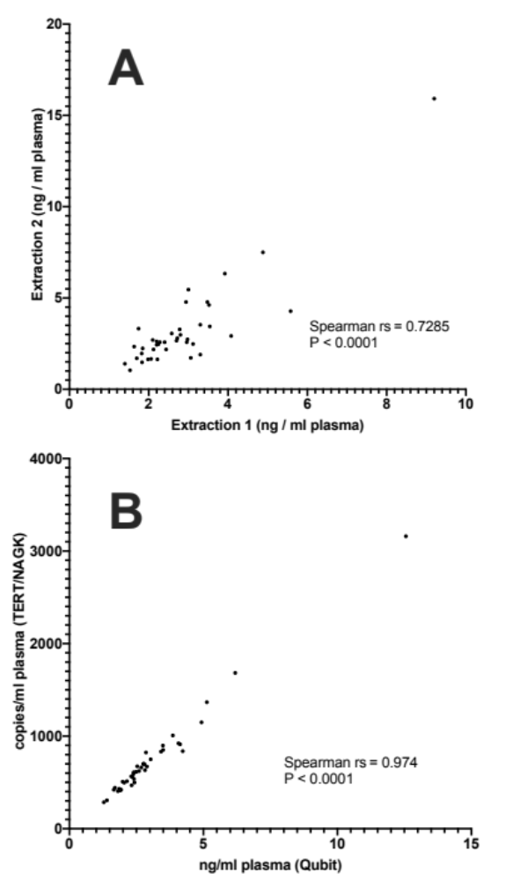
Supplemental Figure S3. Nonparametric Spearman correlation coefficients (rs) calculated between cfDNA extraction 1 and extraction 2 using Qubit measurements (A) and between Qubit and ddPCR (TERT and NAGK averaged) measurements of cfDNA (B). The correlations for both comparisons were statistically significant.

Supplemental Figure S4. Total number of droplets accepted by the QX200 ddPCR droplet reader for nucleic acid quantitation. Number of droplets for each draw are shown for cfDNA cfRNA ddPCR analysis. Technical replicates for each sample were averaged.

Supplemental Figure S5. Negative controls for ddPCR measurement of cDNA derived from cfRNA. Negative controls were measured using ddPCR at the same time as the plasma samples.

Supplemental Table S1. Total plasma cfDNA concentration summaries and statistics as measured by Qubit.

 |  | HD1 | HD2 |  | HD3 | HD4 |  | Overall
Number of values |  | 10 | 10 |  | 10 | 10 |  | 4
Minimumª |  | 1.28 | 2.39 |  | 2.32 | 1.81 |  | 1.82
Medianª |  | 1.88 | 3.46 |  | 3.56 | 2.47 |  | 2.89
Maximumª |  | 2.49 | 4.13 |  | 12.56 | 2.86 |  | 4.61
Meanª |  | 1.82 | 3.31 |  | 4.61 | 2.47 |  | 3.05
Std. Deviationª |  | 0.34 | 0.64 |  | 3.10 | 0.33 |  | 1.20
Lower 95% CI of meanª |  | 1.58 | 2.85 |  | 2.39 | 2.23 |  | 1.14
Upper 95% CI of meanª |  | 2.07 | 3.76 |  | 6.82 | 2.71 |  | 4.96
Post-hoc pairwise comparison | P-value |  |  | Adjusted P |  |  | Summary^{b}
HD1 - HD2 | 0.005 |  |  | 0.030 |  |  | *
HD1 - HD3 | 0.020 |  |  | 0.030 |  |  | *
HD1 - HD4 | 0.016 |  |  | 0.030 |  |  | *
HD2 - HD3 | 0.142 |  |  | 0.142 |  |  | ns
HD2 - HD4 | 0.016 |  |  | 0.030 |  |  | *
HD3 - HD4 | 0.040 |  |  | 0.049 |  |  | *

ªng per ml plasma
^{b} *, P < 0.05; ns, not significant.

Supplemental Table S2. Plasma TERT concentration summaries and statistics as measured by ddPCR.

 | HD1 | HD2 | HD3 | HD4 | Overall
Number of values | 10 | 10 | 10 | 10 | 4
Minimumª | 329.5 | 541.8 | 476.9 | 420.5 | 461.2
Medianª | 452.2 | 878.9 | 779.8 | 612.5 | 722
Maximumª | 610.3 | 1018 | 3282 | 846.4 | 1129
Meanª | 461.2 | 815.5 | 1129 | 628.5 | 758.6
Std. Deviationª | 90.9 | 150.3 | 870.2 | 139.2 | 286.2
Lower 95% CI of meanª | 396.2 | 708 | 506.5 | 528.9 | 303.1
Upper 95% CI of meanª | 526.3 | 923 | 1752 | 728.1 | 1214

Post-hoc pairwise comparison | P-value | Adjusted P | Summary^{b}
HD1 - HD2 | 0.006 | 0.035 | *
HD1 - HD3 | 0.027 | 0.048 | *
HD1 - HD4 | 0.032 | 0.048 | *
HD2 - HD3 | 0.176 | 0.176 | ns
HD2 - HD4 | 0.032 | 0.048 | *
HD3 - HD4 | 0.060 | 0.073 | ns

ªcopies per ml plasma
^{b} *, P < 0.05; ns, not significant.
Supplemental Table S3. Plasma NAGK concentration summaries and statistics as measured by ddPCR.

 | HD1 | HD2 | HD3 | HD4 | Overall
Number of values | 10 | 10 | 10 | 10 | 4
Minimumª | 242.1 | 569.7 | 430.3 | 389.7 | 407
Medianª | 409.1 | 786.6 | 779.5 | 603.3 | 692
Maximumª | 619.4 | 997.1 | 3037 | 800.5 | 1103
Meanª | 407 | 798.3 | 1103 | 585.6 | 723.5
Std. Deviationª | 106.6 | 141.4 | 771.9 | 106.2 | 299.3
Lower 95% CI of meanª | 330.7 | 697.1 | 551 | 509.6 | 247.2
Upper 95% CI of meanª | 483.2 | 899.5 | 1655 | 661.6 | 1200

Post-hoc pairwise comparison | P-value | Adjusted P | Summary^{b}
HD1 - HD2 | 0.005 | 0.029 | *
HD1 - HD3 | 0.023 | 0.035 | *
HD1 - HD4 | 0.019 | 0.035 | *
HD2 - HD3 | 0.177 | 0.177 | ns
HD2 - HD4 | 0.015 | 0.035 | *
HD3 - HD4 | 0.051 | 0.061 | ns

ªcopies per ml plasma
^{b} *, P < 0.05; ns, not significant.

Supplemental Table S4. Total plasma cfRNA concentration summaries and statistics as measured by Bioanalyzer.

 | HD1 | HD2 | HD3 | HD4 | Overall
Number of values | 10 | 10 | 10 | 10 | 4
Minimumª | 1.036 | 0.966 | 0.805 | 0.777 | 1.439
Medianª | 1.428 | 1.638 | 1.369 | 1.663 | 1.558
Maximumª | 2.576 | 2.072 | 2.667 | 2.072 | 1.575
Meanª | 1.57 | 1.546 | 1.439 | 1.575 | 1.533
Std. Deviationª | 0.492 | 0.3864 | 0.511 | 0.406 | 0.0636
Lower 95% CI of meanª | 1.218 | 1.27 | 1.073 | 1.284 | 1.431
Upper 95% CI of meanª | 1.922 | 1.823 | 1.804 | 1.866 | 1.634

ªng per ml plasma

Supplemental Table S5. Plasma ACTB cDNA concentration summaries and statistics as measured by ddPCR.

 | HD1 | HD2 | HD3 | HD4 | Overall
Number of values | 10 | 10 | 10 | 10 | 4
Minimumª | 4,739 | 7,230 | 12,188 | 7,812 | 18,632
Medianª | 19,413 | 33,055 | 20,199 | 27,020 | 25,652
Maximumª | 28,658 | 44,420 | 39,692 | 64,888 | 30,153
Meanª | 18,632 | 29,989 | 21,314 | 30,153 | 25,022
Std. Deviationª | 7,069 | 12,483 | 9,323 | 15,813 | 5,932
Lower 95% CI of meanª | 13,575 | 21,059 | 14,645 | 18,841 | 15,582
Upper 95% CI of meanª | 23,689 | 38,918 | 27,983 | 41,466 | 34,462

ªcopies per ml plasma

Supplemental Table S6. Plasma GAPDH cDNA concentration summaries and statistics as measured by ddPCR.

 | HD1 | HD2 | HD3 | HD4 | Overall
Number of values | 10 | 10 | 10 | 10 | 4
Minimumª | 786 | 1,498 | 3,040 | 1,284 | 4,532
Medianª | 5,821 | 9,666 | 4,353 | 5,479 | 5,478
Maximumª | 7,656 | 11,525 | 7,582 | 8,839 | 8,444
Meanª | 5,597 | 8,444 | 4,532 | 5,359 | 5,983
Std. Deviationª | 2,151 | 3,372 | 1,484 | 2,031 | 1,703
Lower 95% CI of meanª | 4,059 | 6,032 | 3,471 | 3,907 | 3,273
Upper 95% CI of meanª | 7,136 | 10,856 | 5,594 | 6,812 | 8,693

Post-hoc pairwise comparison | P-value | Adjusted P | Summary^{b}
HD1 - HD2 | 0.084 | 0.169 | ns
HD1 - HD3 | 0.169 | 0.254 | ns
HD1 - HD4 | 0.695 | 0.695 | ns
HD2 - HD3 | 0.039 | 0.169 | ns
HD2 - HD4 | 0.067 | 0.169 | ns
HD3 - HD4 | 0.245 | 0.294 | ns

ªcopies per ml plasma
^{b}ns, not significant.

