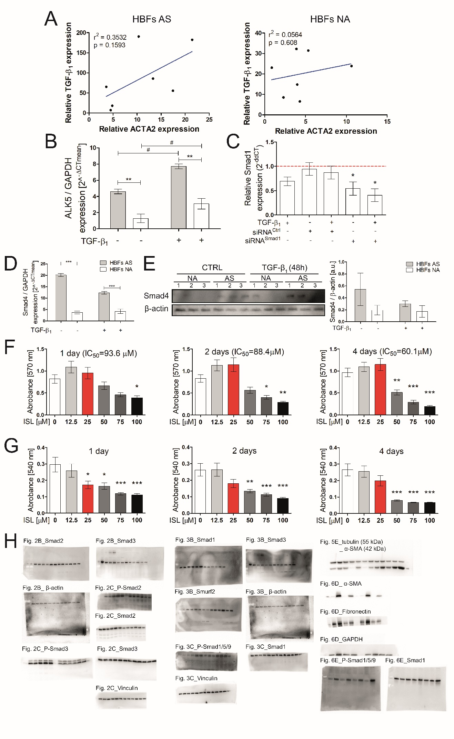
Figure S1.
(A) HBFs (AS: n=7; NA: n=7) were cultured in serum-free conditions in the presence of TGF-β₁ (5ng/ml) for 24 h. RT-qPCR analyses of α-smooth muscle actin (ACTA2) and TGF-β₁ expression were performed. Linear regression has been plotted.
(B) Cells were cultured in a serum-free medium supplemented with TGF-β₁ (5 ng/mL) for 24 h. Then, the mRNA was isolated, and transcripts of ALK5 and Smad4 were analysed using RT-qPCR.
(C) HBFs (n=4) cultured in serum-free medium were transfected with siRNA-Smad1 or control-siRNA were treated with TGF-β₁ (5 ng/ml) for 24 h. Next the RT-qPCR analyse of the level of Smad1 silencing was performed. Red line corresponds to control cells.
(D) HBFs were cultured in a serum-free medium with or without TGF-β₁ (5 ng/mL) for 24 h. RT-qPCR analyses of Smad 4 expression were performed.
(E) Cells were cultured in serum-free medium supplemented with TGF-β₁ (5 ng/mL) for 48 h. Smad4 was detected using immunoblotting.
(F) HBFs (n=8) were cultured in microplates with or without ISL (12.5 μM, 25 μM, 50 μM, 75 μM, 100 μM) for 24 h, 48 h and 4 days. MTT assay were performed and absorbance of formazan product was measured (570 nm). IC50 was calculated for each time of incubation.
(G) HBFs (n=8) were cultured in microplates with or without ISL (12.5 μM, 25 μM, 50 μM, 75 μM, 100 μM) for 24 h, 48 h and 4 days. Crystal Violet assay used to determination of cell proliferation were performed and absorbance of violet was measured (540 nm).
(H) The original, unprocessed versions of immunoblot membranes from Fig. 2 up to Fig.5

