Supporting Information
Rapid Demulsification of Pickering Emulsions Triggered by Controllable Magnetic Field
Hui Yang,^{*,#,a} Shujuan Wang,^{#,a} Wei Zhang,ª Jiazhong Wu,^{b} Siyu Yang,^{b} Danfeng Yu,^{c} Xu Wu,^{c} Yang Sun,^{d} Jinben Wangª
ªCAS Key Lab of Colloid, Interface and Chemical Thermodynamics, Institute of Chemistry, Chinese Academy of Sciences, Beijing 100190, P. R. China
^{b}State Key Laboratory of Enhanced Oil Recovery, Research Institute of Petroleum Exploration and Development of PetroChina, Beijing 100083, P. R. China
^{c}Department of Chemistry and Chemical Engineering, Guangzhou University, Guangzhou, Guangdong 510006, P. R. China
^{d}Center for Physicochemical Analysis and Measurement, Institute of Chemistry, Chinese Academy of Sciences, Beijing 100190, P. R. China
Table S1 Conductivity values in the presence of CIPs at different concentrations.
Particle Concentration wt% | Conductivity  μS/cm
2 | 0.232
5 | 0.835
10 | 0.340
Table S2 Distribution of Particles in the Dodecane-in-Water Pickering Emulsions Stabilized by CIPs Initially in Oil.
Particle concentration/wt% | m_{po}/g | m_{pa}/g | m_{pe}/g | X/%
2 | 0.061 | 0.007 | 0.054 | 88.5
5 | 0.158 | 0.022 | 0.136 | 86.1
10 | 0.333 | 0.083 | 0.25 | 75.1

Table S3 Composition of the Dodecane-in-Water Pickering Emulsions Stabilized by CIPs Initially in Oil.
Particle concentration/wt% | V_{e}/mL | φ_{we}/vol % | φ_{oe}/vol % | m_{pe}/g | φ_{p}/g  (100 mL⁻¹)
2 | 5.4 | 26.0 | 74.0 | 0.054 | 1
5 | 5.7 | 29.8 | 70.2 | 0.136 | 2.4
10 | 6 | 33.3 | 66.7 | 0.25 | 4.2

(a)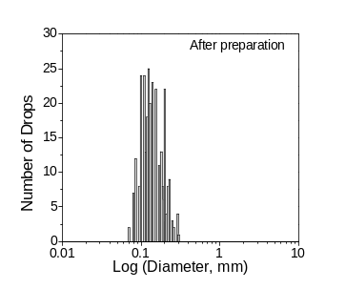 (b) 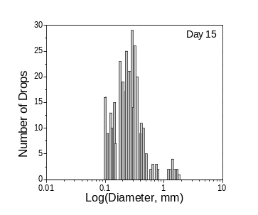
(c)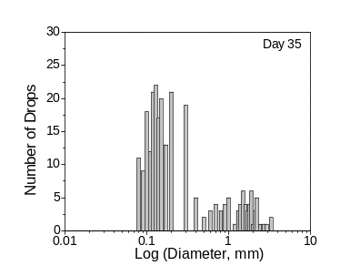 (d)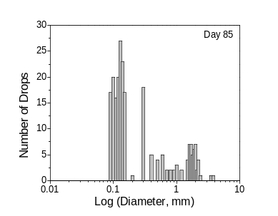
Figure S1. Drop size distributions of emulsions stabilized by CIPs after preparation (a), and placed for 15 day (b), 35 days (c), and 85 days (d) at 5wt%.
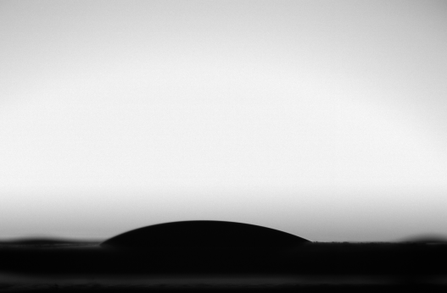
24°
Figure S2 Contact angle (CA) of surfaces pressed by CIPs.
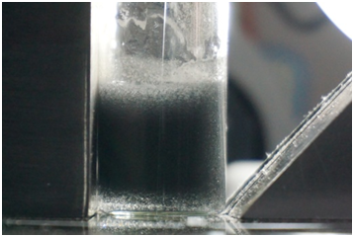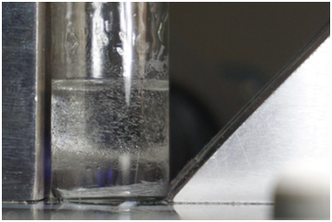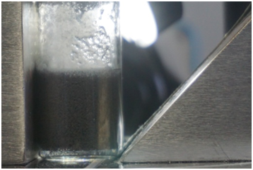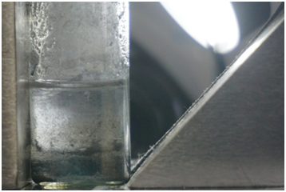
Pickering emulsions
After demulsification
2%
2%
5 min
6 min
10%
10%
a
b
Figure S3 Pickering emulsions stabilized by CIPs under an alternating asymmetrical magnetic field at different concentrations of (a) 2 wt% and (b) 10 wt%.

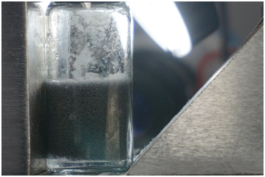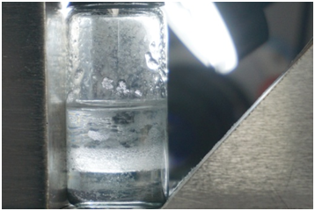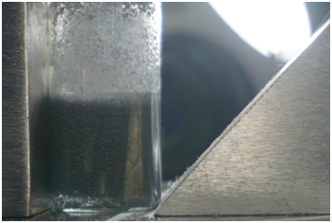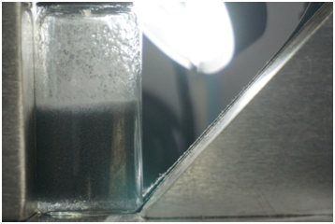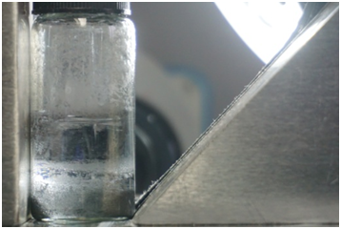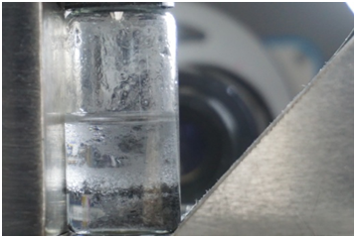
6 min
14 min
22 min
9A 0.2Hz
6A 0.2Hz
4A 0.2Hz
Pickering emulsions
After demulsification
a
b
c
Figure S4 Pickering emulsions stabilized by 5 wt% CIPs under an alternating asymmetrical magnetic field at different currents of (a) 9A, (b) 6A, and (c) 4A.
(a) 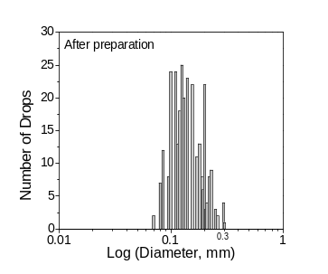 (b)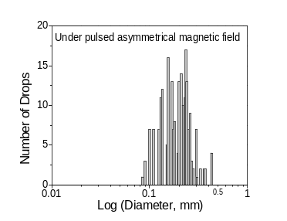
Figure S5. Drop size distributions of emulsions stabilized by CIPs after preparation (a), and under pulsed asymmetrical magnetic field (b).
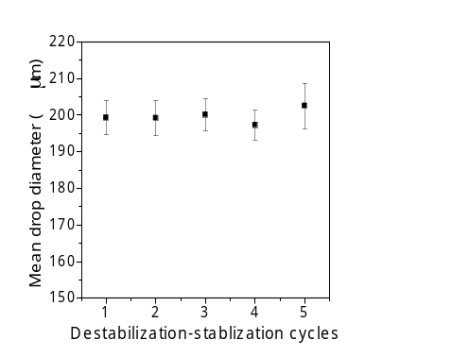
Figure S6. Mean drop size after each cycle of destabilization and reformation.
Oil droplet
CIPs
F_{r1}
F_{r2}
F_{r3}
F_{r4}
N
S
F'_{r1}
N S
N S
N S
N S
N S
N S
N S
N S
N S
N S
N S
N S
N S
N S
N S
N S
N S
N S
N S
N S
N S
N S
N S
N S
N S
N S
N S
N S
N S
N S
N S
N S
N S
N S
N S
N S
N S
N S
N S
N S
N S
N S
N S
N S
N S
N S
N S
N S
N S
N S
N S
N S
N S
N S
N S
N S
N S
N S
N S
N S
N S
N S
N S
N S
N S
N S
N S
N S
N S
N S
N S
N S
N S
N S
N S
F'_{r2}
a. Uniform magnetic field
F_{r5}
F_{r6}
F_{r7}
F_{r8}
N
S
F'_{r3}
N S
N S
N S
N S
N S
N S
N S
N S
N S
N S
N S
N S
N S
N S
N S
N S
N S
N S
N S
N S
N S
N S
N S
N S
N S
N S
N S
N S
N S
N S
N S
N S
N S
N S
N S
N S
N S
N S
N S
N S
N S
N S
N S
N S
N S
N S
N S
N S
N S
N S
N S
N S
N S
N S
N S
N S
N S
N S
N S
N S
N S
N S
N S
N S
N S
N S
N S
N S
N S
N S
N S
N S
N S
N S
N S
F'_{r4}
b. Non-uniform magnetic field
F_{r1} = F_{r2} = F_{r3} = F_{r4}; F'_{r1} = F'_{r2}
F_{r5} > F_{r6} > F_{r7} > F_{r8}; F'_{r3} > F'_{r4}
Figure S7 Corresponding positioning of particles at a model droplet interface giving a solid-stabilized oil-in-water emulsion and analysis of forces after introducing (a) an uniform magnetic field and (b) a non-uniform magnetic field.
a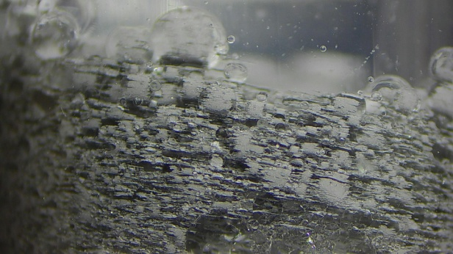 | b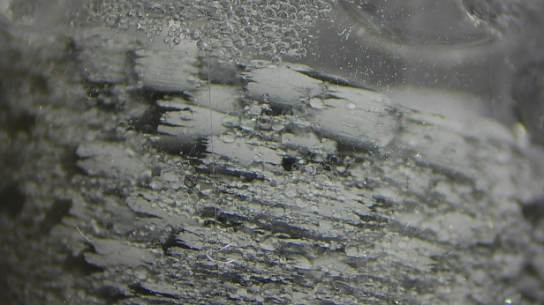 | c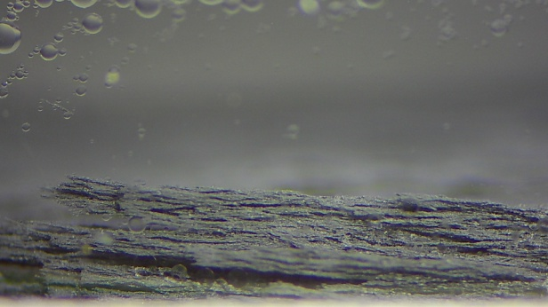
Figure S8 Bottom vial area under magnetic field over time.

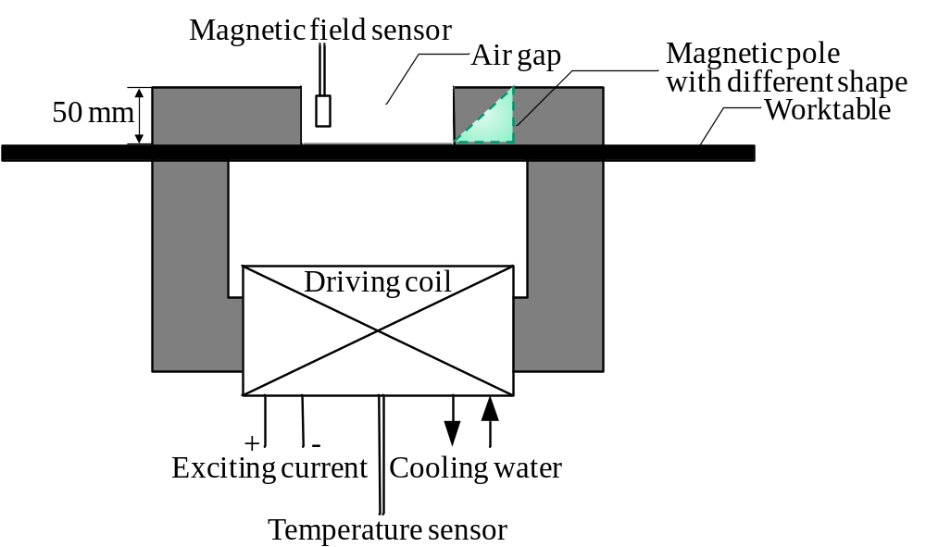
Figure S9 Setup scheme of the electromagnet field generator.

