M1 Macrophage and M1/M2 ratio defined by transcriptomic signatures resemble only part of their conventional clinical characteristics in breast cancer

Masanori Oshi^{1,2†}, Yoshihisa Tokumaru^{1,3†}, Mariko Asaoka^{1,4†}, Li Yan⁵, Vikas Satyananda⁶, Ryusei Matsuyama², Nobuhisa Matsuhashi³, Manabu Futamura³, Takashi Ishikawa⁴, Kazuhiro Yoshida³, Itaru Endo² and Kazuaki Takabe ^{1,2,4,7-9}*

* Authors to whom correspondence should be addressed
† These authors contributed equally

¹ Breast Surgery, Department of Surgical Oncology, Roswell Park Comprehensive Cancer Center, Buffalo, NY 14263, USA
² Department of Gastroenterological Surgery, Yokohama City University Graduate School of Medicine, Yokohama 236-0004, Japan.
³ Department of Surgical Oncology, Graduate School of Medicine, Gifu University, 1-1 Yanagido, Gifu 501-1194, Japan
⁴ Department of Breast Oncology and Surgery, Tokyo Medical University, 6-7-1 Nishishinjuku, Shinjuku, Tokyo, 160-8402, Japan.
⁵ Department of Biostatistics & Bioinformatics, Roswell Park Comprehensive Cancer Center, Buffalo, NY, 14263, USA
⁶ Department of Surgical Oncology, Roswell Park Comprehensive Cancer Center, Buffalo, NY 14263, USA
⁷ Department of Surgery, University at Buffalo Jacobs School of Medicine and Biomedical Sciences, The State University of New York, Buffalo, NY 14263, USA.
⁸ Department of Surgery, Niigata University Graduate School of Medical and Dental Sciences, Niigata 951-8510, Japan.
⁹ Department of Breast Surgery, Fukushima Medical University School of Medicine, Fukushima 960-1295, Japan

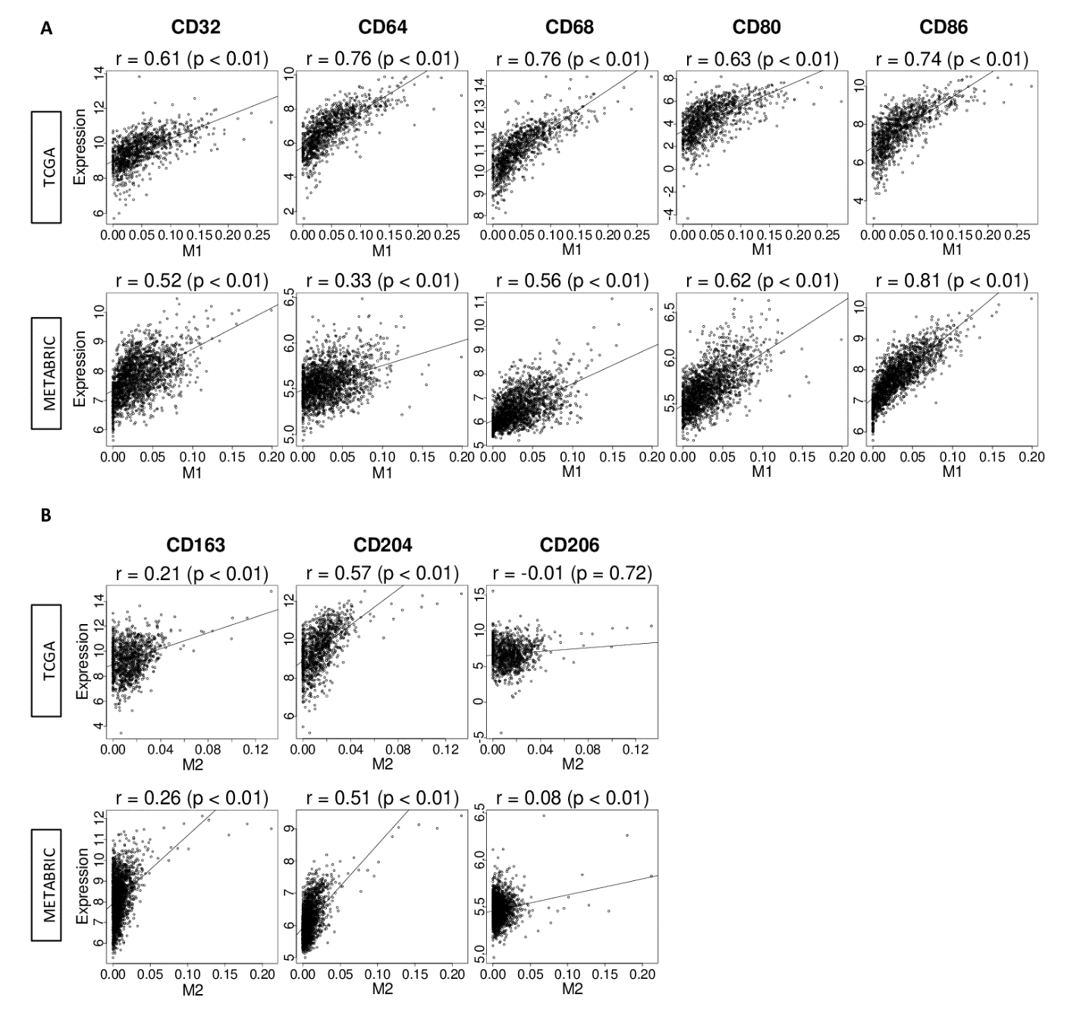
Supplementary Figure S1. (A) “M1” macrophage demonstrated the correlation between previously reported markers of M1 in both TCGA and METBRIC cohort. (B) ”M2” macrophage demonstrated correlation to some of the previously reported markers of M2 in both TCGA and METABRIC cohort.
Supplementary Figure S2. Kaplan Meier survival analysis of DFS, DSS, and OS did not demonstrate the survival benefit of “M1”/”M2” high tumors over “M1”/”M2” low tumors except DFS of TNBC. DFS (Whole, n = 924, High = 468, Low = 456, Hazard ratio (HR) 1.21 (95% Confidence interval [CI]; 0.79-1.86); ER+/HER2-, n = 506, High = 252, Low = 254, HR 1.12 (CI; 0.56-2.25); HER2+, n = 132 , High = 68, Low = 64, HR 0.51 (CI; 0.12-2.15); TNBC, n = 144, High = 71, Low = 73, HR 0.30 (CI; 0.11-2.17)). DSS (Whole, n = 1045, High = 523, low = 522, HR 1.16 (CI; 0.75-1.80); ER+/HER2-, n = 572, High = 288, Low = 284, HR 1.42 (CI; 0.67-3.04); HER2+, n = 153, High = 76, Low = 77, HR 0.41 (CI; 0.11-1.53); TNBC, n = 153, High = 78, Low = 75, HR 0.75 (CI; 0.29-1.94)). OS (Whole, n = 1064, High = 532, low = 532, HR 1.08 (CI; 0.78-1.48); ER+/HER2-, n = 578, High = 289, Low = 289, HR 1.05 (CI; 0.62-1.79); HER2+, n = 156, High = 78, Low = 78, HR 0.42 (CI; 0.17-1.04); TNBC, n = 159, High = 80, Low = 79, HR 0.60 (CI; 0.28-1.29)). M1, “M1” macrophage; M2, “M2” macrophage; DFS, disease free survival; DSS, disease specific survival; OS, overall survival.
Supplementary Figure S3. “M1”/”M2” high tumors did not demonstrate the association with response to neoadjuvant chemotherapy. The association between expression of “M1”/”M2” and pCR rate. GSE20194 (ER+/HER2-, n = 129, High = 60, Low = 69; TNBC, n = 68, High = 34, Low = 34). GSE22358 (ER+/HER2-, n = 67, High = 34, Low = 33; TNBC, n = 50, High = 25, Low = 25). GSE25066 (ER+/HER2-, n = 289, High = 145, Low = 144; TNBC, n = 178, High = 90, Low = 88). GSE32646 (ER+/HER2-, n = 55, High = 28, Low = 27; TNBC, n = 26, High = 13, Low = 13). TNBC, triple negative breast cancer.

Supplementary Figure S4: (A) “M1”/”M2” high tumors were associated with the gene sets related to cell proliferation with only METBRIC cohort. (B) “M1”/”M2” high tumors were associated with Ki-67 transcriptome analysis in both TCGA and METABRIC cohort.

Supplementary Figure S5: “M1”/”M2” high tumors enriched the immune associated gene sets in METABRIC only and demonstrated higher immune activity related scores. (A) M1 high tumors enriched the gene sets related immune activity with METABRIC cohort only. (B) High ratio of “M1”/”M2” was associated with higher score of both favorable and unfavorable immune activity related scores with TCGA.

Supplementary Figure S6: “M1”/”M2” high tumors demonstrated the infiltration of both favorable and unfavorable immune cells in TCGA and METABRIC cohort.
Th1/2, T-helper 1/2; DC, Dendritic Cell; Treg, regulatory T cell; CYT, cytolytic activity score

Supplementary Figure S7: “M1”/”M2” high tumors demonstrated the association with T cell exhaustion markers in both TCGA and METABRIC cohort.
PD-1, programmed death-1; PD-L1/2, programmed death ligand 1/2; CTLA4, cytotoxic T-lymphocyte-associated protein 4; LAG3, lymphocyte activation gene 3.

Supplementary Table S1: Gene Name and Title of the M1 macrophage.

Gene Name | Gene Title
ABCD1 | ATP binding cassette subfamily D member 1
ABI1 | abl interactor 1
ABTB2 | ankyrin repeat and BTB domain containing 2
ACP2 | acid phosphatase 2, lysosomal
ACTR2 | actin related protein 2
ACTR3 | actin related protein 3
ADAMDEC1 | ADAM like decysin 1
ADCK2 | aarF domain containing kinase 2
ADCY3 | adenylate cyclase 3
ADO | 2-aminoethanethiol dioxygenase
ADRA2B | adrenoceptor alpha 2B
AFG3L2 | AFG3 like matrix AAA peptidase subunit 2
AGPS | alkylglycerone phosphate synthase
ALCAM | activated leukocyte cell adhesion molecule
ANXA2 | annexin A2
AP1M2 | adaptor related protein complex 1 subunit mu 2
ARHGEF11 | Rho guanine nucleotide exchange factor 11
ARL8B | ADP ribosylation factor like GTPase 8B
ATOX1 | antioxidant 1 copper chaperone
ATP6V0C | ATPase H+ transporting V0 subunit c
ATP6V1A | ATPase H+ transporting V1 subunit A
ATP6V1D | ATPase H+ transporting V1 subunit D
ATP6V1E1 | ATPase H+ transporting V1 subunit E1
ATP6V1F | ATPase H+ transporting V1 subunit F
ATP6V1H | ATPase H+ transporting V1 subunit H
BCAP31 | B cell receptor associated protein 31
BCKDK | branched chain ketoacid dehydrogenase kinase
BLVRA | biliverdin reductase A
C1QA | complement C1q A chain
C1QB | complement C1q B chain
C3AR1 | complement C3a receptor 1
CALR | calreticulin
CCDC47 | coiled-coil domain containing 47
CCL1 | C-C motif chemokine ligand 1
CCL18 | C-C motif chemokine ligand 18
CCL19 | C-C motif chemokine ligand 19
CCL22 | C-C motif chemokine ligand 22
CCL24 | C-C motif chemokine ligand 24
CCL7 | C-C motif chemokine ligand 7
CCL8 | C-C motif chemokine ligand 8
CCR1 | C-C motif chemokine receptor 1
CD163 | CD163 molecule
CD300C | CD300c molecule
CD48 | CD48 molecule
CD63 | CD63 molecule
CD80 | CD80 molecule
CD84 | CD84 molecule
CECR5 | cat eye syndrome chromosome region, candidate 5
CHIT1 | chitinase 1
CIAO1 | cytosolic iron-sulfur assembly component 1
CLCN7 | chloride voltage-gated channel 7
CLEC4E | C-type lectin domain family 4 member E
CLPB | ClpB homolog, mitochondrial AAA ATPase chaperonin
CLTC | clathrin heavy chain
CMKLR1 | chemerin chemokine-like receptor 1
COQ2 | coenzyme Q2, polyprenyltransferase
CORO7 | coronin 7
COX5B | cytochrome c oxidase subunit 5B
CSF1 | colony stimulating factor 1
CSF1R | colony stimulating factor 1 receptor
CXCL9 | C-X-C motif chemokine ligand 9
CYBB | cytochrome b-245 beta chain
CYC1 | cytochrome c1
CYFIP1 | cytoplasmic FMR1 interacting protein 1
CYP19A1 | cytochrome P450 family 19 subfamily A member 1
DAGLA | diacylglycerol lipase alpha
DLAT | dihydrolipoamide S-acetyltransferase
DNAJC13 | DnaJ heat shock protein family (Hsp40) member C13
DNASE2B | deoxyribonuclease 2 beta
DOT1L | DOT1 like histone lysine methyltransferase
EMILIN1 | elastin microfibril interfacer 1
EXOC5 | exocyst complex component 5
FAM32A | family with sequence similarity 32 member A
FANCE | FA complementation group E
FCER1G | Fc fragment of IgE receptor Ig
FDX1 | ferredoxin 1
FKBP15 | FKBP prolyl isomerase 15
FOLR2 | folate receptor beta
FPR2 | formyl peptide receptor 2
FPR3 | formyl peptide receptor 3
FTL | ferritin light chain
GLRX2 | glutaredoxin 2
GP1BA | glycoprotein Ib platelet subunit alpha
GPD1 | glycerol-3-phosphate dehydrogenase 1
HAMP | hepcidin antimicrobial peptide
HAUS2 | HAUS augmin like complex subunit 2
HEXB | hexosaminidase subunit beta
HK3 | hexokinase 3
HSPB7 | heat shock protein family B (small) member 7
HYAL2 | hyaluronidase 2
IFNAR1 | interferon alpha and beta receptor subunit 1
IGSF6 | immunoglobulin superfamily member 6
IL10 | interleukin 10
IL12B | interleukin 12B
IL17RA | interleukin 17 receptor A
ITGAE | integrin subunit alpha E
ITGB1BP1 | integrin subunit beta 1 binding protein 1
KCNJ1 | potassium voltage-gated channel subfamily J member 1
KCNJ5 | potassium voltage-gated channel subfamily J member 5
KCNK13 | potassium two pore domain channel subfamily K member 13
KIFC3 | kinesin family member C3
LAIR1 | leukocyte associated immunoglobulin like receptor 1
LAMP1 | lysosomal associated membrane protein 1
LILRB1 | Leukocyte Immunoglobulin-Like Receptor, Subfamily B, member 1
LILRB4 | Leukocyte Immunoglobulin-Like Receptor, Subfamily B, member 4
LIMD2 | LIM domain containing 2
LONP1 | lon peptidase 1, mitochondrial
LONRF3 | LON peptidase N-terminal domain and ring finger 3
MAPK13 | mitogen-activated protein kinase 13
MARCO | macrophage receptor with collagenous structure
MFSD7 | major facilitator superfamily domain containing 7
MMP19 | matrix metallopeptidase 19
MRPL12 | mitochondrial ribosomal protein L12
MRPL40 | mitochondrial ribosomal protein L40
MRS2 | magnesium transporter MRS2
MS4A4A | membrane spanning 4-domains A4A
MSR1 | macrophage scavenger receptor 1
MT2A | metallothionein 2A
MYBPH | myosin binding protein H
MYH11 | myosin heavy chain 11
MYO7A | myosin VIIA
MYOF | myoferlin
MYOZ1 | myozenin 1
NARS | asparaginyl-tRNA synthetase
NCAPH | non-SMC condensin I complex subunit H
NDUFAF1 | NADH:ubiquinone oxidoreductase complex assembly factor 1
NDUFS2 | NADH:ubiquinone oxidoreductase core subunit S2
NECAP2 | NECAP endocytosis associated 2
NRBP1 | nuclear receptor binding protein 1
OGFR | opioid growth factor receptor
OTUD4 | OTU deubiquitinase 4
P2RX7 | purinergic receptor P2X 7
PDCL | phosducin like
PHLDB1 | pleckstrin homology like domain family B member 1
PKD2L1 | polycystin 2 like 1, transient receptor potential cation channel
PLEKHB2 | pleckstrin homology domain containing B2
PQLC2 | PQ loop repeat containing 2
PRDX1 | peroxiredoxin 1
PTGIR | prostaglandin I2 receptor
PTPRA | protein tyrosine phosphatase receptor type A
RAB3IL1 | RAB3A interacting protein like 1
RELA | RELA proto-oncogene, NF-kB subunit
RNH1 | ribonuclease/angiogenin inhibitor 1
RRP1 | ribosomal RNA processing 1
S100A11 | S100 calcium binding protein A11
S1PR2 | sphingosine-1-phosphate receptor 2
SCAMP2 | secretory carrier membrane protein 2
SDS | serine dehydratase
SIGLEC1 | sialic acid binding Ig like lectin 1
SIGLEC7 | sialic acid binding Ig like lectin 7
SIGLEC9 | sialic acid binding Ig like lectin 9
SLAMF8 | SLAM family member 8
SLC11A1 | solute carrier family 11 member 1
SLC1A2 | solute carrier family 1 member 2
SLC25A24 | solute carrier family 25 member 24
SLC31A1 | solute carrier family 31 member 1
SLC6A12 | solute carrier family 6 member 12
SNX3 | sorting nexin 3
SPG21 | SPG21 abhydrolase domain containing, maspardin
SPR | sepiapterin reductase
SRC | SRC proto-oncogene, non-receptor tyrosine kinase
STIP1 | stress induced phosphoprotein 1
STX12 | syntaxin 12
STX4 | syntaxin 4
TBC1D16 | TBC1 domain family member 16
TCEB1 | transcription elongation factor B, polypeptide 1
TDRD7 | tudor domain containing 7
TFEC | transcription factor EC
TFRC | transferrin receptor
TIE1 | tyrosine kinase with immunoglobulin like and EGF like domains 1
TMEM33 | transmembrane protein 33
TMEM70 | transmembrane protein 70
TMX1 | thioredoxin related transmembrane protein 1
TPP1 | tripeptidyl peptidase 1
TREM2 | triggering receptor expressed on myeloid cells 2
TRIP4 | thyroid hormone receptor interactor 4
TSPO | translocator protein
UQCR11 | ubiquinol-cytochrome c reductase, complex III subunit XI
USP14 | ubiquitin specific peptidase 14
UTP3 | UTP3 small subunit processome component
VIM | vimentin
VPS33A | VPS33A core subunit of CORVET and HOPS complexes
VSIG4 | V-set and immunoglobulin domain containing 4
WDR11 | WD repeat domain 11
WSB2 | WD repeat and SOCS box containing 2
WTAP | WT1 associated protein
ZC3H15 | zinc finger CCCH-type containing 15
ZMPSTE24 | zinc metallopeptidase STE24

Supplementary Table S2: Gene Name and Title of the M2 macrophage.

Gene Name | Gene Title
ABCD1 | ATP binding cassette subfamily D member 1
ACP2 | acid phosphatase 2, lysosomal
ACSM5 | acyl-CoA synthetase medium chain family member 5
ADAMDEC1 | ADAM like decysin 1
ADCY3 | adenylate cyclase 3
ADRA2B | adrenoceptor alpha 2B
AGGF1 | angiogenic factor with G patch and FHA domains 1
AKR7A2 | aldo-keto reductase family 7, member A2
ALDH9A1 | aldehyde dehydrogenase 9 family member A1
ALG9 | ALG9 alpha-1,2-mannosyltransferase
ALK | ALK receptor tyrosine kinase
ANGPT4 | angiopoietin 4
ANKFY1 | ankyrin repeat and FYVE domain containing 1
ANXA11 | annexin A11
AP1B1 | adaptor related protein complex 1 subunit beta 1
AQP8 | aquaporin 8
ARFGEF2 | ADP ribosylation factor guanine nucleotide exchange factor 2
ARHGEF11 | Rho guanine nucleotide exchange factor 11
ARSB | arylsulfatase B
ATP2A2 | ATPase sarcoplasmic/endoplasmic reticulum Ca2+ transporting 2
ATP6V0A1 | ATPase H+ transporting V0 subunit a1
ATP6V0D1 | ATPase H+ transporting V0 subunit d1
ATP6V1C1 | ATPase H+ transporting V1 subunit C1
ATP6V1D | ATPase H+ transporting V1 subunit D
BAIAP2 | BAI1 associated protein 2
BCAP31 | B cell receptor associated protein 31
BTBD1 | BTB domain containing 1
C10orf76 | chromosome 10 open reading frame 76
C16orf62 | chromosome 16 open reading frame 62
CAMP | cathelicidin antimicrobial peptide
CANX | calnexin
CARD14 | caspase recruitment domain family member 14
CCDC85C | coiled-coil domain containing 85C
CCDC88A | coiled-coil domain containing 88A
CD52 | CD52 molecule
CD63 | CD63 molecule
CD81 | CD81 molecule
CDS2 | CDP-diacylglycerol synthase 2
CEPT1 | choline/ethanolamine phosphotransferase 1
CLCN7 | chloride voltage-gated channel 7
COL4A3BP | collagen type IV alpha 3 binding protein
COMMD9 | COMM domain containing 9
CYFIP1 | cytoplasmic FMR1 interacting protein 1
DHX57 | DExH-box helicase 57
DNASE1L3 | deoxyribonuclease 1 like 3
DNASE2B | deoxyribonuclease 2 beta
EFR3A | EFR3 homolog A
ELK1 | ETS transcription factor ELK1
EXOC1 | exocyst complex component 1
FDX1 | ferredoxin 1
FGR | FGR proto-oncogene, Src family tyrosine kinase
FH | fumarate hydratase
FKBP15 | FKBP prolyl isomerase 15
FLT1 | fms related tyrosine kinase 1
FTL | ferritin light chain
GABARAP | GABA type A receptor-associated protein
GGA1 | golgi associated, gamma adaptin ear containing, ARF binding protein 1
GLB1 | galactosidase beta 1
GORASP1 | golgi reassembly stacking protein 1
GPD1 | glycerol-3-phosphate dehydrogenase 1
GSTO1 | glutathione S-transferase omega 1
GUCA1A | guanylate cyclase activator 1A
HADHB | hydroxyacyl-CoA dehydrogenase trifunctional multienzyme complex subunit beta
HAMP | hepcidin antimicrobial peptide
HEXA | hexosaminidase subunit alpha
HEXB | hexosaminidase subunit beta
HPS1 | HPS1 biogenesis of lysosomal organelles complex 3 subunit 1
HS3ST2 | heparan sulfate-glucosamine 3-sulfotransferase 2
HSPH1 | heat shock protein family H (Hsp110) member 1
IARS2 | isoleucyl-tRNA synthetase 2, mitochondrial
IFNAR1 | interferon alpha and beta receptor subunit 1
IPPK | inositol-pentakisphosphate 2-kinase
ITGAX | integrin subunit alpha X
KCNJ1 | potassium voltage-gated channel subfamily J member 1
KCNJ5 | potassium voltage-gated channel subfamily J member 5
KCNK13 | potassium two pore domain channel subfamily K member 13
KCTD5 | potassium channel tetramerization domain containing 5
KIAA0196 | KIAA0196
LAIR1 | leukocyte associated immunoglobulin like receptor 1
LAMP1 | lysosomal associated membrane protein 1
LILRA2 | leukocyte immunoglobulin-like receptor, subfamily A (with TM domain), member 2
LILRB4 | leukocyte immunoglobulin-like receptor, subfamily B (with TM and ITIM domains), member 4
LONRF3 | LON peptidase N-terminal domain and ring finger 3
MARCO | macrophage receptor with collagenous structure
MFN1 | mitofusin 1
MMP19 | matrix metallopeptidase 19
MRM1 | mitochondrial rRNA methyltransferase 1
MS4A4A | membrane spanning 4-domains A4A
MSR1 | macrophage scavenger receptor 1
MTMR14 | myotubularin related protein 14
MYO15A | myosin XVA
MYO9B | myosin IXB
MYOZ1 | myozenin 1
NAGPA | N-acetylglucosamine-1-phosphodiester alpha-N-acetylglucosaminidase
NCAPH | non-SMC condensin I complex subunit H
NCKAP1L | NCK associated protein 1 like
NDUFB1 | NADH:ubiquinone oxidoreductase subunit B10
NFS1 | NFS1 cysteine desulfurase
NOP10 | NOP10 ribonucleoprotein
NPR1 | natriuretic peptide receptor 1
OS9 | OS9 endoplasmic reticulum lectin
OSBPL11 | oxysterol binding protein like 11
P2RX7 | purinergic receptor P2X 7
PABPC4 | poly(A) binding protein cytoplasmic 4
PDCD6IP | programmed cell death 6 interacting protein
PDE1B | phosphodiesterase 1B
PEX19 | peroxisomal biogenesis factor 19
PICK1 | protein interacting with PRKCA 1
PLEKHM2 | pleckstrin homology and RUN domain containing M2
POGK | pogo transposable element derived with KRAB domain
PQLC2 | PQ loop repeat containing 2
RIN2 | Ras and Rab interactor 2
S100A6 | S100 calcium binding protein A6
SCAMP2 | secretory carrier membrane protein 2
SDCBP | syndecan binding protein
SDS | serine dehydratase
SLAMF8 | SLAM family member 8
SLC25A24 | solute carrier family 25 member 24
SLC25A46 | solute carrier family 25 member 46
SLC31A1 | solute carrier family 31 member 1
SLC38A7 | solute carrier family 38 member 7
SLC39A1 | solute carrier family 39 member 1
SLC6A12 | solute carrier family 6 member 12
SLC6A7 | solute carrier family 6 member 7
SLC9A6 | solute carrier family 9 member A6
SMG5 | SMG5 nonsense mediated mRNA decay factor
SNAPC2 | small nuclear RNA activating complex polypeptide 2
SNX1 | sorting nexin 1
SNX2 | sorting nexin 2
SNX3 | sorting nexin 3
SNX5 | sorting nexin 5
SPG21 | SPG21 abhydrolase domain containing, maspardin
STX18 | syntaxin 18
STX4 | syntaxin 4
TAF10 | TATA-box binding protein associated factor 10
TBC1D9B | TBC1 domain family member 9B
TFEC | transcription factor EC
TMED5 | transmembrane p24 trafficking protein 5
TMEM184C | transmembrane protein 184C
TMEM70 | transmembrane protein 70
TMEM9B | TMEM9 domain family member B
TNFSF14 | TNF superfamily member 14
TPP1 | tripeptidyl peptidase 1
TREM2 | triggering receptor expressed on myeloid cells 2
TSPO | translocator protein
UBXN6 | UBX domain protein 6
UCP3 | uncoupling protein 3
UGP2 | UDP-glucose pyrophosphorylase 2
UNC50 | unc-50 inner nuclear membrane RNA binding protein
USF2 | upstream transcription factor 2, c-fos interacting
VPS35 | VPS35 retromer complex component
VPS53 | VPS53 subunit of GARP complex
VSIG4 | V-set and immunoglobulin domain containing 4
VTI1B | vesicle transport through interaction with t-SNAREs 1B
WDFY3 | WD repeat and FYVE domain containing 3
XPNPEP2 | X-prolyl aminopeptidase 2
ZC3H3 | zinc finger CCCH-type containing 3
ZCCHC4 | zinc finger CCHC-type containing 4
ZNF219 | zinc finger protein 219

