Supplementary Information

Diel vertical migration into anoxic and high-pCO₂ waters: Acoustic and net-based krill observations in the Humboldt Current

Ramiro Riquelme-Bugueño1,2,*, Iván Pérez-Santos3,4, Nicolás Alegría5, Cristian A. Vargas2,6, Mauricio A. Urbina1,2 and Rubén Escribano2,7,+.

1 Departamento de Zoología, Facultad de Ciencias Naturales y Oceanográficas, Universidad de Concepción, Chile
2 Instituto Milenio de Oceanografía (IMO), Universidad de Concepción, Chile.
3 Centro i~mar, Universidad de Los Lagos, Puerto Montt, Chile.
4 COPAS Sur-Austral, Universidad de Concepción, Campus Concepción, Víctor Lamas 1290, Casilla 160-C, CP 4070043, Chile.
5 Instituto de Investigación Pesquera, Talcahuano, Chile.
6 Coastal Ecosystems & Global Environmental Change Lab (ECCA Lab), Department of Aquatic Systems, Faculty of Environmental Sciences & Center for the Study of Multiple-Drivers on Marine Socio-Ecological Systems (MUSELS), Universidad de Concepción, Chile.
7 Departamento de Oceanografía, Facultad de Ciencias Naturales y Oceanográficas, Universidad de Concepción, Chile

* rriquelm@udec.cl

Table S1. System parameters used to collect acoustic data and the calibration results.

Parameters | Setting
Frequency (kHz) | 38 | 70
Power setting (w) | 2000 | 750
Pulse duration (ms) | 1024 | 1024
Data collection range (min–max, m) | 0–1000 | 0–1000
Transducer gain (dB) | 26.45 | 27.00
Absorption coefficient (dB km⁻¹) | 9.1 | 22.8
Sound speed (m s⁻¹) | 1493.9 | 1493.9
s_{A} correction (dB) | -0.62 | -0.54

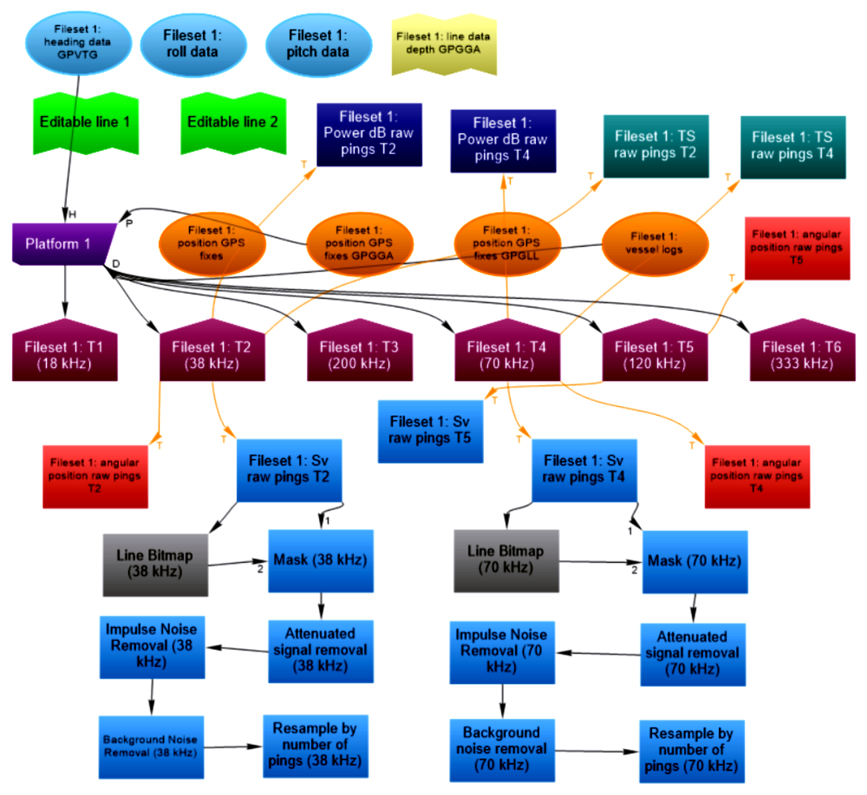

Fig S1. Flow chart (Echoview software) with operators used to analyse the acoustic data of the 38 and 70 kHz frequencies.

