Molecular changes associated with spontaneous phenotypic variation of Paenibacillus polymyxa, a commonly used biocontrol agent, and temperature-dependent control of variation
Running title: Phenotypic variation of Paenibacillus polymyxa and its control during mass production

Younmi Lee^{1, 2}, Young Soo Kim¹, Kotnala Balaraju², Young-Su Seo³, Jungwook Park³, Choong-Min Ryu^{4,5}, Seung-Hwan Park^{4,5}, Jihyun F. Kim^{6, 7}, Seogchan Kang⁸, Yongho Jeon¹*

¹Department of Plant Medicals, Andong National University, Andong 36729, Republic of Korea
²Agricultural Science & Technology Research Institute, Andong National University, Andong, 36729, Republic of Korea
³Department of Microbiology, Pusan National University, Pusan 46241, Republic of Korea
⁴Infectious Disease Research Centre, KRIBB, Daejeon 34141, Republic of Korea
⁵Department of Biosystems and Bioengineering, KRIBB School of Biotechnology, Korea University of Science and Technology, Daejeon 34141, Republic of Korea
⁶Department of Systems Biology, Division of Life Sciences, and Institute for Life Science and Biotechnology, Yonsei University, Seoul 03722, Republic of Korea
⁷Strategic Initiative for Microbiomes in Agriculture and Food (iMAF), Yonsei University, Seoul 03722, Republic of Korea
⁸Department of Plant Pathology & Environmental Microbiology, Pennsylvania State University, University Park, PA 16802, USA

*Corresponding author: Yongho Jeon
E-mail: yongbac@andong.ac.kr
Tel: +82-54-820-5507
Fax: +82-54-820-6320

Supporting information (SI)
Materials and Methods
Mass culture. To commercialize this bacterium for use in the field conditions, the bacterial culture (1.5 L) was inoculated into 250 L capacity fermenter (KoBioTech Co., Ltd., Incheon, Korea) containing industrial medium (Glucose 5.45g, MSG 3.25g, yeast extract 0.67g, KH₂PO₄ 0.27g, CaCl₂ 0.27g, FeSO₄ 0.005g, MgSO₄ 0.08g, MnSO₄ 0.005g, CuSO₄ 0.003g, ZnSO₄ 0.003g per liter), and incubated for 7 days at 30 ℃ with 80 rpm, and air pressure 50 L/min. The seed culture (inoculum) was prepared by culturing the bacterial cells in 4 L capacity conical flask containing industrial medium and incubating for 48 h at 30 ℃ with 150 rpm.
Transmission electron microscopy (TEM) and scanning electron microscopy (SEM) imaging. TEM was used to observe the morphological changes in both B- and F-types over 3 days. Samples for TEM were prepared and the images were captured as per the method described by Jeon et al¹. Morphological and biochemical properties were identified, evaluated, and compared, as described in Bergey’s Manual of Systematic Bacteriology². For SEM, the images of colonized root tips of cucumbers were captured as per the protocol described by Santos et al³.

Assessment of swarming motility. To assess for motility, 5 µl of B-type or F-type broth culture (1×10⁶ cfu/mL) was added dropwise on 1% agar TSA plates⁴. The diameters of the swarming zones were measured after incubation at 28 °C for 48 h.

Siderophore production and biofilm formation. Siderophore production was determined following the method of Schwyn and Neilands⁵. Briefly, a 6 μl sample of the 24-h-old bacterial cultures were spotted on CAS (chrome-azurol S) agar plates. The diameter of the orange halos was measured after the incubation of the plates at 28 °C for 48 h. The ability of the bacteria to form a biofilm on abiotic surfaces was evaluated using a method described previously by Ferrieres and Clarke⁶. Briefly, B-type and F-type colonies were cultured in TSB for 24 h, diluted 100-fold with TSB, and loaded into 96-well polystyrene plates (200 µl/well). TSB alone was used as a control. After incubating the cultures at 28 °C for 72 h without shaking, the cultures were carefully withdrawn with a pipette and the plates were washed twice with water. Each well received 200 µl of 1% (w/v) crystal violet, and the plates were allowed to stand for 15 min at room temperature. The solution was then withdrawn with a pipette, and the plates were carefully washed with water. Dye that had bound to the cells adsorbed on the walls of the wells was dissolved in acetone–ethanol (20:80; 200 µl/well). Biofilm-forming ability was evaluated by the intensity of the color of the solution. For the plates, the absorbance (OD at 595 nm) was read on a Multiskan Ascent analyzer (Thermo Fisher, Vantaa, Finland).

In vitro antagonism and protease activity. The antagonistic properties of B- and F-types were tested in vitro against plant pathogenic fungi, including, Rhizoctonia solani, Colletotrichum gloeosporioides, and Cylindrocarpon destructans, and against Escherichia coli DH5α. All the isolates were provided by the Korean Agricultural Culture Collection (KACC), Suwon, Korea. Mycelial plugs were applied to the center of the potato dextrose agar (PDA) plate that was covered in a bacterial suspension. To test for antibacterial properties, E. coli DH5α was spread uniformly onto a TSA plate and 10 µl of B-type or F-type in TSB (1×10⁶ cfu/mL) was dropped onto a 5 mm sterile disk or directly onto the agar. Plates were incubated for 7 days at 28 °C and the antifungal/antibacterial activity was defined in terms of the zone of inhibition size. To test for protease activity in vitro, B-type and F-type cell suspensions were plated on TSA supplemented with 1% (w/v) skimmed milk. The plates were incubated for 7 days at 28 °C and zones of the clearing were indicative of enzyme activity.

Determination of IAA quantification. Indole-3-acetic acid (IAA) quantification assay was performed using the method described by Meza et al⁷. For the quantitative determination of IAA, the colorimetric Salkowski’s assay was performed⁸. IAA was quantified by integrating areas under peaks with authentic IAA (Sigma) as the standard.

Plant growth-promoting effect on cucumbers. Surface-sterilized cucumber (Cucumis sativus L. var. Eunsung-backdadagi) seeds were used for the growth-promoting assay. The surface-sterilized seeds were dipped in B-type or F-type cell suspensions (1 × 10⁶ cfu/mL) or SDW (control) for 20 min under shaking conditions at 150 rpm, and then air-dried. The seeds were transferred between the paper layers and kept in sealed plastic bags. The root lengths of germinated seedlings were measured 6 days after incubation at 20 ℃.

References
- Jeon, Y. H., Kim, S. G., Hwang, I. & Kim, Y. H. Effects of initial inoculation density of Paenibacillus polymyxa on colony formation and starch-hydrolytic activity in relation to root rot in ginseng. J Appl Microbiol 109, 461–470 (2010).

- Debois, D. et al. Bergey’s Manual of Systematic Bacteriology Vol. 3 (eds P Vos et al.) (Springer, New York, 2009).

- Santos F, et al. A novel interaction between plant-beneficial rhizobacteria and roots: colonization induces corn resistance against the root herbivore Diabrotica speciosa. PLoS One 9, e113280 (2014).

- Tremblay, J., Richardson, A., Lepine, F. & Deziel, E. Self-produced extracellular stimuli modulate the Pseudomonas aeruginosa swarming motility behaviour. Envi Microbiol 9, 2622–2630 (2007).

- Schwyn, B. & Neilands, J. B. Universal chemical assay for the detection and determination of siderophores. Anal Biochem 160, 47–56 (1987).

- Ferrieres, L & Clarke, D. The RcsC sensor kinase is required for normal biofilm formation in Escherichia coli K12 and controls the expression of a regulon in response to growth on a solid surface. Mol Microbiol 50, 1665–1682 (2003).

- Meza, B., de-Bashan, L. E. & Bashan, Y. Involvement of indole-3-acetic acid produced by Azospirillum brasilense in accumulating intracellular ammonium in Chlorella vulgaris. Res Microbiol 166, 72–83 (2015).

- Gordon, S. A. & Weber, R. P. Colorimetric estimation of indoleacetic acid. Plant Physiol 26, 192-195 (1951).

Supplementary tables

Table S1 Transcriptome sequencing results for B and F types of E681
Sample | Direction | Raw | Filtering | Matching | Mapping
B | R1 | 80 090 435 | 74 092 479 | 66 735 650 | 32 069 380
B | R2 | 80 090 435 | 70 050 839 | 66 735 650 | 32 069 380
F | R1 | 69 408 784 | 65 164 819 | 59 801 781 | 55 575 382
F | R2 | 69 408 784 | 62 026 047 | 59 801 781 | 55 575 382

Table S2 Gene Ontology (GO) functional annotation of differentially expressed genes (DEG).
Class | GO ID | GO | # of genes | p-value
biological_process | GO:0071973 | bacterial-type flagellum-dependent cell motility | 15 | 0.000
biological_process | GO:0006189 | 'de novo' IMP biosynthetic process | 13 | 0.000
biological_process | GO:0030435 | sporulation resulting in formation of a cellular spore | 10 | 0.000
biological_process | GO:0044780 | bacterial-type flagellum assembly | 8 | 0.000
biological_process | GO:0006935 | chemotaxis | 12 | 0.000
biological_process | GO:0008643 | carbohydrate transport | 22 | 0.000
biological_process | GO:0006810 | transport | 29 | 0.001
biological_process | GO:0006629 | lipid metabolic process | 6 | 0.003
biological_process | GO:0030436 | asexual sporulation | 4 | 0.007
biological_process | GO:0044781 | bacterial-type flagellum organization | 3 | 0.008
biological_process | GO:0006352 | DNA-templated transcription, initiation | 10 | 0.010
biological_process | GO:0044205 | 'de novo' UMP biosynthetic process | 5 | 0.011
biological_process | GO:0006099 | tricarboxylic acid cycle | 6 | 0.021
biological_process | GO:0007059 | chromosome segregation | 2 | 0.042
biological_process | GO:0009113 | purine nucleobase biosynthetic process | 2 | 0.042
biological_process | GO:0042882 | L-arabinose transport | 2 | 0.042
cellular_component | GO:0009425 | bacterial-type flagellum basal body | 7 | 0.000
cellular_component | GO:0016021 | integral component of membrane | 250 | 0.001
cellular_component | GO:0009288 | bacterial-type flagellum | 3 | 0.008
cellular_component | GO:0009424 | bacterial-type flagellum hook | 3 | 0.008
cellular_component | GO:0005576 | extracellular region | 5 | 0.035
cellular_component | GO:0005886 | plasma membrane | 59 | 0.041
cellular_component | GO:0042601 | endospore-forming forespore | 2 | 0.042
molecular_function | GO:0003774 | motor activity | 6 | 0.000
molecular_function | GO:0005198 | structural molecule activity | 5 | 0.000
molecular_function | GO:0004553 | hydrolase activity, hydrolyzing O-glycosyl compounds | 11 | 0.002
molecular_function | GO:0016740 | transferase activity | 24 | 0.008
molecular_function | GO:0004642 | phosphoribosylformylglycinamidine synthase activity | 3 | 0.008
molecular_function | GO:0016987 | sigma factor activity | 10 | 0.014
molecular_function | GO:0016829 | lyase activity | 11 | 0.017
molecular_function | GO:0016757 | transferase activity, transferring glycosyl groups | 7 | 0.020
molecular_function | GO:0008745 | N-acetylmuramoyl-L-alanine amidase activity | 4 | 0.036
molecular_function | GO:0004088 | carbamoyl-phosphate synthase (glutamine-hydrolyzing) activity | 2 | 0.042
molecular_function | GO:0004644 | phosphoribosylglycinamide formyltransferase activity | 2 | 0.042
molecular_function | GO:0004739 | pyruvate dehydrogenase (acetyl-transferring) activity | 2 | 0.042
molecular_function | GO:0005509 | calcium ion binding | 2 | 0.042
molecular_function | GO:0008514 | organic anion transmembrane transporter activity | 2 | 0.042
molecular_function | GO:0008565 | protein transporter activity | 2 | 0.042
molecular_function | GO:0015612 | L-arabinose-importing ATPase activity | 2 | 0.042
molecular_function | GO:0043365 | [formate-C-acetyltransferase]-activating enzyme activity | 2 | 0.042
molecular_function | GO:0045735 | nutrient reservoir activity | 2 | 0.042
molecular_function | GO:0047371 | butyrate-acetoacetate CoA-transferase activity | 2 | 0.042
molecular_function | GO:0051539 | 4 iron, 4 sulfur cluster binding | 13 | 0.049

Table S3 Summary of KEGG pathways associated with ≥ 2-fold DEGs
ID | Pathway | p-value
ppy02040 | Flagellar assembly | 0
ppy02030 | Bacterial chemotaxis | 3.35E-11
ppy00020 | Citrate cycle (TCA cycle) | 0.000121325
ppy00520 | Amino sugar and nucleotide sugar metabolism | 0.000489019
ppy02020 | Two-component system | 0.002995599
ppy02010 | ABC transporters | 0.003554139
ppy00670 | One carbon pool by folate | 0.027934135
ppy00650 | Butanoate metabolism | 2.49E-06
ppy00071 | Fatty acid degradation | 8.49E-05
ppy00625 | Chloroalkane and chloroalkene degradation | 0.000241879
ppy00626 | Naphthalene degradation | 0.000279292
ppy00350 | Tyrosine metabolism | 0.001063487
ppy00640 | Propanoate metabolism | 0.002539041
ppy01100 | Metabolic pathways | 0.004282199
ppy00072 | Synthesis and degradation of ketone bodies | 0.004315507
ppy01220 | Degradation of aromatic compounds | 0.00482077
ppy00310 | Lysine degradation | 0.008034461
ppy03450 | Non-homologous end-joining | 0.012387936
ppy00440 | Phosphonate and phosphinate metabolism | 0.017497167
ppy01120 | Microbial metabolism in diverse environments | 0.020762284
ppy00620 | Pyruvate metabolism | 0.03485157
ppy00627 | Aminobenzoate degradation | 0.037833094

Table S4 Expression of all the genes constituting GO pathways associated with sporulation
GO id | GO | Description | Locus_tag | B | F | log2  Fold change | p-value
GO:  0030435 | sporulation resulting in formation of a cellular spore | RNA polymerase sigma factor SigD | PPE_RS09310 | 113.19 | 287.67 | 1.45 | 0.000
GO:  0030435 | sporulation resulting in formation of a cellular spore | chemotaxis protein CheY | PPE_RS13740 | 1371.56 | 538.73 | -1.24 | 0.000
GO:  0030435 | sporulation resulting in formation of a cellular spore | septation protein spoVG | PPE_RS00180 | 5453.67 | 1342.65 | -1.92 | 0.000
GO:  0030435 | sporulation resulting in formation of a cellular spore | DNA-directed RNA polymerase sigma-70 factor | PPE_RS15800 | 43.18 | 10.25 | -1.97 | 0.000
GO:  0030435 | sporulation resulting in formation of a cellular spore | anti-sigma F factor antagonist | PPE_RS13625 | 3205.97 | 182.99 | -4.03 | 0.000
GO:  0030435 | sporulation resulting in formation of a cellular spore | DNA-directed RNA polymerase sigma-70 factor | PPE_RS15115 | 694.61 | 33.14 | -4.28 | 0.000
GO:  0030435 | sporulation resulting in formation of a cellular spore | anti-sigma F factor | PPE_RS13620 | 4352.00 | 180.80 | -4.48 | 0.000
GO:  0030435 | sporulation resulting in formation of a cellular spore | DNA-directed RNA polymerase sigma-70 factor | PPE_RS15120 | 569.22 | 17.32 | -4.93 | 0.000
GO:  0030435 | sporulation resulting in formation of a cellular spore | stage II sporulation protein D | PPE_RS21545 | 349.81 | 6.22 | -5.71 | 0.000
GO:  0030435 | sporulation resulting in formation of a cellular spore | stage IV sporulation protein A | PPE_RS13410 | 4635.11 | 16.50 | -8.03 | 0.000
GO:  0030436 | asexual sporulation | acid-soluble spore protein H | PPE_RS20155 | 107.14 | 17.72 | -2.49 | 0.000
GO:  0030436 | asexual sporulation | spore protein | PPE_RS05655 | 63.06 | 10.20 | -2.52 | 0.000
GO:  0030436 | asexual sporulation | anti-sigma F factor | PPE_RS13620 | 4352.00 | 180.80 | -4.48 | 0.000
GO:  0030436 | asexual sporulation | peptidase | PPE_RS15125 | 1345.99 | 28.99 | -5.43 | 0.000
GO:  0042601 | endospore-forming forespore | acid-soluble spore protein H | PPE_RS20155 | 107.14 | 17.72 | -2.49 | 0.000
GO:  0042601 | endospore-forming forespore | spore protein | PPE_RS05655 | 63.06 | 10.20 | -2.52 | 0.000

Table S5 Expression of all the genes related to sporulation stage 0
Description | locus_tag | old_locus | B | F | log2 Fold_change | p-value | Signature  (p-value < 0.01)
soj | PPE_RS23930 | PPE_04944 | 87.16 | 150.23 | 0.89 | 0.000 | TRUE
spo0J | PPE_RS23925 | PPE_04943 | 145.30 | 214.04 | 0.66 | 0.000 | TRUE
sigH | PPE_RS20805 | PPE_04296 | 10353.91 | 4585.43 | -1.07 | 0.000 | TRUE
kin3851 | PPE_RS18645 | PPE_03851 | 60.22 | 24.67 | -1.18 | 0.000 | TRUE
spo0B | PPE_RS17680 | PPE_03655 | 163.52 | 182.67 | 0.26 | 0.088 | FALSE
spo0A | PPE_RS13740 | PPE_02831 | 1371.56 | 538.73 | -1.24 | 0.000 | TRUE
spo0M | PPE_RS13720 | PPE_02826 | 365.76 | 266.27 | -0.35 | 0.002 | TRUE
spo0F | PPE_RS00675 | PPE_00136 | 683.14 | 342.22 | -0.89 | 0.000 | TRUE
abrB | PPE_RS00125 | PPE_00024 | 377.37 | 561.12 | 0.68 | 0.000 | TRUE
abrB | PPE-RS06890 | PPE_01425 | 28.80 | 70.38 | 1.29 | 0.000 | TRUE
yaaT | PPE_RS00105 | PPE_00020 | 176.97 | 210.13 | 0.35 | 0.016 | FALSE

Table S6 Expression of kinase genes
Description | locus_tag | old_locus | B | F | log2 Fold_change | p-value | Signature (p-value < 0.05)
histidine kinase Kin3851 | PPE_RS18645 | PPE_03851 | 60.22 | 24.67 | -1.18 | 0.000 | TRUE
histidine kinase Kin1377 | PPE_RS06650 | PPE_01377 | 817.58 | 395.86 | -0.94 | 0.000 | TRUE
histidine kinase Kin1038 | PPE_RS05010 | PPE_01038 | 59.43 | 43.72 | -0.34 | 0.237 | FALSE
histidine kinase Kin689 | PPE_RS03360 | PPE_00689 | 57.49 | 81.47 | 0.61 | 0.014 | TRUE
histidine kinase Kin99 | PPE_RS00495 | PPE_00099 | 100.24 | 241.12 | 1.37 | 0.000 | TRUE

Table S7 Expression of all the genes constituting bacterial chemotaxis (ppy02030) and Flagella assembly (ppy02040) of KEGG pathway
pathway | Description | locus_tag | log2 Fold_change | p-value
Bacterial chemotaxis (ppy02030) | chemotaxis protein | PPE_RS17265 | 1.57 | 0.002
Bacterial chemotaxis (ppy02030) | chemotaxis protein | PPE_RS13730 | 1.77 | 0.001
Bacterial chemotaxis (ppy02030) | chemotaxis protein | PPE_RS14495 | 1.07 | 0.001
Bacterial chemotaxis (ppy02030) | chemotaxis protein | PPE_RS02325 | 1.06 | 0.000
Bacterial chemotaxis (ppy02030) | LacI family transcriptional regulator | PPE_RS05065 | 1.53 | 0.000
Bacterial chemotaxis (ppy02030) | chemotaxis protein | PPE_RS17485 | 1.47 | 0.000
Bacterial chemotaxis (ppy02030) | chemotaxis protein | PPE_RS22075 | -2.01 | 0.000
Bacterial chemotaxis (ppy02030) | sugar ABC transporter substrate-binding protein | PPE_RS04180 | 2.06 | 0.000
Bacterial chemotaxis (ppy02030) | chemotaxis protein | PPE_RS16160 | 2.02 | 0.000
Bacterial chemotaxis (ppy02030) | chemotaxis protein CheD | PPE_RS09300 | 1.14 | 0.000
Bacterial chemotaxis (ppy02030) | chemotaxis protein CheY | PPE_RS10395 | 1.46 | 0.000
Bacterial chemotaxis (ppy02030) | chemotaxis protein | PPE_RS05835 | 2.02 | 0.000
Bacterial chemotaxis (ppy02030) | flagellar motor protein MotA | PPE_RS21065 | 1.48 | 0.000
Bacterial chemotaxis (ppy02030) | flagellar motor protein MotB | PPE_RS00505 | 1.51 | 0.000
Bacterial chemotaxis (ppy02030) | chemotaxis protein R | PPE_RS19490 | 1.05 | 0.000
Bacterial chemotaxis (ppy02030) | chemotaxis protein CheW | PPE_RS09290 | 1.43 | 0.000
Bacterial chemotaxis (ppy02030) | chemotaxis protein | PPE_RS18220 | 1.51 | 0.000
Bacterial chemotaxis (ppy02030) | flagellar motor protein MotA | PPE_RS00510 | 1.77 | 0.000
Bacterial chemotaxis (ppy02030) | two-component system protein-glutamate methylesterase response regulator | PPE_RS09280 | 2.10 | 0.000
Bacterial chemotaxis (ppy02030) | sugar ABC transporter substrate-binding protein | PPE_RS04165 | 1.91 | 0.000
Bacterial chemotaxis (ppy02030) | chemotaxis protein CheY | PPE_RS09235 | 1.39 | 0.000
Bacterial chemotaxis (ppy02030) | chemotaxis protein CheA | PPE_RS09285 | 1.99 | 0.000
Bacterial chemotaxis (ppy02030) | flagellar motor switch protein FliN | PPE_RS09230 | 2.56 | 0.000
Bacterial chemotaxis (ppy02030) | flagellar motor switch protein FliM | PPE_RS09225 | 2.42 | 0.000
Bacterial chemotaxis (ppy02030) | flagellar motor switch protein FliG | PPE_RS09170 | 3.31 | 0.000
Flagellar assembly (ppy02040) | flagellar biosynthesis protein FlhB | PPE_RS09260 | 1.78 | 0.000
Flagellar assembly (ppy02040) | flagellar biosynthesis protein FliQ | PPE_RS09250 | 2.01 | 0.000
Flagellar assembly (ppy02040) | flagellar biosynthesis protein FliP | PPE_RS09245 | 1.62 | 0.000
Flagellar assembly (ppy02040) | flagellar motor protein MotA | PPE_RS21065 | 1.48 | 0.000
Flagellar assembly (ppy02040) | flagellar biosynthesis protein FliR | PPE_RS09255 | 2.06 | 0.000
Flagellar assembly (ppy02040) | flagellar biosynthesis protein FlhA | PPE_RS09265 | 1.92 | 0.000
Flagellar assembly (ppy02040) | flagellar protein | PPE_RS09240 | 1.53 | 0.000
Flagellar assembly (ppy02040) | flagellar export chaperone FliS | PPE_RS21340 | 1.23 | 0.000
Flagellar assembly (ppy02040) | flagellar motor protein MotB | PPE_RS00505 | 1.51 | 0.000
Flagellar assembly (ppy02040) | flagellar motor protein MotA | PPE_RS00510 | 1.77 | 0.000
Flagellar assembly (ppy02040) | flagellar basal body rod protein | PPE_RS21525 | 1.00 | 0.000
Flagellar assembly (ppy02040) | flagellar hook protein FlgL | PPE_RS21370 | 1.82 | 0.000
Flagellar assembly (ppy02040) | flagellar hook capping protein | PPE_RS09200 | 2.83 | 0.000
Flagellar assembly (ppy02040) | flagellar hook protein FlgK | PPE_RS21375 | 2.39 | 0.000
Flagellar assembly (ppy02040) | flagellar hook-length control protein | PPE_RS09195 | 2.57 | 0.000
Flagellar assembly (ppy02040) | flagellar cap protein FliD | PPE_RS21345 | 2.15 | 0.000
Flagellar assembly (ppy02040) | flagellar motor switch protein FliN | PPE_RS09230 | 2.56 | 0.000
Flagellar assembly (ppy02040) | flagellar biosynthesis protein | PPE_RS09175 | 3.10 | 0.000
Flagellar assembly (ppy02040) | flagellar motor switch protein FliM | PPE_RS09225 | 2.42 | 0.000
Flagellar assembly (ppy02040) | flagellar basal body rod protein FlgG | PPE_RS09210 | 2.62 | 0.000
Flagellar assembly (ppy02040) | flagellar motor switch protein FliG | PPE_RS09170 | 3.31 | 0.000
Flagellar assembly (ppy02040) | hypothetical protein | PPE_RS09185 | 2.72 | 0.000
Flagellar assembly (ppy02040) | ATP synthase | PPE_RS09180 | 3.05 | 0.000
Flagellar assembly (ppy02040) | flagellar M-ring protein FliF | PPE_RS09165 | 2.96 | 0.000
Flagellar assembly (ppy02040) | flagellar hook-basal body protein FliE | PPE_RS09160 | 3.26 | 0.000
Flagellar assembly (ppy02040) | flagellin synthesis anti-sigma-D factor | PPE_RS21385 | 2.64 | 0.000
Flagellar assembly (ppy02040) | flagellar basal body rod protein FlgC | PPE_RS09155 | 3.22 | 0.000
Flagellar assembly (ppy02040) | flagellar biosynthesis protein FlgB | PPE_RS09150 | 3.62 | 0.000
Flagellar assembly (ppy02040) | flagellin | PPE_RS21355 | 2.21 | 0.000

Table S8 Expression of all the genes associated with ‘amino sugar and nucleotide sugar metabolism (ppy00520)
Description | locus | B | F | log2 Fold change | p-value
PTS mannose transporter subunit IID | PPE_01463 | 151.01 | 1376.68 | 3.29 | 0.000
PTS fructose transporter subunit IIB | PPE_01464 | 225.31 | 1982.65 | 3.24 | 0.000
PTS mannose transporter subunit IIC | PPE_01465 | 424.02 | 2439.99 | 2.63 | 0.000
xylosidase | PPE_01656 | 102.06 | 448.43 | 2.24 | 0.000
glucose-1-phosphate adenylyltransferase | PPE_02517 | 206.56 | 817.53 | 2.09 | 0.000
PTS mannose transporter subunit IID | PPE_01466 | 877.49 | 2783.36 | 1.77 | 0.000
flagellar modification protein B | PPE_04402 | 17.92 | 50.44 | 1.60 | 0.000
arabinoxylan arabinofuranohydrolase | PPE_02273 | 395.47 | 1068.51 | 1.54 | 0.000
alpha-N-arabinofuranosidase | PPE_00320 | 113.04 | 266.28 | 1.34 | 0.000
galactokinase | PPE_01014 | 90.53 | 210.76 | 1.32 | 0.000
glutamine amidotransferase | PPE_04214 | 1291.05 | 2864.92 | 1.25 | 0.000
hypothetical protein | PPE_04401 | 41.64 | 89.39 | 1.21 | 0.000
PTS trehalose transporter subunit IIBC | PPE_00251 | 401.31 | 854.59 | 1.20 | 0.000
alpha-N-arabinofuranosidase | PPE_02888 | 39.43 | 83.75 | 1.19 | 0.000
UDP-N-acetylglucosamine 2-epimerase | PPE_04400 | 42.29 | 88.14 | 1.16 | 0.000
UDP-N-acetylglucosamine 1-carboxyvinyltransferase | PPE_00138 | 102.85 | 205.13 | 1.10 | 0.000
UDP-glucose 6-dehydrogenase | PPE_01134 | 156.55 | 303.44 | 1.06 | 0.000
UDP-N-acetylenolpyruvoylglucosamine reductase | PPE_03126 | 487.49 | 213.90 | -1.08 | 0.000
nucleoside-diphosphate sugar epimerase | PPE_03826 | 22.35 | 4.68 | -2.15 | 0.001
mannose-1-phosphate guanylyltransferase | PPE_02199 | 33.08 | 5.70 | -2.43 | 0.000
UDP-N-acetyl-D-glucosamine dehydrogenase | PPE_03756 | 38.62 | 5.60 | -2.68 | 0.000
UDP-glucose 4-epimerase | PPE_03815 | 52.37 | 6.96 | -2.81 | 0.000
UDP-N-acetylglucosamine 2-epimerase | PPE_03829 | 33.24 | 4.05 | -2.93 | 0.000

Table S9 Expression of all the genes associated with ‘two-component system’ (ppy02020)
Description | old_locus | B | F | log2 Fold_change | p-value
flagellar motor protein MotA | PPE_00102 | 80.33 | 254.63 | 1.77 | 0.000
chemotaxis protein | PPE_00476 | 32.50 | 63.20 | 1.06 | 0.000
histidine kinase | PPE_00721 | 43.61 | 93.28 | 1.20 | 0.000
two-component system response regulator | PPE_00722 | 69.32 | 177.49 | 1.46 | 0.000
fatty acid desaturase, Des | PPE_00885 | 213.87 | 448.59 | 1.17 | 0.000
sensor histidine kinase, DesK | PPE_00886 | 43.72 | 89.87 | 1.14 | 0.000
Transcriptional regulator, DesR | PPE_00887 | 29.73 | 53.44 | 0.95 | 0.003
histidine kinase | PPE_01051 | 40.90 | 101.96 | 1.42 | 0.000
two-component system response regulator | PPE_01052 | 38.56 | 110.39 | 1.62 | 0.000
succinyl-CoA--3-ketoacid-CoA transferase | PPE_01172 | 130.61 | 4.82 | -4.66 | 0.000
3-oxoadipate CoA-transferase subunit A | PPE_01173 | 543.01 | 13.93 | -5.18 | 0.000
acetyl-CoA acetyltransferase | PPE_01175 | 450.76 | 13.73 | -4.93 | 0.000
chemotaxis protein | PPE_01208 | 21.10 | 79.59 | 2.02 | 0.000
NAD-dependent malic enzyme (NAD-ME) | PPE_01305 | 381.04 | 929.96 | 1.39 | 0.000
chemotaxis protein CheY | PPE_01454 | 70.28 | 17.41 | -1.91 | 0.000
chemotaxis protein CheY | PPE_01652 | 30.91 | 76.13 | 1.41 | 0.000
chemotaxis protein CheY | PPE_01897 | 240.60 | 585.04 | 1.39 | 0.000
two-component system protein-glutamate methylesterase response regulator | PPE_01906 | 54.10 | 216.32 | 2.10 | 0.000
chemotaxis protein CheA | PPE_01907 | 99.62 | 367.96 | 1.99 | 0.000
chemotaxis protein CheW | PPE_01908 | 103.94 | 260.48 | 1.43 | 0.000
RNA polymerase sigma factor SigD | PPE_01912 | 113.19 | 287.67 | 1.45 | 0.000
chemotaxis protein CheY | PPE_02134 | 41.23 | 105.19 | 1.46 | 0.000
chemotaxis protein | PPE_02829 | 7.52 | 23.86 | 1.77 | 0.001
chemotaxis protein CheY | PPE_02831 | 1371.56 | 538.73 | -1.24 | 0.000
chemotaxis protein | PPE_02987 | 27.75 | 54.21 | 1.07 | 0.001
NAD-dependent malic enzyme 4 (NAD-ME 4) | PPE_03209 | 31.16 | 6.61 | -2.13 | 0.000
L-malate permease | PPE_03210 | 51.99 | 12.48 | -1.95 | 0.000
chemotaxis protein | PPE_03338 | 14.14 | 53.44 | 2.02 | 0.000
histidine kinase | PPE_03457 | 32.86 | 79.99 | 1.39 | 0.000
chemotaxis protein | PPE_03569 | 9.62 | 26.63 | 1.57 | 0.002
2-(5''-triphosphoribosyl)-3'-dephospho-CoA synthase | PPE_03593 | 17.35 | 5.96 | -1.44 | 0.025
DNA-binding protein | PPE_03594 | 42.61 | 18.42 | -1.10 | 0.004
chemotaxis protein | PPE_03616 | 19.72 | 50.69 | 1.47 | 0.000
malate dehydrogenase | PPE_03731 | 25.97 | 4.20 | -2.52 | 0.000
chemotaxis protein | PPE_03762 | 113.56 | 299.80 | 1.51 | 0.000
two-component system sensor histidine kinase | PPE_03851 | 60.22 | 24.67 | -1.18 | 0.000
chemotaxis protein R | PPE_04022 | 214.19 | 413.15 | 1.05 | 0.000
cytochrome D ubiquinol oxidase subunit II | PPE_04044 | 88.47 | 6.49 | -3.66 | 0.000
cytochrome D ubiquinol oxidase subunit I | PPE_04045 | 74.73 | 5.02 | -3.79 | 0.000
two-component system response regulator | PPE_04086 | 17.74 | 50.11 | 1.60 | 0.000
histidine kinase | PPE_04087 | 25.14 | 83.19 | 1.83 | 0.000
flagellar motor protein MotA | PPE_04350 | 48.36 | 125.22 | 1.48 | 0.000
flagellin | PPE_04409 | 3920.25 | 16847.96 | 2.21 | 0.000
chemotaxis protein | PPE_04558 | 47.47 | 10.93 | -2.01 | 0.000
two-component system response regulator | PPE_04713 | 20.26 | 69.31 | 1.88 | 0.000
bacitracin ABC transporter ATP-binding protein | PPE_04799 | 32.00 | 80.90 | 1.44 | 0.000

Table S10 The genes in ‘ABC transporter’ (ppy02010) of KEGG pathway
Gene ID | Description | RPKM |  | log2 Fold change
Gene ID | Description | ‘B’ | ‘F’ | log2 Fold change
PPE_01654 | sugar ABC transporter permease | 111.2 | 870.0 | 3.07
PPE_00517 | sugar ABC transporter permease | 333.6 | 2166.4 | 2.80
PPE_00516 | ABC transporter permease | 304.9 | 1879.7 | 2.73
PPE_01653 | sugar ABC transporter substrate-binding protein | 344.8 | 1809.2 | 2.50
PPE_00642 | sugar ABC transporter substrate-binding protein | 79.1 | 409.6 | 2.48
PPE_01655 | sugar ABC transporter permease | 167.0 | 723.6 | 2.22
PPE_03455 | ABC transporter substrate-binding protein | 19.8 | 83.3 | 2.18
PPE_04079 | sugar ABC transporter permease | 5.5 | 23.1 | 2.17
PPE_04159 | sugar ABC transporter permease | 403.7 | 1606.8 | 2.10
PPE_00860 | sugar ABC transporter substrate-binding protein | 12.2 | 47.3 | 2.06
PPE_00643 | ABC transporter permease | 75.9 | 281.5 | 2.00
PPE_00857 | sugar ABC transporter substrate-binding protein | 81.0 | 283.2 | 1.91
PPE_04641 | ABC transporter substrate-binding protein | 27.8 | 96.2 | 1.89
PPE_04467 | ABC transporter permease | 18.2 | 59.5 | 1.81
PPE_02056 | ABC transporter permease | 23.5 | 73.2 | 1.75
PPE_04161 | ABC transporter substrate-binding protein | 706.9 | 2197.7 | 1.74
PPE_00862 | ABC transporter permease | 9.9 | 29.7 | 1.69
PPE_00861 | sugar ABC transporter ATP-binding protein | 14.8 | 44.1 | 1.68
PPE_01780 | ABC transporter substrate-binding protein | 109.2 | 318.7 | 1.65
PPE_04078 | sugar ABC transporter permease | 15.4 | 43.2 | 1.59
PPE_04160 | ABC transporter permease | 700.8 | 1933.8 | 1.57
PPE_00644 | sugar ABC transporter permease | 59.4 | 160.2 | 1.54
PPE_01050 | LacI family transcriptional regulator | 16.3 | 43.6 | 1.53
PPE_04336 | ABC transporter ATP-binding protein | 45.2 | 114.4 | 1.44
PPE_04799 | bacitracin ABC transporter ATP-binding protein | 32.0 | 80.9 | 1.44
PPE_02388 | sugar ABC transporter permease | 17.9 | 44.8 | 1.43
PPE_02055 | sugar ABC transporter permease | 19.4 | 48.2 | 1.42
PPE_03454 | ABC transporter permease | 33.9 | 83.8 | 1.41
PPE_00518 | ABC transporter substrate-binding protein | 876.2 | 2156.9 | 1.40
PPE_04466 | sugar ABC transporter permease | 31.2 | 75.0 | 1.37
PPE_04465 | ABC transporter substrate-binding protein | 15.8 | 34.8 | 1.24
PPE_04753 | nickel ABC transporter permease | 12.6 | 27.5 | 1.23
PPE_03091 | protein lplB | 28.8 | 59.6 | 1.15
PPE_04640 | sugar ABC transporter permease | 127.9 | 261.5 | 1.14
PPE_03092 | ABC transporter permease | 48.4 | 97.8 | 1.12
PPE_04754 | nickel ABC transporter substrate-binding protein | 39.8 | 79.7 | 1.11
PPE_04337 | teichoic acid ABC transporter permease | 37.6 | 75.3 | 1.11
PPE_03699 | sugar ABC transporter substrate-binding protein | 26.7 | 52.4 | 1.08
PPE_02485 | D-ribose transporter ATP-binding protein | 45.7 | 89.8 | 1.08
PPE_04368 | cell division protein FtsE | 72.9 | 140.3 | 1.05
PPE_00790 | arabinose-binding protein | 138.5 | 265.3 | 1.04
PPE_03089 | sugar ABC transporter substrate-binding protein | 48.4 | 91.2 | 1.02
PPE_00779 | iron-dicitrate ABC transporter permease | 129.6 | 56.8 | -1.08
PPE_03390 | molybdenum ABC transporter substrate-binding protein | 35.8 | 14.7 | -1.18
PPE_03389 | molybdenum ABC transporter permease | 20.6 | 8.3 | -1.21
PPE_04082 | ATP-binding protein | 25.8 | 9.8 | -1.29
PPE_00399 | glutamine ABC transporter permease | 31.5 | 10.1 | -1.54
PPE_01198 | glycerol-3-phosphate ABC transporter permease | 20.8 | 6.3 | -1.63
PPE_00398 | glutamine ABC transporter permease | 35.3 | 9.5 | -1.79
PPE_01168 | multidrug ABC transporter | 246.6 | 58.4 | -1.97
PPE_00400 | glutamine ABC transporter substrate-binding protein | 31.4 | 7.4 | -1.99
PPE_01199 | ABC transporter permease | 34.7 | 7.0 | -2.20
PPE_04708 | bacitracin ABC transporter ATP-binding protein | 1180.2 | 209.5 | -2.39
PPE_00401 | amino acid ABC transporter ATPase | 58.1 | 5.6 | -3.27

Table S11. Expression of antibiotic biosynthesis genes in B- and F-type cells.
 | Description | symbol | locus | B | F | log2 Fold change | p-value
Fusaricidin | non-ribosomal peptide synthetase | FusA | PPE_00083 | 352.67 | 205.63 | -0.67 | 0.000
Polymyxin | non-ribosomal peptide synthetase | pmxA | PPE_04188 | 360.06 | 192.05 | -0.80 | 0.000
Polymyxin | non-ribosomal peptide synthetase | pmxB | PPE_04187 | 310.98 | 159.53 | -0.86 | 0.000
Polymyxin | multidrug ABC transporter permease | pmxC | PPE_04186 | 379.79 | 168.61 | -1.07 | 0.000
Polymyxin | ABC transporter ATP-binding protein | pmxD | PPE_04185 | 272.20 | 114.90 | -1.24 | 0.000
Polymyxin | non-ribosomal peptide synthetase | pmxE | PPE_04184 | 157.08 | 64.99 | -1.17 | 0.000
Lantibiotics | ABC transporter ATP-binding protein | SpaT | PPE_01456 | 85.81 | 27.25 | -1.55 | 0.000
Lantibiotics | lantibiotic biosynthesis protein | SpaB | PPE_01455 | 58.90 | 17.87 | -1.62 | 0.000
Lantibiotics | lantibiotic biosynthesis protein | SpaC | PPE_01453 | 86.46 | 19.92 | -2.01 | 0.000
Lantibiotics | lantibiotic biosynthesis protein | SpaC | PPE_01452 | 458.85 | 87.75 | -2.28 | 0.000
Paenilan | subtilin lantibiotic | pnlA | PPE_04953 | 6825.48 | 293.07 | -4.44 | 0.000
Phospho-glucomutase | phosphoglucomutase | pgm | PPE_04441 | 350.28 | 274.29 | -0.25 | 0.032

Supplementary Figures

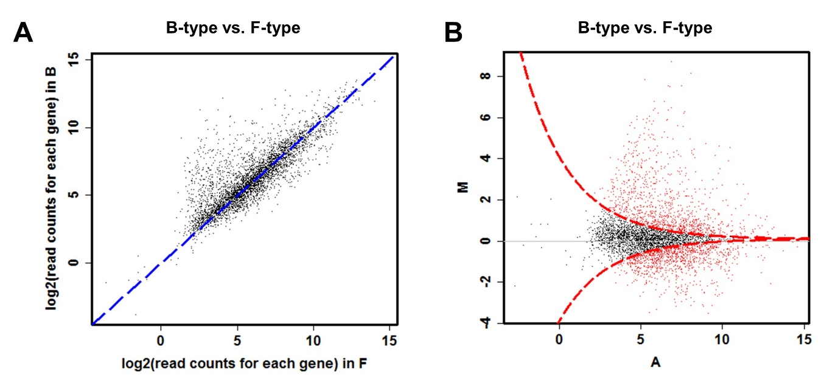

Fig. S1. Differentially expressed genes were represented as a scatterplot graph (A) and MA-plot graph (B) by the DEGseq package with the R language. Each point indicates 4,796 genes. In the scatterplot graph, it is possible to compare the expression level between two groups through the x-axis of read counts in vitro and y-axis of read counts. Red and black points of the MA-plot refer to those differentially and not differentially expressed genes, respectively. In this analysis, red points follow statistic criteria with a p-value ≤ 0.01 as determined by the MARS method.

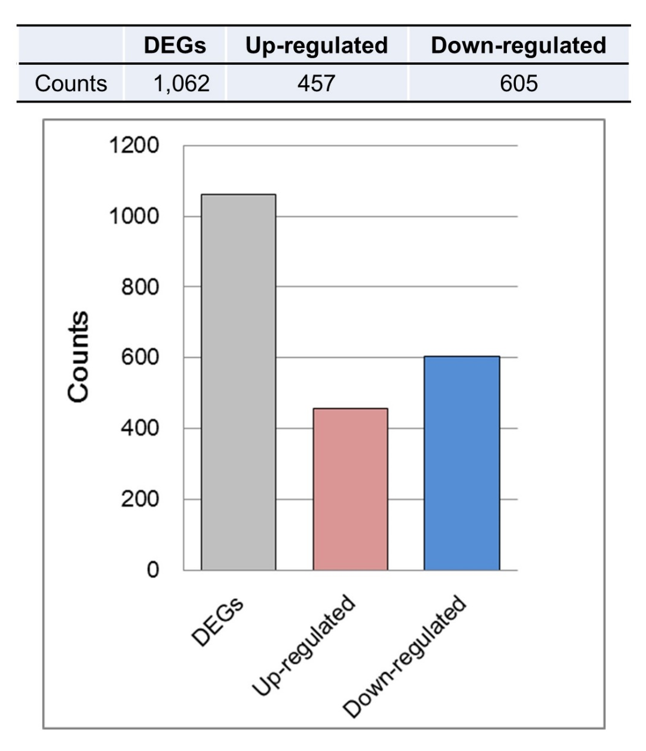

Fig. S2. Counts of DEGs. The number of upregulated and downregulated DEGs in the F-type compared with the B-type.

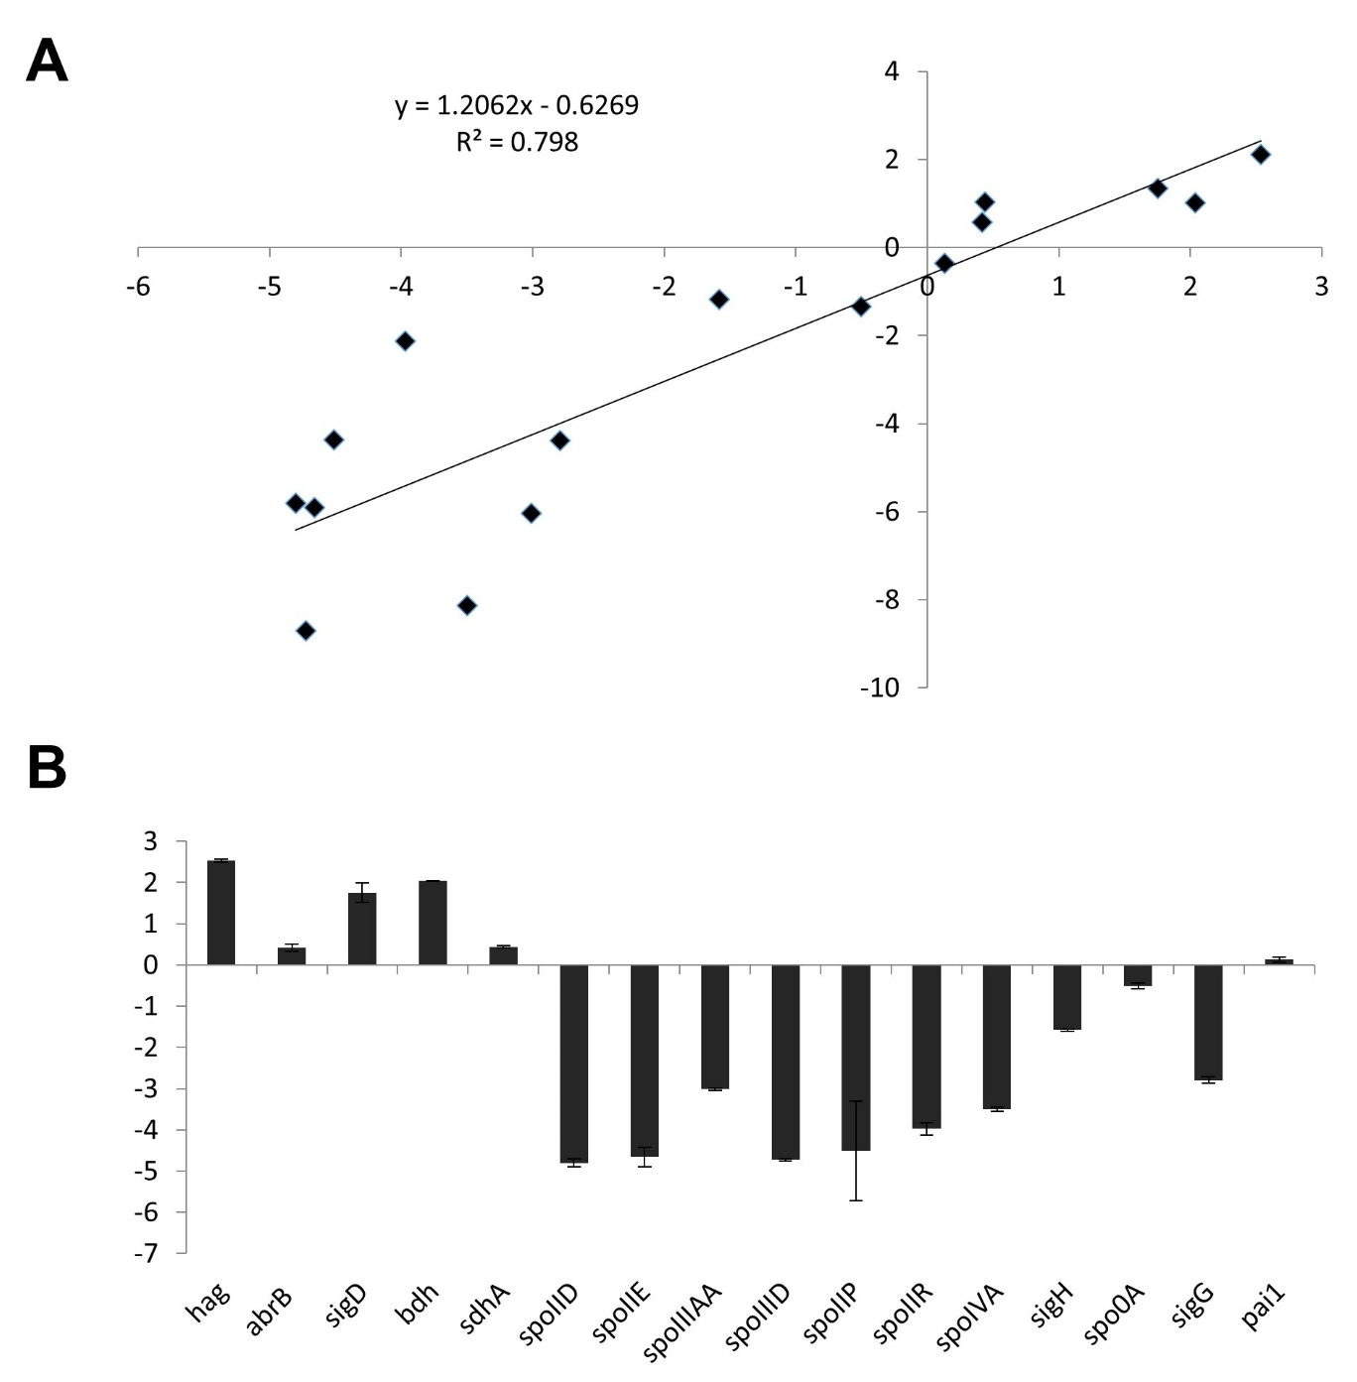

Fig. S3. Validation of RNA-seq results using quantitative real-time PCR (qPCR). The relative expression levels of randomly selected genes were analyzed by qPCR to validate RNA-seq results. (A) Log₂ fold change measured by qPCR. (B) Log₂ fold change measured by qPCR. Error bars represent standard deviation.

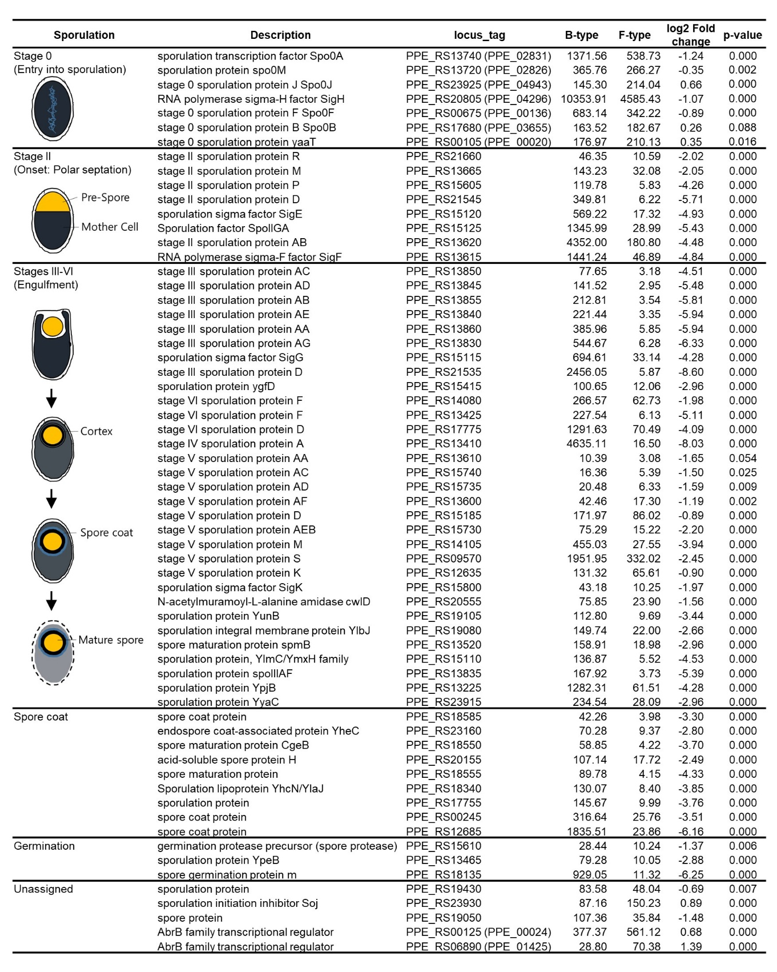
Fig. S4. The expression of genes known to be expressed at each stage of sporulation in F-type.

