Lower leg muscle-tendon unit characteristics are related to marathon running performance
Authors: Bálint Kovács, István Kóbor, Zsolt Gyimes, Örs Sebestyén, József Tihanyi
Reliability tests:
Achilles Tendon
A
Case Processing Summary
 |  | N | %
Cases | Valid | 442 | 67,8
Cases | Excludedª | 210 | 32,2
Cases | Total | 652 | 100,0
a. Listwise deletion based on all variables in the procedure.
Reliability Statistics
Cronbach's Alpha | N of Items
,997 | 2
B
Intraclass Correlation Coefficient
 | Intraclass Correlation^{b} | 95% Confidence Interval |  | F Test with True Value 0
 | Intraclass Correlation^{b} | Lower Bound | Upper Bound | Value | df1 | df2 | Sig
Single Measures | ,995ª | ,993 | ,995 | 362,647 | 441 | 441 | ,000
Average Measures | ,997^{c} | ,997 | ,998 | 362,647 | 441 | 441 | ,000
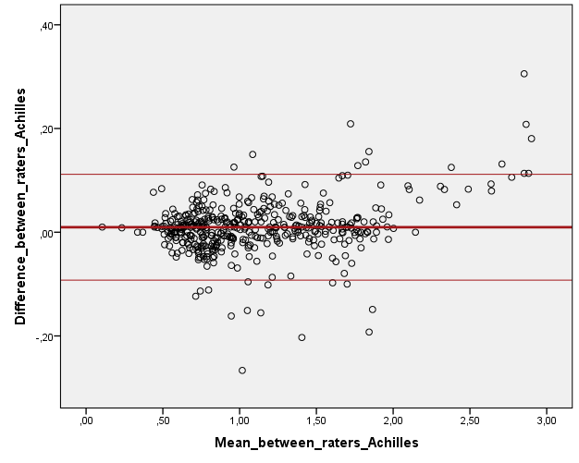
C
Figure 1. Comparisons between the two raters measurements on Achilles tendon. Table A shows the descriptive results of the reliability test, and table B shows results of the reliability test. Results are illustrated (C) by differences between pairs of measurements as a function of the mean measurements. Solid and thin red lines depict bias and 95% limits of agreement, respectively.

SOL
A
Case Processing Summary
 |  | N | %
Cases | Valid | 652 | 100,0
Cases | Excludedª | 0 | ,0
Cases | Total | 652 | 100,0
a. Listwise deletion based on all variables in the procedure.
Reliability Statistics
Cronbach's Alpha | N of Items
,999 | 2
B
Intraclass Correlation Coefficient
 | Intraclass Correlation^{b} | 95% Confidence Interval |  | F Test with True Value 0
 | Intraclass Correlation^{b} | Lower Bound | Upper Bound | Value | df1 | df2 | Sig
Single Measures | ,998ª | ,998 | ,999 | 1197,892 | 651 | 651 | ,000
Average Measures | ,999^{c} | ,999 | ,999 | 1197,892 | 651 | 651 | ,000
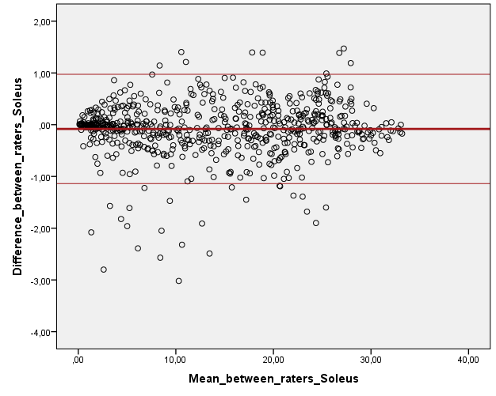
C

Figure 2 Comparisons between the two raters measurements on soleus muscle. Table A shows the descriptive results of the reliability test, and table B shows results of the reliability test. Results are illustrated (C) by differences between pairs of measurements as a function of the mean measurements. Solid and thin red lines depict bias and 95% limits of agreement, respectively.

MG
A
Case Processing Summary
 |  | N | %
Cases | Valid | 519 | 79,6
Cases | Excludedª | 133 | 20,4
Cases | Total | 652 | 100,0
a. Listwise deletion based on all variables in the procedure.
Reliability Statistics
Cronbach's Alpha | N of Items
,999 | 2
B
Intraclass Correlation Coefficient
 | Intraclass Correlation^{b} | 95% Confidence Interval |  | F Test with True Value 0
 | Intraclass Correlation^{b} | Lower Bound | Upper Bound | Value | df1 | df2 | Sig
Single Measures | ,997ª | ,997 | ,998 | 755,434 | 518 | 518 | ,000
Average Measures | ,999^{c} | ,998 | ,999 | 755,434 | 518 | 518 | ,000
C
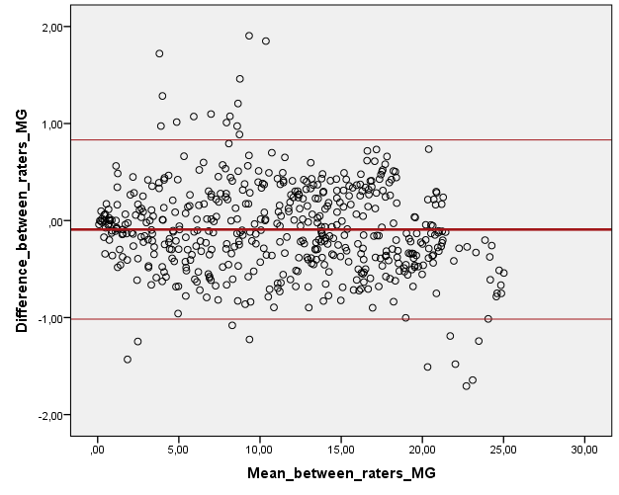

Figure 3 Comparisons between the two raters measurements on medial gastrocnemius muscle. Table A shows the descriptive results of the reliability test, and table B shows results of the reliability test. Results are illustrated (C) by differences between pairs of measurements as a function of the mean measurements. Solid and thin red lines depict bias and 95% limits of agreement, respectively.

LG
A
Case Processing Summary
 |  | N | %
Cases | Valid | 484 | 74,2
Cases | Excludedª | 168 | 25,8
Cases | Total | 652 | 100,0
a. Listwise deletion based on all variables in the procedure.
Reliability Statistics
Cronbach's Alpha | N of Items
,998 | 2
B
Intraclass Correlation Coefficient
 | Intraclass Correlation^{b} | 95% Confidence Interval |  | F Test with True Value 0
 | Intraclass Correlation^{b} | Lower Bound | Upper Bound | Value | df1 | df2 | Sig
Single Measures | ,996ª | ,995 | ,996 | 455,770 | 483 | 483 | ,000
Average Measures | ,998^{c} | ,997 | ,998 | 455,770 | 483 | 483 | ,000
C
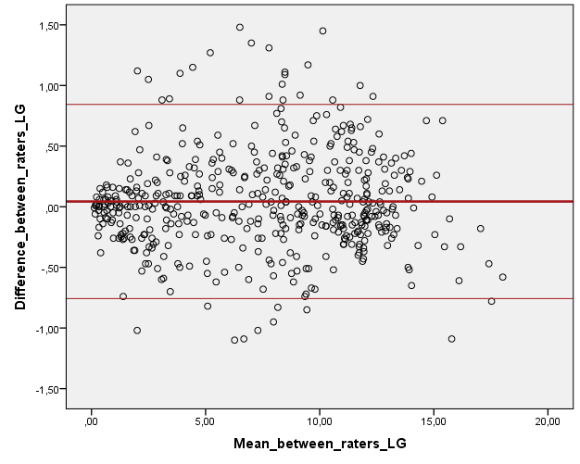
Figure 4. Comparisons between the two raters measurements on lateral gastrocnemius muscle. Table A shows the descriptive results of the reliability test, and table B shows results of the reliability test. Results are illustrated (C) by differences between pairs of measurements as a function of the mean measurements. Solid and thin red lines depict bias and 95% limits of agreement, respectively.
Figure 5. Cross-sectional area along the length of the Achilles tendon (mean and standard deviation). Scan 1 is the first appearance of the Achilles tendon above the calcaneal tuberosity. The last section is the junction point with medial gastrocnemius. Data are means and SD (n=10).

