Supplementary
Impaired left amygdala resting state functional connectivity in subthreshold depression individuals
Xiaoling Peng, MSc^{1,2+}, Way K. W. Lau, PhD^{3,4,5+}, Chanyu Wang, BSc¹, Lingfang Ning, BSc¹,， Ruibin Zhang, PhD^{1,6*}
¹Department of Psychology, School of Public Health, Southern Medical University, Guangzhou 510515, China
²Guangzhou Cana School (Guangzhou Rehabilitation & Research Center for Children with ASD), 510540, China
³Department of Special Education and Counselling, The Education University of Hong Kong, Hong Kong, China
⁴Integrated Centre for Wellbeing, The Education University of Hong Kong, Hong Kong, China
⁵Bioanalytical Laboratory for Educational Sciences, The Education University of Hong Kong, Hong Kong, China
⁶Department of Psychiatry, Zhujiang Hospital, Southern Medical University, Guangzhou 510282, China
⁺ Xiaoling Peng and Way K. W. Lau contributed equally.
* Corresponding author: Ruibin Zhang, Department of Psychology, School of Public Health, Southern Medical University, (e-mail: ruibinzhang@foxmail.com)

Running title: Impaired amygdala functional connectivity in subthreshold depression

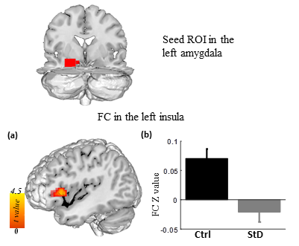
Figure S1 Significant reduced functional connectivity strength of the left insula with the left amygdala in StD group compared with controls after regressed out the global signal (a, b).

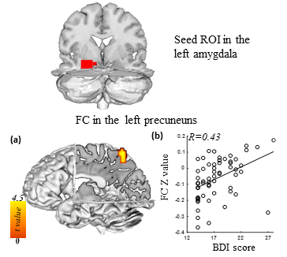
Fig. S2 Functional connectivity of the left amygdala as a function of depression severity as indexed by BDI scores under data preprocessing with global signal regression. (a) For individuals with StD, higher BDI scores were associated with increased functional connectivity between the left amygdala and left precuneus. (b) Correlation between BDI and strength of functional connectivity between the left amygdala and left precuneus.

