Supplementary Information

3D Reconstruction of Coronary Artery Bifurcations from Coronary Angiography and Optical Coherence Tomography: Feasibility, Validation, and Reproducibility

Wei Wu, PhD^{1*}; Saurabhi Samant, MBBS^{1*}; Gijs de Zwart, MSc²; Shijia Zhao, PhD¹; Behram Khan, MBBS¹; Mansoor Ahmad, MBBS¹; Marco Bologna MS³; Yusuke Watanabe, MD⁴; Yoshinobu Murasato, MD, PhD⁵; Francesco Burzotta, MD⁶; Emmanouil S. Brilakis, MD, PhD⁷; George Dangas, MD, PhD⁸; Yves Louvard, MD⁹; Goran Stankovic, MD¹⁰; Ghassan S Kassab, PhD¹¹; Francesco Migliavacca, PhD¹²; Claudio Chiastra, PhD¹³; Yiannis S. Chatzizisis MD, PhD^{1#}

¹Cardiovasclar Biology and Biomechanics Laboratory, Cardiovascular Division, University of Nebraska Medical Center, Omaha, 68105, USA

²StudioGijs, Daendelsstraat 40, 5018 ES Tilburg, Netherland
³Biosignals, Bioimaging and Bioinformatics Laboratory (B3-Lab), Department of Electronics, Information and Bioengineering, Politecnico di Milano, Milan, 20133, Italy

⁴Department of Cardiology, Teikyo University Hospital, Tokyo, 173-0003, Japan
⁵Department of Cardiology, National Hospital Organization Kyushu Medical Center, Fukuoka, 810-0065, Japan
⁶Department of Cardiovascular Sciences, Fondazione Policlinico Universitario A. Gemelli IRCCS Università Cattolica del Sacro Cuore, Rome, 00168, Italy

⁷Minneapolis Heart Institute, Minneapolis, 55407, USA
⁸Department of Cardiovascular Medicine, Mount Sinai Hospital, New York City, 10029, USA

⁹Institut Cardiovasculaire Paris Sud, Massy, 91300, France
¹⁰Department of Cardiology, Clinical Center of Serbia, 11000, Belgrade
¹¹California Medical Innovation Institute, San Diego, CA, 92121, USA.
¹²Laboratory of Biological Structure Mechanics (LaBS), Department of Chemistry, Materials and Chemical Engineering “Giulio Natta,” Politecnico di Milano, Milan, 20133, Italy
¹³PoliTo^{BIO}Med Lab, Department of Mechanical and Aerospace Engineering, Politecnico di Torino, Turin, 10129, Italy

*The first two authors contributed equally
#Yiannis S. Chatzizisis MD, PhD; E-mail: ychatzizisis@icloud.com

Supplementary Figures.
Supplementary Fig. S1. Lumen area along a silicone tube imaged by OCT and µCT.

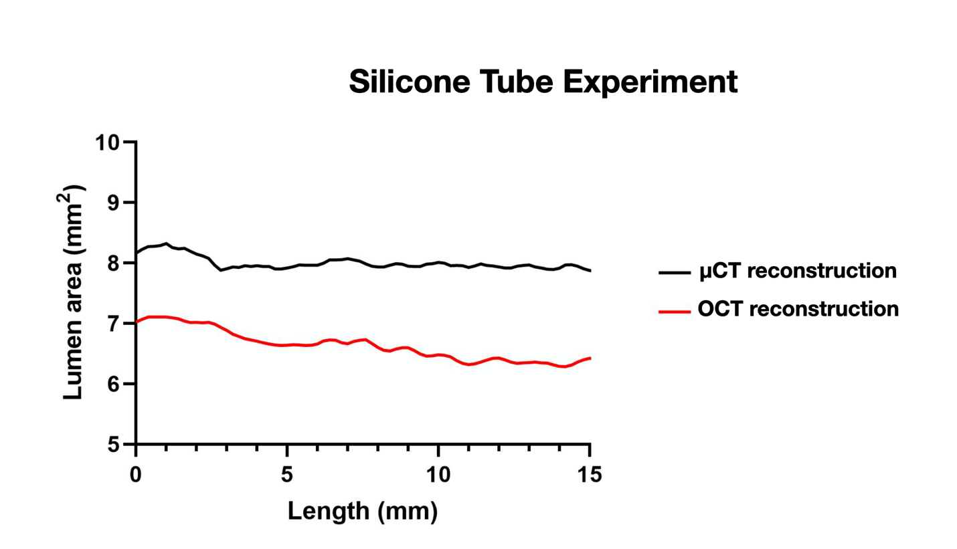

Supplementary Fig. S2: Definition of bifurcation angles: The carina points M’ and S’ were identified on the MV and SB centerlines, respectively, and connected with a straight line. The midpoint P of that straight line was connected with the merging point M of the MV and SB centerlines. The midpoint R of the straight line connecting points M and P were identified as the true carina of the bifurcation. Point R was connected with points m and s of the MV and SB centerlines, respectively, and the three bifurcation angles were calculated: Angle A between the proximal MV and SB, angle B between the distal MV and SB, and angle C between the distal and proximal MV.
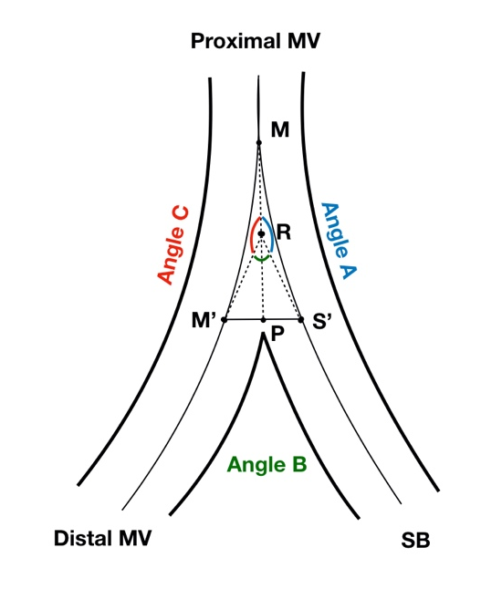

Supplementary Fig. S3: Approach for OCT wall segmentation. Two examples (a and b) showing OCT wall delineation in case of ill-defined outer wall.

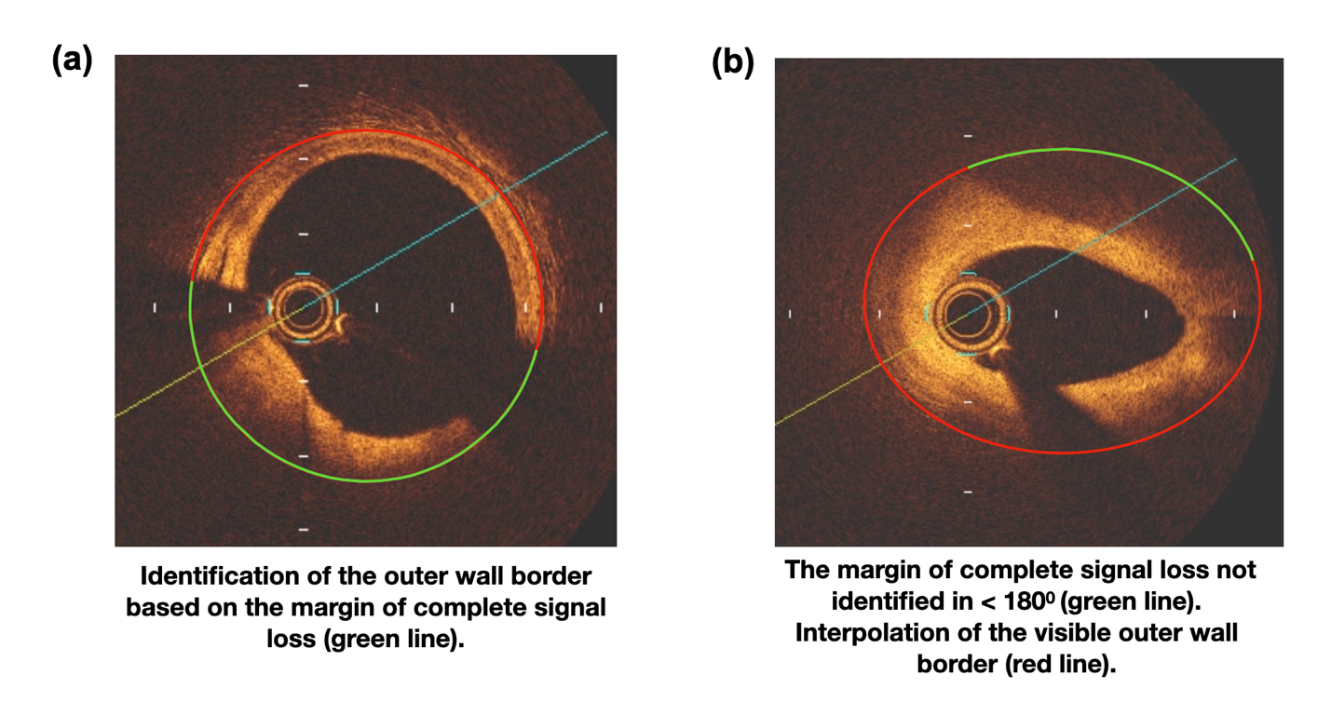

Supplementary Fig. S4: Bland-Altman analysis plots of bifurcation angles and lumen shape showing comparison between (a) 3D OCT reconstructed model vs. µCT reconstructed model (b) first and second 3D OCT reconstructed models
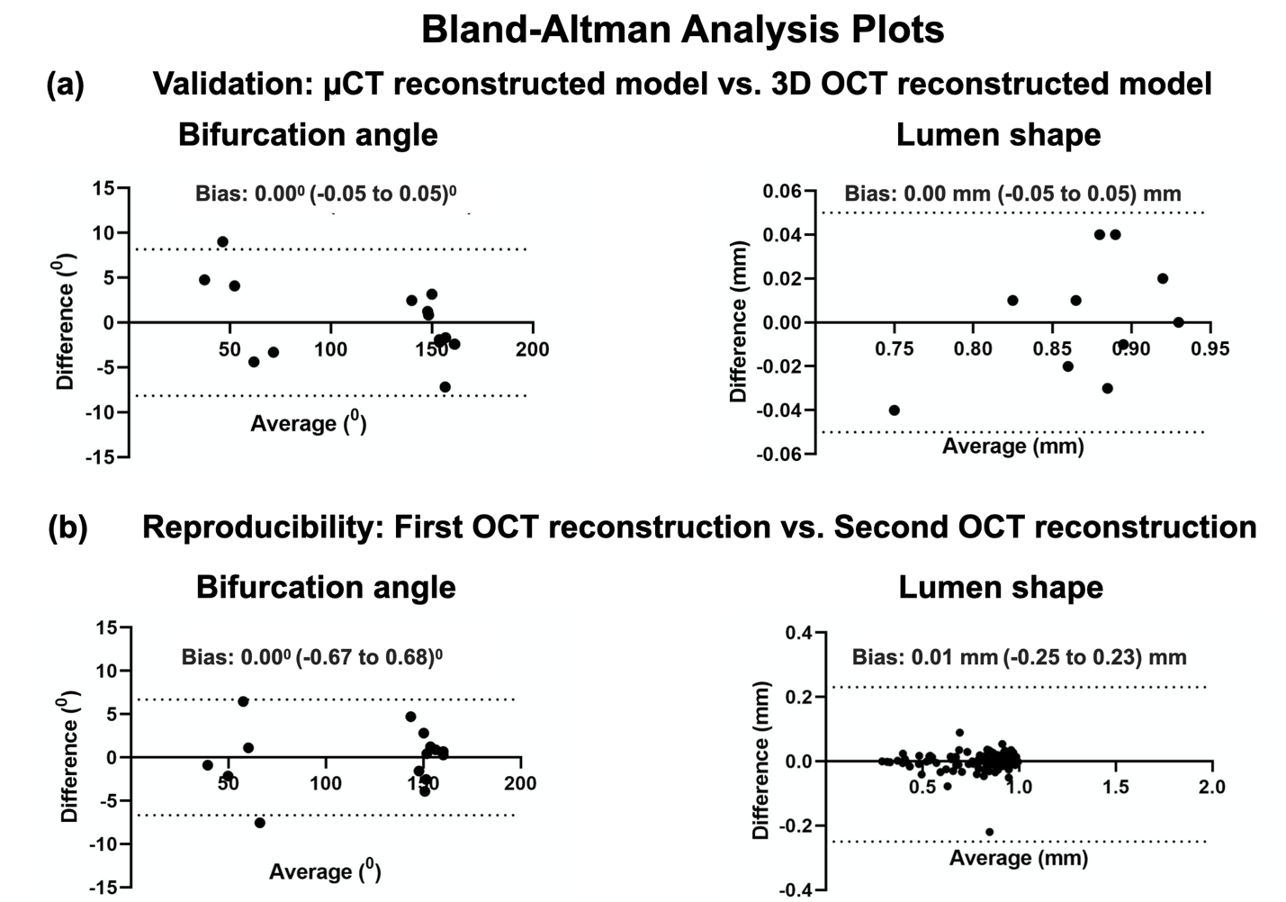

Supplementary Fig. S5. 3D reconstruction of 6 patient bifurcations (lumen and wall) using OCT and angiography.
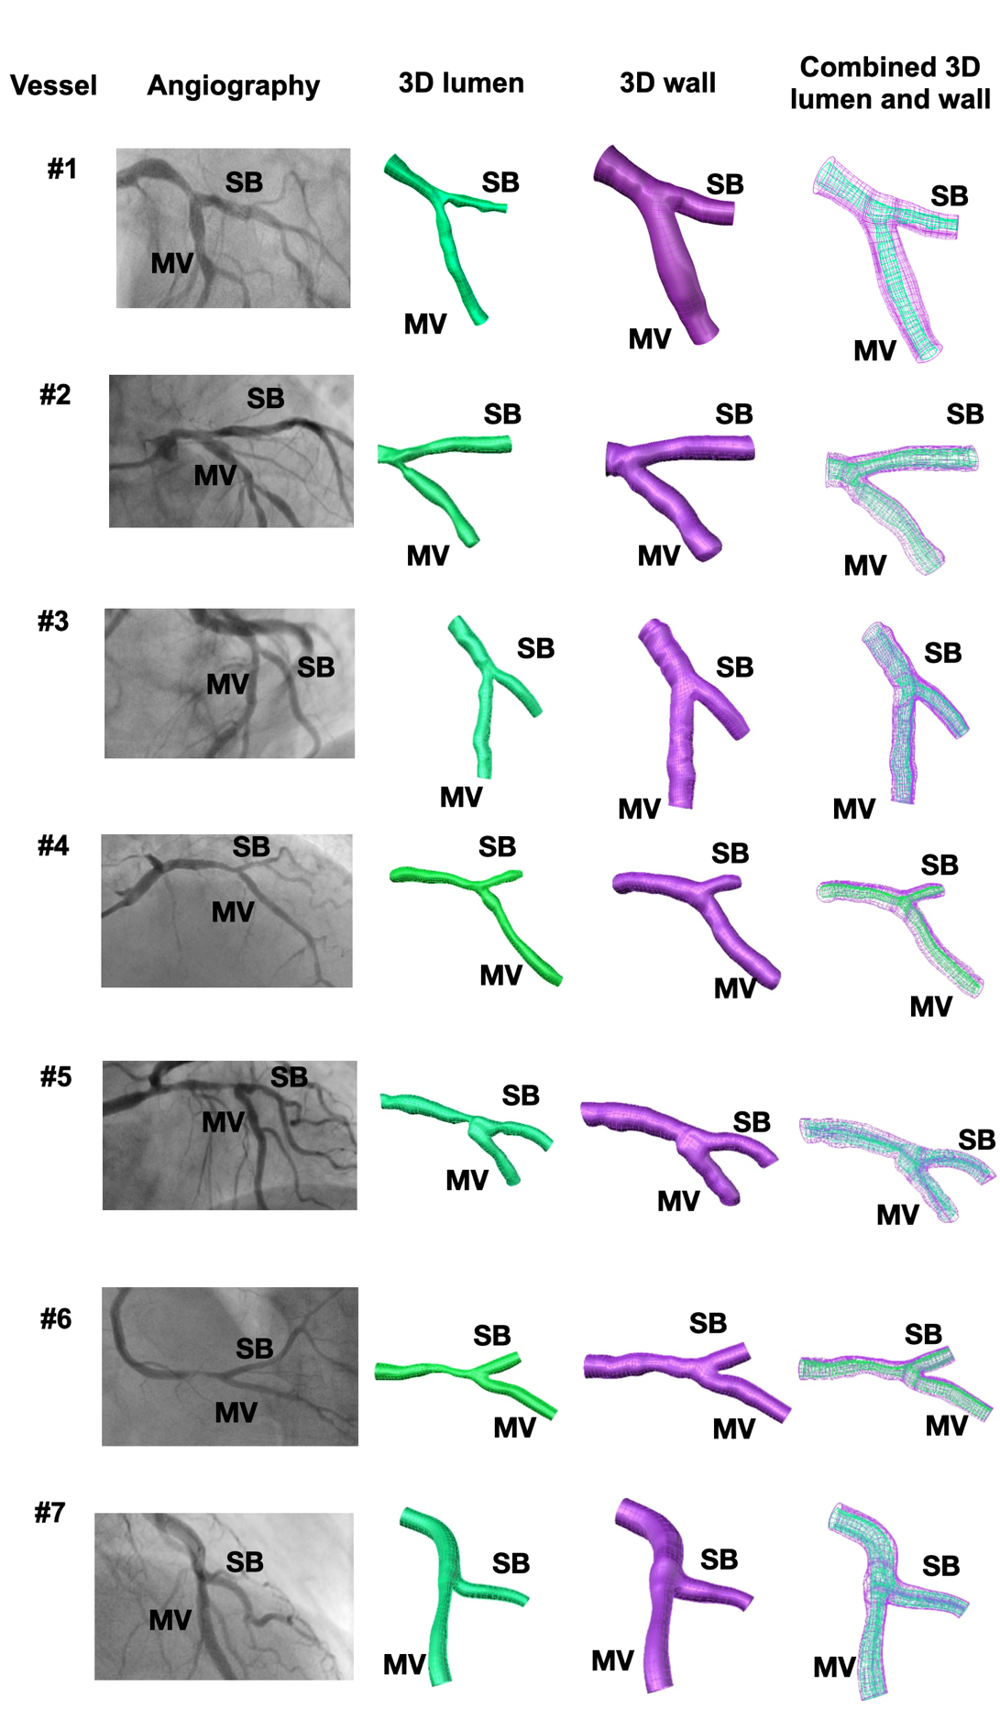

Supplemental Tables.
Supplementary Table S1. Patient-specific silicone and real patient coronary bifurcations used in validation, reproducibility and feasibility studies

Vessel number | Coronary bifurcation
Silicone | Main vessel | Side branch
#1 | Left anterior descending | First diagonal
#2 | Left circumflex artery | Obtuse marginal
#3 | Left circumflex artery | Third obtuse marginal
#4 | Left anterior descending | First diagonal
#5 | Left anterior descending | Second diagonal
Patient | Main vessel | Side branch
#1 | Left anterior descending | Left circumflex artery
#2 | Left anterior descending | Left circumflex artery
#3 | Left anterior descending | First diagonal
#4 | Left anterior descending | First diagonal
#5 | Left anterior descending | First diagonal
#6 | Right coronary artery | Posterolateral branch
#7 | Left anterior descending | Second diagonal

Supplementary Table S2. Bland Altman analysis showing the mean differences in bifurcation angles (A, B and C) between the 3D OCT- vs. µCT-reconstructed models.
Bifurcation Angles | Mean difference (degrees) | 95% Limits of Agreement (degrees)
Angle A | 1.62 | -5.77, 9.01
Angle B | 2.03 | -9.15, 13.22
Angle C | 0.40 | -4.22, 5.02

Supplementary Table S3. Reproducibility of lumen shape (distance Y/distance X ratio) in silicone models.
Models |  | First OCT reconstruction |  | Second OCT reconstruction
 |  | Median | 25^{th,} 75th percentile | Median | 25th, 75th percentile
#1 | MV | 0.85 | 0.66, 0.91 | 0.88 | 0.66, 0.91
 | SB | 0.87 | 0.74, 0.95 | 0.87 | 0.74, 0.96
#2 | MV | 0.82 | 0.72, 0.88 | 0.83 | 0.73, 0.87
 | SB | 0.87 | 0.77, 0.94 | 0.86 | 0.77, 0.95
#3 | MV | 0.92 | 0.86, 0.93 | 0.91 | 0.86, 0.93
 | SB | 0.91 | 0.81, 0.93 | 0.91 | 0.85, 0.92
#4 | MV | 0.87 | 0.73, 0.96 | 0.86 | 0.71, 0.95
 | SB | 0.85 | 0.80, 0.91 | 0.84 | 0.78, 0.90
#5 | MV | 0.78 | 0.62, 0.91 | 0.78 | 0.59, 0.92
 | SB | 0.91 | 0.69, 0.94 | 0.90 | 0.73, 0.54

Supplementary Table S4. Reproducibility of bifurcation angles in silicone models. Bland Altman analysis showing the mean differences of bifurcation angles (A, B, C) between the two OCT reconstructed models.
Bifurcation  Angles | Bias (degrees) | 95% Limits of Agreement  (degrees)
Angle A | 0.43 | -5.09, 5.95
Angle B | 0.59 | -10.55, 9.36
Angle C | 0.17 | -4.68, 5.03

