SUPPLEMENTARY MATERIAL
for

The silk of gorse spider mite Tetranychus lintearius represents a novel natural source of nanoparticles and biomaterials

Antonio Abel Lozano-Pérez*^{1&}, Ana Pagán*¹, Vladimir Zhurov², Stephen D. Hudson³, Jeffrey L. Hutter³, Valerio Pruneri⁴, Ignacio Perez-Moreno⁵, Vojislava Grbic’², José Luis Cenis¹, Miodrag Grbic’^{2,5,6&}, Salvador Aznar-Cervantes¹

¹ Departmento de Biotecnología, Genómica y Mejora Vegetal, IMIDA, c/ Mayor, s/n, 30150 La Alberca (Murcia), Spain
² Department of Biology, The University of Western Ontario, London, Ontario N6A 5B7, Canada
³ Department of Physics and Astronomy, The University of Western Ontario, London, Ontario N6A 3K7, Canada
⁴ICFO—Institut de Ciències Fotòniques, The Barcelona Institute of Science and Technology, 08860 Castelldefels, Barcelona, Spain
⁵Dep. Agriculture and Food, University of La Rioja, c/ Madre de Dios, 53, 26006 Logroño (La Rioja), Spain
⁶ Department of Biology, University of Belgrade, Serbia

*Authors contributed equally to the work.
& Corresponding authors

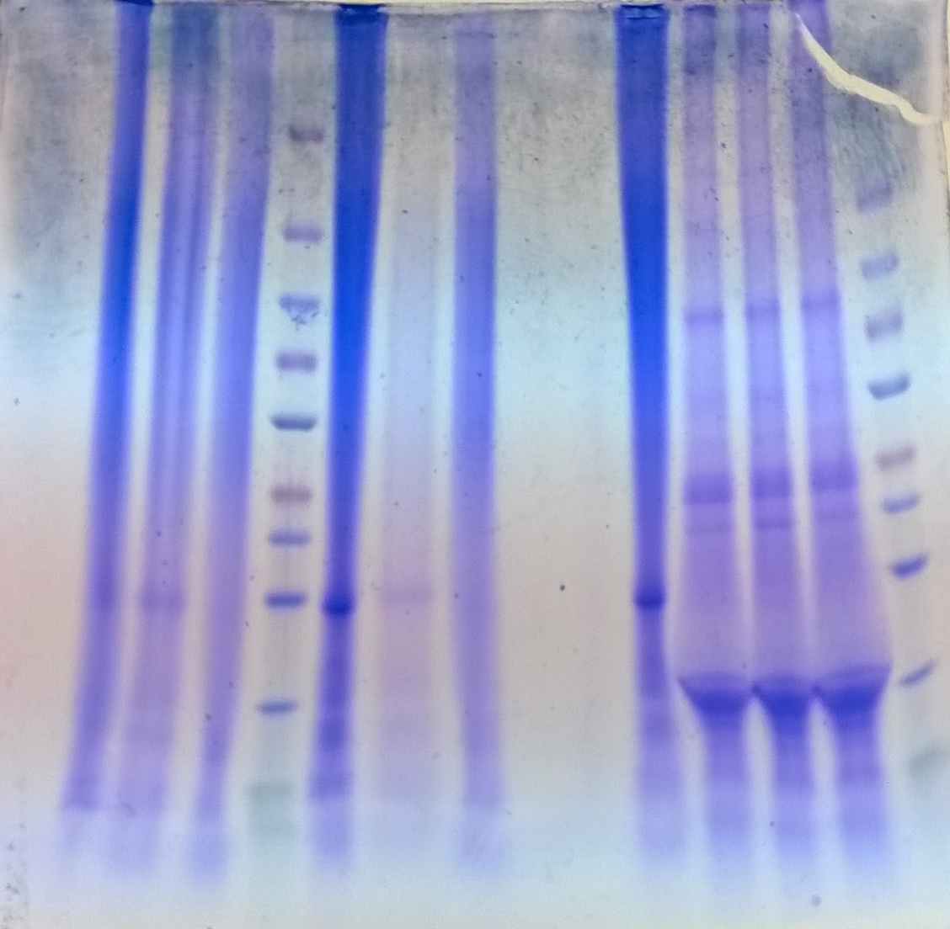Figure S1. Original picture of the SDS-PAGE gel partially reproduced in Figure 3, in compliance with the digital image and integrity policies of the journal.

Supplementary Video. 3D animation from confocal laser scanning microscopy of internalized FITC-labelled Tetranychus lintearius silk nanoparticles (green) in HDF cell line after 24h of exposure. Nuclei were stained with DAPI (blue) and Atto Rho6G phalloidin stained cytoplasmic actin filaments (red).

Tl-SNs_cellular_uptake_3D.mp4

