Supplementary Information

Abrogation of HLA surface expression using CRISPR/Cas9 genome editing: a step toward universal T cell therapy

Jeewon Lee$, Joong Hyuk Sheen$, Okjae Lim, Yunjung Lee, Jihye Ryu, Duckhyang Shin, Yu Young Kim, Munkyung Kim*

MOGAM Institute for Biomedical Research, 93, 30beon-gil, Ihyeon-ro, Giheung-gu, Yongin-si, Gyeonggi-do, South Korea

$These authors contributed equally to this work.

*Corresponding author:
Munkyung Kim
MOGAM Institute for Biomedical Research
93, 30beon-gil, Ihyeon-ro, Giheung-gu, Yongin-si, Gyeonggi-do
16924, South Korea
Tel. +82 31 260 0825
Fax. +82 31 260 9870
E-mail: munkyung.kim@mogam.re.kr

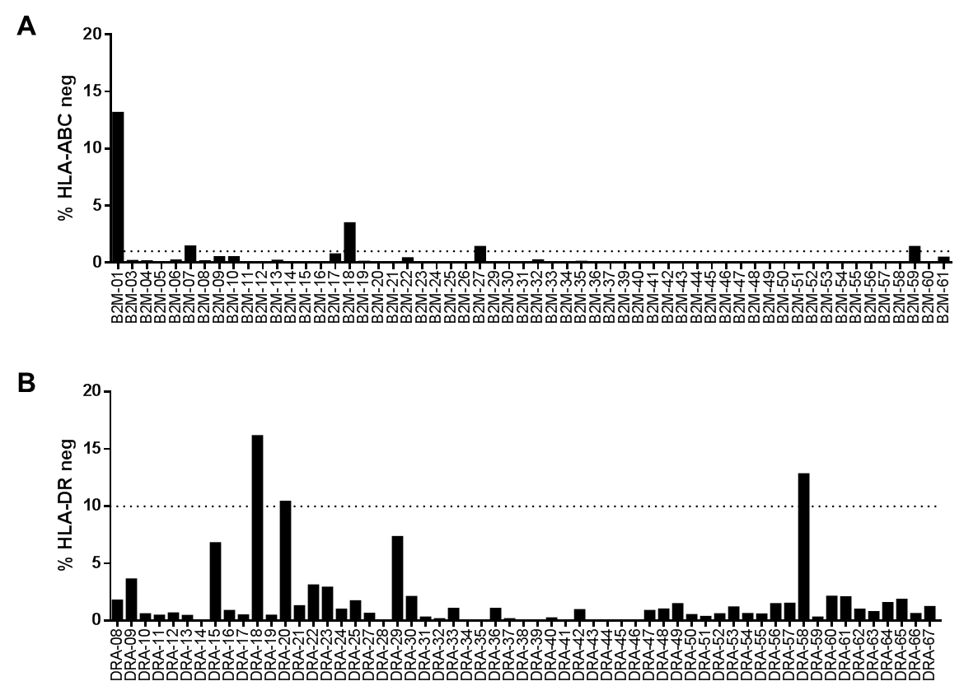
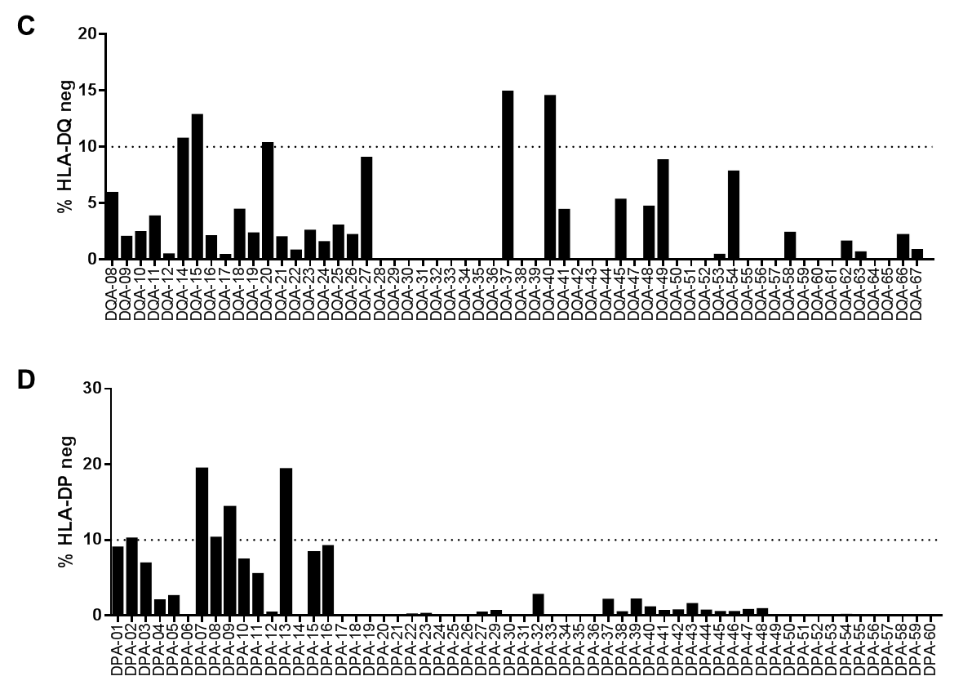
Supplementary figure S1. Target deletion efficiency of designed gRNAs for each target gene. Quantification of flow cytometry analyses of HLA expression on Raji cells transfected with pre-selected gRNAs targeting B2M (A), HLA-DRA (B), HLA-DQA (C) or HLA-DPA (D) together with Cas9 protein. Horizontal dot lines indicate the internal criteria of deletion efficiency for further selection.
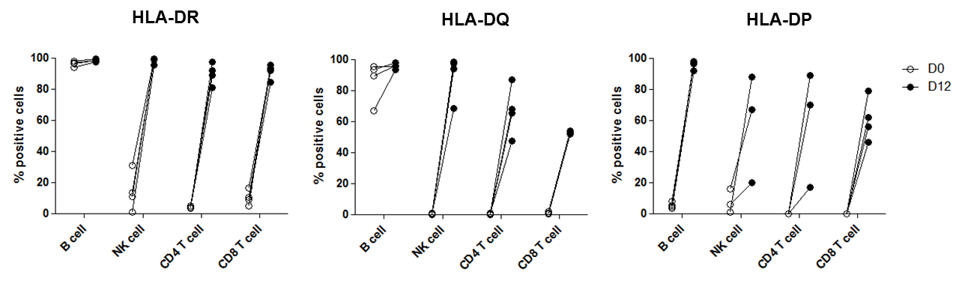
Supplementary figure S2. Increased surface expression of HLA-II in immune cell subsets pre-/post-expansion. Quantification of flow cytometry analyses of HLA-II expression in B, NK and T cells before and after 12 days of ex vivo expansion. Pooled results from three independently performed experiments, total n=3 or 4 different donors.
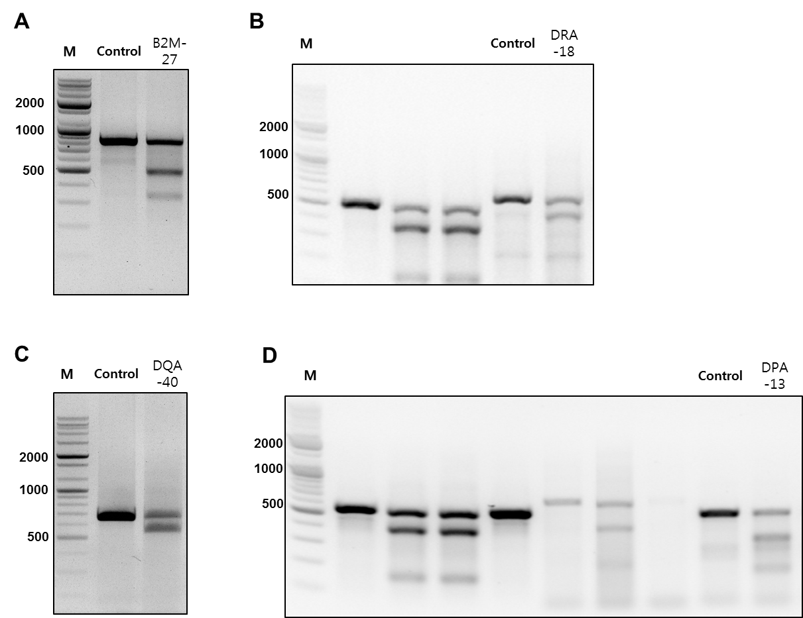
Supplementary figure S3. Display of full-length gel images of cropped images presented in figure 1B. Full length gel associated to B2M-27 gRNA (A), DRA-18 gRNA (B), DQA-40 gRNA (C) or DPA-13 gRNA (D) is shown. M, DNA Marker
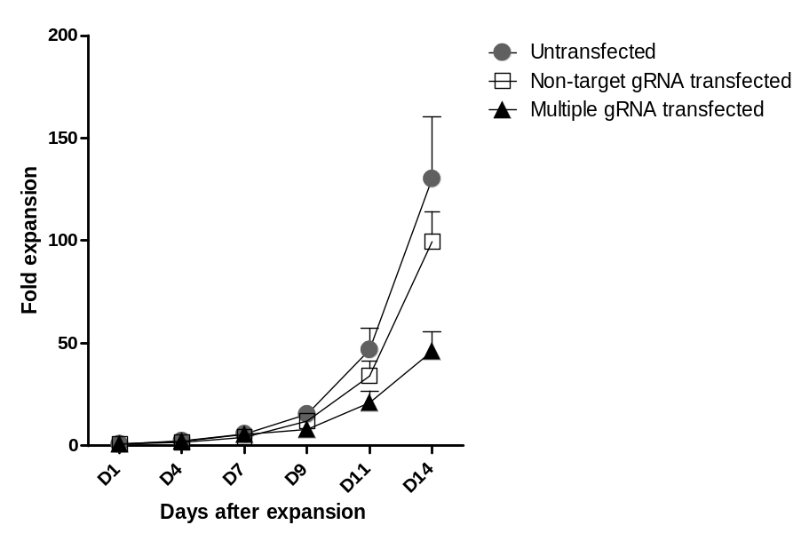
Supplementary figure S4. Fold expansion of T cells with or without HLA engineering. Cell numbers of untransfected, non-targeting gRNA/Cas9-transfected and quadruple-HLA- gRNAs/Cas9-transfected CD3⁺ T cells were measured every 2 to 3 days during ex vivo expansion. Relative fold expansion was calculated as cell numbers at indicated time points with respect to the cell numbers on expansion day 1 (day of Cas9/gRNA transfection). Pooled results from three independently performed experiments are shown, total n=6 different donors. Error bars indicate mean+SEM.
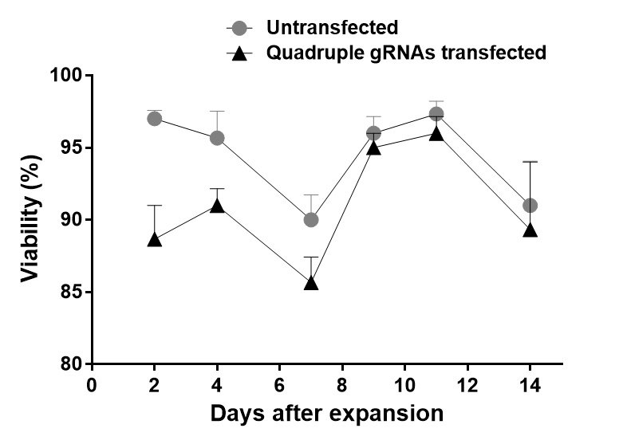
Supplementary figure S5. Viability of primary T cells with or without HLA engineering during ex vivo expansion. Viability of untransfected and quadruple gRNAs/Cas9-transfected T cells was assessed every 2 to 3 days during ex vivo expansion culture using the automated fluorescence cell counter. Pooled results from 3 different PBMC donors. Error bars indicate mean+SEM.

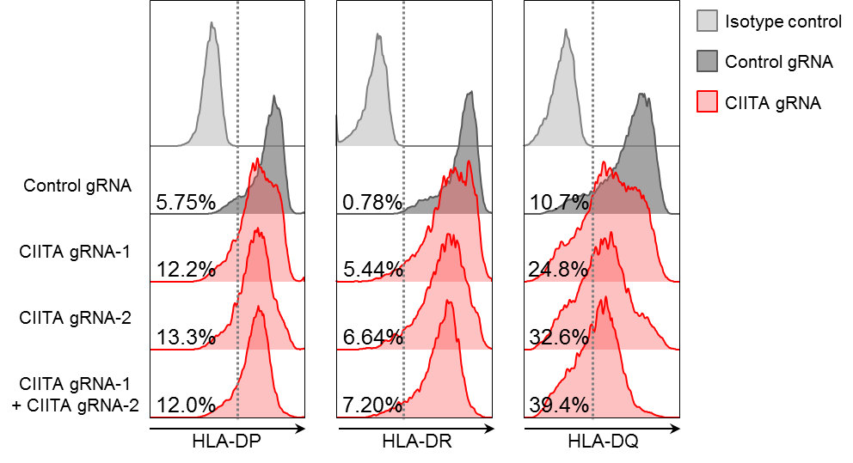
Supplementary figure S6. HLA-II ablation by CIITA-targeting gRNAs in Raji cells. Flow cytometry analyses of HLA-II (HLA-DP, HLA-DR and HLA-DQ) expression in Raji cells 7 days after indicated gRNA/Cas9 transfection. A representative histogram image from two independent experiments is shown. A number in each plot indicates % of HLA-II negative cells out of total cells. HLA-II staining was determined by the isotype control staining (light grey).

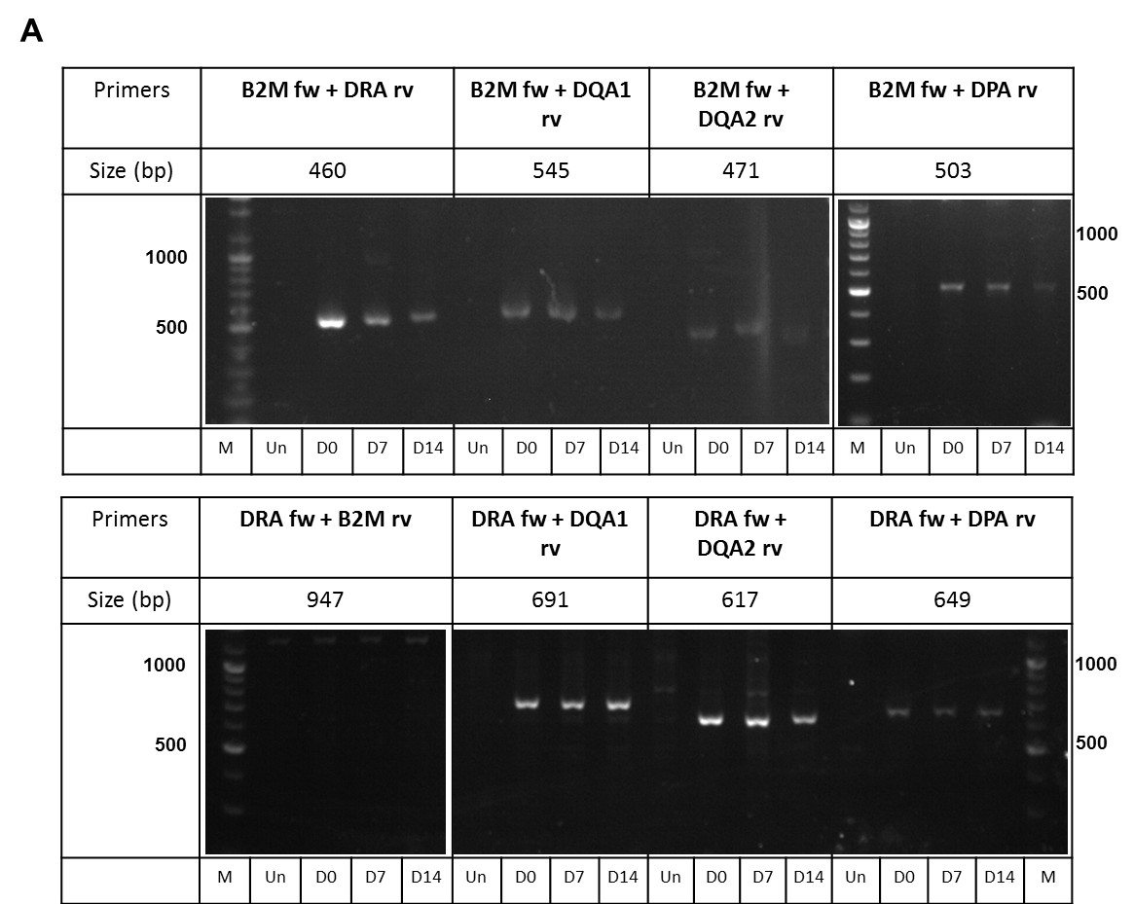
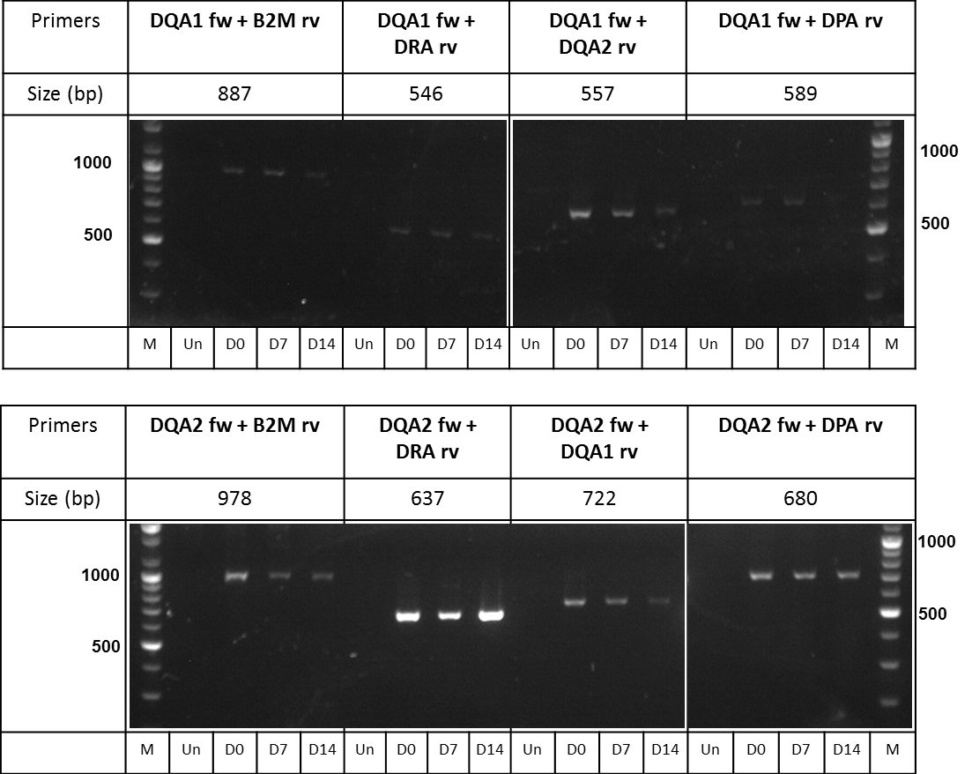
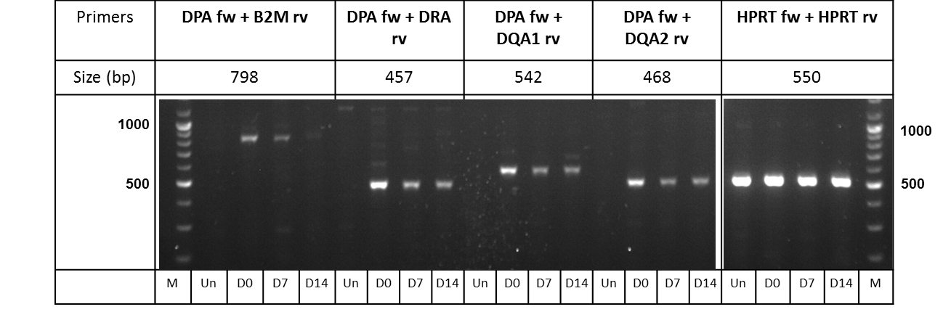
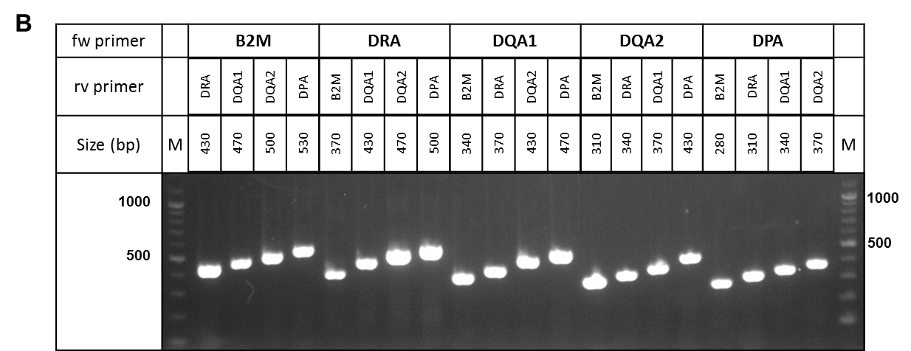
Supplementary figure S7. Detection of chromosomal rearrangements in quadruple-gene-edited T cells. A, Agarose gel electrophoresis of PCR-amplified products from genomic DNA extracted from untransfected (Un) or HLA-I/II-negative T cells (D0, D7, D14). HLA-I/II-negative T cells were sorted on day 14 post expansion from quadruple-HLA gRNAs/Cas9 transfected T cells and genomic DNA was extracted on day 0, 7 and 14 after sorting (D0, D7, D14). Amplicons were obtained using indicated primer sets. All rearrangements tested were detected except one translocation (DRA:B2M). Representative data from 3 different PBMC donors is shown. B, Agarose gel electrophoresis of control PCR with positive control plasmid. Amplicons were obtained using indicated primer sets. fw, forward; rv, reverse; M, DNA Marker.

Supplementary Table S1. The numbers of HLA-II α chain gene alleles and coverage of selected gRNAs. Allele numbers from the IMGT/HLA database, assigned as of Sep 2019.
 | DRA | DQA1 | DPA1
HLA alleles numbers | 29 | 216 | 161
Number of alleles whose genomic sequence is available | 28 | 140 | 86
Number of alleles matched with gRNA sequence | DRA-18 (28/28)  DRA-20 (28/28)  DRA-58 (28/28) | DQA-14 (104/140)  DQA-15 (104/140)  DQA-37 (114/140)  DQA-40 (140/140) | DPA-07 (80/86)  DPA-13 (86/86)

Supplementary Table S2. gRNA sequences and PCR primer sequences for genomic mutation detection.
Target | gRNA sequences | PCR primer forward | PCR primer reverse
B2M
B2M-01 | GAGTAGCGCGAGCACAGCTA
B2M-03 | CTCGCGCTACTCTCTCTTTC
B2M-04 | GCATACTCATCTTTTTCAGT
B2M-05 | GCTACTCTCTCTTTCTGGCC
B2M-06 | GGCATACTCATCTTTTTCAG
B2M-07 | GGCCACGGAGCGAGACATCT
B2M-08 | GGCCGAGATGTCTCGCTCCG
B2M-09 | TCACGTCATCCAGCAGAGAA
B2M-10 | ACAAAGTCACATGGTTCACA
B2M-11 | AGTCACATGGTTCACACGGC
B2M-12 | AAGTCAACTTCAATGTCGGA
B2M-13 | CATACTCATCTTTTTCAGTG
B2M-14 | TCCTGAATTGCTATGTGTCT
B2M-15 | CGTGAGTAAACCTGAATCTT
B2M-16 | TTGGAGTACCTGAGGAATAT
B2M-17 | AGGGTAGGAGAGACTCACGC
B2M-18 | ACAGCCCAAGATAGTTAAGT
B2M-19 | ATACTCATCTTTTTCAGTGG
B2M-20 | TGGAGTACCTGAGGAATATC
B2M-21 | AAGAAAAGGAAACTGAAAAC
B2M-22 | AAGAAGGCATGCACTAGACT
B2M-23 | ACATGTAAGCAGCATCATGG
B2M-24 | ACCCAGACACATAGCAATTC
B2M-25 | ACTTGTCTTTCAGCAAGGAC
B2M-26 | CAAGCCAGCGACGCAGTGCC
B2M-27 | CACAGCCCAAGATAGTTAAG | CCAAGTTAGCCCCAAGTGAA | ACCTACTGGCTTCCTCTAGCT
B2M-29 | CATCACGAGACTCTAAGAAA
B2M-30 | CGCAGTGCCAGGTTAGAGAG
B2M-31 | CTAACCTGGCACTGCGTCGC
B2M-32 | GAAAGTCCCTCTCTCTAACC
B2M-33 | GAGACATGTAAGCAGCATCA
B2M-34 | GAGTCTCGTGATGTTTAAGA
B2M-35 | GCAGTGCCAGGTTAGAGAGA
B2M-36 | TAAGAAGGCATGCACTAGAC
B2M-37 | TCGATCTATGAAAAAGACAG
B2M-39 | TTCAGACTTGTCTTTCAGCA
B2M-40 | TTCCTGAATTGCTATGTGTC
B2M-41 | TAAGAAAAGGAAACTGAAAA
B2M-42 | CTGGCACTGCGTCGCTGGCT
B2M-43 | TGCGTCGCTGGCTTGGAGAC
B2M-44 | GCTGGCTTGGAGACAGGTGA
B2M-45 | AGACAGGTGACGGTCCCTGC
B2M-46 | CAATCAGGACAAGGCCCGCA
B2M-47 | CCTGCGGGCCTTGTCCTGAT
B2M-48 | CCAATCAGGACAAGGCCCGC
B2M-49 | CGGGCCTTGTCCTGATTGGC
B2M-50 | GGGCCTTGTCCTGATTGGCT
B2M-51 | GTGCCCAGCCAATCAGGACA
B2M-52 | AAACGCGTGCCCAGCCAATC
B2M-53 | GGGCACGCGTTTAATATAAG
B2M-54 | CACGCGTTTAATATAAGTGG
B2M-55 | TATAAGTGGAGGCGTCGCGC
B2M-56 | AAGTGGAGGCGTCGCGCTGG
B2M-57 | AGTGGAGGCGTCGCGCTGGC
B2M-58 | TTCCTGAAGCTGACAGCATT
B2M-59 | TCCTGAAGCTGACAGCATTC
B2M-60 | TGGGCTGTGACAAAGTCACA
B2M-61 | ACTCTCTCTTTCTGGCCTGG
DRA
DRA-08 | AAGAAGAAAATGGCCATAAG
DRA-09 | AATCATGGGCTATCAAAGGT
DRA-10 | AGCTGTGCTGATGAGCGCTC
DRA-11 | ATAAGTGGAGTCCCTGTGCT
DRA-12 | ACTTATGGCCATTTTCTTCT
DRA-13 | ATGATGAAAAATCCTAGCAC
DRA-14 | CAGAGCGCCCAAGAAGAAAA
DRA-15 | CAGGAATCATGGGCTATCAA
DRA-16 | CTTATGGCCATTTTCTTCTT
DRA-17 | GACTGTCTCTGACACTCCTG
DRA-18 | GAGCCTCTTCTCAAGCACTG | AATTTCTTGGGGAGGGGGTG | AGCTGGATAGTAGGAGAAGACAGT
DRA-19 | GATAGTGGAACTTGCGGAAA
DRA-20 | GATGAGCGCTCAGGAATCAT
DRA-21 | GCTATCAAAGGTAGGTGCTG
DRA-22 | GTTACCTCTGGAGGTACTGG
DRA-23 | TAGCACAGGGACTCCACTTA
DRA-24 | TGATGAAAAATCCTAGCACA
DRA-25 | TGATGAGCGCTCAGGAATCA
DRA-27 | TTTGCCAGCTTTGAGGCTCA
DRA-28 | AACTATACTCCGATCACCAA
DRA-29 | AGAAGAACATGTGATCATCC
DRA-30 | AGCAGAGAGGGAGGTACCAT
DRA-31 | AGCGCTTTGTCATGATTTCC
DRA-32 | AGCTGTGGACAAAGCCAACC
DRA-33 | AGGGAGGTACCATTGGTGAT
DRA-34 | ATAAACTCGCCTGATTGGTC
DRA-35 | ATTGGTGATCGGAGTATAGT
DRA-36 | CCATGTGGATATGGCAAAGA
DRA-37 | CTTTGAGGCTCAAGGTGCAT
DRA-38 | CTTTGTCATGATTTCCAGGT
DRA-39 | GGATATGGCAAAGAAGGAGA
DRA-40 | TATCTGAATCCTGACCAATC
DRA-41 | TGAGATTTTCCATGTGGATA
DRA-42 | TGATCACATGTTCTTCTGAA
DRA-43 | TGCACCTTGAGCCTCAAAGC
DRA-44 | TGCATTGGCCAACATAGCTG
DRA-45 | TGGACGATTTGCCAGCTTTG
DRA-46 | TGGCAAAGAAGGAGACGGTC
DRA-47 | TGGTGATGAGATTTTCCATG
DRA-48 | AATGTCACGTGGCTTCGAAA
DRA-49 | AGACAAGTTCACCCCACCAG
DRA-50 | CAATCCCTTGATGATGAAGA
DRA-51 | GAACGCAGGGGGCCTCTGTA
DRA-52 | CTGAGGACGTTTACGACTGC
DRA-53 | GCGGAAAAGGTGGTCTTCCC
DRA-54 | GGACGTTTACGACTGCAGGG
DRA-55 | GTCGTAAACGTCCTCAGTTG
DRA-56 | GTGAGCACAGTTACCTCTGG
DRA-57 | GTGTCCCCCAGTACCTCCAG
DRA-58 | TGAGGACGTTTACGACTGCA
DRA-59 | AATGGAAAACCTGTCACCAC
DRA-60 | AGTGGAACTTGCGGAAAAGG
DRA-61 | ATGAAACAGATGAGGACGTT
DRA-62 | CAGAGACAGTCTTCCTGCCC
DRA-63 | CGTGACATTGACCACTGGTG
DRA-64 | TATGAAACAGATGAGGACGT
DRA-65 | TCTGACACTCCTGTGGTGAC
DRA-66 | AAACGTCCTCAGTTGAGGGC
DRA-67 | TCGTAAACGTCCTCAGTTGA
DQA
DQA-08 | TTAGGATCATCCTCTTCCCA
DQA-09 | AACTCTACCGCTGCTACCAA
DQA-10 | ACAATGTCTTCACCTCCACA
DQA-11 | ACCACCGTGATGAGCCCCTG
DQA-12 | ACCCAGTGTCACGGGAGACT
DQA-14 | ACCTCCACAGGGGCTCATCA
DQA-15 | CAATGTCTTCACCTCCACAG
DQA-16 | CACAATGTCTTCACCTCCAC
DQA-17 | CAGTACACCCATGAATTTGA
DQA-18 | CTCTGTGAGCTCTGACATAG
DQA-19 | CTGTGGAGGTGAAGACATTG
DQA-20 | GGCTGGAATCTCAGGCTCTG
DQA-21 | GTTGGGCTGACCCAGTGTCA
DQA-22 | TCATGGGTGTACTGGCCAGA
DQA-23 | TCCAAGTCTCCCGTGACACT
DQA-24 | TCCACAGGGGCTCATCACGG
DQA-25 | TGTGGAGGTGAAGACATTGT
DQA-26 | TTCCAAGTCTCCCGTGACAC
DQA-27 | TTGGGCTGACCCAGTGTCAC
DQA-28 | AACATCACATGGCTGAGCAA
DQA-29 | ACATCACATGGCTGAGCAAT
DQA-30 | AGCCATGTGATGTTGACCAC
DQA-31 | AGGAATGATCACTCTTGGAG
DQA-32 | ATCACTCTTGGAGAGGAAGC
DQA-33 | ATGACTGCAAGGTGGAGCAC
DQA-34 | CAAGGTGGAGCACTGGGGCC
DQA-35 | CATCAAATTCATGGGTGTAC
DQA-36 | CATGTGATGTTGACCACAGG
DQA-37 | CCTCACCACAGAGGTTCCTG
DQA-38 | CTCATCTCCATCAAATTCAT
DQA-39 | CTCCTGTGGTCAACATCACA
DQA-40 | GAAGAAGGAATGATCACTCT | TCCCTCCATACCAGGGTTCA | AACTCATCCTTACCCCAGTGT
DQA-41 | GACTGCAAGGTGGAGCACTG
DQA-42 | GAGGTAACTGATCTTGAAGA
DQA-43 | GGACAACATCTTTCCTCCTG
DQA-44 | GTGCTGTTTCCTCACCACAG
DQA-45 | TCTTCTGAAACACTGGGGTA
DQA-47 | TTCATGGGTGTACTGGCCAG
DQA-48 | AGAGACTGTGGTCTGCGCCC
DQA-49 | GACATAGGGGCTGGAATCTC
DQA-50 | GAGACTGTGGTCTGCGCCCT
DQA-51 | GGCCTCGTGGGCATTGTGGT
DQA-52 | GGGCCTCGTGGGCATTGTGG
DQA-53 | GTCAGAGCTCACAGAGACTG
DQA-54 | GTCTCTGTGAGCTCTGACAT
DQA-55 | GTGAGCTCTGACATAGGGGC
DQA-56 | GTTGGTGCTTCCAGACACCA
DQA-57 | TCTCTGTGAGCTCTGACATA
DQA-58 | TGACTGCAAGGTGGAGCACT
DQA-59 | TGCCCACCACAATGCCCACG
DQA-60 | TGGAAGCACCAACTGAACGC
DQA-61 | TGTGGGCCTCGTGGGCATTG
DQA-62 | TTACCCCAGTGTTTCAGAAG
DQA-63 | TTGGAAAACACTGTGACCTC
DQA-64 | TTGGTGCTTCCAGACACCAA
DQA-65 | AAACAAAGCTCTGCTGCTGG
DQA-66 | AAATCTCATCAGCAGAAGGG
DQA-67 | CTAAACAAAGCTCTGCTGCT
DQA-15 | CAATGTCTTCACCTCCACAG
DPA
DPA-01 | TCTATGCGTCTGTACAAACG
DPA-02 | GTACAGACGCATAGACCAAC
DPA-03 | TACAGACGCATAGACCAACA
DPA-04 | GAAGGAGACCGTCTGGCATC
DPA-05 | GGAGACCGTCTGGCATCTGG
DPA-06 | GTCTGGCATCTGGAGGAGTT
DPA-07 | GTGGTTGGAACGCTGGATCA
DPA-08 | GTCTTCAGGGCGCATGTTGT
DPA-09 | TGTCTTCAGGGCGCATGTTG
DPA-10 | TCTTCAGGGCGCATGTTGTG
DPA-11 | GTTGCATACCCCAGTGCTTG
DPA-12 | GACCTTTGTGCCCTCAGCAG
DPA-13 | GAGACTCAGCAGGAAAGCCA | TGTGAACTGGAGCTCTCTTGA | TATGAGGGCCAGAGGGAACAT
DPA-14 | GAGCCTCAAAGGAAAAGGCT
DPA-15 | GATCTTGAGAGCCCTCTCCT
DPA-16 | GCCATCAAGGGTGAGTGCTC
DPA-17 | GCCATGACCCCCGGGCCCAG
DPA-18 | GCCCAGCTCCACAGGCTCCT
DPA-19 | GCCCTGAGCCTCAAAGGAAA
DPA-20 | GCCTTTTCCTTTGAGGCTCA
DPA-21 | GCGTTCTGGCCATGACCCCC
DPA-22 | GCTTTCCTGCTGAGTCTCCG
DPA-23 | GGAAACACGGTCACCTCAGG
DPA-24 | GGACTTCTATGACTGCAGGG
DPA-25 | GGAGACTGTGCTCTGTGCCC
DPA-26 | GGCCATGACCCCCGGGCCCA
DPA-27 | GGCCTAGTCGGCATCATCGT
DPA-29 | GGGAAACACGGTCACCTCAG
DPA-30 | GGGCCTAGTCGGCATCATCG
DPA-31 | GTCATAGAAGTCCTCTGCTG
DPA-32 | GTCCTCTGCTGAGGGCACAA
DPA-33 | GTGGAAGCTGTAATCTGTTC
DPA-34 | GTGGGAAGAACTTGTCAATG
DPA-35 | GTTGGTGGCCTGAGTGTGGT
DPA-36 | GTTGTCTCAGGCATCTGGAT
DPA-37 | GCTGAGTCTCCGAGGAGCTG
DPA-38 | TCTCTACTGTCTTTATGCAG
DPA-39 | TATGGAACATTCTGTCTTCA
DPA-40 | TCAAGATCACAGCTCTGATA
DPA-41 | TCAAACATAAACTCCCCTGT
DPA-42 | TACCGTTGGTGGCCTGAGTG
DPA-43 | TCCTGAGCACTCACCCTTGA
DPA-44 | TGAGGTGACCGTGTTTCCCA
DPA-45 | TGCGTTCTGGCCATGACCCC
DPA-46 | TTTCCTTTGAGGCTCAGGGC
DPA-47 | TGCCGACTAGGCCCAGCACC
DPA-48 | TCAGCAGGAAAGCCAAGGAG
DPA-49 | TGAAGATGAGATGTTCTATG
DPA-50 | TGCTGAGTCTCCGAGGAGCT
DPA-51 | TGAGATGTTCTATGTGGATC
DPA-52 | TGGGAAACACGGTCACCTCA
DPA-53 | TGGAAGCTGTAATCTGTTCT
DPA-54 | TGGACAAGAAGGAGACCGTC
DPA-55 | TGCCCACGATGATGCCGACT
DPA-56 | TGGCCAAGCCTTTTCCTTTG
DPA-57 | GTGGCTGTGCAACGGGGAGC
DPA-58 | TCCCCTGGGCCCGGGGGTCA
DPA-59 | TCACCTCAGGGGGATCTGGA
DPA-60 | TCTCCTTCCAGATCCCCCTG
CIITA
CIITA-01 | GCTGAACTGGTCGCAGTTGA
CIITA-02 | TGGAAGGTGATGAAGAGACC
Control
Non-target | ACGGAGGCTAAGCGTCGCAA

Supplementary Table S3. Primer sequences for targeted deep sequencing.
Gene target | Primer forward | Primer reverse
B2M
B2M-27-On | GATGAGTATGCCTGCCGTGT | ATGGGATGGGACTCATTCAG
B2M-27-Off-1 | TTTGAAAGGCACCCAAAGAG | TCTGCCCAGTCCTAAAGTGG
B2M-27-Off-2 | GCCTGTTACCCTCAGCTCAT | GGGAACTCCTTTTTGTGAACC
B2M-27-Off-3 | GTGGGGTTGCAGAATAAGGA | AATCAGAGGACCAACGTTCAA
B2M-27-Off-4 | CTGCTCTGGGGCCTGTATAA | CTCTGGAGCTCCCACATCAT
B2M-27-Off-5 | CTTTCCTGGGAGAGGAATAACA | CTTCACTCCCCATTTTATCAGG
DRA
DRA-18-On | CCGCAAGTTCCACTATCTCC | CCGAGTTTCACACAAGCATC
DRA-18-Off-1 | CAGAAAACGGTGTGCTTTGA | AGCAAGGTGCCTCTTAGTGC
DRA-18-Off-2 | TTTCAGGGTTGTGTGTGCAT | GAAAACTGAGGGGCTTATGTG
DRA-18-Off-3 | TCCCAGTTCTCCTCGTCCTA | GAGTGTGCCAGTGATGTTGG
DRA-18-Off-4 | TCCATTACCTGACCTTTGTGC | GGATGCCAGGAGATTATGGA
DRA-18-Off-5 | TGAGTTGGAGTTATAAAGAACGTCAT | ATGGCTGGAGTGCTTGACTT
DQA
DQA-40-On | TGCTCCACCTTGCAGTCATA | CCTGTGGTCAACATCACCTG
DQA-40-Off-1 | CTGAATCCCAGTTTTTCTGTCTTT | TCACTAACCATATTACCCTCAGCA
DQA-40-Off-2 | GGATTCACTGAGTCAAAAACACAC | CATAGTGCATGGCAGAGAGTAAGT
DQA-40-Off-3 | CATTGTCTGGATGAGAAAATTGAG | TTAACATGTGAGTGGAGAAAAGGA
DQA-40-Off-4 | AACTTGCATTTAGAGACAAGATGG | GCCACCACAACCCACTATTT
DQA-40-Off-5 | TGTGGTTTAAGAAAACTGGAAACA | TCCATCTCCAGCCAAAAGAT
DPA
DPA-13-On | ATGTGAACCACCCCATCACT | CGCCCTGAAGACAGAATGTT
DPA-13-Off-1 | ATGTTTCTTGCTGCCCAAAG | GCTGCCAATGACAGTGGTTA
DPA-13-Off-2 | ACTGCGTGTGGCTGAGAAG | CCGTGAACACAGACCTCACA
DPA-13-Off-3 | CCCCTCCTCTATTTTTCAGGA | CCAAAACCTGAACCAACCAA
DPA-13-Off-4 | CCGTCTGTAACAGGGTGAAG | AGCCCCTTGTGGGTACAAC
DPA-13-Off-5 | ACATGAGACACACCAGGCTTTA | GGGTAACATCTGACACCATCG

Supplementary Table S4. Primer sequences for chromosomal rearrangement detection.
Primers | Sequence
B2M_forward | CCCAAGTGAAATACCCTGGCA
B2M_reverse | AGCCCTTCCTACTAGCCTCA
DRA_forward | AATTTCTTGGGGAGGGGGTG
DRA_reverse | AGCTGGATAGTAGGAGAAGACAGT
DQA1_forward | GCATTCAGCAAATCCTTCTAGG
DQA1_reverse | CCCATGAAGTGTGGAAAACA
DQA2_forward | CCAAGTTTTACTCCCTTCTTCTCA
DQA2_reverse | AAACCCATGAAGTGGTGGAA
DPA_forward | TGTGAACTGGAGCTCTCTTGA
DPA_reverse | TATGAGGGCCAGAGGGAACAT
HPRT_forward | TGGGACTCTGTAGGGACCAG
HPRT_reverse | AGACAGAATGCTATGCAACCTT

