Supplementary Materials

Potent inhibition of tumour cell proliferation and immunoregulatory function by mitochondria-targeted atovaquone
Gang Cheng^{1,2}, Micael Hardy⁶, Paytsar Topchyan^{3,7}, Ryan Zander^{3,7}, Peter Volberding^{3,7}, Weiguo Cui^{3,7}, and Balaraman Kalyanaraman^{1,2,4,5}
¹Department of Biophysics, ²Free Radical Research Center, ³Microbiology & Immunology, ⁴Cancer Center, ⁵Center for Disease Prevention Research, Medical College of Wisconsin, 8701 Watertown Plank Road, Milwaukee, WI 53226, United States
⁶Aix Marseille Univ, CNRS, ICR, UMR 7273, Marseille 13013, France
⁷Versiti Blood Research Institute, 8733 Watertown Plank Road, Milwaukee, WI 53226, United States
Corresponding author: Balaraman Kalyanaraman, Department of Biophysics, Medical College of Wisconsin, 8701 Watertown Plank Road, Milwaukee, WI 53226, United States; phone: 414-955-4000; fax: 414-955-6512; email: balarama@mcw.edu

Synthesis of ATO-C₁₀
Decyl-ATO (ATO-C₁₀) was prepared by reacting bromodecane with ATO in the presence of potassium carbonate in DMF (Figure S1).

Bromodecane (0.24 g, 1.1 mmol) was added to a mixture of ATO (0.4 g, 1.1 mmol) and potassium carbonate (0.15 g, 1.1 mmol) in DMF (3 mL). The mixture was stirred at 70°C for 7 h. Diethyl ether was then added to the mixture as well as water (20 mL). The organic layer was washed twice with water and dried over Na₂SO₄. The solvent was removed under reduced pressure. The compound was purified by flash chromatography (hexane/ethyl acetate, 95:5), yielding the final product (0.45 g, 81% yield).

HRMS calculated for ATO-C₁₀ C₃₂H₃₉ClO₃ [MH]⁺ 507.2660, found, 507.2659.
¹H NMR (400.13 MHz, CDCl₃), δ 8.00-7.94 (2H, m), 7.65-7.58 (2H, m), 7.21-7.18 (2H, m), 7.12-7.09 (2H, m), 4.26 (2H, t, J = 6.6), 3.19-3.11 (1H, m), 2.59-2.51 (1H, m), 2.17-2.07 (2H, m), 1.90 (2H, dd, J = 13.6, 2.8), 1.80-1.73 (2H, m), 1.66 (2H, dd, J = 13.3, 3.2), 1.54-1.40 (4H, m), 1.36-1.16 (12H, m), 0.80 (3H, t, J = 6.7). ¹³C NMR (75 MHz, CDCl₃) δ 185.5, 181.9, 158.1, 146.0, 138.6, 133.7, 133.0, 132.4, 131.5, 128.4, 128.2, 126.3, 125.9, 73.7, 43.4, 35.4, 34.5, 31.9, 30.4, 29.9, 29.7, 29.6, 29.4, 29.3, 26.0, 22.7, 14.1.
Synthesis of ATO-C₄
Butyl-ATO (ATO-C₄) was prepared by reacting bromobutane with ATO in the presence of potassium carbonate in DMF (Figure S1).
Bromobutane (0.15 g, 1.1 mmol) was added to a mixture of ATO (0.4 g, 1.1 mmol) and potassium carbonate (0.15 g, 1.1 mmol) in DMF (3 mL). The mixture was stirred at 70°C for 7 h. Diethyl ether was added to the mixture followed by water (20 mL). The organic layer was washed twice with water and dried over Na₂SO₄. The solvent was removed under reduced pressure and purification of the compound by flash chromatography (pentane/ethyl acetate, 98:2) yielded the product (0.38 g, 83%).

HRMS calculated for ATO-C₄ C₂₆H₂₇ClO₃ [MH]⁺ 423.1721, found, 423.1718.
¹H NMR (400.13 MHz, CDCl₃),δ 8.01-7.90 (2H, m), 7.63-7.55 (2H, m), 7.19-7.16 (2H, m), 7.11-7.08 (2H, m), 4.30 (2H, t, J = 6.7), 3.17-3.10 (1H, m), 2.57-2.49 (1H, m), 2.16-2.05 (2H, m), 1.90 (2H, dd, J = 13.5, 2.82), 1.79-1.71 (2H, m), 1.65 (2H, dd, J = 13.3, 3.2), 1.51-1.41 (4H, m), 0.94 (3H, t, J = 7.3). ¹³C NMR (75 MHz, CDCl₃) δ 185.4, 181.8, 158.0, 145.9, 138.6, 133.7, 133.0, 132.4, 131.7, 128.4, 128.1, 126.3, 125.9, 73.7, 43.3, 35.4, 34.5, 32.4, 29.9, 29.9, 19.1, 13.8.
Supplementary Figures
Figure S1. Synthetic schemes for Mito-ATO and alkyl ATO analogs. Reagents and conditions: i, K₂CO₃, DMF, 70°C, 7-12 h.
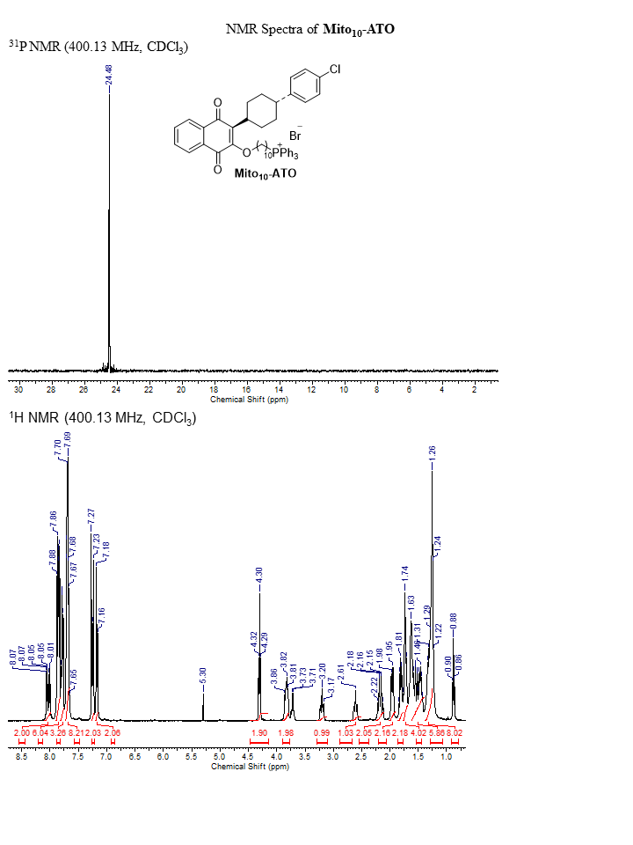
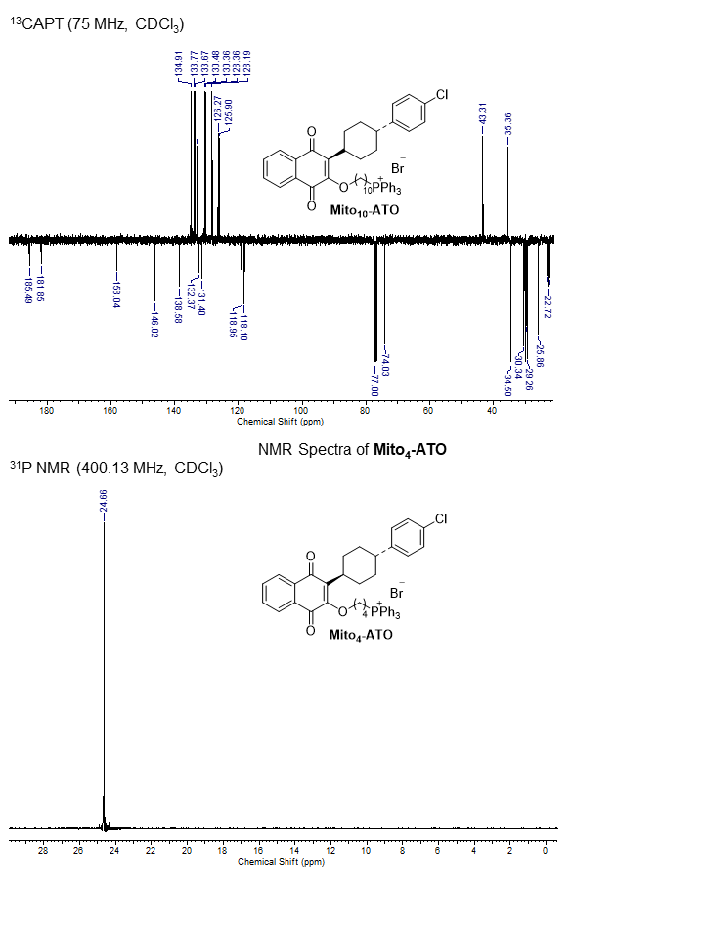
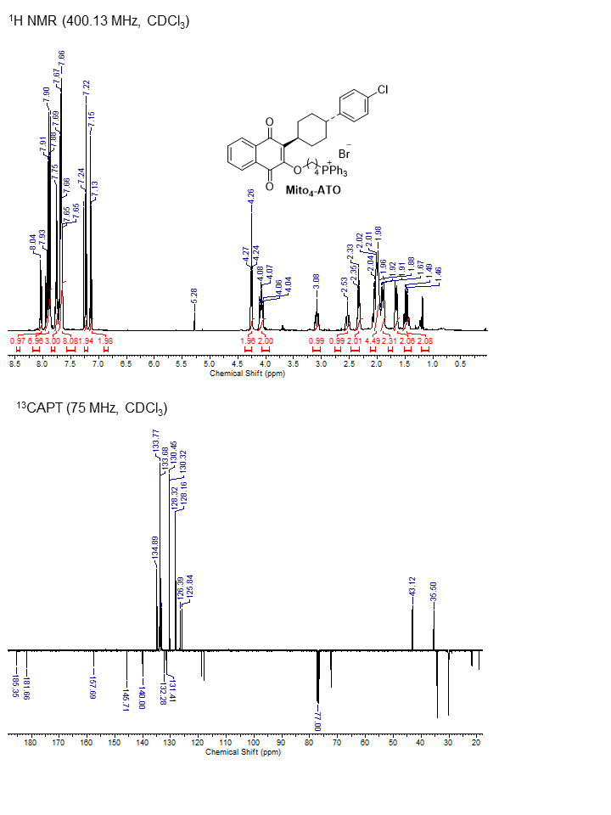
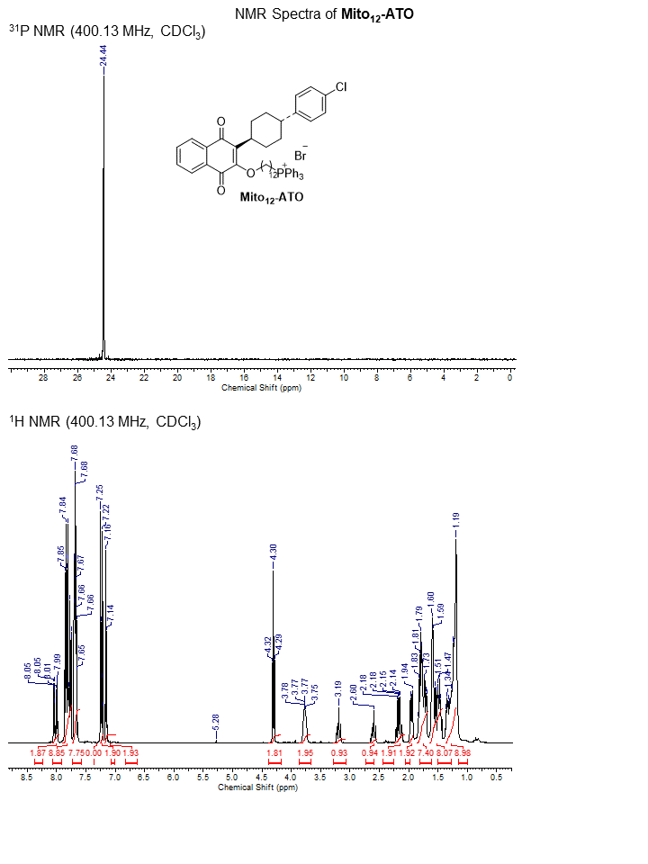
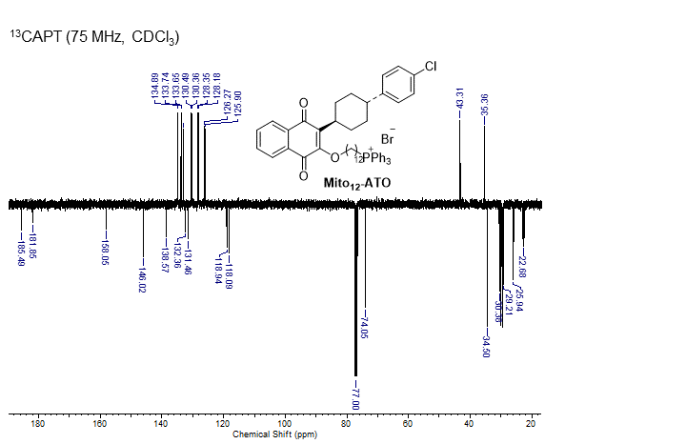

NMR Spectra of Mito₁₆-ATO
³¹P NMR (400.13 MHz, CDCl₃)
¹H NMR (400.13 MHz, CDCl₃)

¹³CAPT (75 MHz, CDCl₃)
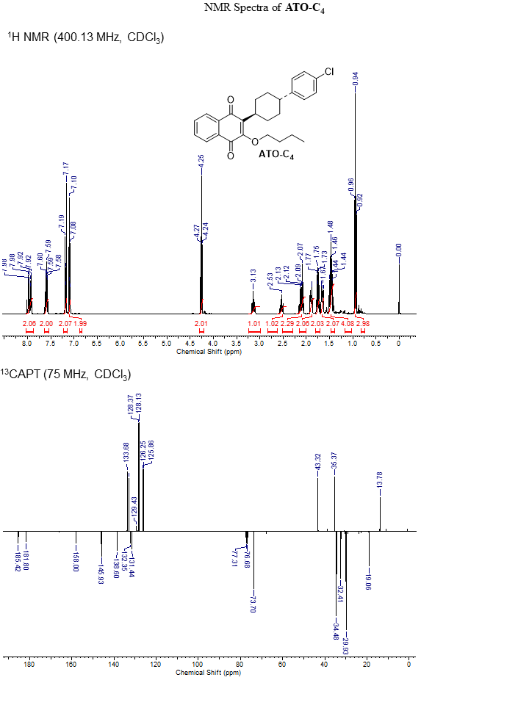
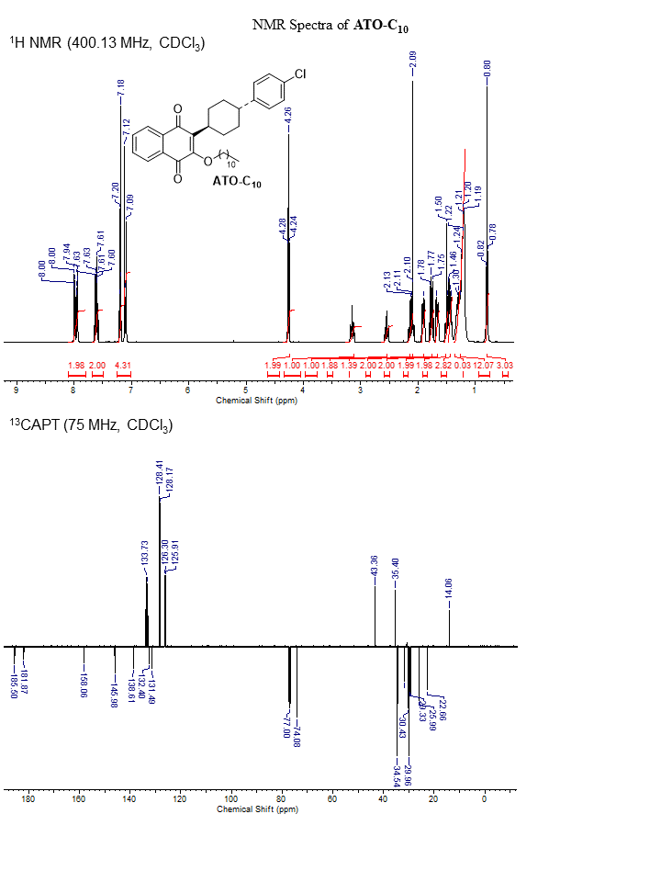
Figure S2. NMR spectra and parameters of Mito-ATO analogs and alkyl-ATO analogs.

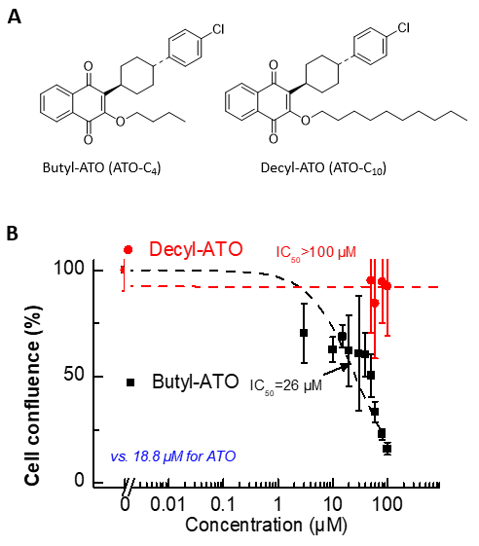
Figure S3. Effects of ATO-C₄ and ATO-C₁₀ on proliferation of MiaPaCa-2 cells. (A) Chemical structures of ATO containing a four-carbon alkyl chain and a 10-carbon alkyl chain. (B) Effects of ATO-C₄ and ATO-C₁₀ on the proliferation of MiaPaCa-2 cells were monitored as shown in Fig. 2. Cell confluence is plotted against concentration and the dashed lines represent the fitting curves used to determine the IC₅₀ values.

Figure S4. Cellular uptake of Mito-ATO and ATO. (A) Pancreatic cancer cells, MiaPaCa-2, were treated with Mito₁₀-ATO (left) and ATO (right) for 1, 2, 4, and 24 h. Cellular uptake of Mito₁₀-ATO and ATO was quantified using LC-MS/MS. (B) Cellular uptake of Mito-ATO in lung cancer cells, A549, was quantified using LC-MS/MS.

