SUPPLEMENTARY MATERIAL

Anti-apoptotic peptide for long term cardioprotection in a mouse model of myocardial ischemia-reperfusion injury

Aurélie Covinhes^{1,2}, Laura Gallot^{1,2}, Christian Barrère^{1,2}, Anne Vincent^{1,2,}, Catherine Sportouch^{1,2,3}, Christophe Piot^{1,2,3}, Bernard Lebleu⁴, Joël Nargeot^{1,2}, Prisca Boisguérin^{5,#} and Stéphanie Barrère-Lemaire^{1,2#*}

¹, IGF, Université de Montpellier, CNRS, INSERM, Montpellier, France;
², Laboratory of Excellence Ion Channel Science and Therapeutics, Valbonne, France;
³, Département de Cardiologie Interventionnelle, Clinique du Millénaire; Montpellier, France;
⁴, LPHI, Université de Montpellier, CNRS, Montpellier, France;
⁵, CRBM, Université de Montpellier, CNRS, Montpellier, France.
#, considered as joint last authors

* Corresponding author:
Stéphanie Barrère-Lemaire
Institut de Génomique Fonctionnelle
141, rue de la Cardonille - 34094 Montpellier Cedex 5 -France
Tel: +33 4 34 35 92 46 - Fax: +33 4 67 54 24 32

Email: stephanie.barrere@igf.cnrs.fr

Supplemental Tables

Table S1: Data mean values for conventional parameters evaluated by VevoLAB
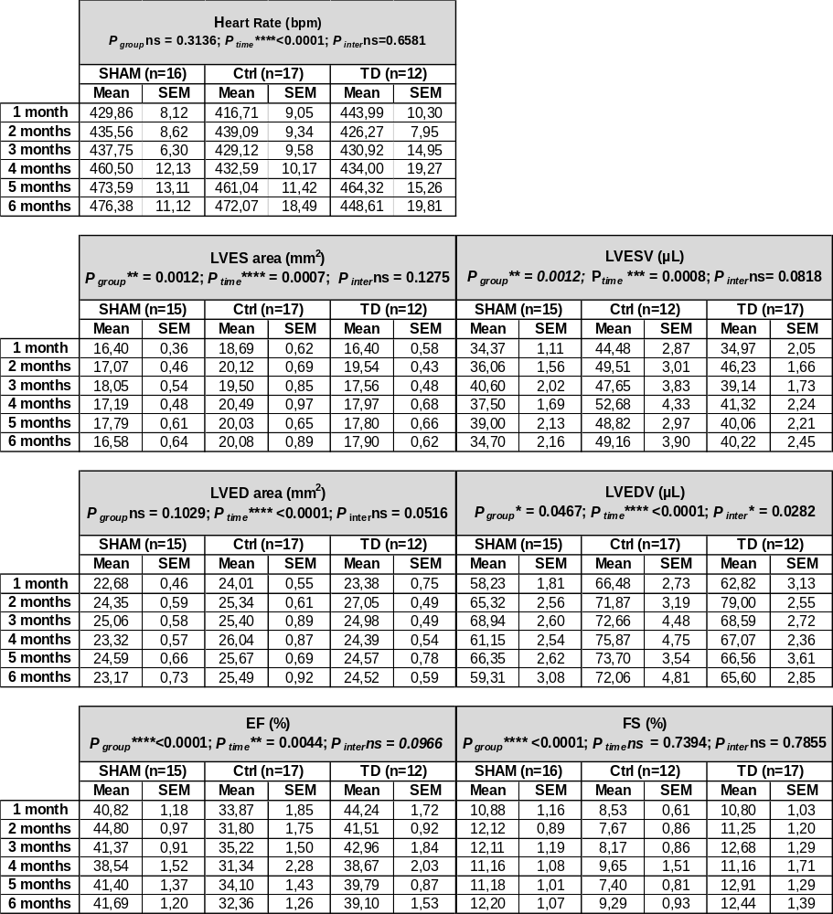

Table S2: Data mean values for Strain parameters evaluated by VevoStrain
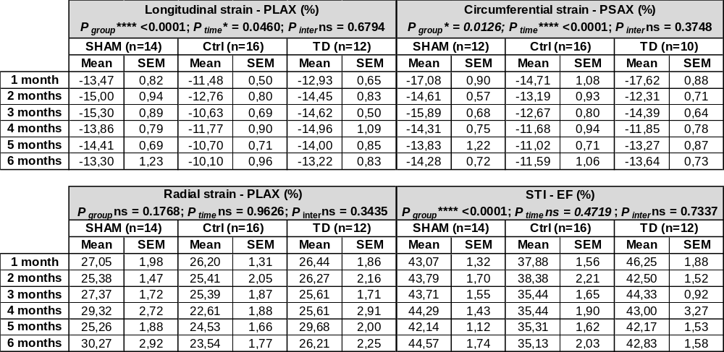

Table S3: Data mean values for conventional parameters evaluated by echocardiography using the pulsed-wave Doppler mode.
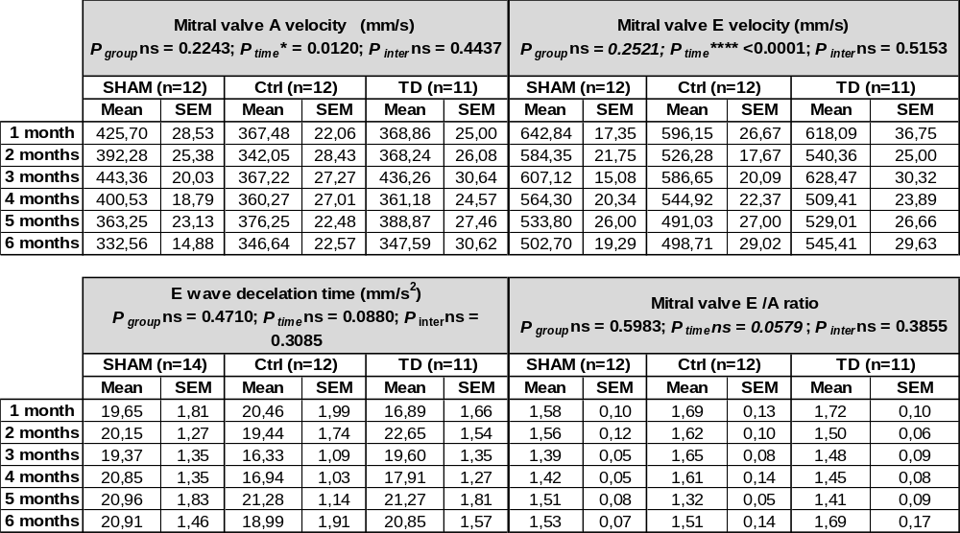

Supplemental Figures:
Figure S1: HE staining on LV slices at 6 months post-MI and evaluation of cross-sectional area of the cardiomyocytes. (A) Representative LV slices stained with hematoxylin & eosin (HE) from SHAM, Ctrl and TD groups. (B) Representative images of cross-section of longitudinal fibers from the remote non-infarcted area (interventricular septum) shown for each study group and scatter-dot plot and mean ± SD for quantification of cardiomyocyte cross-sectional area (CSA) measured on 180 random cells/heart, n=7 hearts per group. Statistical analysis was performed using the non-parametric test Kruskal-Wallis; p = 0.1175. Bar scale is indicated for each panel.

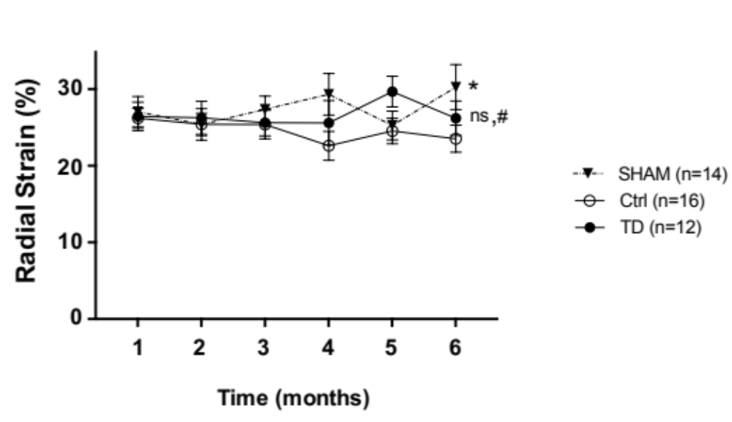
Figure S2: Speckle-tracking imaging using Vevostrain software to evaluate radial strain (average, peak %) from a parasternal long axis view in SHAM (n = 14), Ctrl (n = 16) and TD (n = 12) mice. Statistical significance was tested using Two-way ANOVA followed by the Tukey’s post-test for repeated measures. Data are presented as mean ± SEM and connecting lines. ns was noted for p = 0.1766 for TD versus Ctrl, * for p = 0.0372 for SHAM versus Ctrl, and # for p = 0.7947 for TD versus SHAM.

