Genomic analysis of European bovine Staphylococcus aureus from clinical versus subclinical mastitis
Jurriaan Hoekstra^{1,*}, Aldert L. Zomer², Victor P.M.G. Rutten², Lindert Benedictus¹, Arjan Stegeman¹, Mirlin P. Spaninks¹, Torben W. Bennedsgaard^{3,+}, Andrew Biggs^{4,+}, Sarne De Vliegher^{5,+}, Demetrio Herrera Mateo^{6,+}, Reglindis Huber-Schlenstedt^{7,+}, Jørgen Katholm^{8,+}, Péter Kovács^{9,+}, Volker Krömker^{10,+}, Guillaume Lequeux^{11,+}, Paolo Moroni^{12,+}, Luís Pinho^{13,+}, Sebastian Smulski^{14,+}, Karlien Supré^{15,+}, Jantijn M. Swinkels^{16,+}, Mark A. Holmes¹⁷, Theo J. G. M. Lam^{1, 18,+} and Gerrit Koop^{1,+}

- Department Population Health Sciences, Faculty of Veterinary Medicine, University of Utrecht, The Netherlands
- Department of Basic Sciences, Faculty of Veterinary Medicine, Utrecht University, The Netherlands
- Department of Animal Science, Aarhus University, Denmark
- The Vale Veterinary Group, Tiverton, United Kingdom
- Department of Obstetrics, reproduction and herd health, Faculty of Veterinary Medicine, University of Ghent
- Q-Llet SLP, Seva (Barcelona), Spain
- Bavarian Animal Health Service, Poing, Germany.
- DNA Diagnostic, Risskov, Denmark
- University of Veterinary Medicine Budapest, Hungary
- Department of Veterinary and Animal Sciences, University of Copenhagen, Denmark.
- LABOCEA, Fougères, France
- Department of Veterinary Medicine, University of Milan, Italy
- Department of Veterinary Clinics, Abel Salazar Biomedical sciences Institute, University of Porto, Portugal
- Department of Internal Diseases and Diagnosis, Faculty of Veterinary Medicine and Animal Science, Poznan University of Life Science, Poland
- MCC-Vlaanderen, Lier, Belgium
- MSD Animal Health, Boxmeer, The Netherlands
- Department of Veterinary Medicine, University of Cambridge, UK.
- Royal GD, Deventer, The Netherlands
+ These authors are members of the European Mastitis Panel
* Correspondence to j.hoekstra1@uu.nl

Supplementary Materials

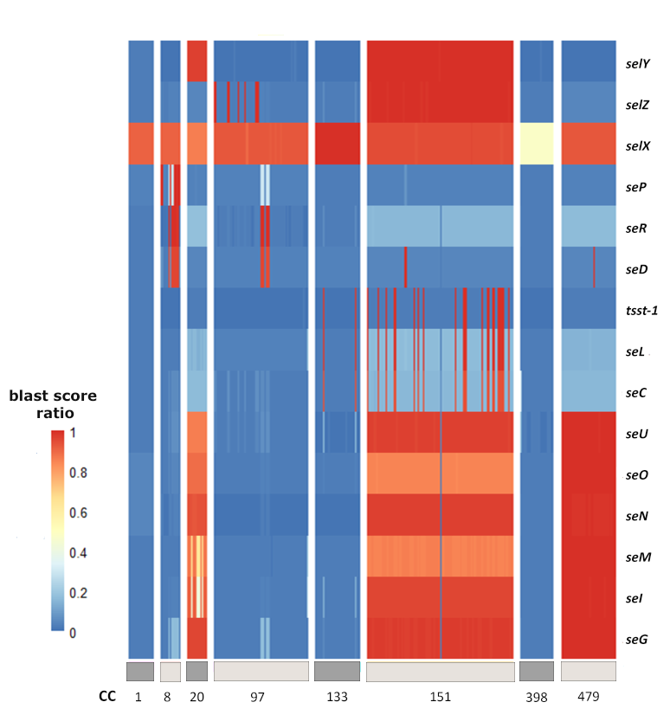

Supplementary Figure 1.
A heatmap of BLAST score ratio²⁵ (BSR) of genes annotated as Staphylococcal enterotoxins (SEs) by prokka²⁶ of bovine S. aureus isolates obtained from clinical and subclinical mastitis cases in 11 European countries calculated using the large-scale BLAST score ratio (LS-BSR) pipeline²⁵. Heatmap was visualized using the pheatmap package⁴² of R statistical software version 3.5.4⁴³. Dark and light grey shading displays Clonal Complex (CC) and only S. aureus isolates belonging to CCs with n > 10 in our collection are presented in this heatmap.

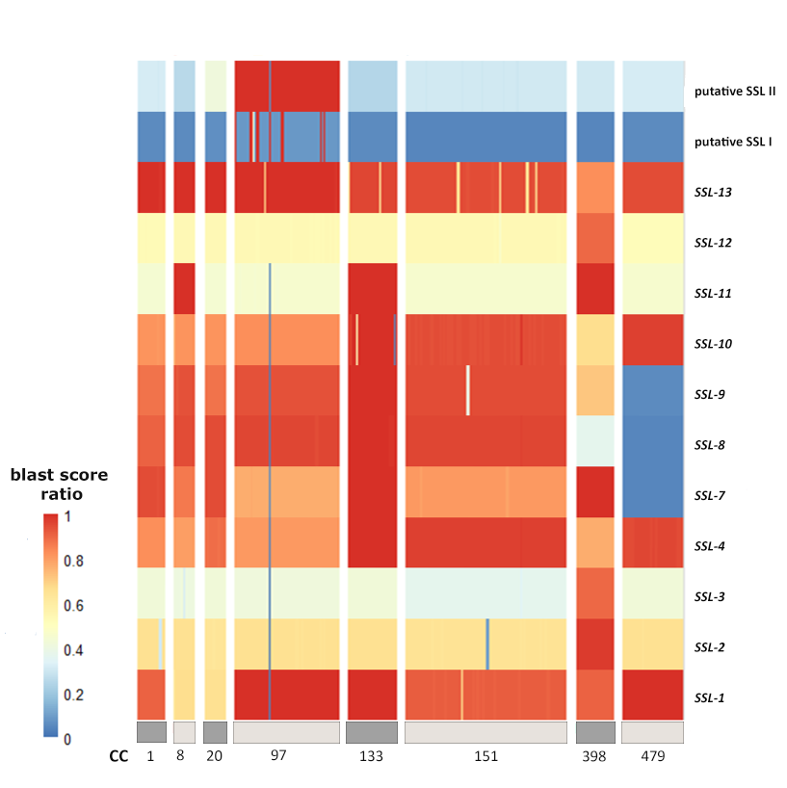

Supplementary Figure 2.
A heatmap of BLAST score ratio²⁵ (BSR) of genes annotated as Staphylococcal Superantigen like proteins (SLLs) by prokka²⁶ of bovine S. aureus isolates obtained from clinical and subclinical mastitis cases in 11 European countries calculated using the large-scale BLAST score ratio (LS-BSR) pipeline²⁵. Two yet unnamed SLLs are labeled as putative SLL I (GenBank reference: WP_143564871.1) and putative SLL II (GenBank reference WP_124375191). Heatmap was visualized using the pheatmap package⁴² of R statistical software version 3.5.4⁴³. Dark and light grey shading displays Clonal Complex (CC) and only S. aureus isolates belonging to CCs with n > 10 in our collection are presented in this heatmap.

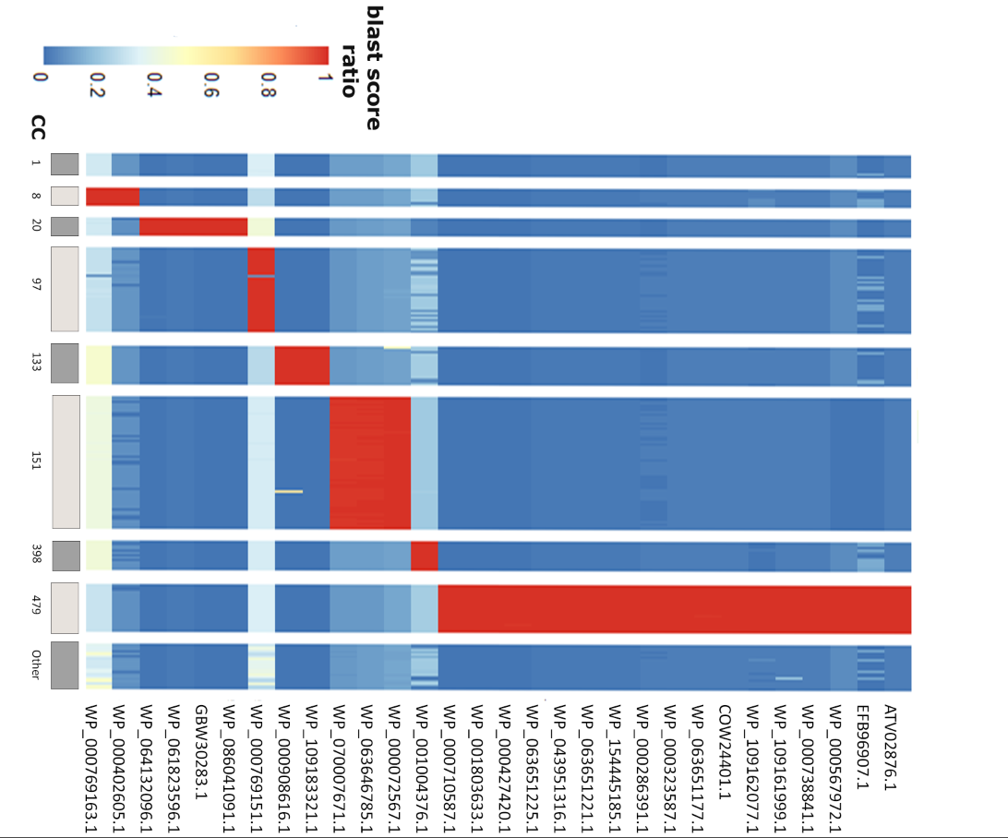

Supplementary Figure 3.
A heatmap of BLAST score ratio²⁵ (BSR) and GenBank Reference of Clonal complex (CC) exclusive genes of bovine S. aureus isolates obtained from clinical and subclinical mastitis cases in 11 European countries calculated using the large-scale BLAST score ratio (LS-BSR) pipeline²⁵. Heatmap was visualized using the pheatmap package⁴ of R statistical software version 3.5.4⁴³. Dark and light grey shading displays Clonal Complex (CC) and isolates belonging to CCs with n > 10 (CC9, CC50, CC5, CC49, CC7, CC45, CC101, CC20, CC30 and CC425.

Associated CC | Predicted function of gene-encoded Protein | GenBank Reference
CC8 | SSL-11 variant | WP_000769163.1
CC8 | hypothetical protein | WP_000402605.1
CC20 | site-specific DNA-methyltransferase | WP_064132096.1
CC20 | hypothetical protein | WP_061823596.1
CC20 | hypothetical protein | GBW30283.1
CC20 | DEAD/DEAH box helicase | WP_086041091.1
CC97 | hypothetical protein | WP_000769151.1
CC133 | AAA family ATPase | WP_000908616.1
CC133 | ATP-dependent helicase | WP_109183321.1
CC151 | restriction endonuclease subunit S | WP_070007671.1
CC151 | hypothetical protein | WP_063646785.1
CC151 | restriction endonuclease subunit S II | WP_000072567.1
CC398 | DUF5085 family protein | WP_001004376.1
CC479 | Gfo/Idh/MocA family oxidoreductase | WP_000710587.1
CC479 | polyketide synthase | WP_001803633.1
CC479 | AMP-binding protein | WP_000427420.1
CC479 | salicylate synthase | WP_063651225.1
CC479 | DNA (cytosine-5-)-methyltransferase | WP_043951316.1
CC479 | ABC transporter ATP-binding protein | WP_063651221.1
CC479 | hypothetical protein | WP_154445185.1
CC479 | hypothetical protein | WP_000286391.1
CC479 | 4'-phosphopantetheinyl transferase superfamily protein | WP_000323587.1
CC479 | Eco47II family restriction endonuclease | WP_063651177.1
CC479 | transmembrane component of ECF transporter | COW24401.1
CC479 | helix-turn-helix domain-containing protein | WP_109162077.1
CC479 | YqcI/YcgG family protein | WP_109161999.1
CC479 | MptD family putative ECF transporter S component | WP_000738841.1
CC479 | hypothetical protein | WP_000567972.1
CC479 | hypothetical protein | EFB96907.1
CC479 | Iron aquisition yersiniabactin synthesis enzyme | ATV02876.1
Table S1.
Predicted function and GenBank reference of Clonal complex (CC) exclusive genes among 276 S. aureus isolates obtained from bovine clinical and subclinical mastitis in 11 European countries.

