Cytotoxic lanthanum oxide nanoparticles sensitize glioblastoma cells to radiation therapy and temozolomide: An in vitro rationale for translational studies.
Authors:
Victor M. Lu MD PhD^{1,2}*, Toni Rose Jue DVM PhD¹, Kerrie L. McDonald PhD¹
Affiliations:
- Lowy Cancer Center, University of New South Wales, Sydney, NSW, Australia.
- Department of Neurosurgery, Mayo Clinic, Rochester, MN, USA.
*Corresponding Author:
Dr. Victor M. Lu MD PhD
Department of Neurologic Surgery, Mayo Clinic.
200 First St. SW, Rochester, MN, 55905, United States.
Email: lu.victor@mayo.edu
Running title: Lanthanum oxide nanoparticle in glioblastoma.
Disclosures: All authors report no conflicts of interest concerning the materials or methods used in this study or the findings specified in this paper.
Approval: Not required.
Word Count: 3,867
Figure Count: 5
Table Count: 0
Supplementary: Yes
Keywords: glioblastoma; nanoparticle; lanthanum; rare earth; cytotoxic; radiosensitization.

Supplementary

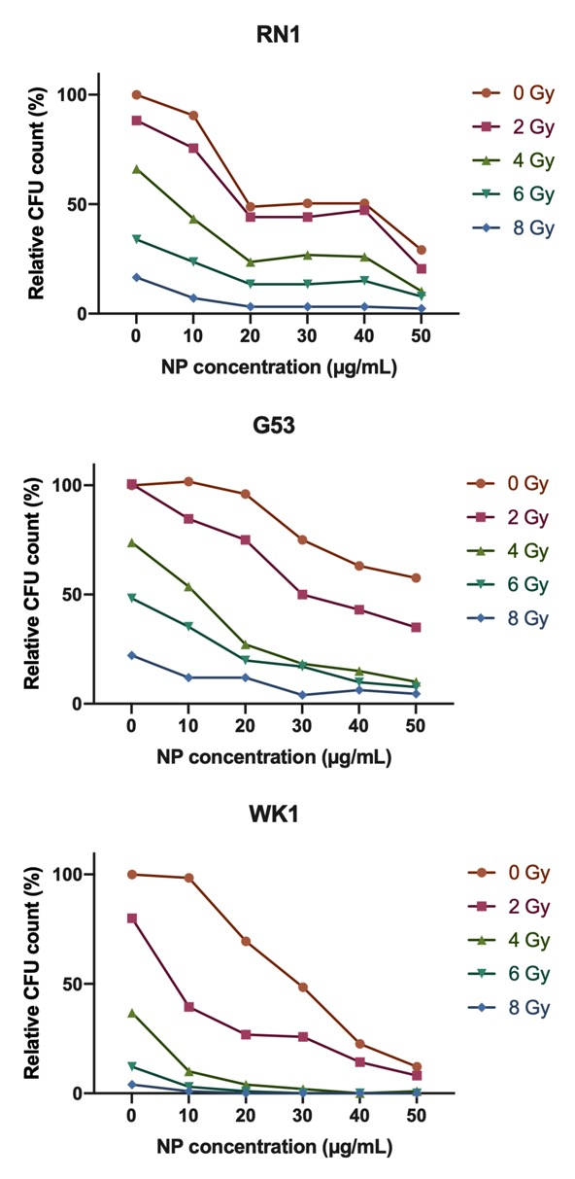
Supplementary Figure 1. Preliminary 14-day colony-forming unit (CFU) dose response curves in colony-forming patient-derived cell lines following exposure to radiation therapy (RT) 1 hour after nanoparticle (NP) administration. All CFU and fluorescence data were obtained in technical triplicate and presented as mean ± SD.

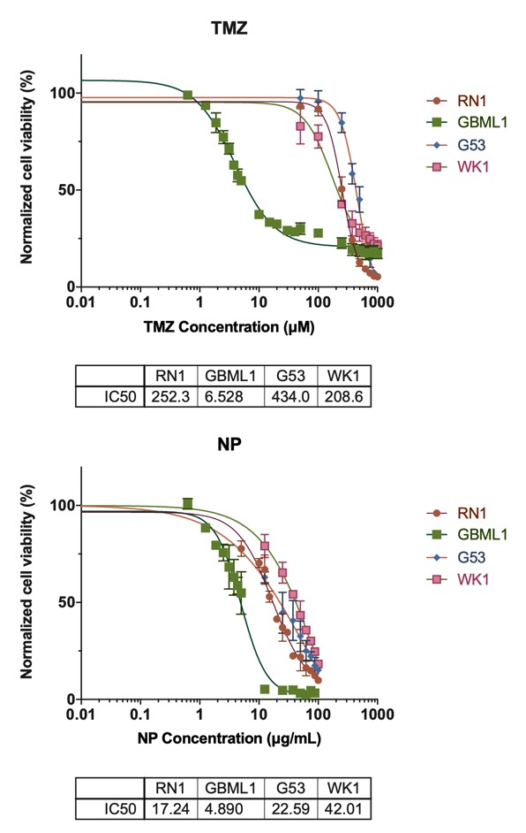
Supplementary Figure 2. Preliminary 8-day cell viability dose response curves in colony-forming patient-derived cell lines following exposure to temozolomide (TMZ) and nanoparticle (NP) administration. All data were obtained in technical triplicate in three independent tests and datapoints presented as mean ± SD. IC50 data presented as mean.

Full blots

Fig 2E, cPARP

Fig 2E, Caspase-9

Fig 2E, cCaspase-8

Fig 2E, bcl-2

Fig 2E, bax

Fig 2E, H2AX

Fig 2E, LC-3

Fig 2G, cPARP

Fig 2G, Caspase-9

Fig 2G, cCaspase-8

Fig 3E, H2AX

Fig 4C, Bcl-2

