NSAIDs-dependent adaption of the mitochondria-proteasome system in immortalized human cardiomyocytes

Laura Brandolini¹, Andrea Antonosante², Cristina Giorgio¹, Michela Bagnasco¹, Michele d’Angelo², Vanessa Castelli², Elisabetta Benedetti², Annamaria Cimini^{2,3}, Marcello Allegretti¹.
¹ Dompé Farmaceutici SpA, Via Campo di Pile, L’Aquila, Italy
² Department of Life, Health and Environmental Sciences, University of L’Aquila, Italy
³ Sbarro Institute for Cancer Research and Molecular Medicine and Centre for Biotechnology, Temple University, Philadelphia, USA

Supplementary information

Supplementary Figure S1

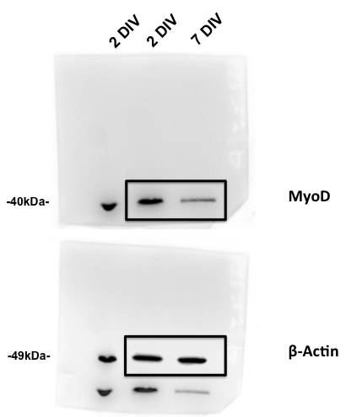

Supplementary figure S1. Full length Western blots. The boxed regions were presented in Fig. 1D. In our experimental conditions, Myod appeared about at 40 kDa, while the Actin (housekeeping, incubated the day after) is about 49 kDa. We loaded twice 2 DIV conditions (1st and 2nd lanes), the third sample represents 7 DIV. In the representative figure we chose to show 2nd and 3rd lanes. Altough in our experimental conditions MyoD appeared about at 40 kDa, in the figure into the paper we preferred to indicate 45kDa, which is the molecular weight referred to the data sheet provided from the company (Santa Cruz Biothecnology, MyoD (G-1): sc-377460).

Supplementary Figure S2
Supplementary figure S2. Full length Western blots of native-gel electrophoresis presented in Fig. 7A, B. We cannot indicate the specific molecular weight of the band, it is due to the very high molecular weight of the structures recognized by anti-PSMA6 antibody. Molecular mass of these proteasome structures is about 2500 kDa for proteasome 26DC and 750 kDa for proteasome 20S.

Supplementary Figure S3
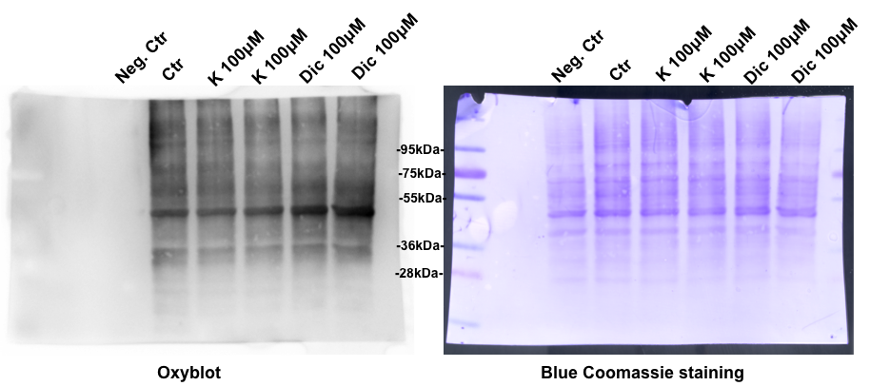
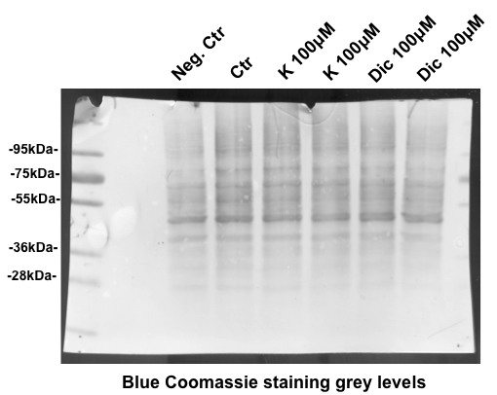

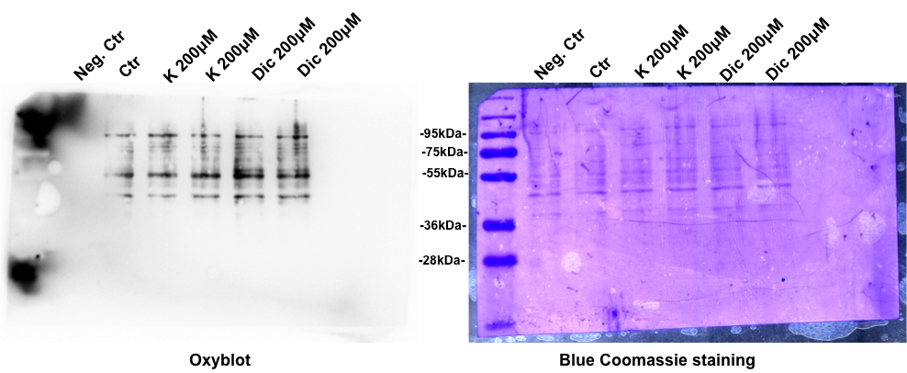
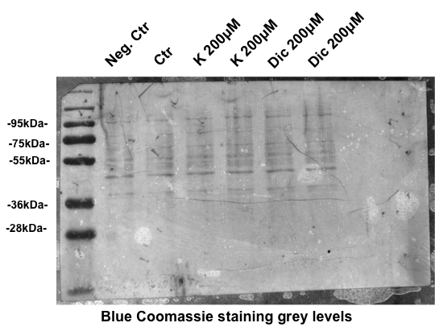

Supplementary figure S3. Full length Western blots and membrane stained with Blue coomassie presented in Fig. 8A-B.

