RISK OF DENGUE VIRUS INFECTION ACCORDING TO SEROSTATUS IN INDIVIDUALS FROM DENGUE ENDEMIC AREAS OF MEXICO
I.Y. AMAYA-LARIOS^{,2} R.A. MARTÍNEZ-VEGA^{3,4} F.A. DIAZ-QUIJANO⁵ E. SARTI⁶ E. PUENTES-ROSAS⁶, L. CHIHU¹ AND J. RAMOS-CASTAÑEDA^{1,7*}
¹Instituto Nacional de Salud Pública, Mexico. ²Consejo Nacional de Ciencia y Tecnología, México. ³Universidad de Santander, Colombia. ⁴Organización Latinoamericana para el Fomento de la Investigación en Salud, Colombia. Faculdade de Saúde Pública, Universidade de São Paulo, Brazil ⁶ , Sanofi Pasteur. ⁷Center for Tropical Diseases, University of Texas-Medical Branch. USA.

*Corresponding Author. Centro de Investigaciones sobre Enfermedades Infecciosas. Instituto Nacional de Salud Publica. Av Universidad 655, Santa Maria Ahuacatitlan. Cuernavaca, Morelos, Mexico 62100. jramos@insp.mx

Supplementary Material

Supplementary Table S1. DENV positive samples from Morelos, México (2014-2016). José Ramos-Castañeda, unpublished data.
Year |  | DENV
Year |  | 1 | 2
2014 | % | 93.6 | 6.4
2014 | n | 29 | 2
2015 | % | 66.7 | 33.3
2015 | n | 14 | 7
2016 | % | 57.7 | 42.3
2016 | n | 56 | 41
% : Percent; n: Number of samples

Supplementary Table S2: Classification of recent DENV infections according to the results of diagnostic tests by follow-up stage.
Follow-up
Follow-up | (IgM - IgG +) | (IgM + IgG +) | IgG-Indirect | (IgM +) | TOTAL
February, 2015 to May, 2015 (Follow-up 4) | 6 | 1 | 0 | 0 | 7
August, 2015 to November, 2015. (Follow-up 5) | 0 | 0 | 2 | 6 | 8
February, 2016 to May, 2016  (Follow-up 6) | 0 | 0 | 0 | 6 | 6
August, 2016 to November, 2016.  (Follow-up 7) | 0 | 0 | 5 | 22 | 27
TOTAL | 6 | 1 | 7 | 34 | 48

Supplementary Table S3. Factors related to incident DENV infection in cohort participants from Axochiapan and Tepalcingo, Morelos (2014-2016), considering an 80% sensitivity of the IgM test.
 | HR* | Robust Standard Error | p>|z| | 95% Confidence Interval
Group
Seronegative | 1
Seropositive with at least one previous infections | 1.01 | 0.430 | 0.997 | 0.44 | 2.32
Seropositive with at least two previous infections | 0.58 | 0.221 | 0.150 | 0.27 | 1.22
Age | 1.01 | 0.007 | 0.122 | 1.00 | 1.03
Locality
Tepalcingo | 1
Axochiapan | 0.51 | 0.177 | 0.054 | 0.26 | 1.01
* HR: Hazard Ratio

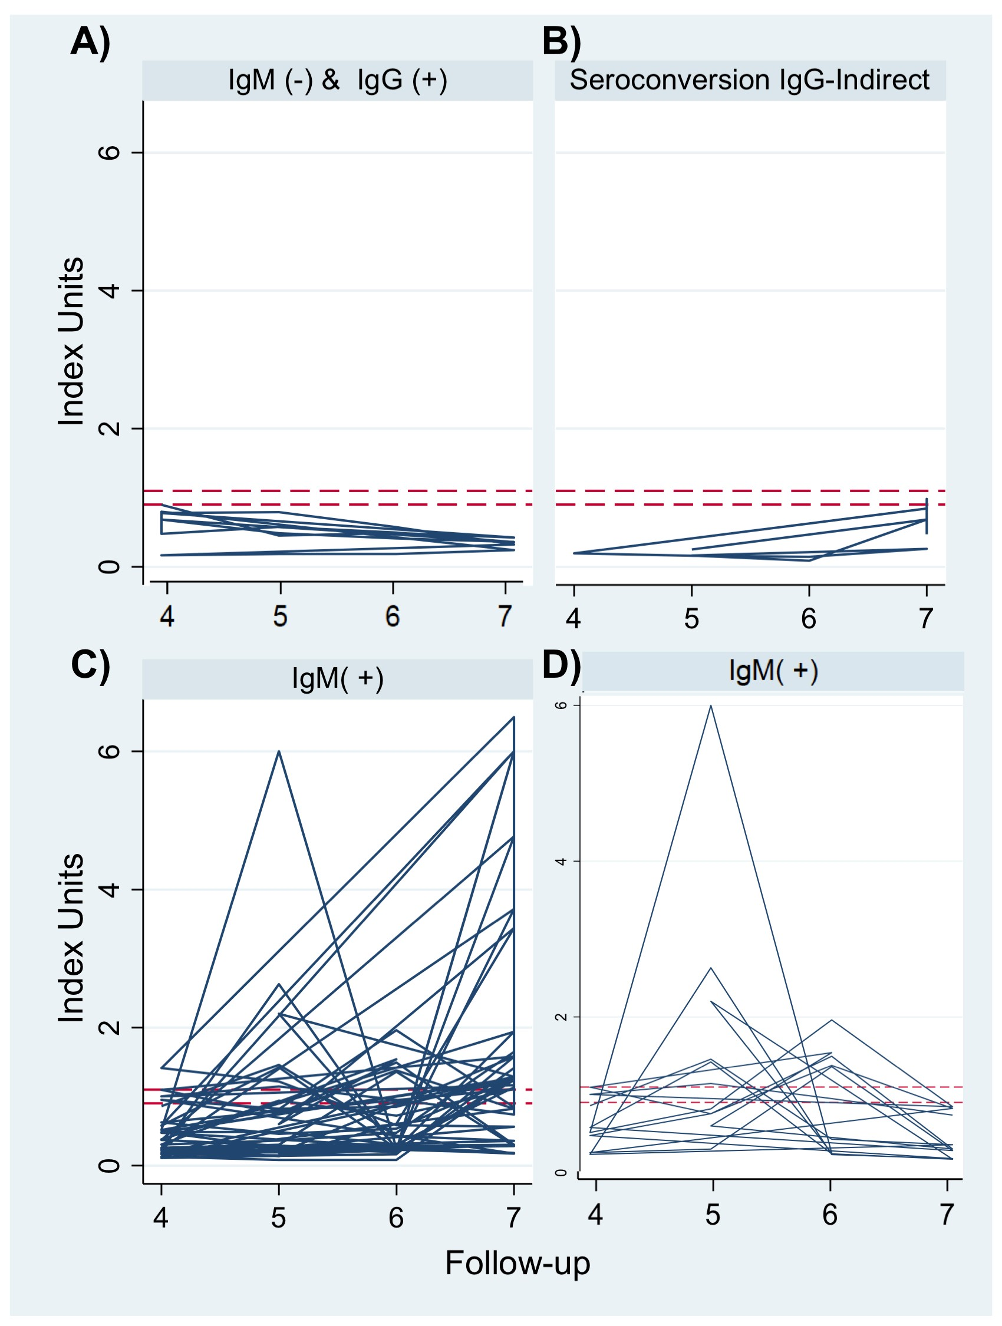
Supplementary Figure S1: IgM reactivity through time in sera of subjects diagnosed as DENV infected. IgM reactivity among subjects who have an IgG(+) capture reaction (A); IgM reactivity among subjects who seroconvert according to IgG indirect positive reaction (B); IgM reactivity in participants diagnosed as DENV infected (C); (D) reactivity of the subjects that where diagnosed infected in the 4-6 follow up (C) and shows no persistence of IgM reactivity.

