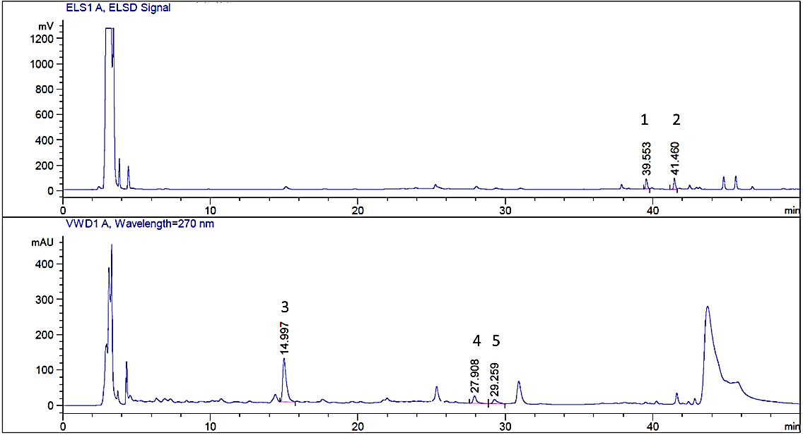
Figure S1. A typical HPLC-UV-ELSD chromatogram of an Astragali radix supernatant. Peak 1, 2, 3, 4, 5represented Astragaloside IV, Astragaloside Ⅱ, Calycosin-7-O-β-D-glucoside, 9,10-dimethoxypterocarpan-3-O-β-D- glucoside, and 2-hydroxy-3',4'-dimethoxyisoflavane-7-O-β-D-glucoside, respectively.

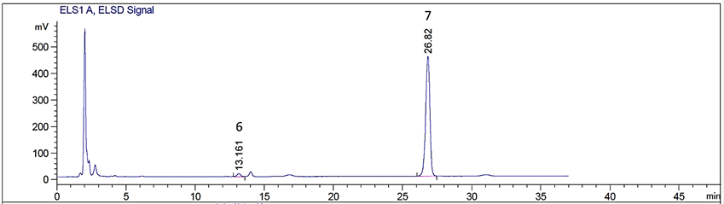
Figure S2. A typical HPLC-ELSD chromatogram of an Astragali radix concentrate. Peaks 6, 7 represented D-fructose, and sucrose, respectively.

Table S1 Temperature control in the experiments
Temperature of concentrate (ºC) | Temperature of refrigeration circulation device (ºC) | Temperature of thermostatic bath (ºC) | Temperature of mixture after stirring for 5min (ºC)
25$±$2 | -20$±$0.5 | 5$±$0.5 | 5$±$0.5
25$±$2 | -5$±$0.5 | 15$±$0.5 | 15$±$0.5
25$±$2 | 25$±$0.5 | 25$±$0.5 | 25$±$0.5

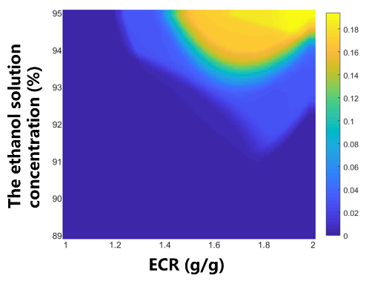
Figure S3. Design space calculation results of N12

