Supporting Information for
Ionospheric monitoring with the Chilean GPS eyeball during the South American Total solar eclipse on 2nd July 2019

Ajeet K Maurya¹, Mahesh N Shrivastava^{2,3*} and Kondapalli Niranjan Kumar⁴

¹Department of Physics, Doon University, Dehradun, India
²Universidad Católica del Norte, Antofagasta, Chile
³National Research Center for Integrated Natural Disaster Management, Santiago, Chile
⁴National Centre for Medium Range Weather Forecasting, Ministry of Earth Sciences, Noida, India.

Contents of this file
Table S1
Figure S1

Introduction
This supporting material consists of one supporting table of the GPS stations and one supporting figure of background wind speed used for this study.

Table S1: Detail about the GPS stations analyzed, their location, eclipse condition, magnitude and change in VTEC at each station
S.N. | GPS Station | Lat.  (⁰S) | Long. (⁰W) | Eclipse Start time [UTC] | Max eclipse time [UTC] | Eclipse End time [UTC] | Eclipse Magnitude | Change in VTEC in TEC unit
1 | chda | -33.79 | -70.59 | 19.36 | 20.61 | 21.72 | 0.91 | 1.53
2 | navi | -33.75 | -71.8 | 19.36 | 20.6 | 21.72 | 0.91 | 1.96
3 | rcsd | -33.46 | -71.59 | 19.36 | 20.6 | 21.72 | 0.92 | 1.19
4 | vzch | -33.4 | -70.48 | 19.37 | 20.61 | 21.73 | 0.92 | 1.33
5 | dgf1 | -33.26 | -70.64 | 19.36 | 20.62 | 21.73 | 0.92 | 0.775
6 | caln | -33.2 | -70.52 | 19.37 | 20.62 | 21.73 | 0.92 | 1.57
7 | qsco | -33.19 | -70.68 | 19.33 | 20.6 | 21.72 | 0.92 | 0.89
8 | qtay | -33 | -71.68 | 19.33 | 20.61 | 21.72 | 0.92 | 1.26
9 | valn | -32.83 | -71.61 | 19.33 | 20.61 | 21.73 | 0.93 | 0.84
10 | trpd | -32.83 | -71.63 | 19.34 | 20.61 | 21.73 | 0.93 | 1.18
11 | rob1 | -32.78 | -71 | 19.34 | 20.62 | 21.73 | 0.94 | 1.43
12 | ctpc | -32.37 | -71.28 | 19.34 | 20.62 | 21.74 | 0.94 | 1.18
13 | zapa | -32.36 | -71.5 | 19.35 | 20.62 | 21.74 | 0.94 | 1.3
14 | cmba | -31 | -70.98 | 19.37 | 20.65 | 21.76 | 0.98 | 2.24
15 | emat | -30.96 | -71.646 | 19.35 | 20.64 | 21.76 | 0.97 | 1.21
16 | pvca | -30.08 | -71.6 | 19.36 | 20.65 | 21.77 | 1 | 0.56
17 | sill | -29.07 | -70.722 | 19.4 | 20.67 | 21.79 | 1 | 0.38
18 | hsco | -28.28 | -71.21 | 19.4 | 20.675 | 21.8 | 0.98 | -1.59
19 | llch | -28.01 | -70.06 | 19.4 | 20.68 | 21.8 | 0.97 | -1.7
20 | udat | -27.18 | -70.33 | 19.43 | 20.7 | 21.82 | 0.94 | -3.45
21 | fmco | -26.4 | -70.67 | 19.43 | 20.7 | 21.82 | 0.93 | -3.16
22 | pazu | -25.97 | -70.58 | 19.44 | 20.71 | 21.82 | 0.92 | -3.87
23 | cifu | -25.48 | -70.63 | 19.44 | 20.72 | 21.82 | 0.9 | -3.89
24 | vlzl | -22.96 | -69.95 | 19.49 | 20.75 | 21.83 | 0.83 | -3.39

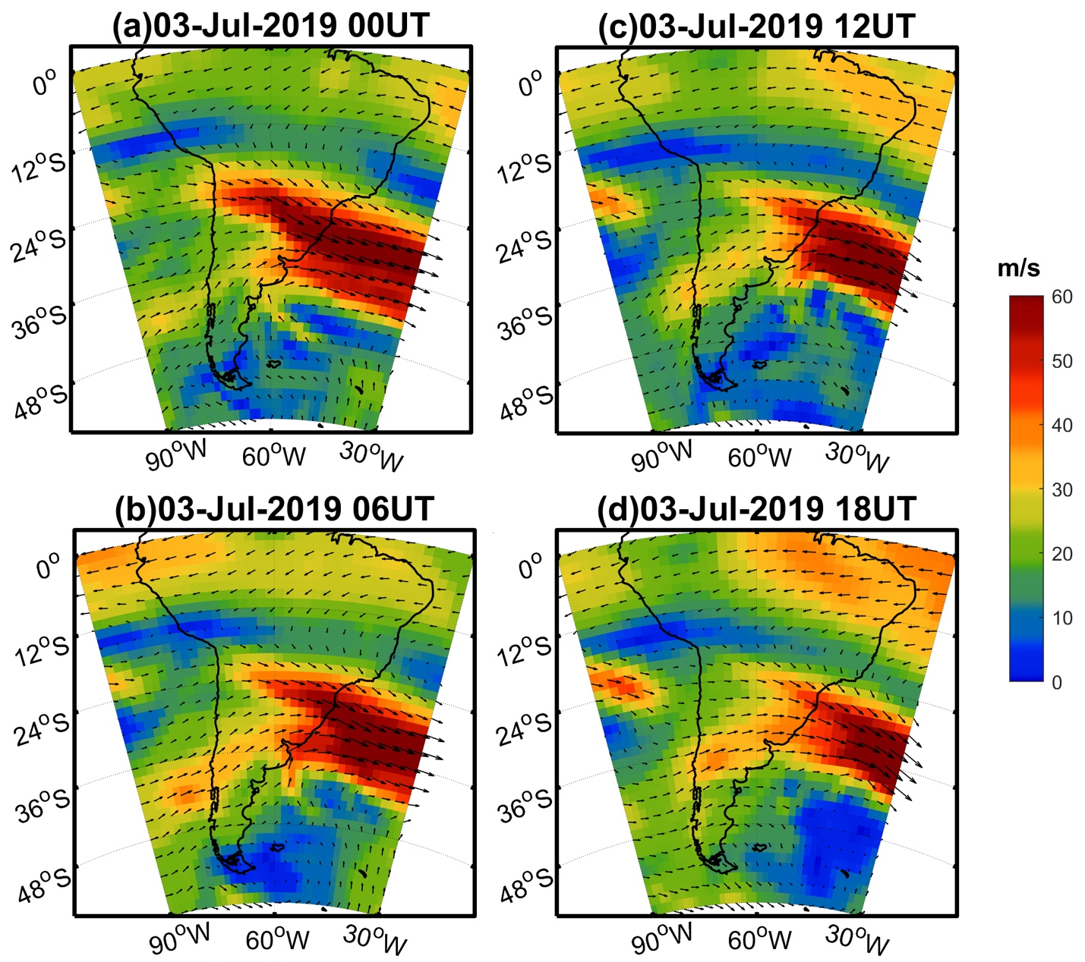

Figure S1: The background wind speed (shaded) and vector winds over the South America on for four different timings (0, 6, 12 and 18 UTC) on solar eclipse day on July 3, 2019 at ~80 km from ERA5 reanalysis data. The figure is prepared using the (URL: http://gmt.soest.hawaii.edu/projects/gmt) GMT 5.1.1¹.

References

1. Wessel, Paul, et al. Generic mapping tools: improved version released. Eos, Transactions American Geophysical Union 94.45: 409-410. https://doi.org/10.1002/2013EO450001 (2013).

