Supplementary Materials

Inhibition of red blood cell development by arsenic-induced disruption of GATA-1

Xixi Zhou, Sebastian Medina, Alicia M. Bolt, Haikun Zhang, Guanghua Wan, Huan Xu, Fredine T. Lauer, Shu Chun Wang, Scott W. Burchiel, and Ke Jian Liu*

Table S1. Total viable bone marrow cell recoveries (per femur set)^{1,2,3}.
Time Point | Control, ×10⁶ | 0.1 µM AsIII, ×10⁶ | 0.5 µM AsIII, ×10⁶
24 h | 0.40 ± 0.04 | 0.37 ± 0.05 | 0.38 ± 0.02
48 h | 1.26 ± 0.06 | 1.18 ± 0.05* | 0.88 ± 0.04*
72 h | 2.03 ± 0.19 | 1.69 ± 0.10* | 1.25 ± 0.10*
¹Mice were exposed to 0, 20, 100, and 500 ppb AsIII via their drinking water for 30 days.
²Viable cells were measured using acridine orange/propidium iodide staining and a Nexcelom Cellometer Auto 2000.
³Data are expressed as mean ± SD, n = 5.

Table S2. Total viable primary mouse bone marrow hematopoietic progenitor cells (stimulated with EPO and SCF) measured following 24, 48, and 72 h AsIII exposure^{1,2,3}.
AsIII Dose Group | Total Viable Cells, ×10⁶
Control (0 ppb) | 44.91 ± 10.45
20 ppb | 38.30 ± 13.40
100 ppb | 36.24 ± 2.68
500 ppb | 30.47 ± 1.93
¹Cells were plated at approximately 3×10⁵ cells (0 h timepoint).
²Viable cells were measured using acridine orange/propidium iodide staining and a Nexcelom Cellometer Auto 2000.
³Data are expressed as mean ± SD, n = 6, *p<0.05 in one-way ANOVA, Tukey’s multiple-comparison tests compared to untreated control group.

Table S3. ChIP-qPCR primer sequences¹.
Region | Sequence
Klf-1 | FWD: 5’–CTGATAGCGGCCTGAAACAT – 3’  REV: 5’– AAGGTCTTTGGGACCCTTTG – 3’
Nfe2 | FWD: 5’ – CCCTCTCCTCCCATCCTTAC – 3’  REV: 5’ – GGGACATGACCAAATGACCT – 3’
¹Supplementary Figure S2 and S3 depicts the genomic region the primers were designed to amplify.

Supplementary Figures

Supplementary Fig. S1

Supplementary Fig. S1. Analysis of erythro-megakaryocytic and myeloid progenitor subsets following 24 h exposure of primary mouse bone marrow hematopoietic progenitor cells (stimulated with EPO and SCF to promote erythroid differentiation) to 0.1 and 0.5 µM AsIII. (a) Percentages of surface marker defined erythro-megakaryocytic progenitors: CMP (Lin⁻, cKit⁺, SCA-1⁻, CD16/32⁻, CD34⁺); PreMegE (Lin⁻, cKit⁺, SCA-1⁻, CD16/32⁻, CD150⁺, CD105^{-, low}); MEP (Lin⁻, cKit⁺, SCA-1⁻, CD16/32⁻, CD34⁻), BFU-E (Lin⁻, cKit⁺, SCA-1⁻, CD16/32⁻, CD150⁺, CD105⁺); CFU-E (Lin⁻, cKit⁺, SCA-1⁻, CD16/32⁻, CD150⁻, CD105⁺) and (b) myeloid progenitors: Pre-GM (Lin⁻, cKit⁺, SCA-1⁻, CD16/32⁻, CD150⁻, CD105⁻); GMP (Lin⁻, cKit⁺, SCA-1⁻, CD16/32⁺, CD150⁻) after 24 h exposure to 0, 0.1, and 0.5 μM AsIII. (c-e) Percentage of erythroblast subsets (early erythroblasts, CD71^{low/high}, Ter119^{-,low}; basophilic (EryA), CD71^{high}Ter119^{high}FSC^{high}; late basophilic and polychromatic (EryB), CD71^{high}Ter119^{high}FSC^{low}; orthochromatic (EryC), CD71^{low}Ter119^{high}FSC^{low}) after 24, 48, and 72 h exposure to 0, 0.1, and 0.5 μM AsIII. Data are expressed as mean ± SD, n =3, *p<0.05 in one-way ANOVA, Tukey’s post hoc test compared to no treatment control group.

Supplementary Fig. S2
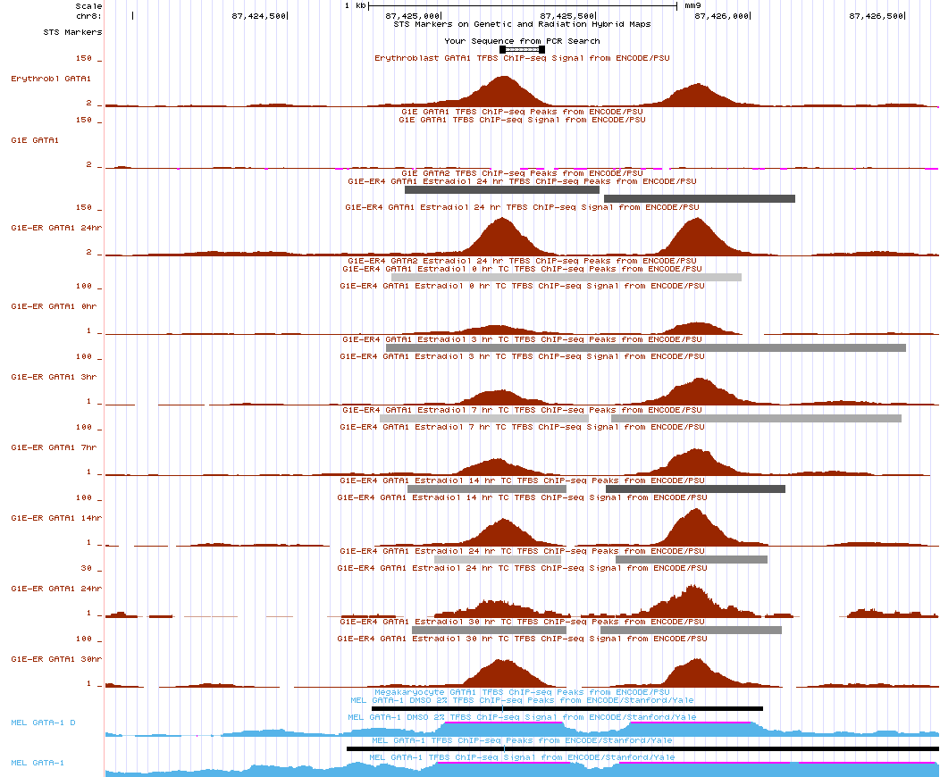

Supplementary Fig. S2. Image showing the enrichment of GATA-1 binding at the Klf-1 sequence used as our target for ChIP-qPCR experiments (indicated with the red box). The y-axis represents available ChIP-seq data from various erythroid progenitor cell types deposited in the University of California Santa Cruz (UCSC) Encyclopedia of DNA Elements Genome Browser on Mouse (https://genome.ucsc.edu/ENCODE/index.html). Image was generated using the in-silico PCR tool on the UCSC Encyclopedia of DNA Elements webpage with the primer sequences provided in Supplementary Table S3.

Supplementary Fig. S3

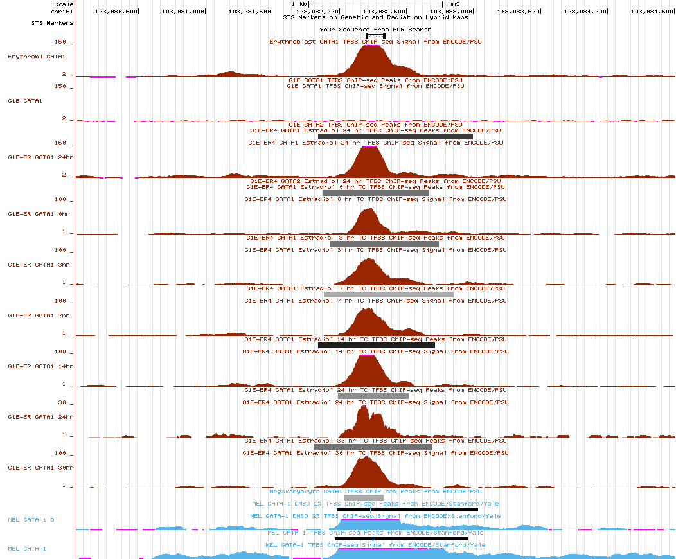

Supplementary Fig. S3. Image showing the enrichment of GATA-1 binding at the Nfe2 sequence used as our target for ChIP-qPCR experiments (indicated with the red box). The y-axis represents available ChIP-seq data from various erythroid progenitor cell types deposited in the University of California Santa Cruz (UCSC) Encyclopedia of DNA Elements Genome Browser on Mouse (https://genome.ucsc.edu/ENCODE/index.html). Image was generated using the in-silico PCR tool on the UCSC Encyclopedia of DNA Elements webpage with the primer sequences provided in Supplementary Table S3.

Supplementary Fig. S4

Input:
GATA-1 | FOG-1
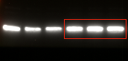 | 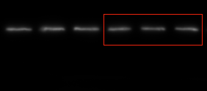
GAPDH
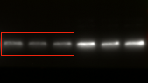
IP:
GATA-1 | FOG-1
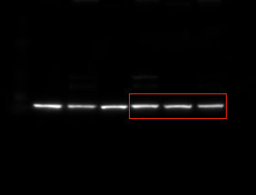 | 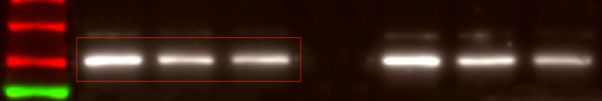

Supplementary Fig. S4. Full-length blots corresponding to Fig. 4e. Lanes from left to right for all blot images: untreated, 0.1 µM AsIII, or 0.5 µM AsIII.

Supplementary Fig. S5.
Input:
GATA-1 | FOG-1
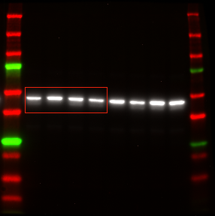 | 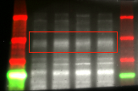
β-actin
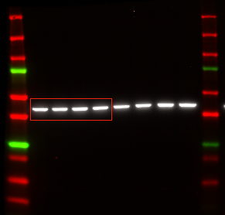
IP:
GATA-1 | FOG-1
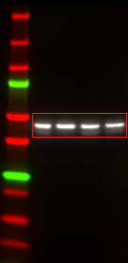 | 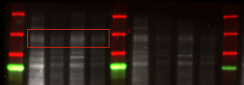

Supplementary Fig. S5. Full-length blots corresponding to Fig. 4g. Lanes from left to right for all blot images: untreated without the zinc chelator, TPEN, untreated with TPEN, 0.5 µM AsIII, or 2 µM AsIII.

