Bioengineering of non-pathogenic Escherichia coli to enrich for accumulation of environmental copper
Dharmender K. Gahlot^{1,2,*}, Nayyer Taheri², Dhani Ram Mahato³, Matthew S. Francis²
¹Department of Biology, University of York, Wentworth Way, York, YO10 5DD, United Kingdom
²Department of Molecular Biology, Umeå University, 90187 Umeå, Sweden
³Deartment of Chemistry, Umeå University, 90187 Umeå, Sweden
*Address correspondence to Dharmender K. Gahlot, E-mail: dharmender.kumar@umu.se, Tel: +46-76 751 63 28

Running title: Copper accumulation by bioengineered E. coli

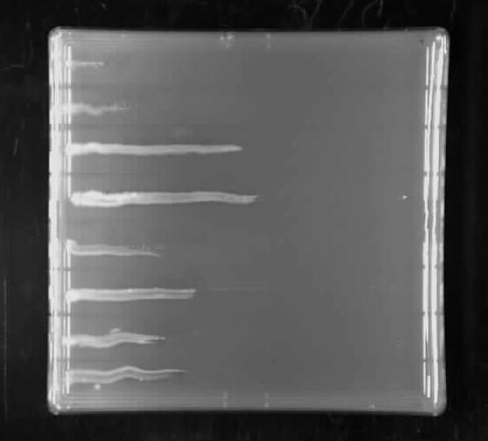

Ctrl P1 P2
P3 P4
P5

P6
P7

0 CuSO4 gradient
10 mM

Figure S1. Original plate for Figure 2B. Representative gradient plate of three
independent experimental sets. Same plate image is shown in figure 2B.

kDa M P1 P2 P3 P4 P5 P6 P7 Ctrl -

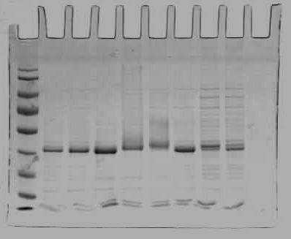170
130
Periplasmic cMBP
95
72
55
43
34
26
17

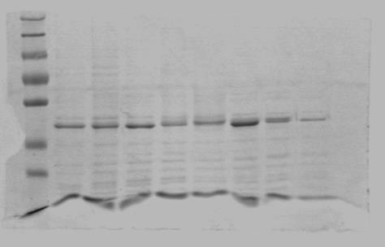170
130
95
72
Purified cMBP
55

43
34
26
17

Figure S2. Original gel image for figure 3A. SDS-PAGE of periplasmic fractions and column-purified periplasmic cMBP. Gel inside dotted square is shown in figure 3A.

A C
B D

Figure S3. Metal ions binding potential of Ctrl and cMBP1-3 fusions, predicted by MIB server. Metal ions binding potential score per amino acid (AA) residue of the modelled structure of MBP Ctrl and chimeric MBP1-3 (B-D) is shown with eight different divalent transition metals. A zoomed in version of cMBP1-3 (B-D) C-terminal, encompassing peptide 1-3, is represented in Fig. 5.

