Autofluorescence-based sorting removes senescent cells from mesenchymal stromal cell cultures
by Alessandro Bertolo¹, Julien Guerrero², Jivko Stoyanov^{1*}

¹ Swiss Paraplegic Research, Nottwil, 6207, Switzerland.
² Tissue Engineering for Orthopaedics & Mechanobiology (TOM), Department for Biomedical Research (DBMR), University of Bern, Bern, 3008, Switzerland.
* jivko.stoyanov@paraplegie.ch

Figure S1 | Comparative analysis of RNA-seq data acquired from MSC sorted by autofluorescence. MSC were divided in control and unsorted groups, and low (LA) and high (HA) autofluorescence groups. Data was plotted by group for all genes for count versus dispersion (a), principal component analysis (PCA) and multi-dimensional scaling (MDS) plots for gene-level features (b).
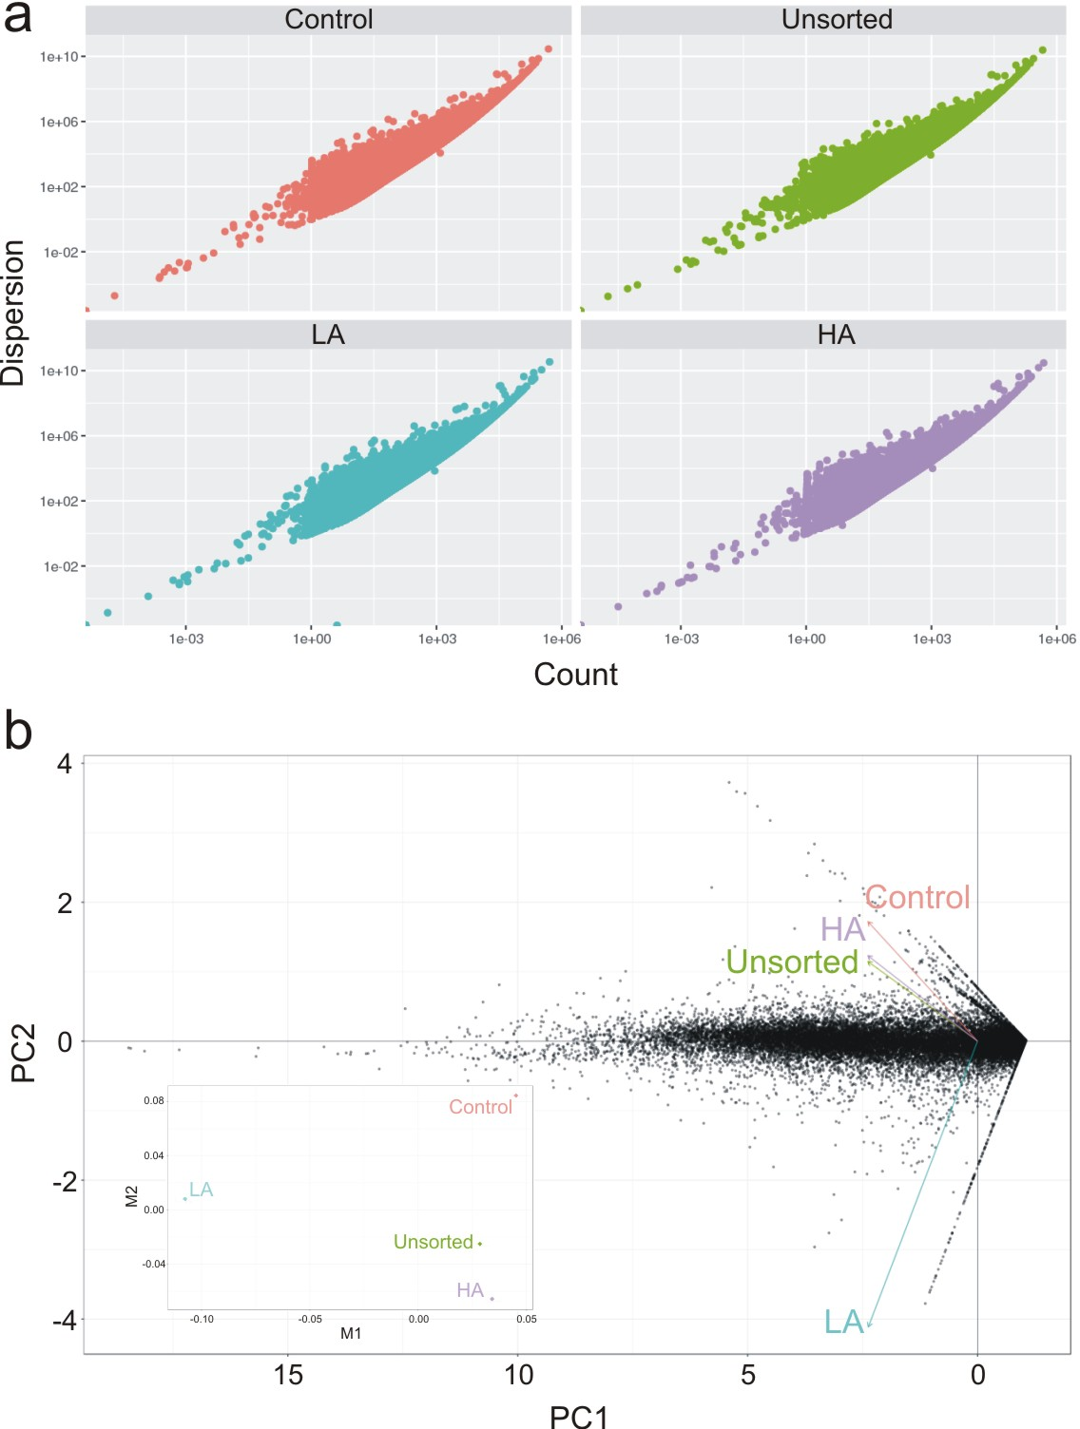
Figure S2 | Full-length immunoblots at different exposure times. Prior to antibody incubations, membranes were cut according to the size of the protein of interest. Samples were loaded in the following order, starting from the left side: Control, Unsorted, LA, MA and HA.

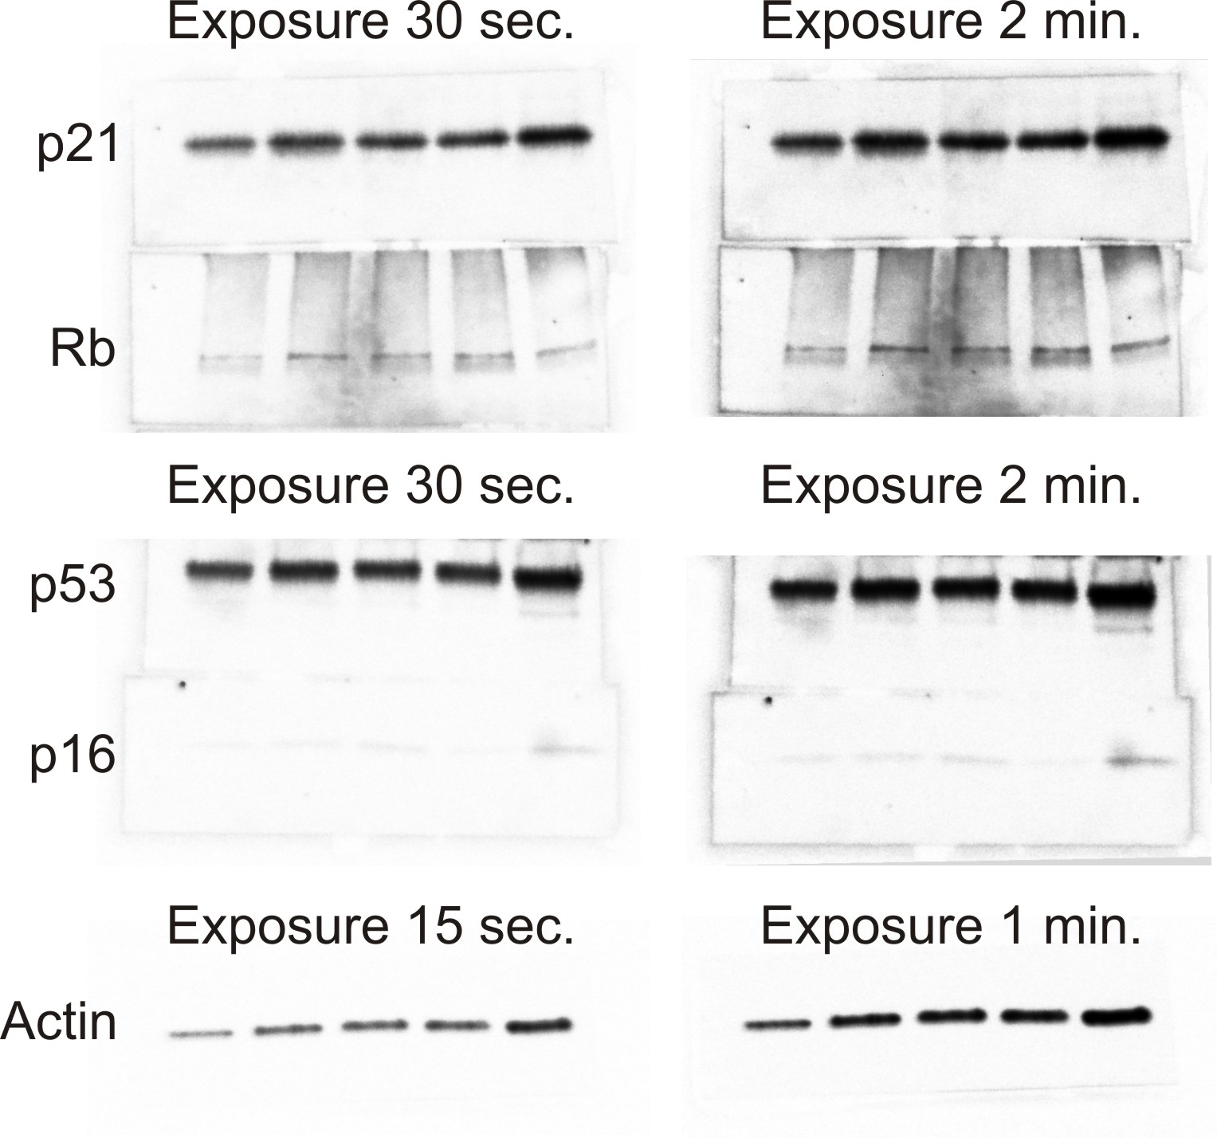

Table S1. Primer pairs of human genes used in quantitative RT-PCR (F = Forward, R = Reverse. bp = base pairs)

Gene | Primer nucleotide sequence (5’ to 3’) | Amplicon
(NCBI Reference Sequence) |  | (bp)
Housekeeping genes
PPIA ⁵³ | F - GTCAACCCCACCGTGTTCTT | 97
(NM_021130) | R - CTGCTGTCTTTGGGACCTTGT
Actin beta | F - CCAACCGCGAGAAGATGA | 97
(NM_001101.5) | R - CCAGAGGCGTACAGGGATAG
Senescence associated genes
p16^{INK4a} | F - GTGGACCTGGCTGAGGAG | 132
(NM_000077) | R - CTTTCAATCGGGGATGTCTG
p18^{INK4C} | F - AGAGATCTGTAGCGTAGGTACGTG | 74
(NM_078626) | R - ACATACATTCCTGGTTAATGACTCC
p21^{CIP1} | F - CGAAGTCAGTTCCTTGTGGAG | 111
(NM_000389) | R - CATGGGTTCTGACGGACAT
E2F1 | F - TCCAAGAACCACATCCAGTG | 75
(NM_005225) | R - CTGGGTCAACCCCTCAAG
CDCA7 ³² | F - CTGCCCAGAAGCCGTCGCTC | 222
(NM_031942) | R - GAACTGGCCTCGAACGCCCC
ANKRD1 ³² | F - CGGAACCTGTGGATGTGCCTACG | 245
(NM_014391) | R - TCCTCCACGGCTTGCCCAGT

Table S1. Human genes used in quantitative RT-PCR. (Continuation)

Gene | Primer nucleotide sequence (5’ to 3’) | Amplicon
(NCBI Reference Sequence) |  | (bp)
RNA-Seq validation
BEX1 | F - CCCTGCTTTCGAATTTACATGTTCA | 107
(NM_018476.4) | R - AACACAATATTCAATTAGAAGCTGG
C1R | F - AAGATTCCTCGGTGCTTGC | 82
(NM_001354346.2) | R - CTTTTTGCCCTCCGATGAT
C7 | F - GAAAGCACACAATGCGAAGA | 62
(NM_000587.4) | R - AAGCAATGTGGTTCAAGCAAC
TPD52L1 | F - CTGTCACAAGCCTCAAGACG | 111
(NM_003287.4) | R - AGCCTCCTGCCAAGCTCT
VCAM | F - TGCACAGTGACTTGTGGACAT | 92
(NM_001078.4) | R - CCACTCATCTCGATTTCTGGA
POLG | F - GGGCACAATGTTTCCTTTGA | 94
(NM_002693.2) | R - TGTGCATGCTCATGGTGTC
SERPINB2 | F - ACCTCATACAGATTCTGCAAAGATT | 69
(NM_001143818.1) | R - GCCACACAAAGATCCTCCAT
PLAT | F - GAAGAGAGGGCTCTGCTGTG | 114
(NM_033011.4) | R - TCGCTGCAACCTTGGTAAG
MYCT1 | F - GGCCTCAACAGAACTGGATT | 61
(NM_025107.2) | R - GGCTGAGGTTGCTTCGAC
KRT34 | F - GTGTGAGATCAACACGTACCG | 93
(NM_021013.3) | R - GAGTTGCCACTAGCATTGGTG
TMEM171 | F - GATCCAGATTATGGAGCCTGTC | 98
(NM_173490.8) | R - CAGAAGCTGAAGATTCAGGAAAG
ESM1 | F - CATGGATGGCATGAAGTGTG | 106
(NM_007036.5) | R - GGTGCCGTAGGGACAGTCT

Table S1. Human genes used in quantitative RT-PCR. (Continuation)

Gene | Primer nucleotide sequence (5’ to 3’) | Amplicon
(NCBI Reference Sequence) |  | (bp)
CAV1 | F - GAGCTGAGCGAGAAGCAAGT | 130
(NM_001753.5) | R - TCCCTTCTGGTTCTGCAATC
EPGN | F - TGCATCAACGGTGCTTGT | 78
(NM_001270989.2) | R - TTCTCCAGTATAACCAGTAAAACACCT
CXCL12 | F - TTGACCCGAAGCTAAAGTGG | 73
(NM_000609.7) | R - CCCTCTCACATCTTGAACCTCT
FGFR2 | F - CCTGCGGAGACAGGTAACAG | 82
(NM_000141) | R - GCGTGTTGTTATCCTCACCA
FMO2 | F - TGTGTGGATGAGGGACTTGA | 102
(NM_001460.5) | R - GATACTTGCTCGGCCATCTT
NDNF | F - CTTCTCACCAAAAAGTCACCTTC | 75
(NM_024574.4) | R - TCCCATCTCTTCTCACTTGGAT

