Platycodin D enhances LDLR expression and LDL uptake via down-regulation of IDOL mRNA in Hepatic cells

Yu-Jeong Choi,¹ Sol Ji Lee,^{1,2} Hyo In Kim,¹ Hee Jung Lee,³ So Jung Kang,⁴ Tai Young Kim,^{2,5,*} Chunhoo Cheon,⁵ and Seong-Gyu Ko^{5,*}

¹ Department of Science in Korean Medicine, Graduate School, Kyung Hee University, Seoul, 02447, Republic of Korea
² Center for Cognition and Sociality, Institute for Basic Science, Daejeon, 34126, Republic of Korea
³Department Global Public Health and Korean Medicine Management, College of Korean Medicine, Graduate School, Kyung Hee University, Seoul, Republic of Korea
⁴ Department of Clinical Koeran Medicine, Graduate School, Kyung Hee University, Seoul, Republic of Korea
⁵ Department of Preventive Medicine, College of Korean Medicine, Kyung Hee University, Seoul, 02447, Republic of Korea

*To whom correspondence should be addressed:

Dr. Tai Young Kim
Center for Cognition and Sociality, Institute for Basic Science, Daejeon, 34126, Republic of Korea
Email: taik@ibs.re.kr, Fax: 82-42-878-9151, Phone: 82-42-878-9155

Dr. Seong-Gyu Ko
Department of Preventive Medicine, College of Korean Medicine, Kyung Hee University, 1 Hoegi, Seoul, 130-701, Korea
Email: epiko@khu.ac.kr, Fax: 82-2-966-1165, Phone: 82-2-961-0329

Supplementary figures and figure legends

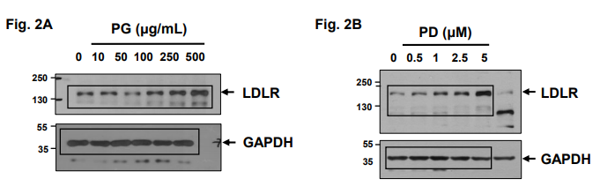

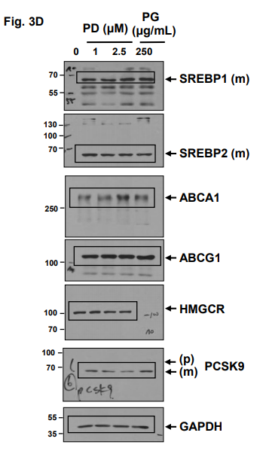
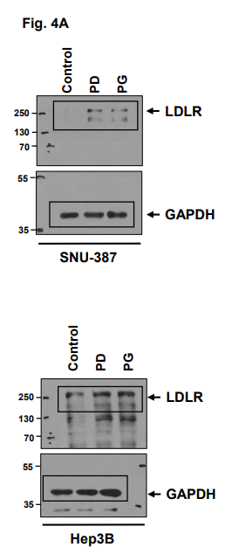

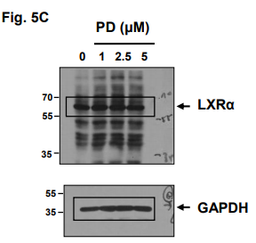
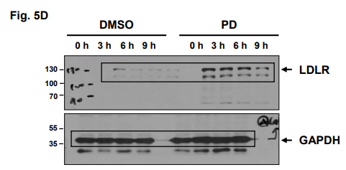
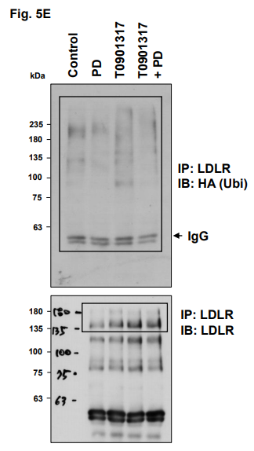
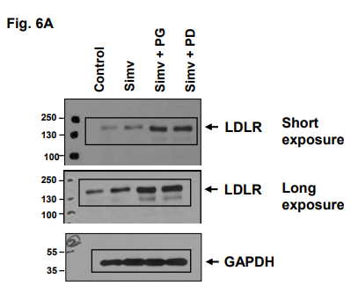

Supplementary Figure S1. Uncropped western blot images.

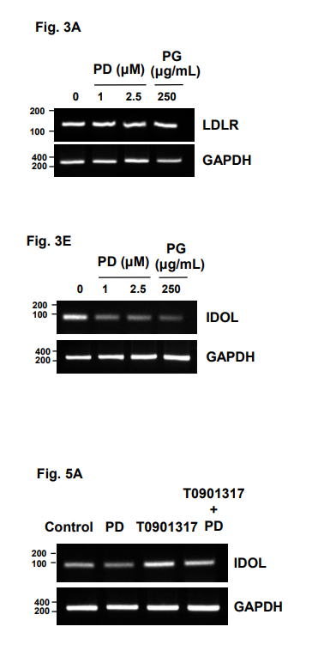

Supplementary Figure S2. Uncropped PCR images.

