SUPPLEMENTARY INFORMATION

Coxsackievirus infection induces a non-canonical autophagy independent of the ULK and PI3K complexes
Yasir Mohamud^{1,2}, Junyan Shi^{1,2}, Hui Tang^{1,3}, Pinhao Xiang^{1,2}, Yuan Chao Xue^{1,2}, Huitao Liu^{1,2}, Chen Seng Ng^{1,2}, Honglin Luo^{1,2*}

¹Centre for Heart Lung Innovation, St. Paul's Hospital, Vancouver, BC, Canada
²Department of Pathology and Laboratory Medicine, University of British Columbia, Vancouver, BC, Canada
³ Department of Pharmacy, Shandong Provincial Hospital Affiliated to Shandong First Medical University

*Correspondence:
Honglin Luo, Centre for Heart Lung Innovation, St. Paul’s Hospital, 1081 Burrard St., Vancouver, BC V6Z 1Y6, Canada. Email: honglin.luo@hli.ubc.ca

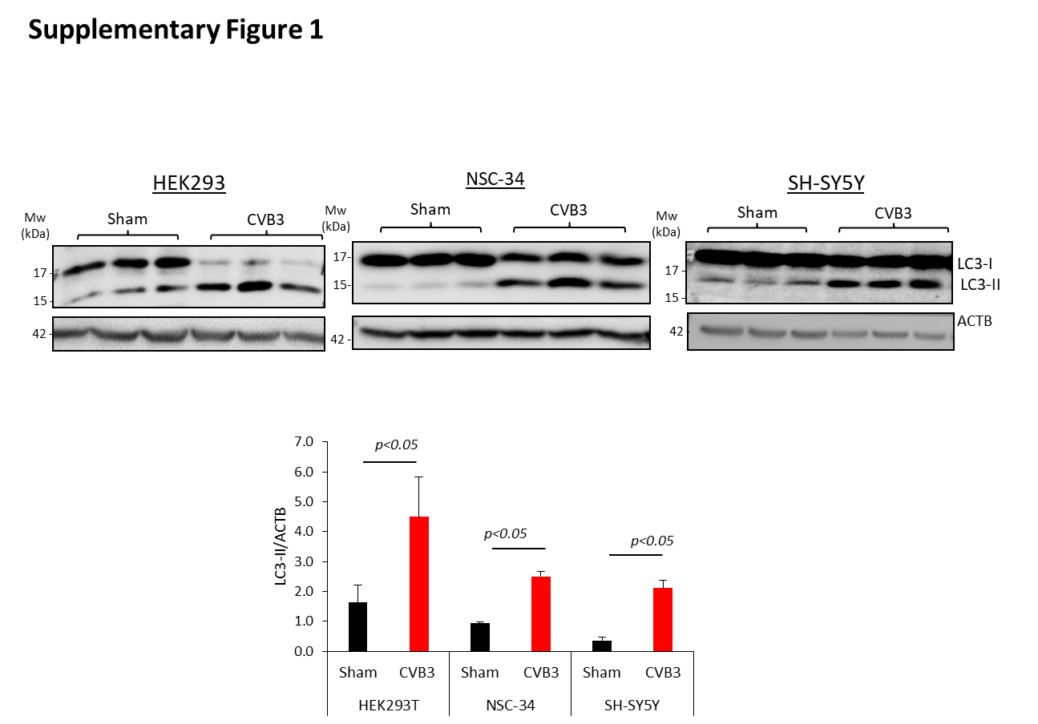

Supplementary Figure 1. CVB3-induced LC3 accumulation in HEK293, NSC-34, and SH-SY5Y cells.
HEK293A, NSC-34, and SH-SY5Y cells were sham- or CVB3-infected for 16h. Cell lysates were harvested for western blot analysis. Autophagy induction was assayed by LC3-II conversion, normalized to ACTV and quantified in the bottom panel (mean±SD, n=3, analyzed by unpaired Student t-test).

