Supplementary Materials for

A causal role for the right Angular Gyrus in Self-Location mediated Perspective Taking

D.M.L. de Boer^{1,3}*, P.J. Johnston^{1,3}, G. Kerr^{2,3}, M. Meinzer^{4,5}, A. Cleeremans⁶.
Correspondence to: debbie.boer@hdr.qut.edu.au

This file includes:

Tables S1 to S3 (note: 300dpi images in separate files)
Figs. S1 to S3 (note: 300dpi images in separate files)
Data S1

Other Supplementary Materials for this manuscript include the following:

Data S2 (OSF)

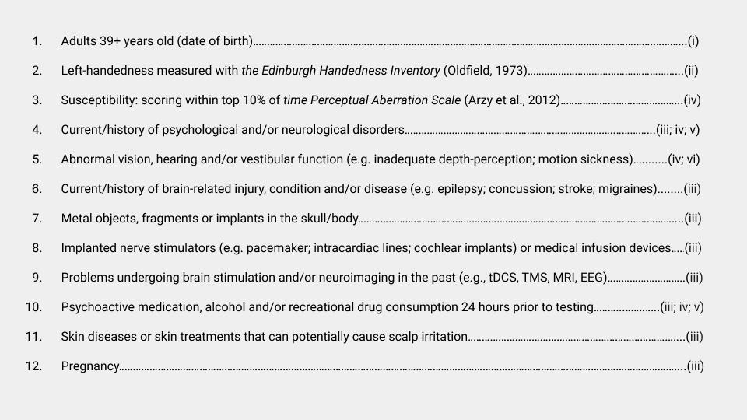
Table S1. Exclusion Criteria.

Prospective participants were prescreened online for (i) age, (ii) handedness, (iii) tDCS Safety, (iv) pre-existing susceptibility to body illusions / right Angular Gyrus dysfunction 37, (v) (history of) psychological and/or neurological disorders, and (vi) visual or vestibular problems viewing 3D content (corrected-to-normal vision was allowed using contact lenses). Participants’ eligibility was double-checked prior to testing (e.g., date of birth, check 3D vision, tDCS Safety Screening Questionnaire 35-36; Edinburgh Handedness Inventory 34). Further restrictions aimed to control for declines in reaction times with age and left-right differences in hemispheric organization.

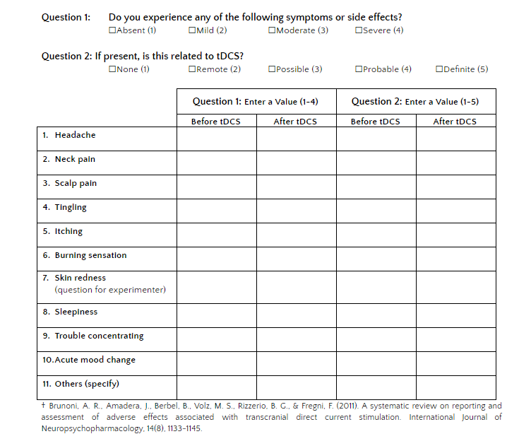
Table S2. Adverse Effects tDCS.
Participants rated the intensity of 11 potential adverse effects before and after each tDCS session, e.g., ‘Headache’ ranging from ‘1= Absent,’ ‘2 = Mild,’ ‘3 = Moderate’ to ‘4 = Severe’ (40). Questions 1 & 2 were compared to identify potential symptoms that were related to the tDCS administration. This protocol assured safe tDCS administration and blinding to stimulation condition.

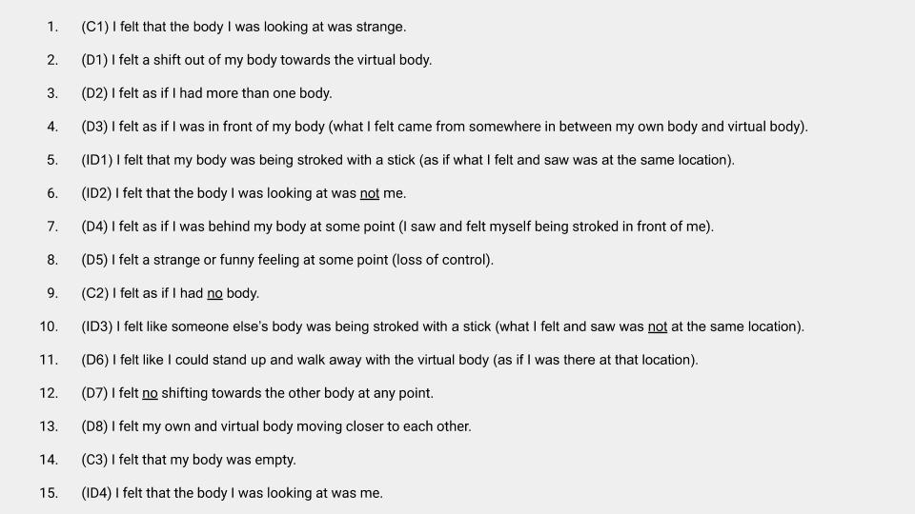
Table S3. Full-body Illusion (FBI) Exit Interview.
Listed items were answered and scored on 5-point Likert scales ranging from ‘5 = Strongly Agree,’ ‘4 = Agree,’ ‘3 = Neither agree or disagree,’ ‘2 = Disagree’ to ‘1 = Strongly Disagree’ (negatively phrased items reverse-coded); Item Codes: D1-8 Displacement; ID1-4 Self-Identification; C1-3 Control (C1 measured ‘General Disposition’ to illusion between sessions); D5 & D6 measured changes in perceived control, i.e., ‘Sense of Agency’ (answers were verified with response to open question: ‘Please describe your experience in a few words’).

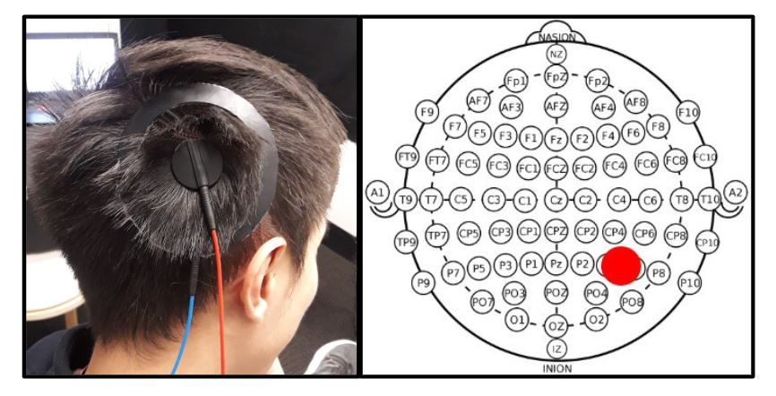
Fig. S1. HD-tDCS montage & P4-P6 electrode positioning.
(L) HD-tDCS concentric center-ring montage to right Angular Gyrus;
(R) P4-P6 electrode positioning (Brodmann Area 39) in 10-10 International EEG system.

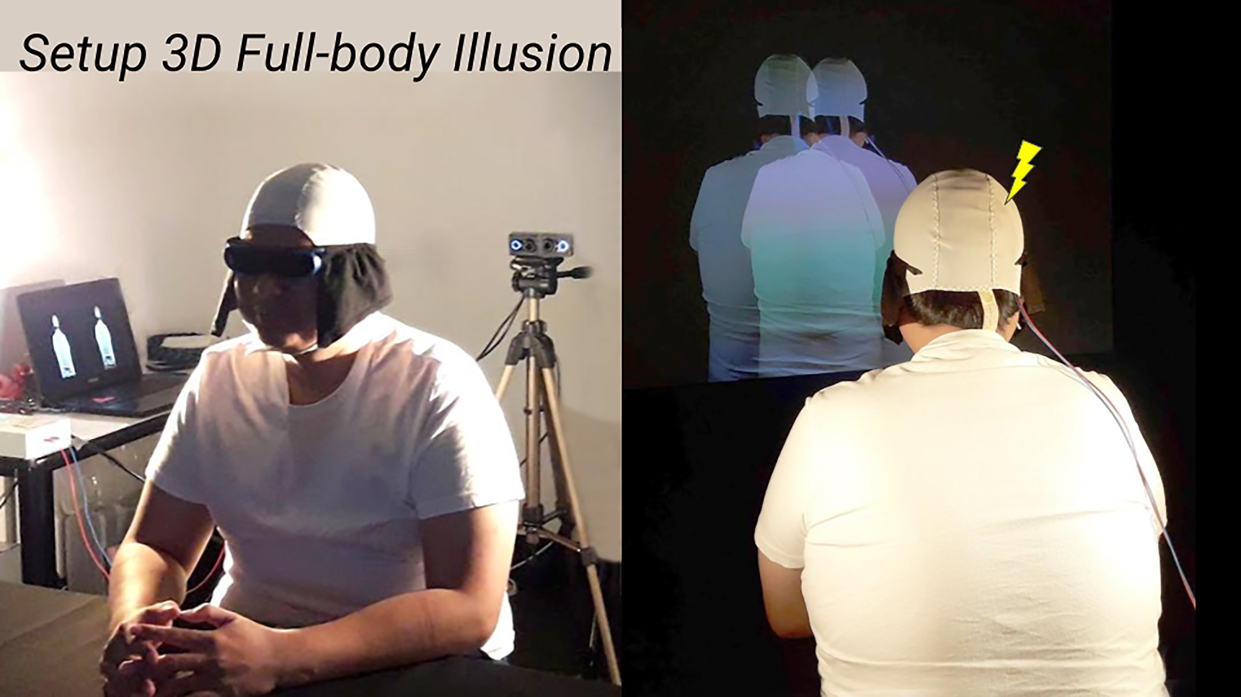
Fig. S2. Stereoscopic 3D Full-body Illusion combined with HD-tDCS.
Front (L) and back (R) view of Full-body Illusion paradigm based on live-streaming stereoscopic 3D-images with Bino 3D Player (41). Here combined with High Definition transcranial Direct Current Stimulation (HD-tDCS).

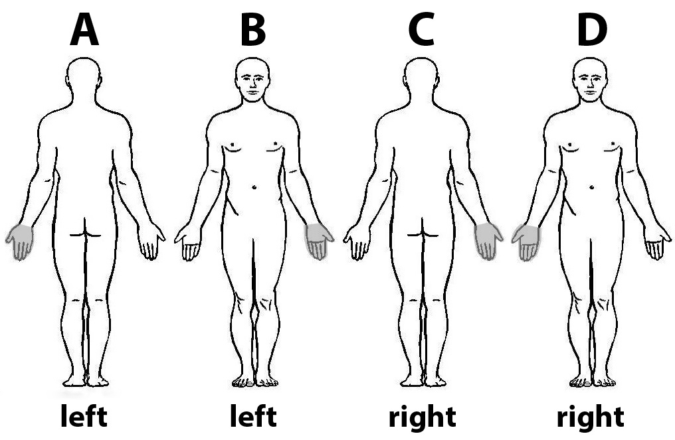
Fig. S3. Own-body Transformation task (OBT & LAT) stimuli A-D.
Own-body Transformation and control Lateralization stimuli A-D; below correct answers OBT-task.
Adapted from (32) including more realistic human sketches.

Data S1. Full-body Illusion (FBI) Exit Interview

The FBI exit-interview consisted of 15 items (incl. 3 control items) that were answered and scored on 5-point Likert scales. There were eight ‘Displacement Items,’ two of them measured sense-of-agency (i.e., ‘Agency low’ & ‘Agency high’), and four ‘Self-Identification Items,’ see Table S3. Negatively phrased questions were reverse coded and did not indicate inconsistencies in answers. Subsequently, a high score on each item (excl. control items) represented a more pronounced full-body illusion. Descriptive statistics pooled over the sessions confirmed that all items (except control items 9 & 14) had a mean score around 3 points and SD > 1 point (except Item 15). As expected, the displacement items (Items 2, 3, 4, 7, 8, 11, 12 & 13) were strongly correlated, r(33) > 0.5, p = 0.01; while other items were not correlated, r = 0 one-tailed Bonferroni corrected. Inter-item correlations measured with Cronbach’s α: 0.89 Session 1; 0.87 Session 2 (displacement items); 0.81 Session 1; 0.79 Session 2 (15 items excl. control items 1, 9 & 14). “Total Exit Interview Scores” were calculated excluding the control items.

Data S2. (OSF) https://osf.io/b9tku/

