Placenta-derived macaque trophoblast stem cells: differentiation to syncytiotrophoblasts and extravillous trophoblasts reveals phenotypic reprogramming

Jenna Kropp Schmidt^{1*}, Logan T. Keding², Lindsey N. Block¹, Gregory J. Wiepz², Michelle R. Koenig², Michael G. Meyer¹, Brittany M. Dusek¹, Kamryn M. Kroner¹, Mario J. Bertogliat¹, Avery R. Kallio¹, Katherine D. Mean¹ and Thaddeus G. Golos^{1,2,3}

¹Wisconsin National Primate Research Center, University of Wisconsin-Madison
²Department of Comparative Biosciences, University of Wisconsin-Madison
³Department of Obstetrics and Gynecology, University of Wisconsin-Madison

*Corresponding Author
Jenna Kropp Schmidt
Wisconsin National Primate Research Center
1220 Capitol Ct.
Madison, WI 53715-1299
jkropp@wisc.edu

Supplemental Figure S1. Time course of TSC and in vitro differentiation of pri-ST cultures. Immunocytochemistry for Ki-67 (pink, nuclear) and nuclear stain, DAPI (blue). Ki67 expression is lost within 48h of culture as pri-ST differentiate. Scale bars in all panels represent 100 µm.

Supplemental Figure S2. IgG control immunostaining of cultured cells used in this study.

Supplemental Figure S3. Extravillous trophoblast (EVT) morphology by phase contrast imaging. Representative images from EVTs derived from three TSC lines across 8 days in EVT differentiation medium. Scale bars represent 500 µm.

Supplemental Figure S4. t-SNE distribution of cellular gene expression determined by scRNA-seq at passage 2 (p2, A) and passage 10 (p10, B). The number of significantly up or down regulated genes in panel B appear in parentheses next to the cluster number. No genes were significantly differentially expressed across the clusters of passage 2 cells.

Supplemental Figure S5. scRNA-seq expression of individual genes within the t-SNE distribution. Top differentially expressed genes in common between clusters identified by K-means clustering analysis (A) or LMO algorithm (B).

Supplemental Figure S6. Gel electrophoresis images of RT-PCR products from Figure 3A. A 100 base pair (bp) step-wise ladder was used with 500 bp mark indicated on the gel image. All lanes in which a product was loaded are labeled by cell type and gene. No cDNA control and no reverse transcriptase control reactions were run in parallel for each cell type and primer pair (not shown).

Supplemental Figure S1
72 h
24 h
48 h
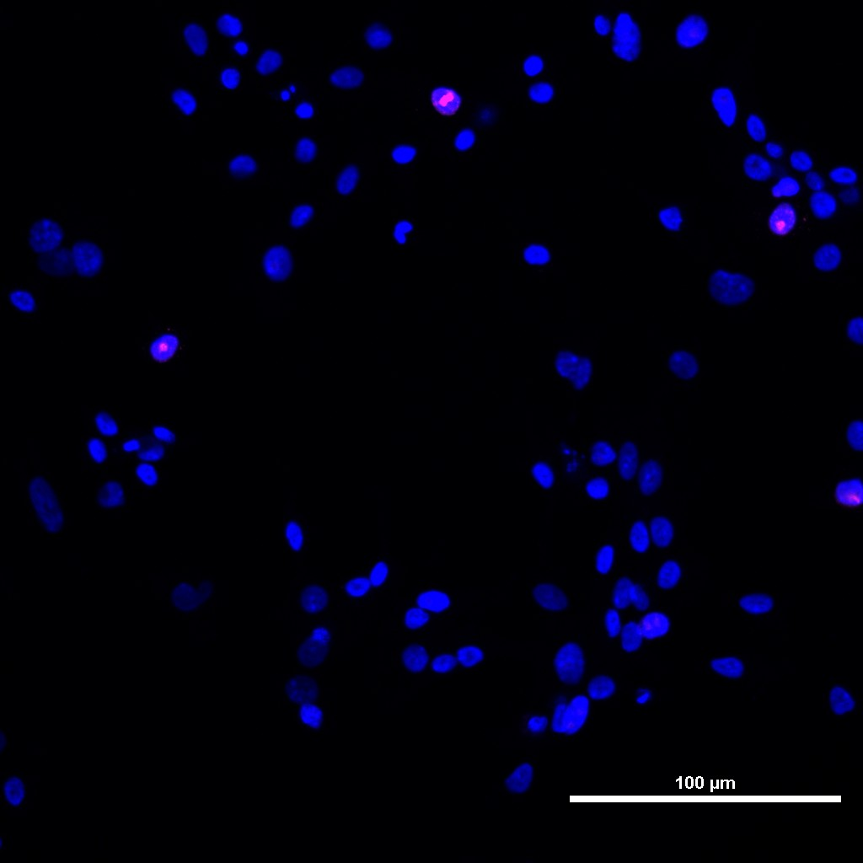
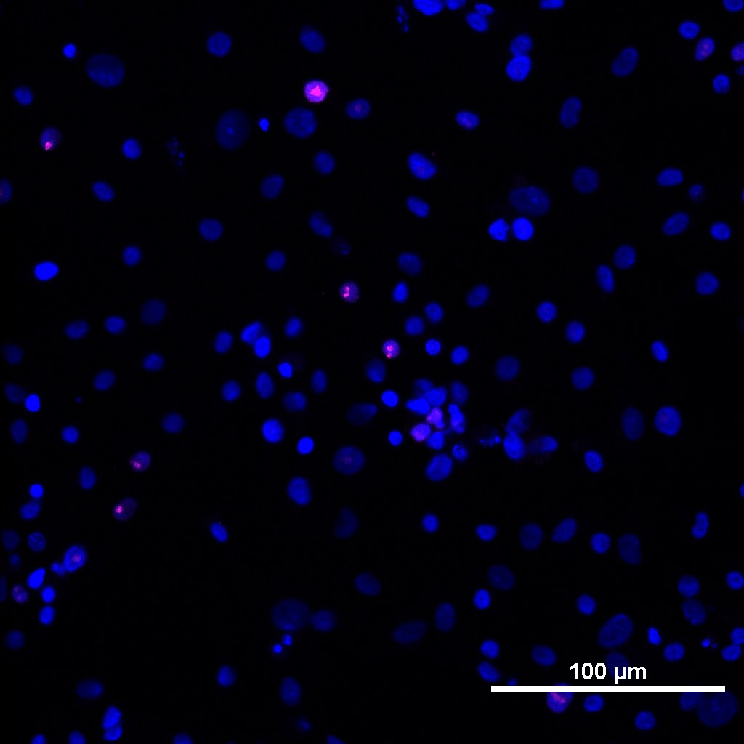
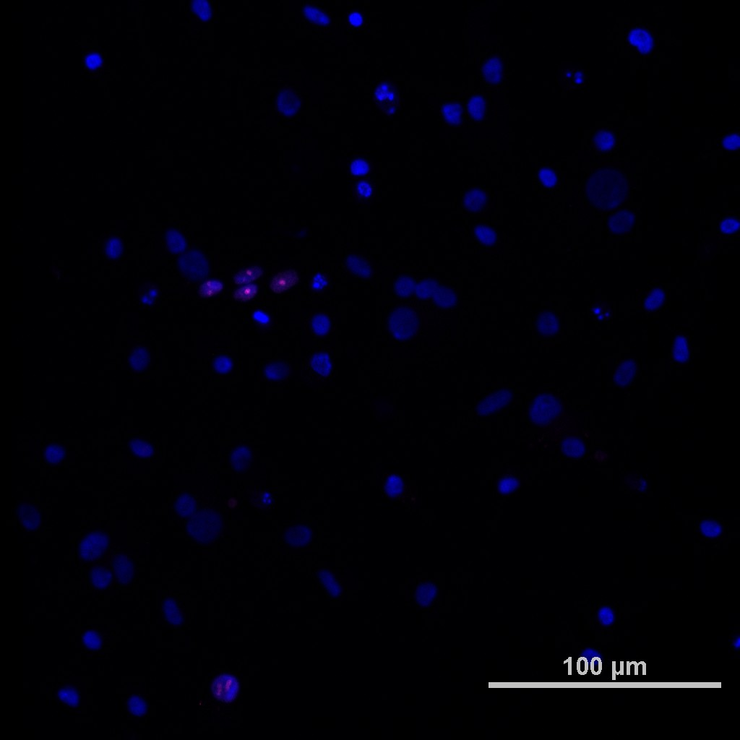

TSC
TSC

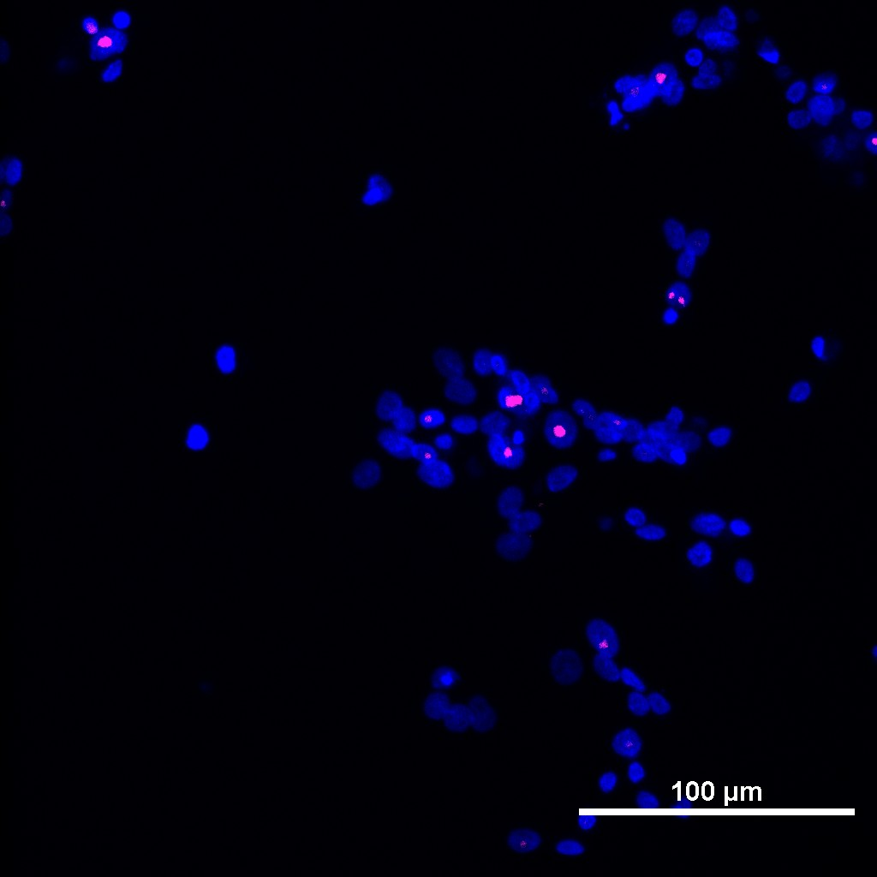
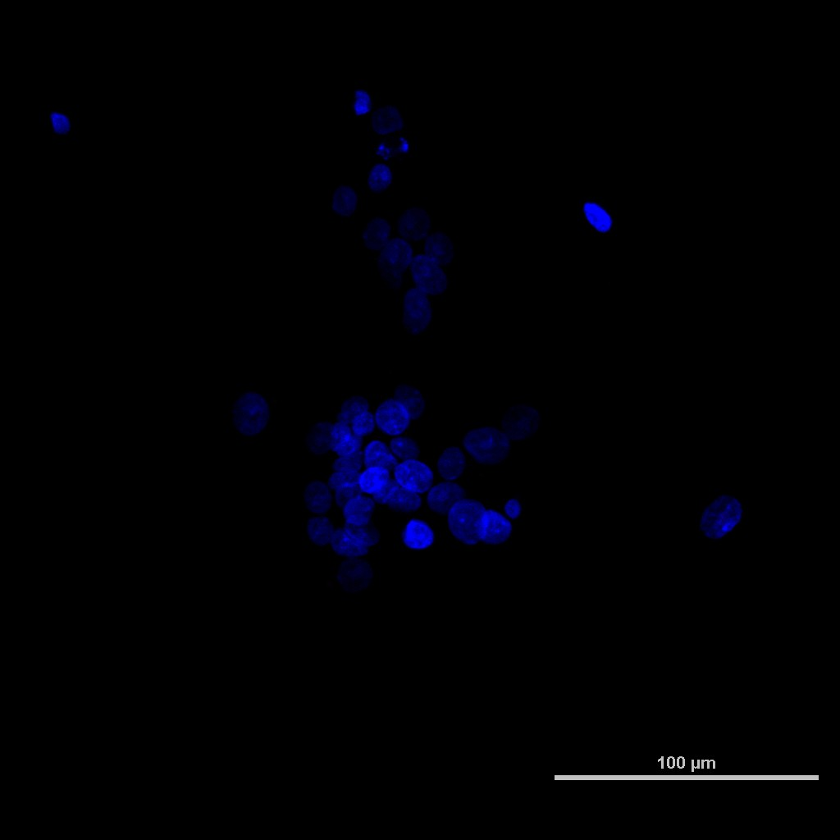
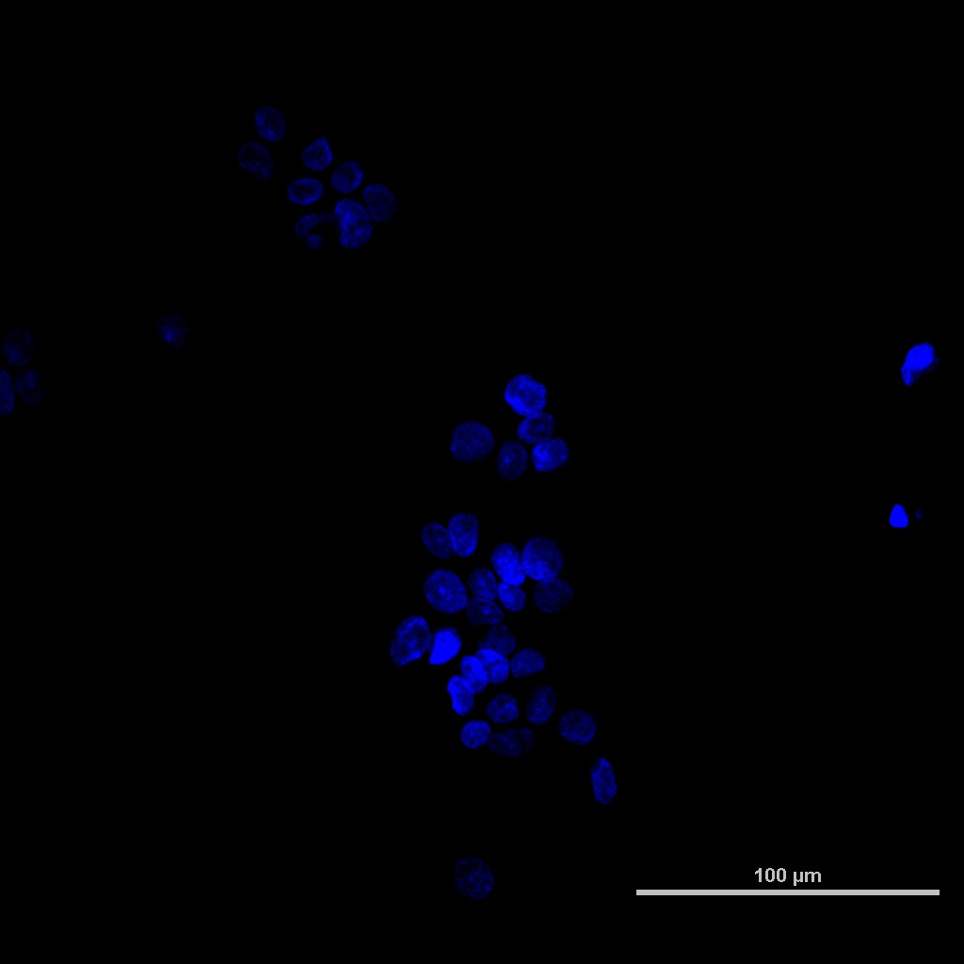

pri-ST
pri-ST

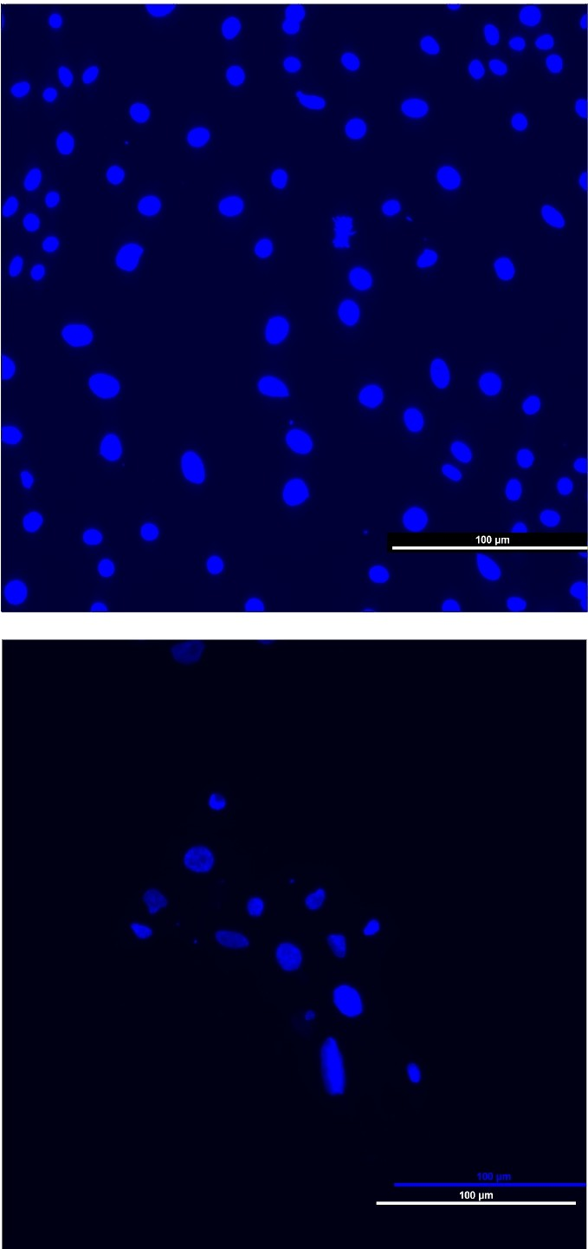
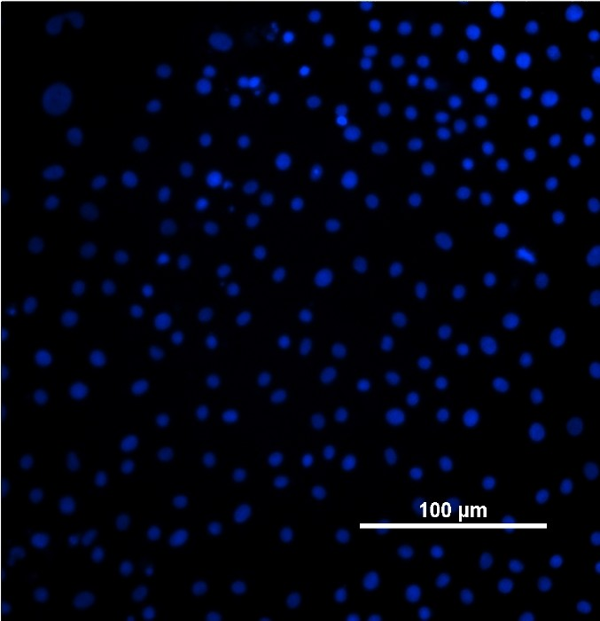
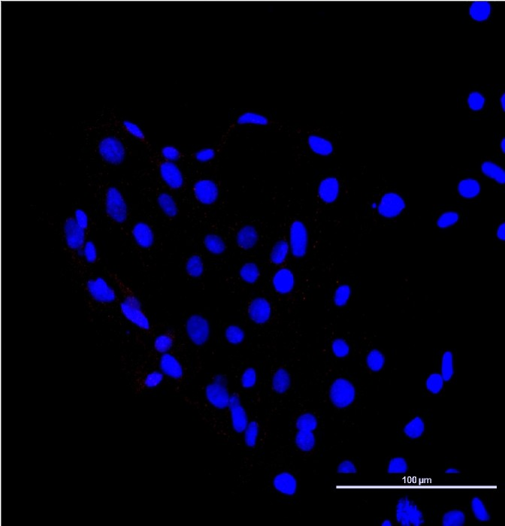
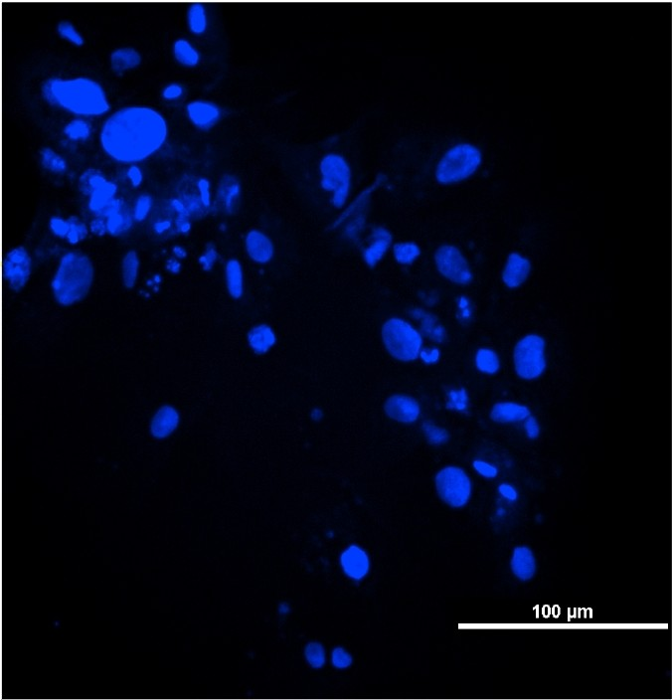
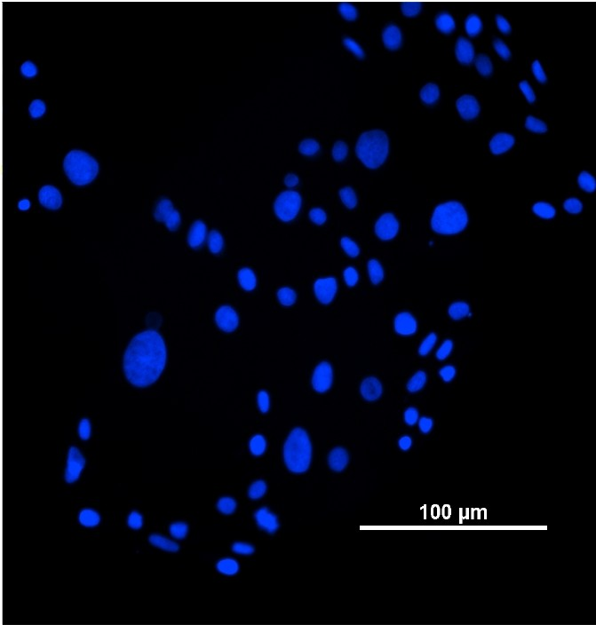
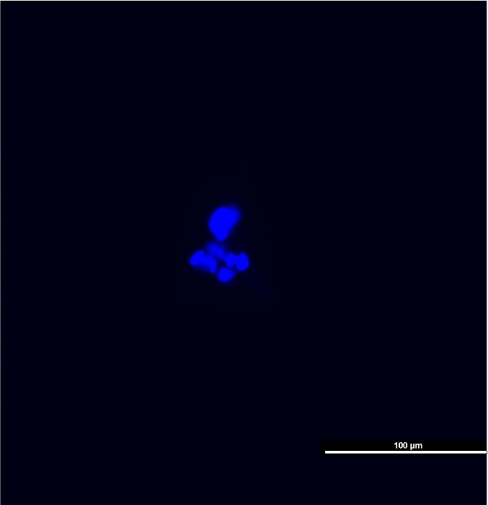
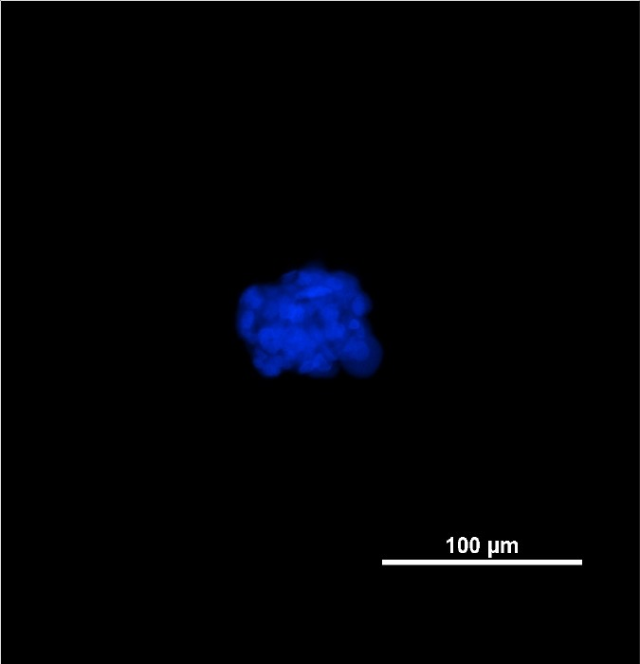
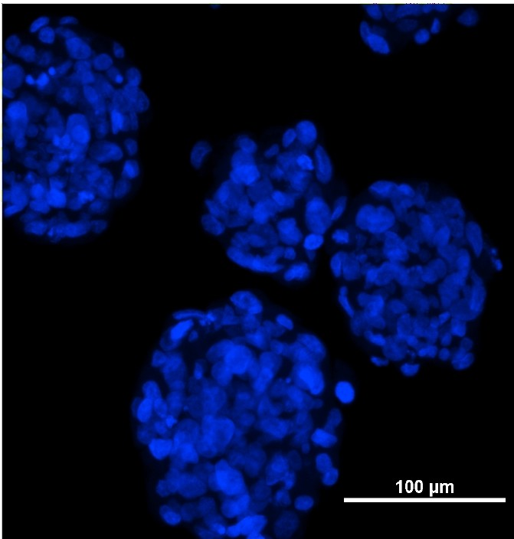
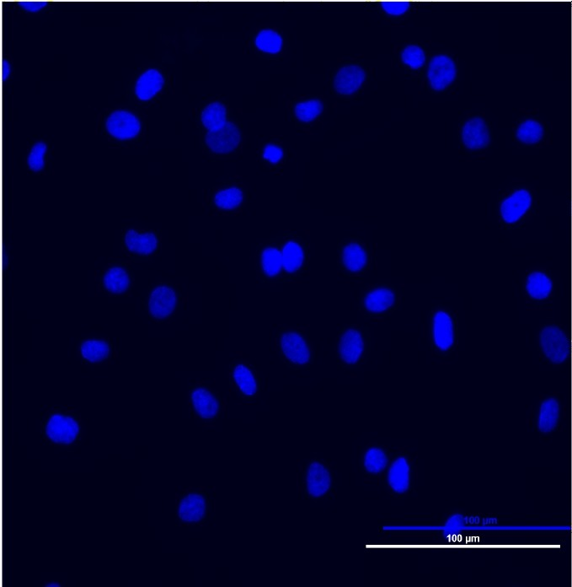
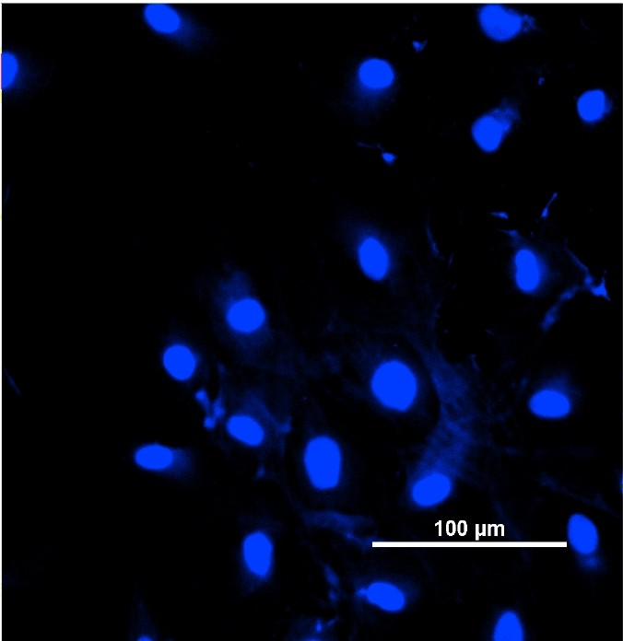
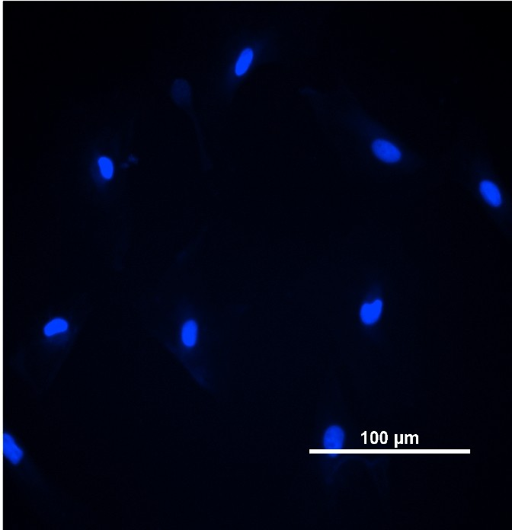
rab-IgG
ms-IgG2A
ms-IgG1
Supplemental Figure S2

TSC

TSC

ST-2D

ST-2D

ST-3D

ST-3D

fibroblast

Fibroblast
Supplemental Figure S3
day 8
day 6
day 3
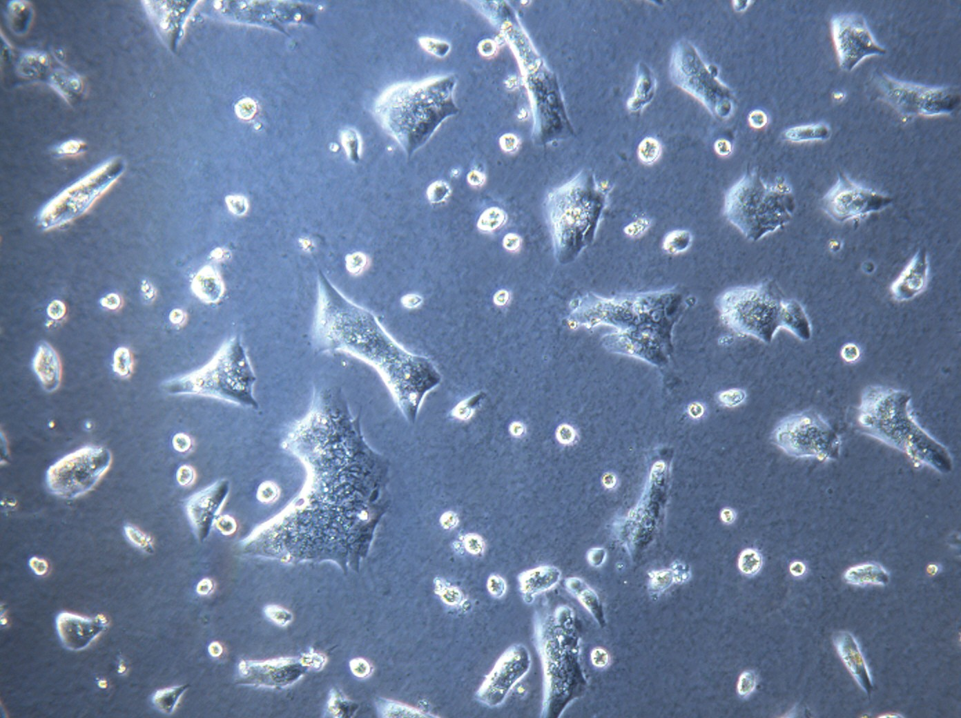
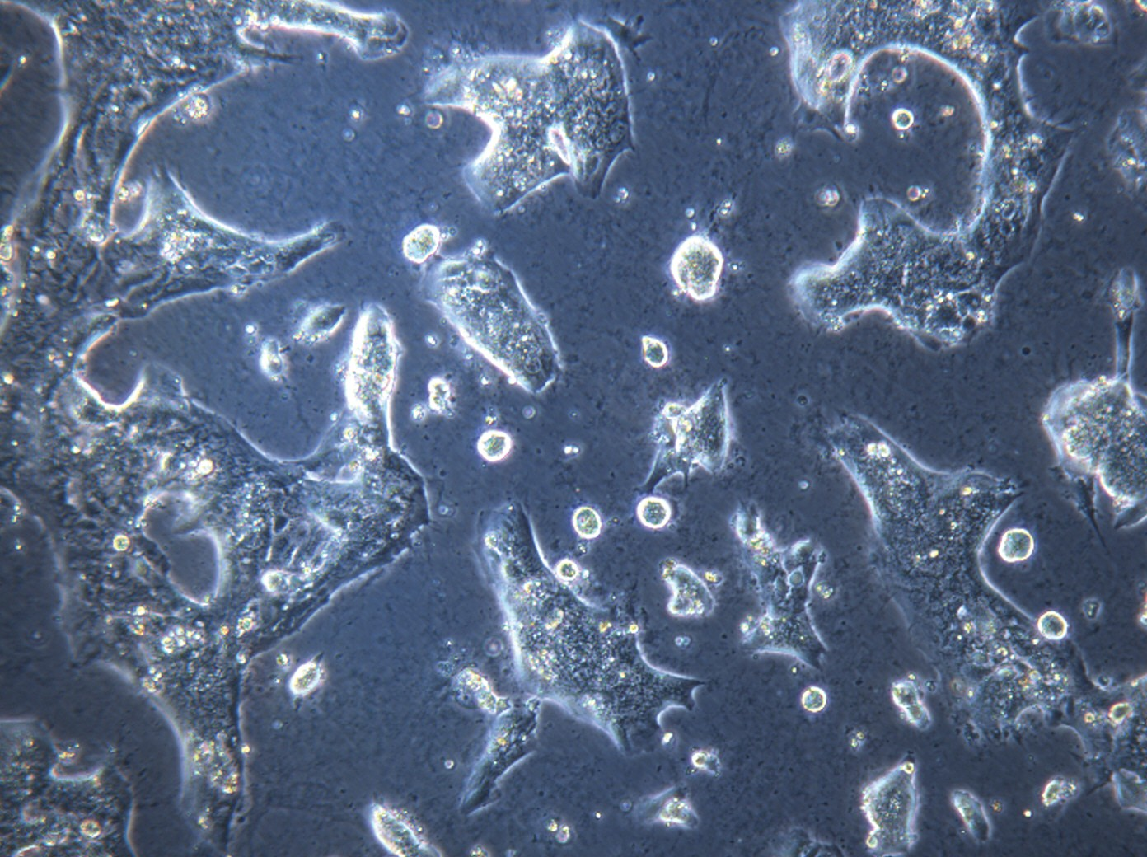
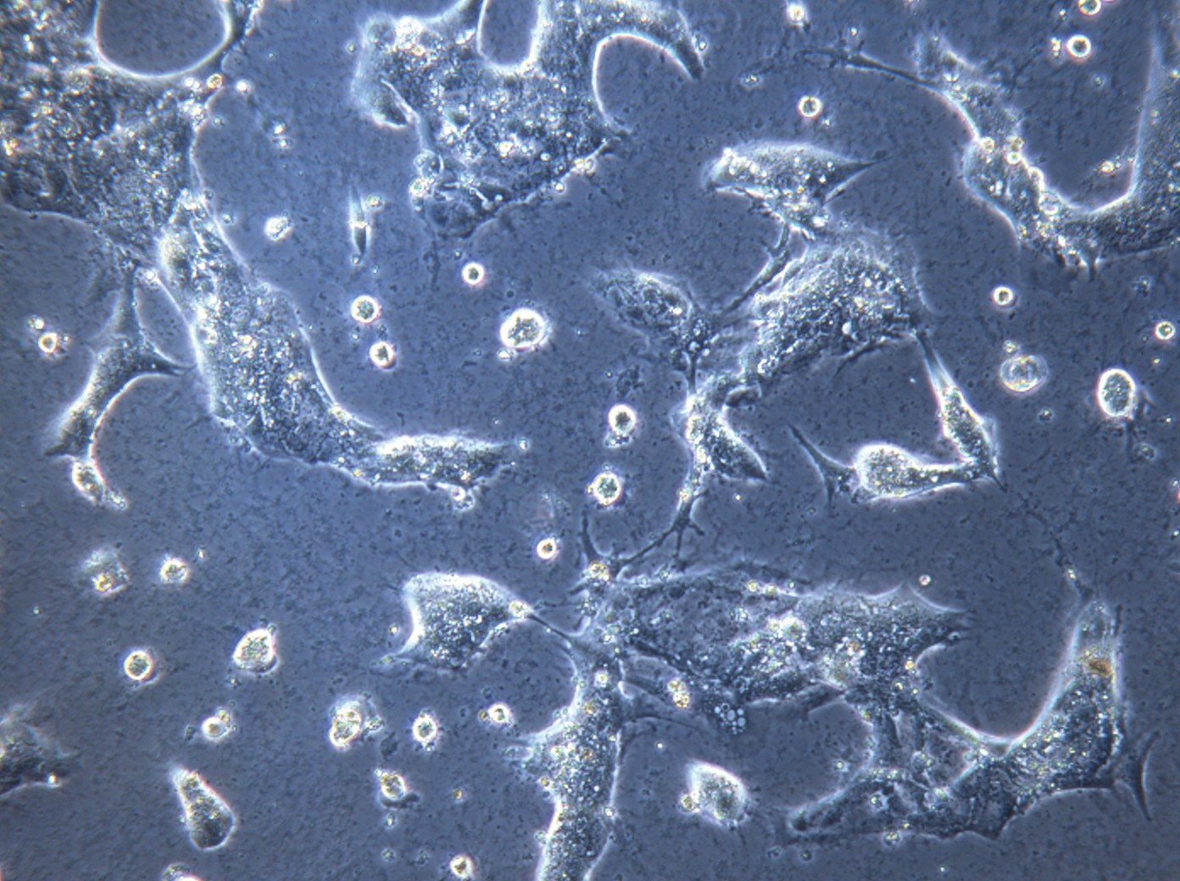
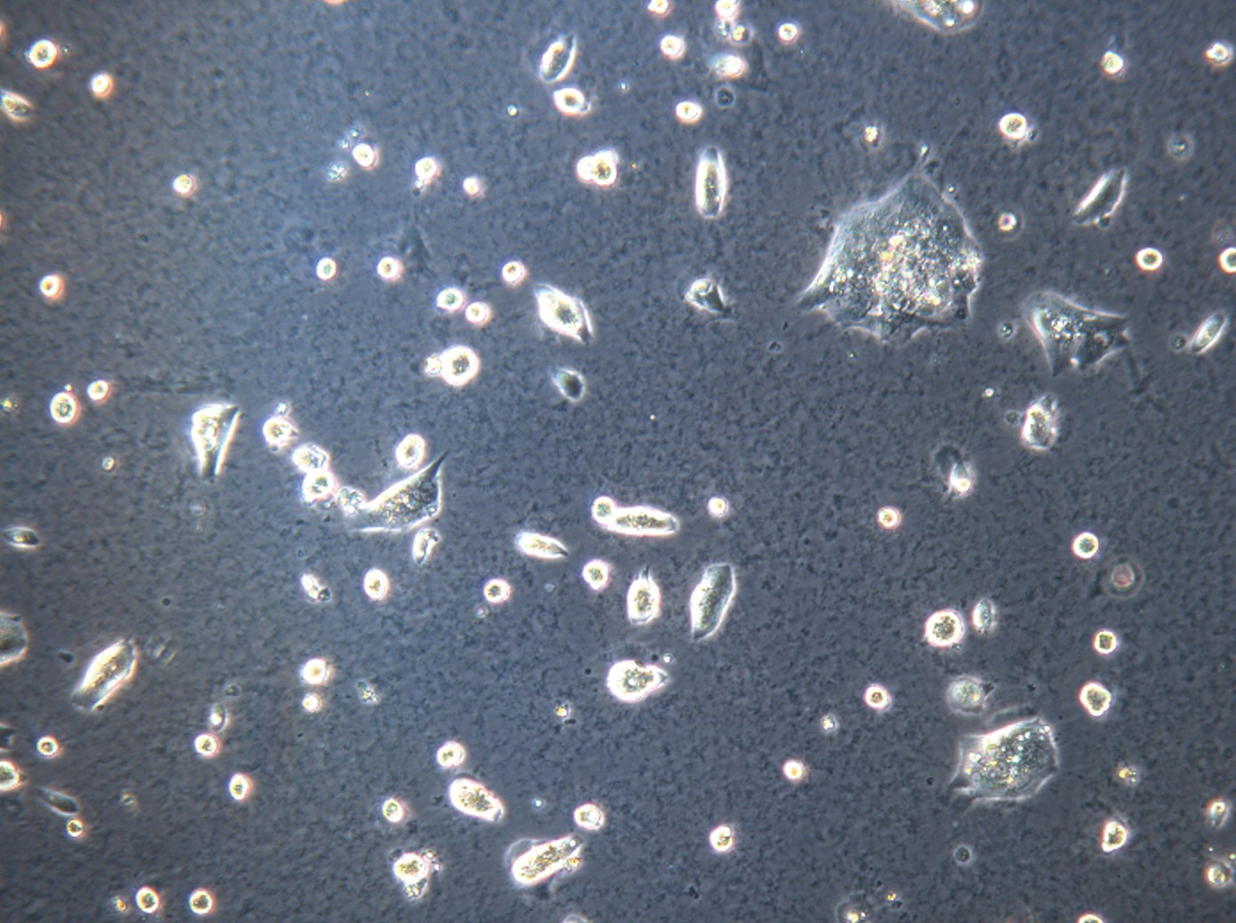
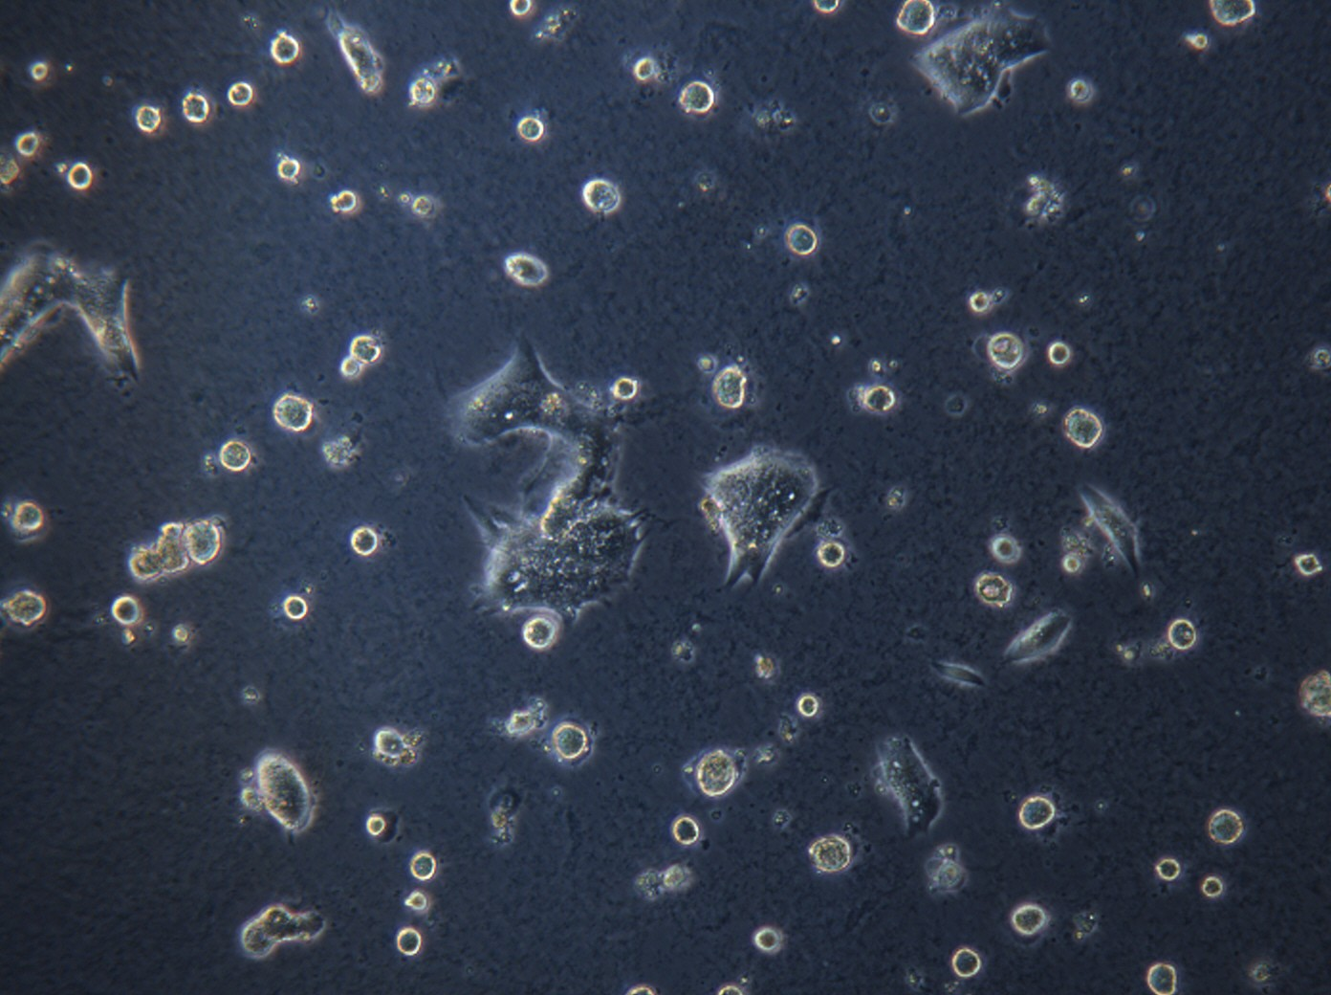
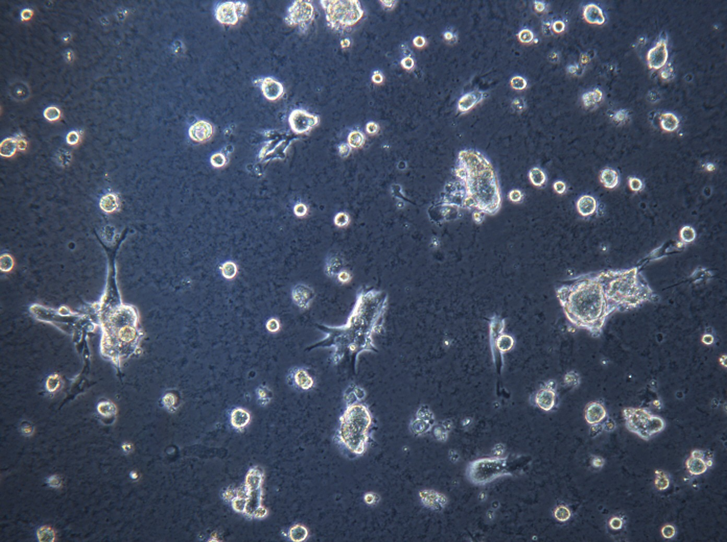
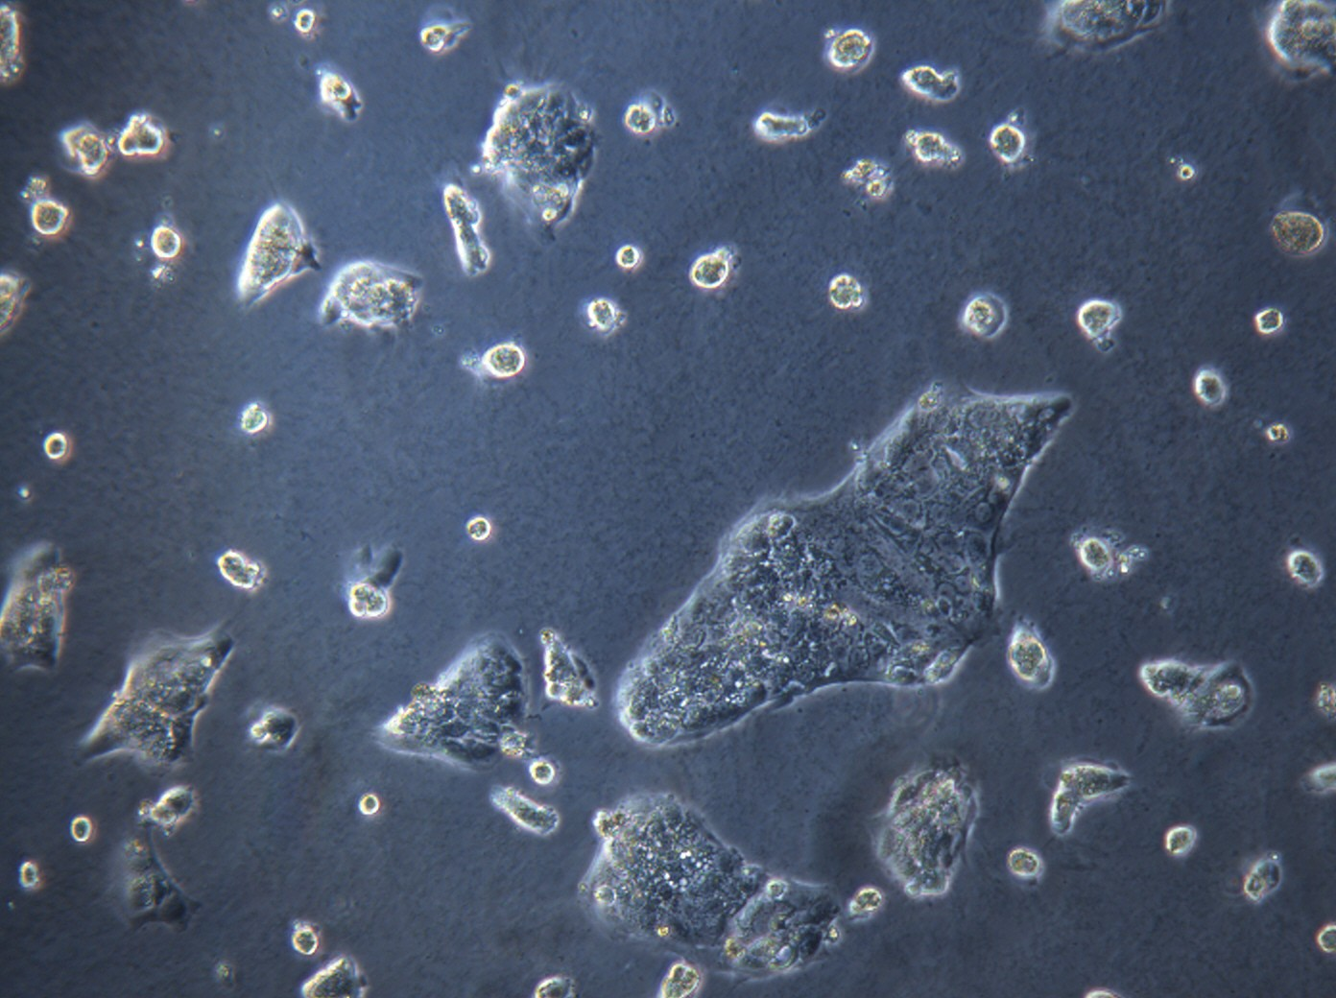
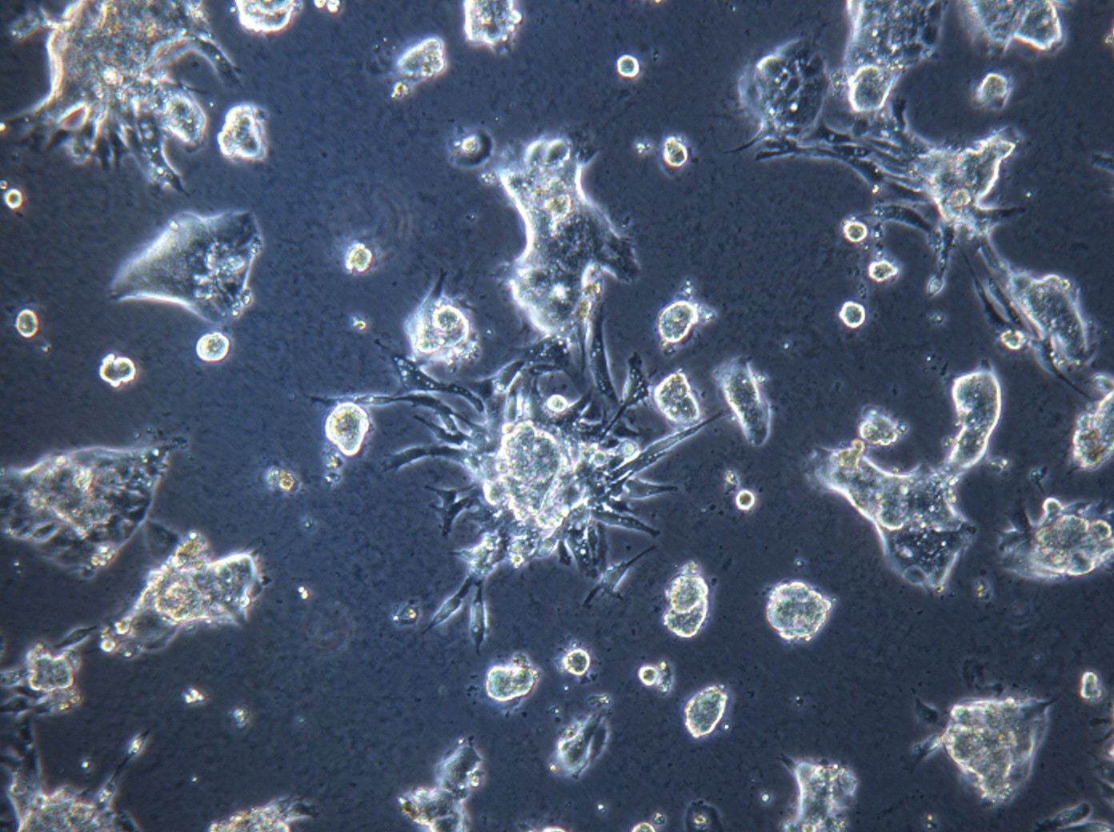
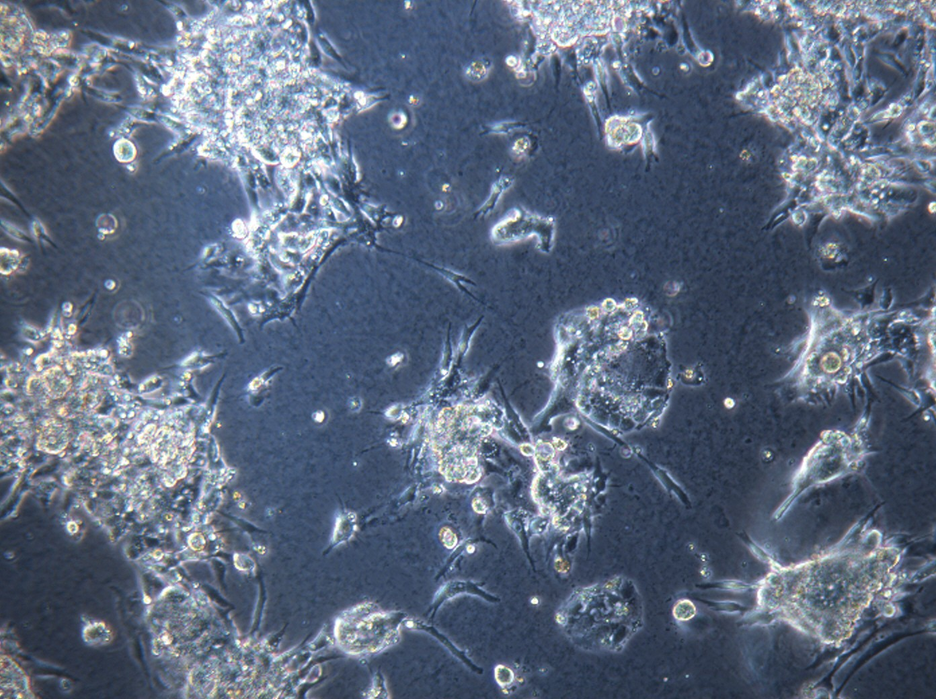
rh052318
rh010319
rh020119

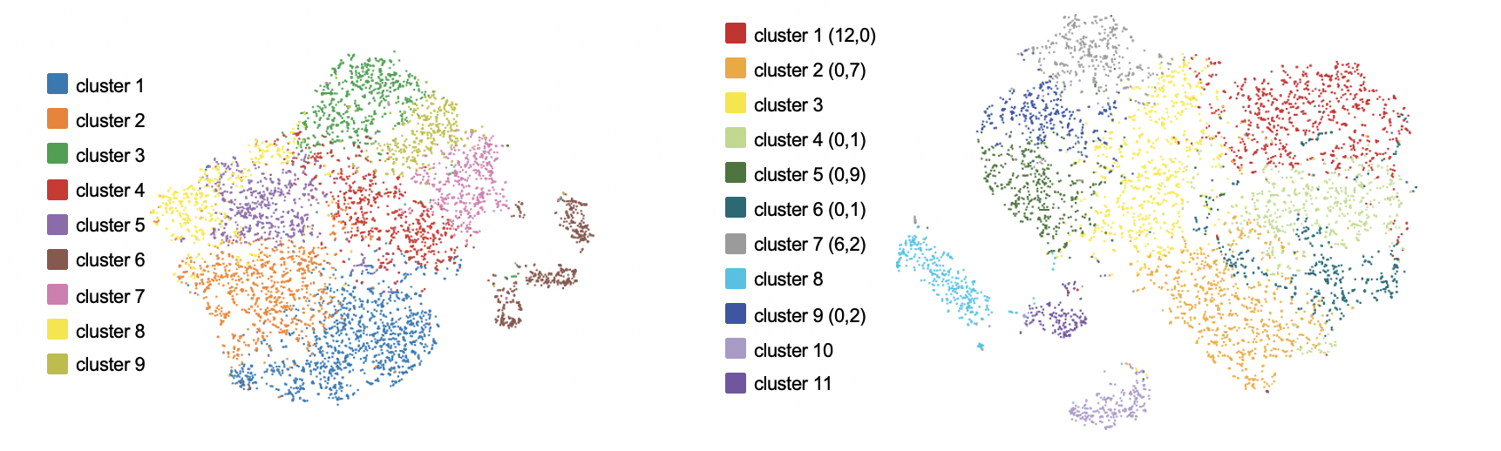
Supplemental Figure S4

passage 2
passage 10
B.
A.

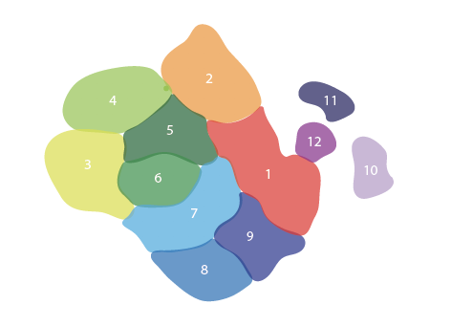
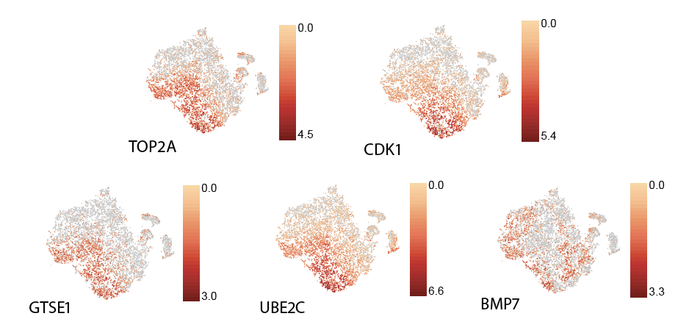
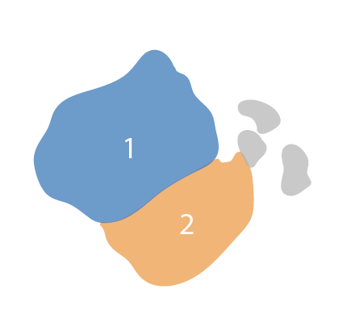
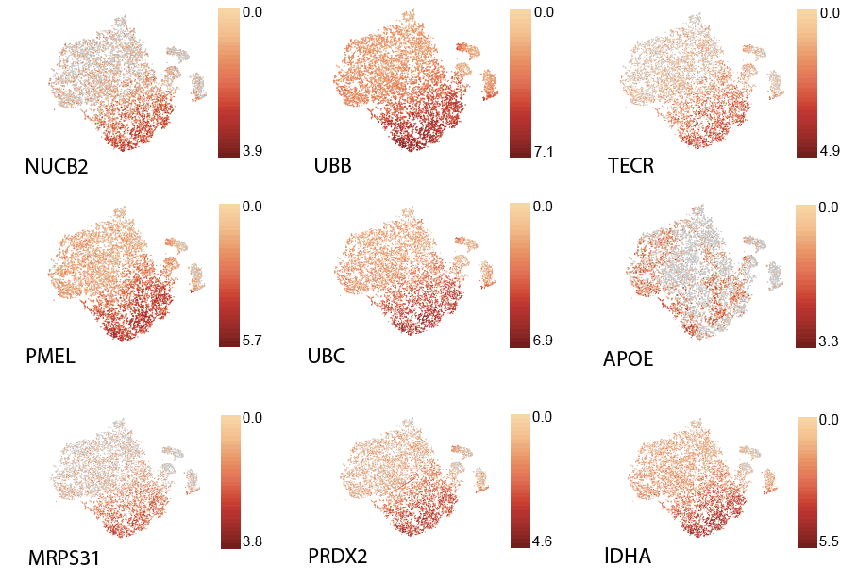
Supplemental Figure S5

B.
A.
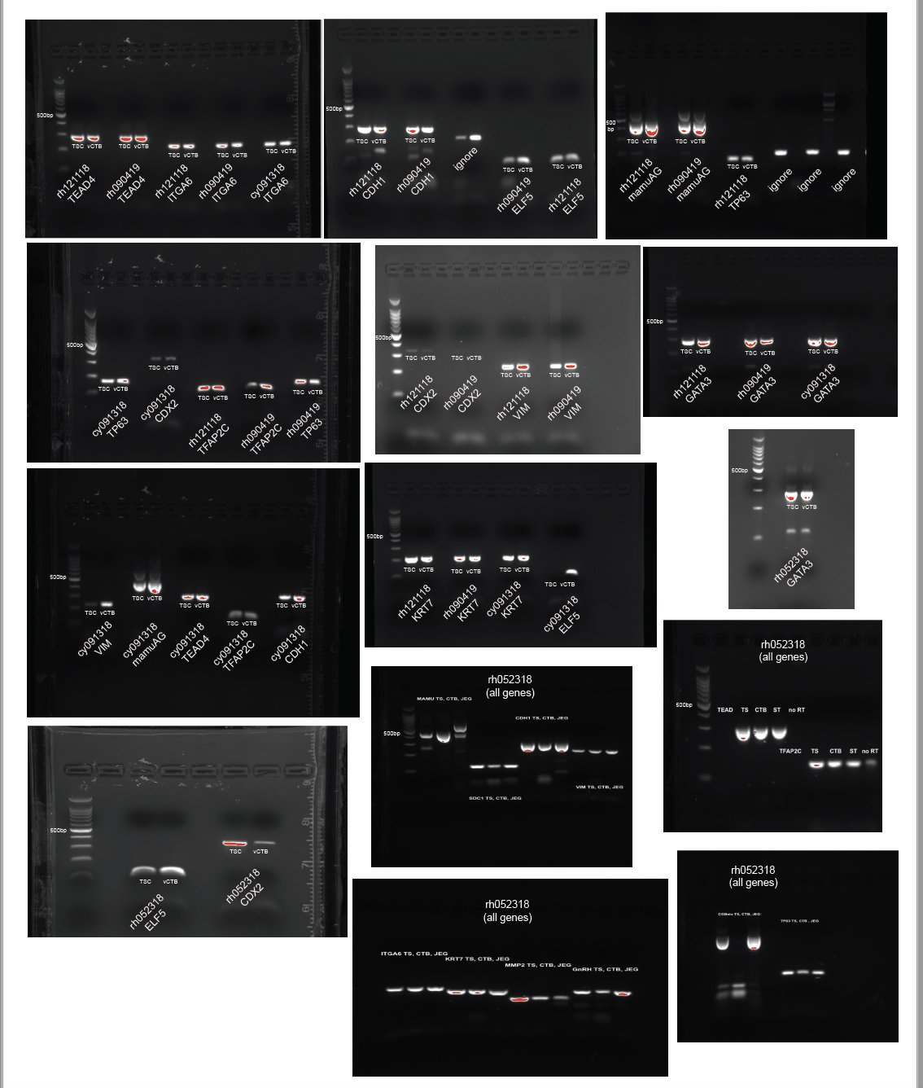
Supplemental Figure S6
Supplemental Table S1. Karyotype analysis of TSC lines
TSC Line | Gestation  Date | Gender | Passage | Result | Summary
rhesus
rh052318 | 40 | XX | 35 | abnormal | 2 clones with translocations and inversion of chr 2, 3, 12.
rh052318 | 40 | XX | 10a | normal | 17 normal cells, 2 non-clonal aberrations
rh052318 | 40 | XX | 30a | abnormal | 10 normal cells, 4 cells trisomy chr 3, 6 cells non-clonal aberrations
rh121118 | 62 | XY | 13 | abnormal | 11 normal cells, 1 cell non-clonal aberrations, 3 abnormal clones: clone 1) 3 cells duplication chr 2, clone 2) 3 cells trisomy chr3, clone 3) 2 cells trisomy chr 3
rh010319 | 58 | XY | 12 | normal | 18 normal cells, 2 cell non-clonal aberrations
rh012919 | 57 | XY | 7 | normal | 17 normal cells, 3 cells non-clonal aberrations
rh020119 | 74 | XX | 7 | normal | 17 normal cells, 3 non-clonal aberrations
rh090419 | 75 | XX | 8 | normal | 18 normal cells, 2 cell non-clonal aberrations
cynomolgus
cy091318 | 50 | XY | 7 | abnormal | 11 normal cells, 9 non-clonal aberrations. 33% of metaphase cells were polyploidy
cy091318 | 50 | XY | 6a | abnormal | 3 cells analyzed, all were tetraploid
cy020519 | 57 | XX | 11 | abnormal | 11 normal cells, 5 cells trisomy chr 6, 4 cells non-clonal aberrations

a: denotes a passage generated from a previous cryopreserved vial of cells; chr: chromosome

Supplemental Table S2. RNA-seq survey of gene expression in rh121118 cells. Gene expression values are represented as transcripts per million for one replicate of each cell type.
Gene Name | pri-CTB | TSC | pri-ST | ST-2D | ST-3D | Fibroblast
KRT7 | 64.78 | 96.88 | 98.26 | 67.61 | 325.36 | 424.47
KRT8 | 917.26 | 3347.73 | 2610.18 | 2300.72 | 4488.45 | 667.67
KRT18 | 1069.15 | 4627.46 | 4898.16 | 2728.91 | 6067.56 | 1042.26
VIM | 313.73 | 2 | 377.77 | 0.49 | 0.27 | 2034.67
ELF5 | 6.44 | 0.09 | 0 | 0.65 | 2.48 | 0
GATA2 | 49.1 | 52.69 | 9.86 | 244.39 | 193.52 | 10.94
GATA3 | 13.72 | 30.47 | 10.62 | 28.06 | 24.54 | 3.49
GATA4 | 0.2 | 0.01 | 0.03 | 0.1 | 0.07 | 0
GATA6 | 0.75 | 17.29 | 0.43 | 2.97 | 3.24 | 23.2
GCM1 | 560.54 | 2 | 579.13 | 307.66 | 278.22 | 0
HAND1 | 0.1 | 5.22 | 0 | 19.45 | 4.37 | 12.14
ID2 | 52.64 | 23.68 | 21.15 | 17.95 | 3.76 | 29.88
TEAD4 | 15.79 | 64.04 | 2.78 | 19.93 | 10.35 | 7.98
TFAP2A | 65.77 | 36.41 | 47.59 | 123.35 | 73.36 | 3.75
TFAP2C | 43.79 | 96.05 | 93.05 | 105.12 | 132.61 | 0.37
TP63 | 27.48 | 18.9 | 0.58 | 14.82 | 5.93 | 0
PLAC1 | 28.29 | 14.34 | 54.85 | 18.72 | 40.13 | 0.54
PLAC8 | 1308 | 64.76 | 2948.95 | 739.73 | 1759.73 | 1355.35
ERVFRD1 | 235.24 | 2.09 | 10.14 | 95.73 | 117.51 | 0.02
ERVV1 | 324.6 | 0.64 | 81.3 | 95.4 | 110.26 | 0
CDH1 | 47.96 | 180.59 | 66.65 | 126.72 | 60.03 | 0
SDC1 | 25.18 | 12.25 | 50.2 | 131.52 | 143.01 | 12.34
ITGA1 | 215.9 | 16.71 | 456.42 | 291.16 | 263.43 | 117.56
ITGA5 | 356.7 | 18.99 | 1076.73 | 467.91 | 542.53 | 218.67
ITGA6 | 325.51 | 302.33 | 153.79 | 328.09 | 180.13 | 91.96
MMP2 | 686.77 | 611.56 | 1831.27 | 4279.43 | 6015.36 | 351.72
MMP9 | 2.14 | 0.09 | 41.93 | 0.08 | 1.38 | 0
CGA | 1227.43 | 334.23 | 585.2 | 25852.41 | 50906.56 | 0.25
CGB8 | 0 | 0.38 | 0 | 911.61 | 1628.96 | 0
CSH1 | 706.85 | 0.08 | 91.66 | 178.29 | 38.23 | 0.58
CSH4 | 146.58 | 0 | 82.01 | 24.66 | 38.83 | 1.17
CYP11A1 | 57.64 | 171.47 | 245.54 | 451.19 | 666.96 | 0
CYP19A1 | 9.16 | 0.5 | 7.49 | 0.7 | 0.88 | 0
ESRRB | 0 | 0 | 0 | 0.11 | 0 | 0
GNRH1 | 2.13 | 1.36 | 3.87 | 1.24 | 2.08 | 0.38
HSD17B1 | 0.21 | 9.02 | 5.23 | 11.56 | 11.01 | 0
MAMUA | 327.58 | 261.09 | 1115.74 | 631.94 | 632.46 | 49.63
MAMUE | 99.55 | 199.96 | 299.25 | 224 | 312.51 | 81.31
MAMUAG | 1061.53 | 342.37 | 3825.23 | 2181.64 | 2397.55 | 9.65
Supplemental Table S3. RNA-seq survey of gene expression in rh121118 TSCs and EVTs. Gene expression values are represented as transcripts per million for one replicate of each cell type.
Gene Name | TSC | EVT
KRT7 | 96.88 | 28.63
KRT8 | 3347.73 | 1697.04
KRT14 | 20.22 | 161.35
KRT18 | 4627.46 | 1514.6
VIM | 2 | 0.12
ELF5 | 0.09 | 0
GATA2 | 52.69 | 149.77
GATA3 | 30.47 | 33.13
GATA4 | 0.01 | 0
GATA6 | 17.29 | 3.67
GCM1 | 2 | 127.45
HAND1 | 5.22 | 5.18
ID2 | 23.68 | 22.87
TEAD4 | 64.04 | 25.76
TFAP2A | 36.41 | 89.45
TFAP2C | 96.05 | 81.85
TP63 | 18.9 | 33.32
PLAC1 | 14.34 | 7.16
PLAC8 | 64.76 | 79.76
ERVFRD1 | 2.09 | 21.66
ERVV1 | 0.64 | 23.46
CALD1 | 109.09 | 289.36
CDH1 | 180.59 | 177.08
CDH5 | 0.17 | 67.94
SDC1 | 12.25 | 54.1
ITGA1 | 16.71 | 78.49
ITGA5 | 18.99 | 146.42
ITGA6 | 302.33 | 479.35
IL1RN | 610 | 944
HTRA4 | 0.21 | 0.57
MMP2 | 611.56 | 1688.1
MMP9 | 0.09 | 0.02
NCAM1 | 249.57 | 169.75
BMP1 | 6.38 | 56.72
TGFB1 | 22.59 | 49.55
NOTCH1 | 2.44 | 2.21
NOTCH2 | 33.42 | 67.45
TCF4 | 3.67 | 2.57
CGA | 334.23 | 4247.01
CGB8 | 0.38 | 110.45
CSH1 | 0.08 | 37.84
CSH4 | 0 | 9.15
MAMUA | 261.09 | 445.96
MAMUE | 199.96 | 119.33
MAMUAG | 342.37 | 1694.32
Supplemental Table S4. miRNA expression of miRNAs within the pregnancy-associated miRNA cluster. miRNA expression levels represented as transcripts per million

 | pri-CTB | TSC | pri-ST | ST-2D | ST-3D | EVT | fibroblast
miR-371-3 cluster
miR-371-3p | 0 | 1 | 0 | 1 | 0 | 1 | 0
miR-371-5p | 11 | 884 | 23 | 124 | 56 | 9 | 0
miR-372-3p | 6 | 207 | 20 | 52 | 25 | 3 | 0
miR-372-5p | 0 | 3 | 0 | 0 | 0 | 0 | 0
miR-373 | 6 | 147 | 6 | 25 | 18 | 1 | 0
C19MC
miR-512-3p | 323 | 134 | 463 | 200 | 476 | 64 | 0
miR-512-5p | 2706 | 3064 | 3329 | 1901 | 9167 | 1473 | 0
miR-1323-3p | 0 | 0 | 3 | 0 | 2 | 0 | 0
miR-1323-5p | 7263 | 9535 | 17798 | 10796 | 18964 | 7026 | 5
miR-498-5p | 2548 | 2008 | 3321 | 1960 | 5295 | 1016 | 0
miR-519e | 23361 | 23081 | 38525 | 24422 | 51396 | 8382 | 0
miR-1283 | 583 | 320 | 492 | 338 | 352 | 80 | 0
miR-520a-3p | 1455 | 1209 | 1882 | 1783 | 3497 | 465 | 0
miR-520a-5p | 1863 | 939 | 1974 | 2228 | 1294 | 446 | 0
miR-526b | 5524 | 2766 | 9295 | 3723 | 5678 | 1284 | 0
miR-525 | 392 | 141 | 436 | 363 | 349 | 81 | 0
miR-523a | 492 | 230 | 601 | 316 | 500 | 94 | 0
miR-518f | 10919 | 11651 | 15307 | 13635 | 15787 | 4859 | 0
miR-519a-3p | 46 | 47 | 8 | 69 | 58 | 3 | 0
miR-519a-5p | 484 | 867 | 805 | 781 | 1355 | 457 | 0
miR-518b | 7215 | 4904 | 8910 | 4982 | 8068 | 1942 | 1
miR-518c-5p | 43 | 41 | 90 | 40 | 66 | 17 | 0
miR-518c-3p | 4095 | 1256 | 3532 | 2119 | 1785 | 318 | 0
miR-524-5p | 668 | 433 | 780 | 783 | 1414 | 160 | 0
miR-524-3p | 28 | 24 | 37 | 32 | 38 | 1 | 0
miR-517a | 2598 | 1148 | 2043 | 1701 | 2054 | 276 | 0
miR-519d | 1036 | 472 | 997 | 751 | 782 | 130 | 0
miR-518a-3p | 1632 | 1642 | 3748 | 2207 | 6296 | 523 | 0
miR-518a-5p | 437 | 361 | 398 | 369 | 669 | 64 | 0
miR-520g-3p | 8 | 1 | 5 | 5 | 4 | 0 | 0
miR-518d-3p | 552 | 573 | 757 | 795 | 1035 | 131 | 0
miR-518d-5p | 6598 | 7371 | 17889 | 8850 | 17281 | 4809 | 1
miR-523b | 381 | 289 | 364 | 421 | 454 | 87 | 0
miR-516b | 2116 | 1309 | 2990 | 2335 | 2943 | 380 | 0
miR-518a-3p | 1632 | 1642 | 3748 | 2207 | 6296 | 523 | 0
miR-518a-5p | 437 | 361 | 398 | 369 | 669 | 64 | 0
miR-517c | 4474 | 5917 | 8006 | 7528 | 11482 | 2061 | 0
miR-519b | 76 | 62 | 154 | 86 | 182 | 35 | 0
miR-521 | 11 | 8 | 16 | 6 | 27 | 4 | 0
miR-518e | 39 | 50 | 110 | 97 | 213 | 32 | 0
miR-518a-3p | 1632 | 1642 | 3748 | 2207 | 6296 | 523 | 0
miR-518a-5p | 437 | 361 | 398 | 369 | 669 | 64 | 0
miR-516a-3p | 1085 | 1371 | 2165 | 1906 | 2489 | 531 | 0
miR-516a-5p | 21483 | 10598 | 43883 | 15764 | 21448 | 4654 | 1
C14MC
miR-770-5p | 0 | 0 | 0 | 0 | 0 | 0 | 1
miR-493-3p | 12 | 0 | 0 | 0 | 0 | 0 | 17
miR-493-5p | 108 | 0 | 31 | 0 | 0 | 0 | 293
miR-337-3p | 8 | 0 | 3 | 0 | 0 | 0 | 26
miR-337-5p | 10 | 0 | 0 | 0 | 0 | 0 | 10
miR-665 | 1 | 0 | 0 | 0 | 0 | 0 | 3
miR-431 | 529 | 0 | 69 | 0 | 1 | 0 | 253
miR-433-3p | 6 | 0 | 2 | 0 | 0 | 0 | 25
miR-433-5p | 1 | 0 | 0 | 0 | 0 | 0 | 0
miR-127-3p | 1571 | 0 | 203 | 0 | 0 | 0 | 2193
miR-127-5p | 4 | 0 | 1 | 0 | 0 | 0 | 0
miR-432-3p | 0 | 0 | 0 | 0 | 0 | 0 | 2
miR-432-5p | 775 | 0 | 167 | 0 | 0 | 1 | 3776
miR-136 | 5 | 0 | 0 | 0 | 0 | 0 | 0
miR-370-3p | 65 | 0 | 3 | 0 | 0 | 0 | 173
miR-370-5p | 3 | 0 | 1 | 0 | 0 | 0 | 16
miR-379-3p | 5 | 0 | 0 | 0 | 0 | 0 | 18
miR-379-5p | 217 | 0 | 22 | 0 | 0 | 0 | 309
miR-411-3p | 2 | 0 | 0 | 0 | 0 | 0 | 11
miR-411-5p | 363 | 0 | 19 | 0 | 0 | 0 | 280
miR-299-3p | 88 | 0 | 7 | 0 | 0 | 0 | 50
miR-299-5p | 427 | 0 | 82 | 0 | 2 | 3 | 992
miR-380-3p | 0 | 0 | 0 | 0 | 0 | 0 | 4
miR-380-5p | 0 | 0 | 0 | 0 | 0 | 0 | 2
miR-323a-3p | 35 | 0 | 4 | 0 | 0 | 0 | 145
miR-323a-5p | 0 | 0 | 0 | 0 | 0 | 0 | 0
miR-758-3p | 2 | 0 | 0 | 0 | 0 | 0 | 5
miR-758-5p | 1 | 0 | 0 | 0 | 0 | 0 | 0
miR-329-3p | 13 | 0 | 1 | 0 | 0 | 0 | 56
miR-329-1-5p | 0 | 0 | 0 | 0 | 0 | 0 | 2
miR-329-2-5p | 0 | 0 | 0 | 0 | 0 | 0 | 0
miR-494-3p | 15 | 0 | 4 | 0 | 0 | 0 | 50
miR-494-5p | 0 | 0 | 0 | 0 | 0 | 0 | 1
miR-543-3p | 13 | 0 | 2 | 0 | 0 | 0 | 38
miR-543-5p | 4 | 0 | 0 | 0 | 0 | 0 | 13
miR-495-3p | 10 | 0 | 0 | 0 | 0 | 0 | 11
miR-495-5p | 5 | 0 | 1 | 0 | 0 | 0 | 9
miR-376c-3p | 121 | 0 | 7 | 0 | 0 | 0 | 52
miR-376c-5p | 6 | 0 | 0 | 0 | 0 | 0 | 1
miR-376a-3p | 60 | 0 | 6 | 1 | 0 | 0 | 46
miR-376a-1-5p | 3 | 0 | 1 | 0 | 0 | 0 | 0
miR-376a-2-5p | 1 | 0 | 0 | 0 | 0 | 0 | 0
miR-654-3p | 386 | 0 | 57 | 0 | 0 | 2 | 1631
miR-654-5p | 0 | 0 | 0 | 0 | 0 | 0 | 0
miR-376b-3p | 6 | 0 | 2 | 0 | 0 | 0 | 2
miR-376b-5p | 3 | 0 | 0 | 0 | 0 | 0 | 1
miR-376a-1-5p | 3 | 0 | 1 | 0 | 0 | 0 | 0
miR-376a-2-5p | 1 | 0 | 0 | 0 | 0 | 0 | 0
miR-376a-3p | 60 | 0 | 6 | 1 | 0 | 0 | 46
miR-1185-3p | 3 | 0 | 1 | 0 | 0 | 0 | 10
miR-1185-5p | 8 | 0 | 0 | 0 | 0 | 0 | 2
miR-381-3p | 77 | 0 | 9 | 0 | 0 | 1 | 88
miR-381-5p | 0 | 0 | 0 | 0 | 0 | 0 | 1
miR-487b-3p | 110 | 0 | 18 | 0 | 0 | 0 | 183
miR-487b-5p | 4 | 0 | 0 | 0 | 0 | 0 | 30
miR-539 | 0 | 0 | 0 | 0 | 0 | 0 | 0
miR-889-3p | 53 | 0 | 4 | 0 | 0 | 0 | 44
miR-889-5p | 0 | 0 | 0 | 0 | 0 | 0 | 0
miR-544 | 0 | 0 | 0 | 0 | 0 | 0 | 0
miR-487a | 0 | 0 | 0 | 0 | 0 | 0 | 0
miR-382-3p | 27 | 0 | 5 | 0 | 0 | 0 | 69
miR-382-5p | 371 | 0 | 76 | 0 | 0 | 0 | 1164
miR-134-3p | 0 | 0 | 0 | 0 | 0 | 0 | 1
miR-134-5p | 95 | 0 | 12 | 0 | 0 | 2 | 544
miR-668 | 4 | 0 | 1 | 0 | 0 | 0 | 9
miR-485-3p | 46 | 0 | 14 | 0 | 1 | 0 | 1102
miR-485-5p | 32 | 0 | 2 | 0 | 0 | 0 | 201
miR-323b-3p | 28 | 0 | 6 | 0 | 0 | 0 | 279
miR-323b-5p | 0 | 0 | 0 | 0 | 0 | 0 | 0
miR-154-3p | 2 | 0 | 0 | 0 | 0 | 0 | 6
miR-154-5p | 48 | 0 | 8 | 0 | 0 | 0 | 54
miR-496 | 4 | 0 | 0 | 0 | 0 | 0 | 7
miR-337-3p | 8 | 0 | 3 | 0 | 0 | 0 | 26
miR-337-5p | 10 | 0 | 0 | 0 | 0 | 0 | 10
miR-541-3p | 0 | 0 | 0 | 0 | 0 | 0 | 0
miR-541-5p | 0 | 0 | 0 | 0 | 0 | 0 | 10
miR-409-3p | 532 | 0 | 73 | 0 | 0 | 1 | 2165
miR-409-5p | 34 | 0 | 5 | 0 | 0 | 0 | 115
miR-412-3p | 0 | 0 | 0 | 0 | 0 | 0 | 1
miR-412-5p | 33 | 0 | 5 | 0 | 0 | 0 | 16
miR-369-3p | 78 | 0 | 1 | 0 | 0 | 0 | 45
miR-369-5p | 166 | 0 | 15 | 0 | 0 | 0 | 335
miR-410-3p | 2 | 0 | 0 | 0 | 0 | 0 | 3
mIR-410-5p | 0 | 0 | 0 | 0 | 0 | 0 | 13
miR-656-3p | 3 | 0 | 0 | 0 | 0 | 0 | 11
miR-656-5p | 0 | 0 | 0 | 0 | 0 | 0 | 1
miR-1247-3p | 7 | 0 | 0 | 0 | 0 | 0 | 0
miR-1247-5p | 118 | 0 | 14 | 0 | 0 | 0 | 0

Supplemental Table S5. Summary of the mean percentage of cells expressing a marker by flow cytometry.
 | Cytokeratin 7/8  mean % pos ± SD | Vimentin  mean % neg± SD | Ki67  Mean % pos ± SD | Mamu-AG  mean % pos ± SD | CD56  mean % pos± SD
TSC experiment
TSC | 72.3 ± 6.76 | 99.28 ± 1.08 | 86.97 ± 0.24 | 84.6 ± 4.76 | 87.39 ± 0.17
unstained TSC* | 0.00 | 100.00 | 0.00 | 0.00 | 0.00
fibroblast* | 80.80 | 1.13 | 93.84 | 44.50 | 97.39
EVT experiment
EVT | 94.76 ± 2.74 | 99.37 ± 0.49 | 94.26 ± 3.86 | 95.05 ± 2.13 | 95.90 ± 3.26
TSC* | 98.53 | 100.00 | 0.10 | 0.10 | 0.20
unstained TSC* | 0.10 | 97.90 | 98.59 | 91.63 | 98.53
Fibroblast* | 91.05 | 0.22 | 92.32 | 22.50 | 98.16

An individual flow cytometry experiment was performed for TSC replicates and EVT replicates due to differences in cell size. In the EVT experiment, one TSC and fibroblast replicate was run in parallel. *: denotes a line that was evaluated in the same run with 1 replicate per cell type.
Pos: positive, neg: negative.

Supplemental Table S6. Differentially expressed genes between passage 10 TSC clusters identified by scRNA-Seq t-SNE analysis. Parenthesis indicate number of genes either significantly down or upregulated (p <0.05) and greater than 2-fold change in expression.
Cluster 1 | Cluster 2 | Cluster 4 | Cluster 5 | Cluster 6 | Cluster 7 | Cluster 9
Up (12) | Down (7) | Down (1) | Down (9) | Down (1) | Up (6) | Down (2)
TOP2A | TOP2A | TOP2A | TOP2A | TOP2A | TOP2A | EDA2R
PRC1 | PRC1 |  | PRC1 |  | UBE2S | IRS2
CHAC1 | H2AFX |  | CHAC1 |  | PRC1
PRRG4 | UBE2S |  | BIRC5 |  | BIRC5
EDA2R | BIRC5 |  | WEE1 |  | ARL6IP1
RHNO1 | CKAP5 |  | UBE2S |  | CKAP5
SUN2 | ARL6IP1 |  | IRS2
UBE2S |  |  | SLC7A1 |  | Down (2)
MYADM |  |  | H2AFX |  | IRS2
WEE1 |  |  |  |  | THBS1
H2AFX
BIRC5

Supplemental Table S7. Differentially expressed genes between TSC clusters identified by scRNA-Seq K-means analysis of p2 and p10 cells combined. Parenthesis indicate number of genes either significantly down or upregulated (p <0.05) and greater than 2-fold change in expression.
Cluster 1 | Cluster 2
Down (187) | Up (171)
APOE | NUCB2
NUCB2 | UBB
UBB | TECR
TECR | PMEL
PMEL | UBC
PLTP | APOE
UBC | MRPS31
TUBA3C | PRDX4
PRDX4 | PLTP
MRPS31 | LDHA
LDHA | TUBA3C
PRDX2 | PSMB3
PSMB3 | ANXA2
CTNNBL1 | PRDX2
ANXA2 | CTNNBL1
NSDHL | CDK1
CDK1 | NSDHL
CKB | EIF4A3
DRG1 | CKB
EIF4A3 | DRG1
BLVRB | PSME2
RBM42 | TYMS
PSME2 | PGK1
SUGT1 | WDR61
ISYNA1 | SUGT1
PGK1 | BLVRB
TYMS | PSMC4
PSMC4 | DDX39A
DDX39A | RBM42
WDR61 | CD9
KPNA2 | KPNA2
CD9 | PSMD12
PSMD12 | ISYNA1
FOLR1 | PNP
C22orf28 | LDHB
LDHB | GHITM
PNP | ATP5B
GHITM | C22orf28
ATP5B | FOLR1
RUVBL2 | RUVBL2
KRT18 | UFD1L
UFD1L | PSMA6
PSMC5 | CLDN6
CLDN6 | KRT18
PDIA3 | TK1
FAM50A | PDIA3
PSMA6 | PRMT1
PSMD7 | PSMC5
PRMT1 | PSMD7
PKM | NUDT5
ACP5 | RAB11A
TK1 | UQCRC2
PLD3 | PKM
RAB11A | FAM50A
NUDT5 | TUBA1B
UQCRC2 | KRT7
PRPF19 | ITM2B
KRT7 | ACP5
ITM2B | PRPF19
AURKB | RDM1
TUBA1B | MYL12B
RDM1 | AURKB
CTSA | AHSA1
PSMC3 | LGALS3
MYL12B | PSMC1
AHSA1 | UBE2C
MVD | MVD
PSMC1 | PYGL
GRN | PSMA3
UBE2C | NDUFA9
LGALS3 | PA2G4
XRCC6 | PLK1
PYGL | PSMC3
PA2G4 | MYL12A
WDR18 | XRCC6
PLK1 | WDR18
TMEM205 | CTSA
PSMA3 | GOT1
NDUFA9 | PLD3
HMOX1 | EML2
GOT1 | CDC123
MYL12A | RNASEH2A
EML2 | HMOX1
PPP2R1A | TMEM205
RNASEH2A | ATP5C1
PPIB | PPP2R1A
NDUFV1 | SNRPB2
COMMD4 | GRN
CDC123 | NDUFV1
ATP6V0D1 | COMMD4
CLDN7 | TPI1
SNRPB2 | MAGEA4
HSP90B1 | PPIB
PVRL2 | ATP6V0D1
IRS2 | CLDN7
TPI1 | MCTS1
ADRM1 | TUBG1
ATP5C1 | EIF2S1
MCTS1 | MRPL46
HEXA | ADRM1
TUBG1 | HSP90B1
MAGEA4 | MPV17L2
EIF2S1 | RSU1
GPS1 | ACAT1
SLC16A3 | ATP5H
CYBA | SAR1A
ETFB | ORMDL2
CD151 | CD151
NOSIP | AP1M2
MPV17L2 | GPS1
RSU1 | SLC16A3
MRPL46 | MYL6
CDC37 | NSMCE1
ORMDL2 | TALDO1
ACAT1 | ESD
ATP5H | KRR1
SAR1A | CDC37
NSMCE1 | POLR2C
AP1M2 | HEXA
PHB | ANP32A
MYL6 | PSMB6
HSD17B14 | PHB
PSMD3 | NOSIP
SF3B2 | PVRL2
ANP32A | SF3B2
GSTP1 | PSME1
TALDO1 | GSTP1
PSMB6 | HSD17B14
POLR2C | ETFB
TIMM50 | EXOSC8
ESD | TIMM50
PAGE4 | TMBIM6
TAC3 | NLRP2
KRR1 | DPM1
NLRP2 | ARPC3
TMBIM6 | NDUFS3
BCAP31 | BCAP31
NDUFS3 | MTCH2
FUS | CYBA
PELP1 | PSMD3
NEMF | FUS
PSME1 | VGLL1
PRSS8 | PAGE2B
PAGE2B | MAGOHB
EXOSC8 | PCNA
VGLL1 | RSL1D1
DPM1 | TRAPPC4
MFGE8 | TSG101
PCNA | MRPL48
ARPC3 | TAC3
MVB12A | HSD17B10
RSL1D1 | PAGE4
VPS25 | NEMF
TSG101 | VPS25
TUFM | SPCS2
MTCH2 | HNRNPH3
RBM25 | TXNL1
MRPL48 | CHMP4A
HNRNPH3 | GLRX3
HSD17B10 | PELP1
SPCS2 | MVB12A
MAGOHB | PRSS8
CHMP4A | RAN
TRAPPC4 | TUFM
BSG | STIP1
TXNL1 | COMMD3
ILK | ACAA2
AMDHD2 | EIF4A1
GLRX3 | DERA
TOMM40 | MFGE8
STIP1 | RBM25
ATP6AP1
MRPL38 | Down (1)
RAN | IRS2
TUBA1C
POLR2E
MTHFD1
TIMM23
DERA
DAD1
EIF4A1
SNRNP70
ACAA2
COMMD3
STX8
AKAP8L
JUNB

Supplemental Table S8. Differentially expressed genes between TSC clusters segregated by the LMO algorithm applied to scRNA-seq gene expression levels of combined p2 and p10 cells. Parenthesis indicate number of genes either significantly down or upregulated (p <0.05) and greater than 2-fold change in expression.
Cluster 1 | Cluster 2 | Cluster 3 | Cluster 4 | Cluster 5 | Cluster 6 | Cluster 8 | Cluster 9
Up (3) | Down (75) | Up (13) | Up (1) | Up (2) | Down (8) | Up (95) | Up (51)
APOE | CDK1 | WEE1 | PLEKHF1 | TOP2A | PLK1 | CCNB2 | MCM5
PMEL | UBE2C | THBS1 |  | GTSE1 | UBE2C | PLK1 | TK1
FOLR1 | TOP2A | BMP7 | Down (24) |  | APOE | CDCA3 | RAD51
 | PRC1 | FADS2 | CDK1 | Down (28) | CCNB2 | UBE2C | PCNA
Down (19) | GTSE1 | MT1E | UBE2C | PMEL | UBB | KPNA2 | FEN1
TOP2A | CDCA3 | MYADM | TOP2A | TAC3 | PMEL | AURKB | PRIM1
GTSE1 | TK1 | EDA2R | AURKB | APOE | CDCA3 | CDK1 | GOT1
UBE2C | KPNA2 | CGB | CDCA3 | PLTP | UBC | TUBA3C | ORC6
PRC1 | PLK1 |  | PRC1 | ACP5 |  | DLGAP5 | LDHA
CDK1 | RAD51 | Down (40) | TK1 | PAGE2 |  | NUP37 | NUCB2
CDCA3 | AURKB | APOE | GTSE1 | CD9 |  | UBB | MPV17L2
AURKB | UBB | TECR | PLK1 | PSMB3 |  | TUBA1B | PA2G4
PLK1 | TPX2 | PSMB3 | KPNA2 | PRDX4 |  | DDX39A | NSDHL
TPX2 | KIF20B | PSME1 | TUBA3C | NUCB2 |  | KIF20B | MVD
BIRC5 | MCM5 | LDHB | KIF20B | PRDX2 |  | RBM42 | KRT7
CASC5 | CTNNBL1 | BLVRB | RAD51 | BMP7 |  | MRPS31 | TECR
UBE2S | APOE | PRDX2 | NUP37 | CLDN6 |  | TYMS | PLTP
KIF20B | NUCB2 | PRDX4 | MCM5 | UBB |  | ARL6IP1 | CTNNBL1
H2AFX | PMEL | NUCB2 | TECR | ATP5B |  | PSMD12 | UBC
MCM10 | UBC | FOLR1 | APOE | PSME2 |  | RDM1 | CLDN6
BRCA2 | GOT1 | ANXA2 | NUCB2 | BLVRB |  | UBC | PRDX4
TK1 | CKB | MRPS31 | UBB | TECR |  | NUCB2 | KRT18
CHAF1A | TUBA3C | UBB | UBC | MAGEH1 |  | PRC1 | LGALS3
RHNO1 | NUP85 | SLC25A5 | PKMYT1 | ANXA2 |  | CTNNBL1 | CLDN7
 | CLDN6 | PSME2 | ANXA2 | PNP |  | TUBA1C | PMEL
 | PCNA | PSMC4 | TPX2 | UBC |  | CDKN3 | APOE
 | BIRC5 | PSMA3 | EIF4A3 | MCM5 |  | UBE2S | PKM
 | DRG1 | TUBA3C |  | FOLR1 |  | C22orf28 | CD9
 | LDHA | KRT19 |  | MRPS31 |  | DRG1 | CKB
 | TAC3 | PMEL |  | LDHA |  | TBL3 | PPAN
 | PLTP | SUGT1 |  | CKB |  | PSMD7 | PRDX2
 | ORC6 | ESD |  | ISYNA1 |  | TOP2A | PGK1
 | FEN1 | UBC |  |  |  | RUVBL2 | EIF4A3
 | BMP7 | KRT18 |  |  |  | LDHA | MCM10
 | PSMD7 | ISYNA1 |  |  |  | SUGT1 | LDHB
 | ATP5B | NSDHL |  |  |  | PSMB3 | GINS2
 | PRIM1 | PSMC5 |  |  |  | RAD51 | CHAF1A
 | RANGAP1 | WDR61 |  |  |  | NUP85 | DRG1
 | ARL6IP1 | RPN2 |  |  |  | AHSA1 | NUDT5
 | NUP37 | RNASEH2A |  |  |  | CKB | PRPF19
 | PKM | RBM42 |  |  |  | SAAL1 | MPHOSPH8
 | UBE2S | ACAT1 |  |  |  | MARS | NUP85
 | PSMD12 | EIF4A3 |  |  |  | TECR | BLVRB
 | ANXA2 | PLTP |  |  |  | CKLF | UBB
 | MRPS31 | KRT7 |  |  |  | NSDHL | PNP
 | PKMYT1 | TUFM |  |  |  | PRDX4 | FOLR1
 | RUVBL2 | RUVBL2 |  |  |  | PSMC4 | ANXA2
 | CENPJ | MCTS1 |  |  |  | RNASEH2A | RAB11A
 | DLGAP5 | NUP37 |  |  |  | BIRC5 | HSP90B1
 | H2AFX | PSMA6 |  |  |  | PGK1 | PYGL
 | MCM10 |  |  |  |  | FAM50A | TUBA3C
 | CASC5 |  |  |  |  | TPX2
 | GHITM |  |  |  |  | CARS | Down (1)
 | TECR |  |  |  |  | EIF4A3 | EDA2R
 | PRDX4 |  |  |  |  | TK1
 | NSDHL |  |  |  |  | PSMA6
 | ACP5 |  |  |  |  | KRR1
 | LGMN |  |  |  |  | PSMC5
 | NLRP2 |  |  |  |  | PLTP
 | EIF4A3 |  |  |  |  | PSMC1
 | CD9 |  |  |  |  | CIAPIN1
 | TYMS |  |  |  |  | PRDX2
 | PSMC3 |  |  |  |  | PMEL
 | C22orf28 |  |  |  |  | MYL12A
 | PDIA3 |  |  |  |  | GTSE1
 | TUBA1B |  |  |  |  | NUDT5
 | CTSA |  |  |  |  | FUS
 | TBL3 |  |  |  |  | PRMT1
 | DDX39A |  |  |  |  | GHITM
 | MPV17L2 |  |  |  |  | PSMD3
 | SERTAD1 |  |  |  |  | EIF2S1
 | PLD3 |  |  |  |  | POLR2C
 | PSMC4 |  |  |  |  | PSMC3
 | FAM50A |  |  |  |  | XRCC6
 | DHCR7 |  |  |  |  | UQCRC2
 |  |  |  |  |  | WDR18
 |  |  |  |  |  | SNRPB2
 |  |  |  |  |  | HMGB1
 |  |  |  |  |  | PSME2
 |  |  |  |  |  | UFD1L
 |  |  |  |  |  | RAB11A
 |  |  |  |  |  | SARS2
 |  |  |  |  |  | MAGOHB
 |  |  |  |  |  | STIP1
 |  |  |  |  |  | PRPF19
 |  |  |  |  |  | TUBG1
 |  |  |  |  |  | APOE
 |  |  |  |  |  | SNRNP70
 |  |  |  |  |  | LDHB
 |  |  |  |  |  | ANXA2
 |  |  |  |  |  | GOT1
 |  |  |  |  |  | PNP
 |  |  |  |  |  | WDR61
 |  |  |  |  |  | RPN2
 |  |  |  |  |  | FTHL17
 |  |  |  |  |  | Down (6)
 |  |  |  |  |  | IRS2
 |  |  |  |  |  | CRISPLD2
 |  |  |  |  |  | DUSP5
 |  |  |  |  |  | SLC7A8
 |  |  |  |  |  | FOSB
 |  |  |  |  |  | MARVELD1

Supplementary Table S9. Immunocytochemistry antibodies and fluorescent conjugates
Target | Vendor | Catalog  Number | Clone | Stock Concentration | Final Concentration | Lot# | Isotype | RRID #
Primary antibodies
AP2- γ | Invitrogen | PA5-84329 | Poly | 0.050 mg/ml | 0.5 μg/ml |  | rabbit IgG | AB_2791481
Cytokeratin | Sigma-Aldrich/Cell Marque | 452M-94 | CAM5.2 | 81.6 μg/ml | 1.6 μg/ml |  | mouse IgG2a
Ki-67-Alexa 647 | BD | BD561126 | B56
Mamu-AG¹ | Golos lab |  | 25D3 | 1.92 mg/ml | 5 μg/ml | A8082175 | IgG1
Macaque CG² | University of California-Davis |  | 518B7 | 2 mg/ml |  | 7/05 | IgG1
Vimentin | BD | BD550513 |  | 0.5 mg/ml | 5 μg/ml | 8169851 | IgG1
Secondary Antibodies
Donkey anti-mouse CF568 | Biotium | 20105 |  | 2 mg/ml | 2 μg/ml | 17C1116 | polyclonal
Donkey anti-rabbit CF640 | Biotium | 20178 |  | 2 mg/ml | 2 μg/ml | 17C0131 | polyclonal
Donkey anti-rabbit | Biotium | 20098 |  | 2 mg/ml | 2 μg/ml | 18C0703 | polyclonal
Fluorescent Conjugates
DAPI, diacetate | Invitrogen | D3571 |  | 10 mg/ml | 1 μg/ml
Hoerscht 33342 | BD Pharminogen | 561908 |  | 1 mg/ml | 2 μg/ml | 9037866
Wheat germ agglutinin (WGA) | Invitrogen | W7024 |  | 1 mg/ml | 5 μg/ml | 2068234

¹Slukvin et al. 2000 PNAS; ²Ziegler et al. 1993 Am J Primatol.

Gene | Forward (5’-3’) | Reverse (5’-3’) | Amplicon Size
ACTB | CTA CCA TGA GCT GCG TGT GG | GTA CAT GGC TGG GGT GTT GA | 130
CD9 | CAT GCT GGG ACT GTT CTT TGG | TAG TGG ATG GCT TTC AGC GT | 183
CDH1 | TCG GAA CTG CAA AGC ACC TG | CAA AAC TCA CTC TGC CCA GGA C | 289
CDX2 | GAG GAC TGG AAT GGC TAC GC | GTC CTG GTT TTC ACT TGG CTG | 332
ELF5 | ACA GCA CCT TCC TGC CTA AT | AGG AGT AAC CTG TCT GAT GCT | 111
FN1 | CCC ATC AGC AGG AAC ACC TT | GTG GGA GCA TCC AGT TTG GT | 140
GATA3 | GTG TGA ACT GCG GAG CAA C | GGT CAG GGG TCT GTT AAT ATT GTG | 278
ITGA1 | CCG AGA TGT GGC CGT AGT TA | ACA CGG TAC TGC AAA TCA GC | 180
ITGA5 | TTA CGG GAC TCA ACT GCA CC | CTC CGG GCA TTT CAG GAT CT | 149
ITGA6 | CAA ATG CAG GCA CTC AGG TTC | TTA TCA GAT GGC TGA GCA TGG A | 226
KRT7 | TCC CAG AAG TCT TTG AGG CCC | GTA GGC AGC ATC CAC ATC CTT C | 206
Mamu-AG | GAC CCC CCC AAG ACA AAT | CAG CCT GAG AGT AGC TCC CGC C | 423
MMP2 | TGG ATG ATG CCT TTG CTC GT | TAT CCG TCA CCA TGC TCC CA | 127
NOTCH1 | GAC GGC ATC AAT GGC TTC AC | CAG TCG CAC TTG TAC CCG TT | 140
NOTCH2 | CCT CTT GGC CTT CCA ACT CCT | ATC TCG ACA CTG CAA GGC TTC T | 165
TCF4 | ATG CAT CAC CAA CAG CGA ATG | ACA GGA GGT GAA AAC ATC GCA | 89
TEAD4 | ACT GGA CAA GCC CAT CGA CAA | TCC TTA GCT GCC TGG TCC TTT | 282
TFAP2C | TGC CTA TGT CTG TGA AGC CG | ATT CTT TAC ACA GTT GCT GGG C | 134
TP63 | TGG AAA CCA GAG ATG GGC AAG | TGT GTG TTC TGA CGA AAC GGG | 135
VIM | ACA AGT CCA AGT TTG CTG ACC | TTG CAG ACG GCC AAT AGT GT | 227
C19MC* | GGT TGG TTT TTT TAT TTG TAA AGT TTT T | CAT CAT AAA ATA TAC ATA C | 449
ELF5* | AAG GGT TGT GTA TAA ATT TGA AAA AT | AAC AAA CAA ATC TCT CTC AAA CAA AC | 342
Supplementary Table S10. PCR primer sequences
*primer designed for bisulfite-converted DNA sequence

Supplementary Table S11. Flow cytometry antibodies
Antibody | Vendor | Catalog Number | Fluorophore
Cytokeratin 7/8 | BD Biosciences | 564709 | BV421
Vimentin | BioLegend | 677809 | Alexa Fluor 488
Ki-67 | BioLegend | 350515 | BV711
Mamu-AG¹ (25D3) | Golos lab |  | Alexa Fluor 647
Mamu-E² (MEM-E/06) | Invitrogen | MA1-19356 | PE
CD56 | BD Biosciences | 562328 | PE CF594
Live/Dead | Tonbo Biosciences | 13-0865 | Ghost Red 780

¹Slukvin et al. 2000 PNAS
²Dambaeva et al. 2008 Placenta
BV: brilliant violet

