Antibiofilm effects of N,O-acetals derived from 2-amino-1,4-naphthoquinone are associated with downregulation of important global virulence regulators in methicillin-resistant Staphylococcus aureus

Juliana Silva Novais¹, Mariana Fernandes Carvalho¹, Mariana Severo Ramundo², Cristiana Ossaille Beltrame², Reinaldo Barros Geraldo¹, Alessandro Kappel Jordão³, Vítor Francisco Ferreira⁴, Helena Carla Castro^{1*} & Agnes Marie Sá Figueiredo^{1,2*}

¹Universidade Federal Fluminense, Programa de Pós-graduação em Ciências e Biotecnologia, Instituto de Biologia, Niterói, 24210130, Brazil
²Universidade Federal do Rio de Janeiro, Instituto de Microbiologia Professor Paulo de Góes, Departamento de Microbiologia Médica, Rio de Janeiro, 21941902, Brazil
³Universidade Federal do Rio Grande do Norte, Centro de Ciências da Saúde, Departamento de Farmácia, Natal, 59012-570, Brazil
⁴Universidade Federal Fluminense, Departamento de Química Orgânica, Instituto de Química, Campus do Valonguinho, Niterói, 24020-007, Brazil

*Corresponding author. H. C. Castro: Instituto de Biologia, Universidade Federal Fluminense, Campus Valonguinho, 24210-130. Niterói, RJ, Brazil. Tel:+55 21 26299954. E-mail hcastrorangel@yahoo.com.br. A. M. S. Figueiredo: Instituto de Microbiologia Paulo de Góes, Universidade Federal do Rio de Janeiro, Departamento de Microbiologia Médica, Bloco I, Cidade Universitária, 24220-590, Rio de Janeiro, RJ, Brazil. Tel: +55 21 22604193. E-mail: agnes@micro.ufrj.br.
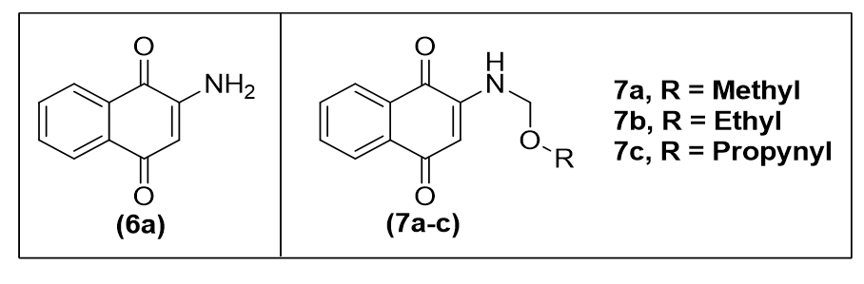
Supplementary Figure S1. Chemical structure of the N,O acetals 7a, 7b, and 7c derived from 2-amino-1,4-naphthoquinone (6a).
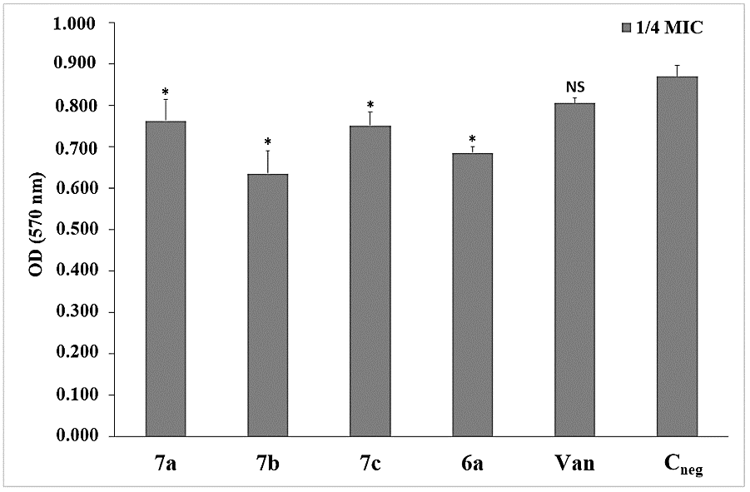
**
***
***
**

Supplementary Figure S2. Effect of 1/4MIC N,O-acetals 7a (64 µg/mL), 7b (32 µg/mL), 7c (16 µg/mL) derived from 2-amino-1,4-naphthoquinones 6a (32 µg/mL), and 1/4MIC vancomycin ( 0.5 µg/mL) on cell growth of the strain MRSA strain BMB9393. Cneg, negative control with 2% DMSO only. NS: not significant; **: p value < 0.001; ***p<0.0001. Colony forming units (CFU) were also determined to confirm the viability of the cells grown in the presence of 1/4MIC of the derivatives 7b (1.60 X 10⁸ CFU/mL) and 7c (3.53 X 10⁸ CFU/mL), which displayed important antibiofilm effects, and also for the negative control: Cneg (4.53 x 10⁸ CFU/mL).
Supplementary Table S1. Primers used in this study.
Gene | Gene product | Primer | Reference
gyrA | DNA gyrase subunit A | F: GCAGTTCGCTTAACAAGTGG | This study
gyrA | DNA gyrase subunit A | R: GCCGTACAGCAACGGGTG | This study
gyrB | DNA gyrase subunit B | F: GATGTAGCAAGTCTTCCAGG | This study
gyrB | DNA gyrase subunit B | R: ACAAAATCTGGTCGTGACTC | This study
atlA | Autolysin | F: TGTCGAAGTATTTGCCGACTTCGC | 1
atlA | Autolysin | R: TGGAATCCTGCACATCCAGGAAC | 1
fnbA | Fibronectin binding protein A | F: ACTTGATTTTGTGTAGCCTTTTT | 2
fnbA | Fibronectin binding protein A | R: GAAGAAGCACCAAAAGCAGTA | 2
hla | Alpha-toxin | F: TTTGTCATTTCTTCTTTTTCCCA | 2
hla | Alpha-toxin | R: AAGCATCCAAACAACAAACAAAT | 2
spa | Protein A | F: TGGTTTGCTGGTTGCTTCTTA | 2
spa | Protein A | R: GCAAAAGCAAACGGCACTAC | 2
pmsα3 | Phenol soluble modulin α3 | F: TATCAAAAGCTTAATCGAACAATTC | 3
pmsα3 | Phenol soluble modulin α3 | R: CCCCTTCAAATAAGATGTTCATATC | 3
mecA | Penicillin binding protein 2a | F: TCCAGATTACAACTTCACCAGG | 4
mecA | Penicillin binding protein 2a | R: CCACTTCATATCTTGTAACG | 4
rnaIII | Agr rnaIII | F: AATTTGTTCACTGTGTCGATAAT | 2
rnaIII | Agr rnaIII | R: TGGAAAATAGTTGATGAGTTGTT | 2
sarA | Transcriptional regulator SarA | F: TTCTTTCTCTTTGTTTTCGCTG | 2
sarA | Transcriptional regulator SarA | R: GTTATCAATGGTCACTTATGCT | 2
sigB | Sigma factor | F: TCAGCGGTTAGTTCATCGCTCACT | 5
sigB | Sigma factor | R: GTCCTTTGAACGGAAGTTTGAAGCC | 5
16S rrna | Reference gene | F: AGAGATAGAGCCTTCCCCTT | 2
16S rrna | Reference gene | R: TTAACCCAACATCTCACGACA | 2

Supplementary Table S2. Disk diffusion test for N,O acetals derived from 2-amino-1,4-naphthoquinone using reference strain and MRSA strains from different international lineages.
Strain |  | Inhibition zone (mm)
 |  | 6a | 7a | 7b | 7c | VAN*
Control strain | S. aureus ATCC 25923 | 9±1.4 | 9.7±2.0 | 12.5±3.5 | 14±3.4 | 13±1.0
MRSA | ST239-SCCmecIII  (BMB9393) | 8±2.0 | 10±1.5 | 10±1.0 | 13±1.0 | 14±1.0
MRSA | ST5-SCCmecII  (USA100) | 9±1.0 | 12±1.0 | 13±2.0 | 12±1.5 | 16±1.5
MRSA | ST8-SCCmecIV  (USA300) | 9±1.0 | 14±1.0 | 12±2.0 | 13±1.3 | 17±1.0
MRSA | (ST1-SCCmecIV)  (USA400) | 8±1.2 | 13±2.0 | 13±1.0 | 11±0.8 | 16±2.0
MRSA | ST30-SCCmecIV  (USA1100) | 10±0.5 | 13±1.0 | 13±1.0 | 15±0.8 | 16±1.5
MRSA | ST5-SCCmecIV  (USA800) | 8±1.0 | 12±1.0 | 13±0.5 | 13±1.0 | 17±1.5
*VAN, vancomycin. VAN was used as control.
References
1. Biswas, R. et al. Activity of the major staphylococcal autolysin Atl. FEMS Microbiol. Lett. 259, 260–268 (2006).
2. Ferreira FA et al. Impact of agr dysfunction on virulence profiles and infections associated with a novel methicillin-resistant Staphylococcus aureus (MRSA) variant of the lineage ST1-SCCmec IV. BMC Microbiol. 13, 93. https://doi.org/ 10.1186/1471-2180-13-93 (2013).
3. Li, M. et al. Comparative analysis of virulence and toxin expression of global community-associated methicillin-resistant Staphylococcus aureus strains. J. Infect. Dis. 202, 1866–1876 (2010).
4. Oliveira, D. C. & de Lencastre, H. Multiplex PCR strategy for rapid identification of structural types and variants of the mec element in methicillin-resistant Staphylococcus aureus. Antimicrob. Agents Chemother. 46, 2155–2161 (2002).
5. Lauderdale, K. J., Boles, B. R., Cheung, A. L. & Horswill, A. R. Interconnections between Sigma B, agr, and proteolytic activity in Staphylococcus aureus biofilm maturation. Infect. Immun. 77, 1623–1635 (2009).

