Enzymatic decolorization of melanin by lignin peroxidase from Phanerochaete chrysosporium
Beenish Sadaqat¹, Nazia Khatoon², Aneela Younas Malik¹, Asif Jamal¹, Uzma Farooq¹, Muhammad Ishtiaq Ali^{1*}, Huan He³, Fang-Jing, Liu³, Hongguang Guo⁴, Michael Urynowicz⁵, Qiurong Wang⁶, Zaixing Huang^{3,5*}
¹Department of Microbiology, Quaid-i-Azam University, 45320, Islamabad, Pakistan
²Instiute of Space Technology, 44000, Islamabad, Pakistan
³Key Laboratory of Coal Processing and Efficient Utilization of Ministry of Education, School of Chemical Engineering and Technology, China University of Mining and Technology, Xuzhou, 221116, China
⁴College of Safety and Emergency Management and Engineering, Taiyuan University of Technology, Taiyuan 030024, China
⁵Department of Civil and Architectural Engineering, University of Wyoming, 82071, USA
⁶Department of Animal Science, University of Wyoming, Laramie, WY 82071, USA

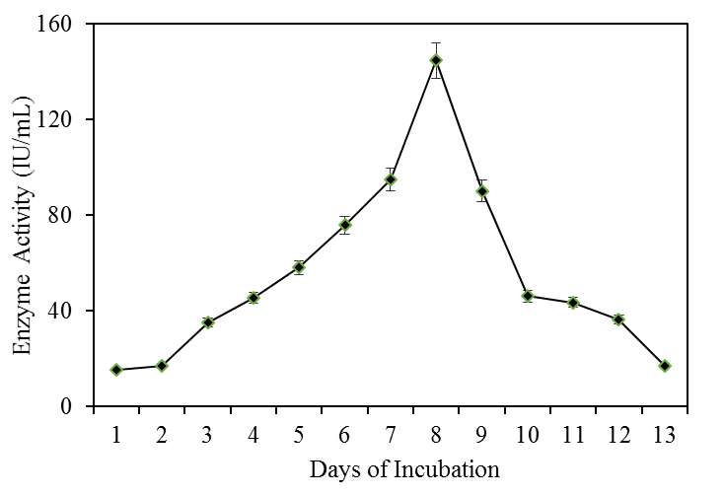
Supplementary Figure 1 Enzyme activity over incubation time. Data points represent the means ± s.d., n=2/group.

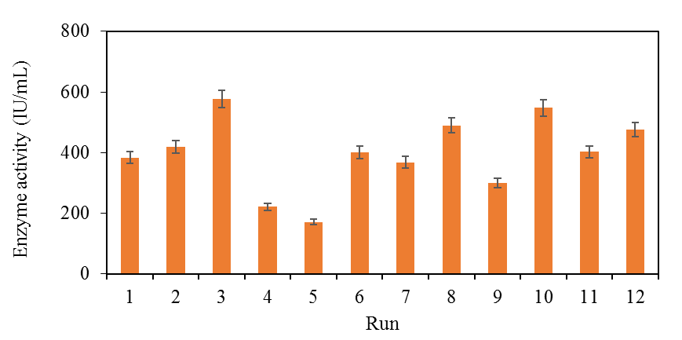Supplementary Figure 2 Optimization of enzymatic activity under different combinations of 9 factors in 12 experimental runs. Data points represent the means ± s.d., n=3/group.

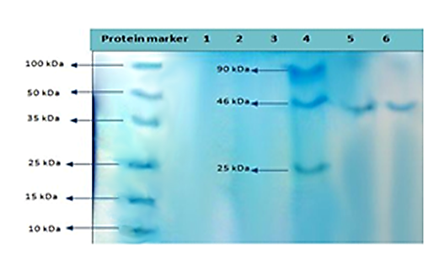
Supplementary Figure 3 Molecular weight identification of the purified fraction from the gel filtration chromatography by separation of characteristic band on SDS acrylamide gel.

